
SEMESTER 2
SESSION 2019/2020 SEMESTER 2

COURSE CODE
UHMT1012 – GRADUATE SUCCESS ATTRIBUTES

LECTURER’S NAME
Dr Farhana Binti Mohd Noordin

Reflection Based on Activity Participated Before

NAME
HAM JING YI
MATRIC NO
A19EC0048
SECTION
26

Date of Submission: 14/07/2020

Reflection
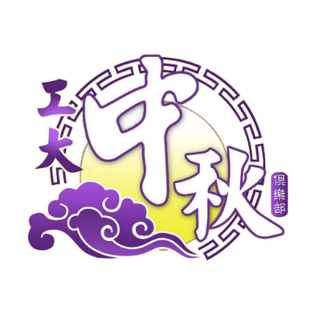
One of the most interesting and unforgettable memories that kept deep in my heart is related with the Pesta Tanglung UTM. I am thankful to be one of the members of preparation of opening ceremony of a Mooncake Festival and Culture Night held by Secretariat of Pesta Tanglung UTM on the 29th and 30th of November 2019. The opportunity is golden. Pesta Tanglung UTM is a Chinese club with aspiration to preserve Chinese culture by celebrating the Mooncake festival and Chinese New Year. The event is themed “Ming Juan ∙ Cheng Yi”. The theme is about four classical Chinese novels. The event consists of games playing, various type of performances, decorations, food, and the celebrities. Since an event needed event planning group, sales group, running crews, gophers, venue team and more.
One of the team among these team is the event planning team. The event planning team must plan and organize the events, invite the celebrities for the singing show, make sure the events planned are going well. Since the program planning team is the busiest team, it needs a lot of backstage crews, gophers, stage stages and more. I am one of the members in the program planning group who involved in opening ceremony stuff and the stage crew. The job scope is preparing and creating the materials that needed for the opening ceremony. Since the theme is about four classical Chinese novels, we must come out 4 different drawings that related to the four classical Chinese novels and tied them together to become a big book. Of course, some decorations are added to beautify the book cover. There are 3D pop-up cards inside showing the name of the theme. My three friends and I are involved in this important drawing program. My team communicate using WhatsApp since the team leader is always busy and the only way to discuss the recommend potential solution to solve the problems is using video call via WhatsApp. To decrease the time consumption, one person in charge of the frame and stand making, one person taking care of the cutting and shaping the boards, 2 persons take the jobs of sketching and painting.
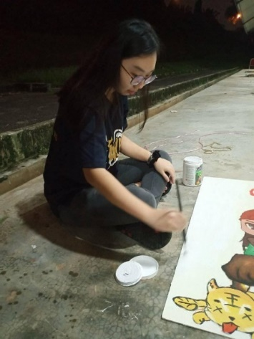
My job is to sketch the characters of the four classical Chinese novels in details and painting. The painting part is crucial since all the VIPs are involved in opening this prop and the paintings will be on the newspapers the next day. Our team face a lot of problems while doing the props. The stands used to support the pop-up cards is not strong enough. So, we must squeeze our brain to think an ideal solution. At the same time, exam period is just around the corner and I must complete my drawing stuff in a few days. So, I must manage the tasks and have a good time management. As we know, slow and steady win the race. After two weeks spending 6 hours every night in N24, four nice drawings turn into book and it is ready for the opening ceremony. So, the preparation task before the festival done. At the first day of festival, I must be the stage crew, carrying the props. The props used in the opening ceremony is the book that four of us prepared. At the second day, I must be the running crews, remind the master of the ceremonies what to take note, what to mention and more. It is undeniable that running crews really plays an important job in message delivery so that the performances on the stage can go well.
My goal about this club activity is to learn the planning skills and organizational skills. I hope that I can plan a big program and things will well organized after participating in this club’s event. After taking part in this event, I know that planning an event is not as easy as ABC. Then, a good leader and teammates in event are very important. My leader in this event always motivate us when we almost give up on the book-making and good leader always building confidence for us. A good teammate is important in working together with us to complete a task, helping us when we are facing troubles. I know that I am not mature in event planning. So, I will participate in more similar events so that I can gain more experiences and mature in event planning.

