Program Information
Date: 2nd March 2020
Venue: Dewan Sultan Iskandar, UTM JB
Organizer: Faculty of Engineering, General, Industrial/Institutional Collaboration & Networking

Position and Role
Position: Participant of the program
Role: Participate in the activities conducted by organizer.

Graduate Attributes
1. Information gathering skills
2. Self-awareness
3. Adaptability skills

Mini Report
On 2nd March 2020, Universiti Teknologi Malaysia (UTM) held an event, Huawei Connected Campus at Dewan Sultan Iskandar, UTM JB hosted by Huawei. UTM became the first public university to host this event this year. There were various activities conducted including talk by Huawei leaders, campus recruitment, and showcase of Huawei products. More than 3000 students joined the one-day event.
The event was launched by UTM Vice-Chancellor, Prof. Datuk Ir. Dr. Wahid Omar before talk session given by Huawei leaders. The talk session started at the evening around 2.30 PM. There was many useful information that I got from the talk session. I learn some information on specifications of our next generation of telecom networks (fifth generation or 5G) and the improvement that it had compared to 4G network. As for example, I just knew that that 5G has a data rate up to 10Gbps that is 10 to 100 times improvement over 4G networks. I also knew some information on IoT (Internet of Things) that is very useful for me as we are living in Industrial Revolution 4.0.

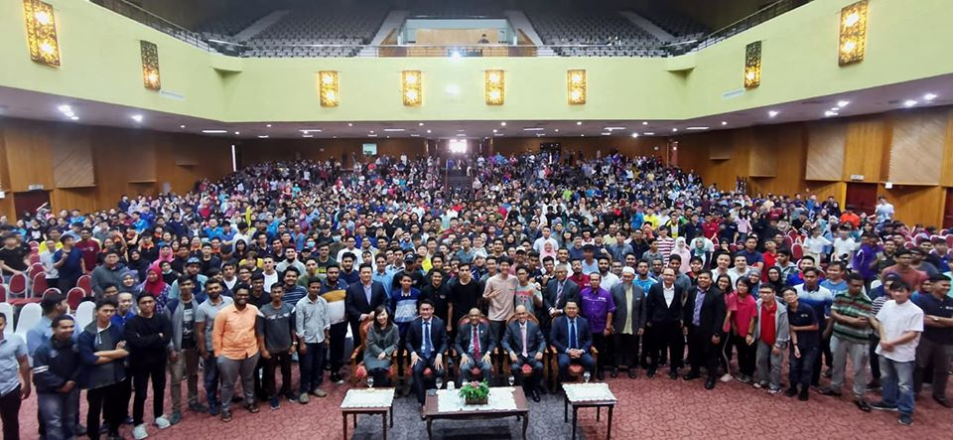

Self-Reflection
From this Huawei event, there’s some things useful that I have gain from joining this event. I can enhance my knowledge about the Huawei background and what they doing now days. From this gathering it makes me more clearly understand on the latest issues between the Huawei company and United states. Next, by joining the event with a lots of student we can polish our focusing skill to during the talk and this is include in soft skill during our studies and if we are joining for the next events because when we are having a class lecture or a talk by certain people, some of the lecturer or the presenter will talk without highlighting the main information and point. So, its depends on us to give a higher attention and focus during that time because I will lose some info from that if we are not focus. By joining a lot of event like this we can polish our focusing skill so we not have a problem to understand from the what topic and point that deliver.
Next I learnt that we should have a high self-awareness on technologies issues now days especially on modern technologies. This is because we need to gain more knowledge, explore the technologies development and adapt with the technologies now days because we are living on Industrial Revolution 4.0, where we are introduced with IoT (Internet of Things), Big Data, Artificial Intelligence (AI), and many more. If we do not catch up with current development, we will be left behind and our chances to be employed is lower as an employee need to adapt and have more knowledge with current development.

