

Group Project
Course Code
Computer Organization and Architecture- SECR2033-02
Lecturer
Dr Zuriahati Mohd Yunos

Member Name | Matric Number
MOHAMAD AMIN HAZEEQ BIN HISHAM | A19EC0087
LOH YEW CHONG | A19EC0076
IMRAN HAKIM BIN NORASMADI | A19EC0189

Table Of Contents

Content | Page
- Member Responsibilities | 3
- Coding and Explanation | 4-7
- Example of inputs & Outputs | 8-10
- Discussion & Conclusion | 11-12
- References | 13

Member responsibilities
Member Name | Responsibilities
Mohamad Amin Hazeeq  Bin Hisham | Code – 1’s Complement  and Reverse every bit in Hex  Report --Coding and Explanation  Member Responsibilities
Loh Yew Chong | Code- Invoke Str_compare and Convert and Compare using ASCII  Report - Cover page, Table of Content,  and Discussion
Imran Hakim Bin Norasmadi | Code – Two’s Complement  Invoke Str_ucase  Report -- Sample input and Output  and Conclusion

Coding and Explanation
TITLE COA Project (case4.asm)

; Group Members:
; MOHAMAD AMIN HAZEEQ BIN HISHAM ( A19EC0087 )
; IMRAN HAKIM NORASMADI ( A19EC0189 )
; LOH YEW CHONG ( A19EC0076 )

; Section : 02

INCLUDE Irvine32.inc

.data
perkataan byte 10 dup(0) ;making “perkataan” with 10 arrays
count dword 0 ;store the length of char array

MAX = 50 ;max chars to read
inputString byte MAX+1 DUP(?) ;room null
test1 byte "y",0 ;test1 initialize with string “y”
test2 byte "n",0 ;test2 initialize with string “n”
prompt1 BYTE "Please Enter 4-digit Hexadecimal integer (e.g.,A1B2) : ",0 ;prompt1
prompt2 BYTE "Two's Complement of Hex ",0 ;prompt2
prompt3 BYTE " is ",0 ;prompt3
prompt4 BYTE " Error ",0 ;prompt4
prompt5 BYTE "Try again? (y/n) ",0 ;prompt5
prompt6 BYTE "You enter WRONG CODE!!, please re-enter carefully !!!",0 ; prompt6
carrybit byte 0 ;Check when propagation or not

.code
main PROC

WHILE1:
mov edx, OFFSET prompt1 ;move into register edx from prompt1 using OFFSET
; (address” and is a way of handling the overloading of
; the “mov” instruction.

call WriteString ;display the string of prompt1

mov edx, OFFSET perkataan ;move into register edx from perkataan using OFFSET
; (address” and is a way of handling the overloading of
; the “mov” instruction.

mov ecx, SIZEOF perkataan; ;SIZEOF will refer to the length of perkataan and
; will move to register ecx
call ReadString ;This is the library for user input
;when using “ReadString” it store at register edx
mov count, eax ;move value in eax into “count” variables

mov edx, OFFSET prompt2 ;move into register edx from prompt2 using OFFSET
; (address” and is a way of handling the overloading of
; the “mov” instruction.

call WriteString ;display the string of prompt2

mov edx, OFFSET perkataan ;move into register edx from perkataan using OFFSET
; (address” and is a way of handling the overloading of
; the “mov” instruction.

call WriteString ;display the value from perkataan
mov edx, OFFSET prompt3 ;move into register edx from prompt3 using OFFSET
; (address” and is a way of handling the overloading of
; the “mov” instruction.

call WriteString ;display the string of prompt3

INVOKE Str_ucase, ADDR perkataan ;Str_ucase is procedure to convert a string to all
;uppercase character

mov esi, OFFSET perkataan ;store the address of first member of perkataan
mov ecx, 3 ;Set loop counter to 3

FIRST_Complement:
mov al, byte ptr [esi+ecx] ;here we take the first character and move it into al
;esi contain value in perkataan and than ecx is to refer
;the offset of the esi (location) using little endian order as
;we using it in byte

cmp al, 53 ;53 decimal if convert to char it is “5” (compare the character ;with 5 in char)in ascii
;if al > 53, jump to FIRST_Complement_Number
ja FIRST_Complement_Number ;if al <= 53, means that the number is smaller or equal to 5

sub al, 48 ;48 decimal if in char is “0”(subtract the al with 0)in ascii
;to get the distance between two values

mov bl, 70 ;move 70 into bl (70 decimal if in char is “F”)in ascii
sub bl, al ;this we will get the result of 1’s complement
jmp PLUS ;jump to PLUS to continue the 2’s complement step

FIRST_Complement_Number:
cmp al, 57 ;if al <= 57, means that the number is smaller
; or equal to 9 but bigger than 5
ja FIRST_Complement_Alphabet ;if al > 57, jump to FIRST_Complement_Alphabet
sub al, 54 ;54 decimal if in char is “6”(subtract the al with 6)
;to get the distance between two values

mov bl, 57 ;move 57 into bl (57 decimal if in char is “9”) in ascii

sub bl, al ;this we will get the result of 1’s complement

jmp PLUS ;jump to PLUS to continue the 2’s complement step

FIRST_Complement_Alphabet:
cmp al, 70 ;if al <=70, means that the number is smaller of equal to F but bigger than 9 (A-F)
;in ascii
ja exi2 ;if al > 70, jump to exi2(means that this is a alphabet bigger than F, so invalid)
;in ascii
sub al, 65 ; 65 decimal if in char is “A”(subtract the al with 65)
;to get the distance between two values

mov bl, 53 ;move 53 into bl (53 decimal if in char is “5”) in ascii

sub bl, al ;This we will get the result of 1’s complement
jmp PLUS ;jump to PLUS to continue the 2’s complement step

PLUS :
cmp ecx, 3 ;to check whether it is MSB or not because only add 1 to the (MSB)
jne PROPAGATION ;if it is not the MSB, will directly skip the below step to PROPAGATION

YES9: ;carrybit propagation only occur if the digit is F
cmp bl, 57 ;first compare it is 57 (57 decimal is 9) in ascii
; if it is nine, it will become A
jne not9 ;if it is not 9, jump to not9 to do the next checking
mov bl, 65 ;ASCII value of A is 65 decimal

mov carrybit, 0 ;we will set "carrybit" to 0 because 9+1 = A, no carrybit bit !!
;9+1 operation please use calculator base 16 to check the value
jmp SAMBUNG ;then jump to sambung

not9:
cmp bl, 70 ;compare it is F(70 in ascii table) or not, if it is F, it will become 0 after adding 1
jne notf ;if it is not F, jump to F
mov bl, 48
mov carrybit, 1 ; we'll set "carrybit" to 1 because F+1=10, have carrybit !!
;F+1 operation please use calculator base 16 to check the value

jmp SAMBUNG ;then jump to sambung

notf:
add bl, 1 ;add bl with 1 and nothing to be concern (no carrybit)
mov carrybit, 0 ;since the hexa value is not F so no carrybit
jmp SAMBUNG ;then jump to sambung

PROPAGATION:
cmp carrybit, 0 ;after adding 1, we will check whether there is carrybit propagation or not
jne YES9 ;if there is no carrybit, jump back to YES9 to check the next digit

SAMBUNG:
mov byte ptr [esi+ecx], bl ;here we take the new character and move it into bl
;esi contain value in perkataan and than ecx is to refer
;the offset of the esi (location) using little endian order as
;we using it in byte

dec ecx ;update the loop counter
;need to decrease because since we reverse in the stack
cmp ecx, -1 ; compare ecx with -1
je exi1 ;if equal jump to exi1 (to exit step)
jmp FIRST_Complement ;if not re-loop again and jump to FIRST_Complement

exi1:
mov edx, OFFSET perkataan ;move into register edx from perkataan using OFFSET
; (address” and is a way of handling the overloading of
; the “mov” instruction.

call WriteString ;display the two’s complement here
call Crlf ;new line
jmp exi ;jump to exi ask user want to try again or not

exi2:
mov edx, OFFSET prompt4 ;move into register edx from prompt4 using OFFSET
; (address” and is a way of handling the overloading of
; the “mov” instruction.

call WriteString ;display the prompt 4 “Error” message

call Crlf ;new line
jmp exi ;jump exi ask user want to try again or not

exi:

mov edx, OFFSET prompt5 ;move into register edx from prompt5 using OFFSET
; (address” and is a way of handling the overloading of
; the “mov” instruction.

call WriteString ;display prompt 5 to try again (y/n)

mov edx,OFFSET inputString ;move into register edx from inputString using OFFSET
; (address” and is a way of handling the overloading of
; the “mov” instruction.

mov ecx ,MAX ;move MAX into ecx
call ReadString ;This is the library for user input
;when using “ReadString” it store at register edx

INVOKE Str_compare, ADDR inputString, ADDR test1 ;Str_compare is to compare two null-terminated strings.
;this compare user input with test1=”y”
jne No ;jump to No if not equal
call Crlf ;new line
jmp WHILE1 ;jump back to WHILE1

No:
INVOKE Str_compare, ADDR inputString, ADDR test2 ;Str_compare is to compare two null-terminated strings.
;this compare user input with test1=”n”

jne OTHER ;jump to OTHER if not equal

call Crlf ;new line
jmp HERE ;jmp HERE to terminate the program

OTHER:
call Crlf ;new line
call Crlf ;new line
mov edx, OFFSET prompt6 ;move into register edx from prompt6 using OFFSET
; (address” and is a way of handling the overloading of
; the “mov” instruction.

call WriteString ;display prompt6
call Crlf ;new line
call Crlf ;new line
call WaitMsg ; "Press [Enter]..."
call Clrscr ; clear screen
jmp exi ;jump back to exi for the proper code enter

HERE:
call WaitMsg ; "Press [Enter]..."
call Clrscr ; clear screen
exit ;exit the program
main ENDP
END main

Example input & output

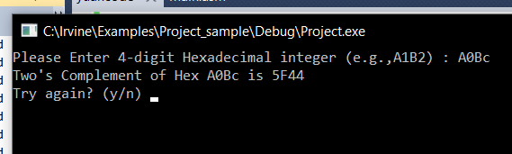
(figure 1) example of hexa value

In figure 1, the computer will first of all prompt the user for a 4-digit Hexadecimal integer. The user will respond by inputting the input A0Bc. The output at the console will be the input of the user and the two’s complement of the user’s input. Then finally the computer will prompt the user if they want to try again, with options being y or n.

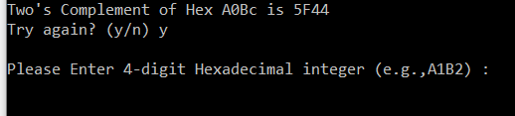
(figure 2) option to try again

In this case the user inputs ‘y’ into the computer and the prompt asking the user to enter a 4-digit hexadecimal input is brought up.

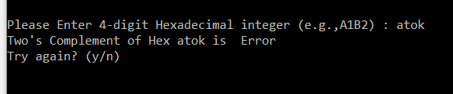
Figure 3

In figure 3, the user enters ‘atok’ when prompted to enter a 4-digit hexadecimal input. Indeed, the input is incorrect and is displayed ‘error’ at the end of the second line. Then the user will be prompted if they want to try again.

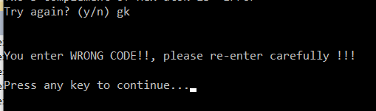
Figure 4

In the figure above, the user is prompted to the “try again” question, but this time the user has inputted incorrectly. A message saying that the user has entered the wrong input and asks the user to re-enter carefully. Another prompt will appear asking the user to enter any key to continue.

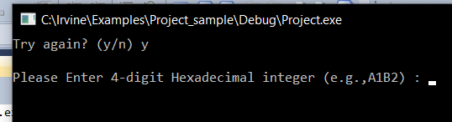
Figure 5
This is continuing from the above figure, where the user will again be asked if they want to try again. Only this time the user has entered a correct input ‘y’ and will return to the default prompt.

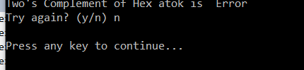
Figure 6

The above figure shows the user has entered an incorrect input. But this time when prompt to try again the user inputs ‘n’. The user will be asked to enter any key to continue but this time ending program when the user has done so.

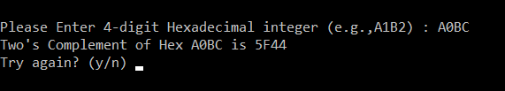
Figure 7
In the figure 7, when asked for a 4-digit hexadecimal input the user inputs it in all uppercase letters. The program still can output the two’s complement. As the program will convert the input into all lowercase and remain the uppercase then convert it to its two complement.

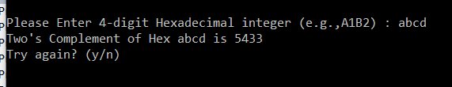
Figure 8

In the figure 8, when asked for a 4-digit hexadecimal input the user inputs it in all lowercase letters. But the program still outputs the two’s complement. As the program will convert the input into all lowercase and then convert it to its two complement.

Discussion
This assembly program that we were asked to write is a program that allows the user to convert a 4-digit Hexadecimal integer which was input by them to its Two's Complement. Besides that , the program will ask the user whether they want to try again which will allow the user to convert another 4-digit Hexadecimal integer when they wish to do so. It will continue to allow the user to convert a 4-digit Hexadecimal integer after the user enters “y” to continue. Based on the question , the example of output given does not display error feedback when the user enters the invalid input when the program ask whether to try again , hence we decide to add this feature to our program. After the user enters invalid input , there will be an error feedback and when they enter, the screen will be clear and they will be asked to enter input for conversion.
The concept we have applied for the one’s complement conversion is by comparing the input with the decimal based on the ascii table and then subtract a decimal number with distance of the between the decimal number we compare according to our mean to get one complement.It may cause carrybit in this process. Then we add the lowest bit with 1 and check whether there is a carry bit or not. After that we print the value out. Before we do the one’s complement we make the input which is alphabet to its uppercase when it is in lowercase.

One of our major findings is PTR Overrides which is a default type of a label (variable). It provides the flexibility to access part of a variable.When integers are loaded from memory into the register the bytes are automatically re-reverse into their correct position. We also get introduced to the Str_compare that compares two null-terminated strings. “Offset” is an assembler directive in the x86 assembly language. It actually means “address” and is a way of handling the overloading of the “mov” instruction. We found that there is a mnemonic which is parsedecimal32 that is able to convert decimal to binary.But we did not use it in the program because we think that it is not that suitable. We did use readHex but instead we use readstring as we think that i would be more suitable

Conclusion

In conclusion, this computer organization project had tasked us to write a simple code to input a 4-digit hexadecimal number, converting that input to its two complement. To tackle this question, we had broken the code into partitions that we could solve one by one as a group. The manual two’s complement calculation (carry and propagation), input and input checking. To tackle the input, we had used ASCII values in checking if the input was valid or not. Not only that ASCII made our work easier but we gained a lot of knowledge regarding how ASCII values work. In tackling the two’s complement, there are actually a variety of techniques to perform 2’s complement but here we use ASCII as it is the most efficient way to do this task. Two's complement is the most common method of representing signed integers on computers and it is more generally, fixed point binary values.
Technically, 2’s complement is highly used in developing systems in computers. The method of 2’s complement had long been used to perform subtraction in the decimal adding machine and also the calculator. Long time ago, John von Neumann suggested use of two's complement binary representation as it is the best type of complements at that time rather than signed and 1’s complement. Because the exchange value or the value converted is equivalent to the expected values.
For the input, the user input would be stored in a char array so that it would be easier to access and convert lower case letters to capital letters. Not only it enabled us to use ASCII values.
Clearly, we have all gained numerous amounts of knowledge in letting us apply what we have learned in Computer Organization Architecture, whilst gaining new knowledge when studying to complete this project.

References

Irvine Library Help
http://csc.csudh.edu/mmccullough/asm/help/index.html?page=source%2Fmacros32%2Fmdumpmem.htm

Reverse using ptr
https://www.csie.ntu.edu.tw/~cyy/courses/assembly/12fall/lectures/handouts/lec13_x86Asm.pdf

Reference ascii table
