
SECI2143 SEC 02
PROBABILITY & STATISTICAL DATA ANALYSIS
Project 1: The ideal characteristics and attributes of an ideal PARTNER

LECTURER: Mr. Chan Weng Howe
NAMES : Matric Number
ALVIN HEE JUN SHEUNG A19EC0015

LEE SZE YUAN A19EC0068

LOH YEW CHONG A19EC0076

THANNEERMALAI A/L UDAYAPPAN A19EC0171

Table of Content
1.0 INTRODUCTION 3
2.0 METHODOLOGY 5
3.0 RESULT ANALYSIS AND DISCUSSION 6
4.0 CONCLUSION 22
5.0 REFERENCE 23

1.0 INTRODUCTION
On 1st of March, a group of students from University Technology Malaysia, School of Computing received a project from Mr Chan Weng Howe. They were required to conduct a study on any relevant topic. Then they need to collect data, analyse the collected data and produce useful information from these data. They decide to conduct a study on “The ideal characteristics and attributes of an ideal partner”
This study aims to find out what are the ideal characteristics and attributes of an ideal partner that a UTM student looks for. This is also a great chance and platform for UTM students to share their own thoughts in choosing the future life partner. We hope we can analyse the data from the perspective of UTM students and provide valuable insight from the data.
Nowadays, Flash marriages are very common among millennials. This might seem like a good thing to expand the population but the divorce rate in our country is getting higher too. From the statistics provided by the Department of Statistic Malaysia, the number of divorces decreased from 50,314 (2017) to 50,356 (2018) yet the divorce rate still remained at 1.6 per 1000 populations. The median age of marriage among Malaysians is 28 for male and 26 for female. However, the median age of divorce is 37 for male and 34 for female. This shows that people nowadays tend to get a divorce only a few years after their marriage.
This phenomenon will bring various negative effects. For example, children have to face pressure of having a broken family. This may affect the healthy mental growth of a child. This will also cause changes in the socio-economic state of adults and also children. Children might develop behavioral and social problems. So, we hope that our study could provide a plausible solution to this problem.
Therefore, We strongly believe that the result of this survey will help UTM students to have a clearer mindset in choosing their ideal future partner. The result itself will also act as a motivation and guidance for UTM students so that they know how to improve themselves or choose partners that are suitable for them.

Last but not least, we hope that the result of this survey is not only confined to UTM students, but also benefits others because UTM students consists of all age groups whom originated from all over malaysia and also other foreign countries.We hope that the result of this survey can be useful in future research on related topic.

2.0 METHODOLOGY
We planned to conduct a survey among UTM students and collect primary data from them. We aimed to get about 70 respondents. So, We prepared a questionnaire for this survey. Inside this questionnaire, we have prepared several types of questions. The first part of this questionnaire consists of questions focused on getting details of the respondents who are filling this form. Then in the second part of this questionnaire, our questions focused on getting UTM students preference on characteristics and attributes of their ideal partner.
We used Google From to create our questionnaire since it is easy and convenient. After we finished creating our questionnaire, we distributed it to the whole UTM students through social media like Facebook and chat apps like Whatsapp and Telegram.
The type of Data that can be collected through this questionnaire is quantitative data. We are also able to collect ratio class, interval class, nominal class and also ordinal class data type.
After we collected enough respondents. We tabulated the data and cleaned the data. Because some of the responses we got are considered irrelevant and illogical, so we had to delete the data. We saved our dataset in the format of xlsx file format.
Then, we started to do the analysis of data. We used R studio to analyse the data and visualise the data into various forms of graphical representation. For example, there are scatter plots, bar charts, histograms, pie charts etc. Every form of visualisation of data can provide different kinds of insight contributing to the topic. We explained it and presented it in a form of report.

3.0 RESULT ANALYSIS AND DISCUSSION
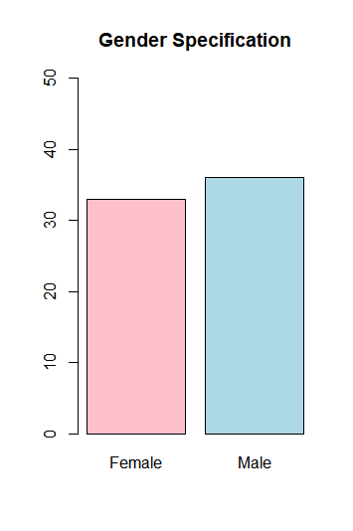
Figure 1.0: Gender Specification
Based on the survey that we had carried out in UTM, we received a total of 69 respondents from nearly every faculty in UTM. A total of 36 males (52.17%) were involved in this survey, whereas 33 females (47.83 %) did participate in our survey as well. Since there is only a difference of 3 between the gender specification, hence we believe that the data provided by our respondents will not be biased due to the same gender might have the same preference.

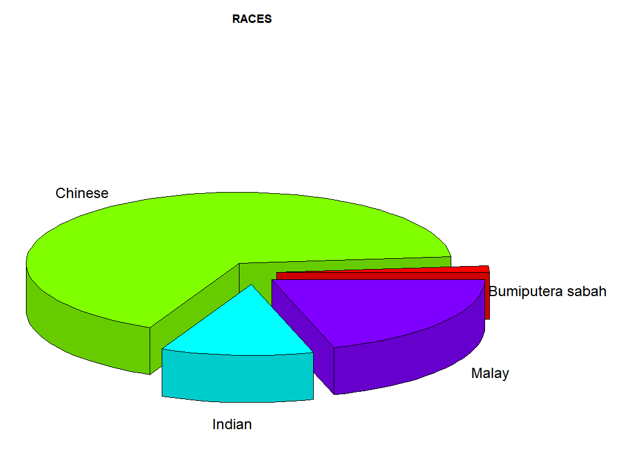
Figure 2.0: Population of each Race
Pie chart is what we used to represent one of the fundamental data which is race. Out of 69 respondents, there are exactly 1 bumiputera from Sabah (1.45%) which is the race that least participated in our survey. Next, there are a total of 8 Indians (11.59%) that are ranked at 3rd, whereas (20.29%) of Malay students which is equivalent to the amount of 14 has contributed their thoughts in this particular survey. Chinese is the race that participated the most which is 46 (66.67%).

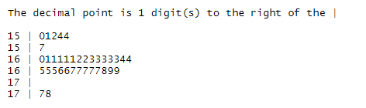

Figure 3.0: Height preference of Male’s Ideal Partner
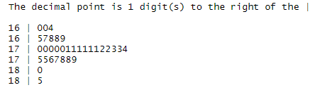
Figure 4.0: Height preference of Female’s Ideal Partner
We used the stem and leaf representation to represent the height preference of the ideal partner. We can conclude a few statements from the representation. For males, it shows that the most ideal height of a partner would be ranged from 150 to 178. While, for the females, the ideal height of their partner would be ranged from 160 to 185. The result is realistic because typical Asians are grouped within the rage based on the Department of Statistics in Malaysia.
For male, the mean height preference is 163.1389 and the data set consists of 3 modes (161, 163 and 167) for an occurrence of 5 times. Whereas for females, the mean height preference is 171.6364. For females, there is only 1 mode which is 171 for a occurence of 6 times

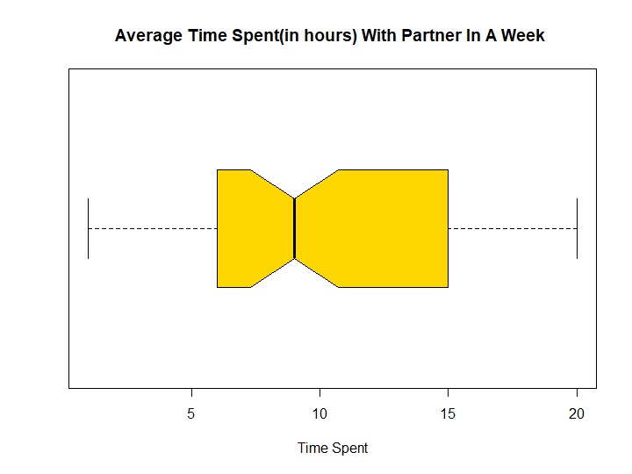
Figure 5.0: Average Time Spent(in hours) With Partner in A Week
In order to display the processed data of average time spent with a partner in a week,we have chosen a box plot to represent the said data . From the box plot above, we have concluded that the first quartile (Q1= 6) is equal to 6 whereas the median (Q2= 9) is equal to 9 and the third quartile (Q3= 15) is 15.The highest time spent with a partner in a week is 20 hours and the least time spent is only 1 hour per week.. On the other hand, there are no outliers from the data that we have collected. We can conclude that the average time(in hours) that UTM students like to spend time with a partner ranges from 1 to 20 hours.

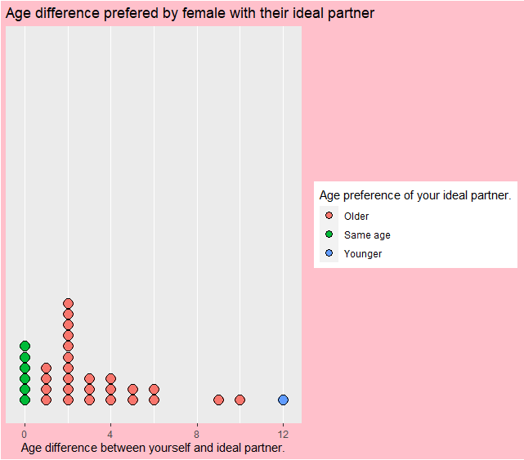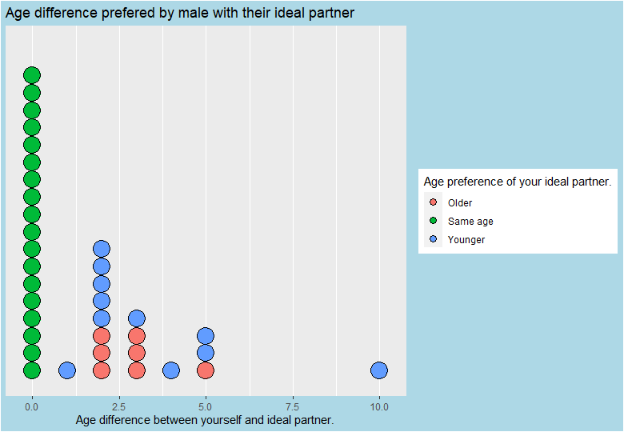
Figure 6.0: Age difference preference by male and female with their ideal partner

We used dot plots to identify the ideal age gap between respondent and partner preferred based on the gender specification either older or younger have also been taken into consideration.
Among the male respondents, we can see that out of the 36 males, a total of 18(50%) males have a preference of having a partner of the same age. Then, there are a total of 11 (31%) males who prefer their partner to be young of age(range from 1 to 10 years). Besides, there are 7 males (19%) who prefer their partner to be older than them (range from 2 to 5 years.)
Meanwhile, we can conclude that 6 out of 33 females(18%) prefer their ideal partner to have a partner of the same age. Then, we could also see an obvious number of female respondents tend to choose a partner at an older age. The number is 26(78%). This clearly shows that females tend to like men which are older than them ( range of 1 to 10 years). Last but not least, we could see only 1 female (3%) who prefers a partner younger than themself.
It seems like a large number of age differences is not only showing a tremendous gap in terms of generation, interested topics and hobbies but also hindering these young teenagers to accept their ideal partner that are tremendously younger or older than themselves.

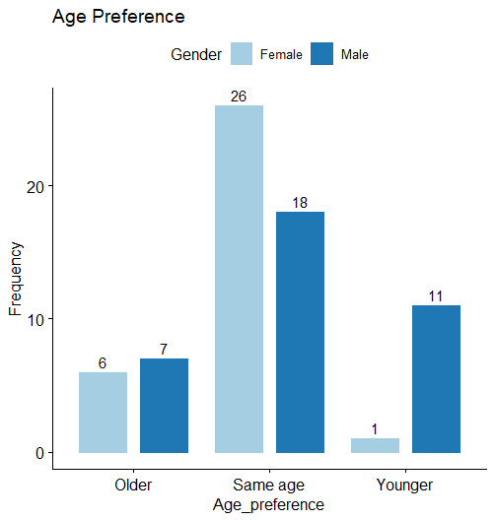
Figure 7.0: Age difference preference by male and female with their ideal partner
For age preference, it consists of 3 options older ,younger or same age.Out of 33 females ,26 of them (78.79 %) choose to have a future partner who has the same age with them, but only 6 females (18.18) choose an ideal partner that is older than them. In the category of younger age, there is exactly 1 female (3.03 %) out of 33 females , this might be due to the mindset of most of the females thinking that most of the younger age partners might not be able to fulfill the criteria of ideal partner that they are looking for. Yet, out of 36 males, there are exactly half of them (50%) who have chosen to have a future partner with no age difference. About 11 males (30.56 %) believe that having a younger age of ideal partner is what makes a happy and wonderful relationship. But 7 males (19.44%) which is slightly 1 more than the amount of females prefer the older age category.

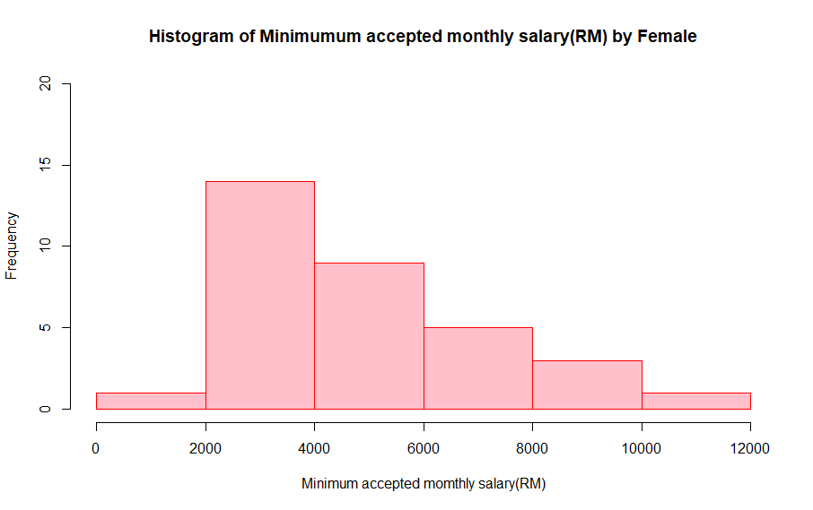

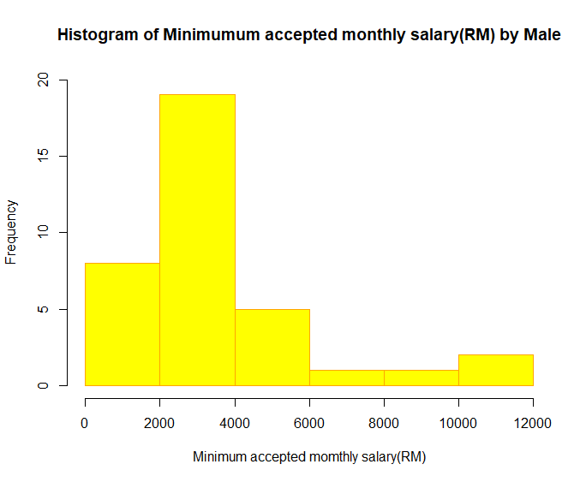

Figure 8.0: The Minimum Monthly Salary (in RM) of your Future Partner that you could accept

Data collected :
Male

Female

From the histogram above, we can see that many males prefer their partner to have a salary that ranges from 2000 to 4000. Among the males, the mode salary is 2500. There are 3 males for each salary category (3500, 3600, 4500). The preferred minimum salary is 1100 and maximum salary is 12000. The median salary is 3100. The range of acceptable salary is 10900.

For females, the mode salary is 3500. While the minimum preferred salary of a partner is 1800 and maximum salary is 10000. Then , the median salary is 3500. The range of acceptable salary for females is 8200.
From here we can know that females expect their partner to have a higher salary than what males expect. Because both the median and minimum salary is higher than that of male .

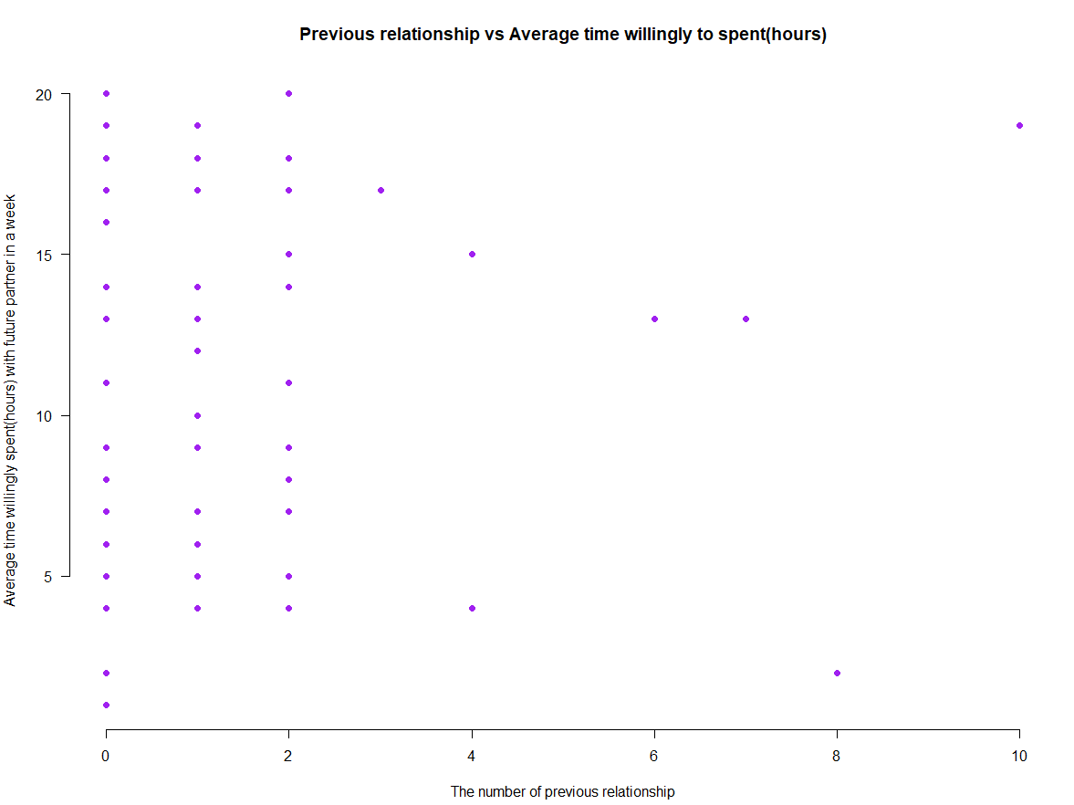
Figure 9.0: Previous Relationship VS Average Time Willingly to spent(hours)

For this plot, we related the number of previous relationships of a person and the average time willingly spent by one person with his/her partner in a week. For the people who have 1,2 or 3 previous relationships, the average time they are willing to spend with their partner in the future ranges from 0 to 20 hrs. Then, for people with more than 3 previous relationships, there is no pattern or trend showing that they have a preferred average amount of time they are willing to spend with their partners. This shows that there is no specific relationship between these 2 variables. The average time a person willing to spend with their partners is not affected by the number of previous relationships that he or she has.

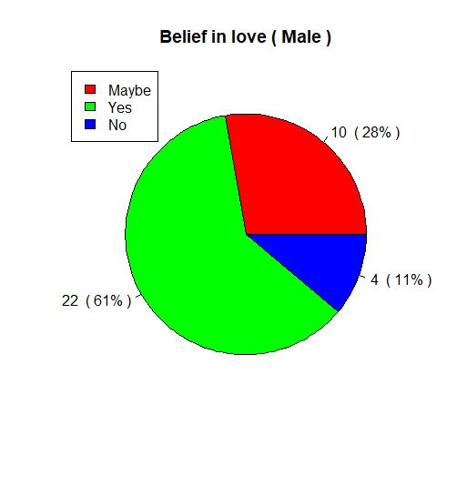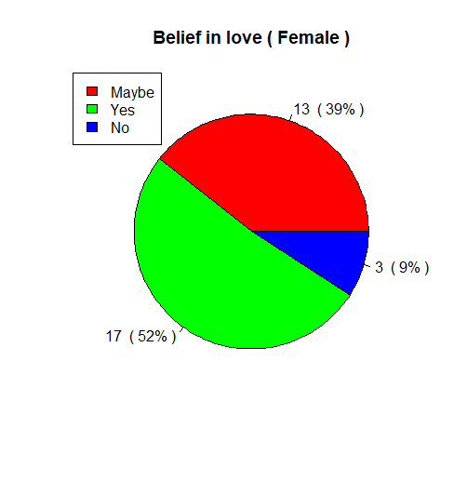
Figure 10.0: Belief in Love among Male and Female
We used another pie chart to illustrate the number of males and females that have belief in love. Among the 36 males, there are 22 people(61%) who answered ‘Yes’ and 10 people(28%) who answered ‘No’ in the questions. Then there are 4 males(11%) who answered ‘Maybe’. Among females, out of 33 females, there are 17 of them(52%) answered ‘Yes’ while 13 of them(39%) answered ‘Maybe’. Then there is a small portion of female respondents who answered ‘No’(3 , 9%). If we compare by percentage, we can see that the percentage of males that answered ‘Yes’ is more than that of females by 9%. We can also see this pattern in the percentage of females and males who choose ‘No’ in these questions. The percentage of males who answered ‘No’ is more than that of male by 3%.
From this data, we can conclude that in UTM the number of people who believe in love is still the majority compared to those who do not believe or choose to be neutral in these topic of love.

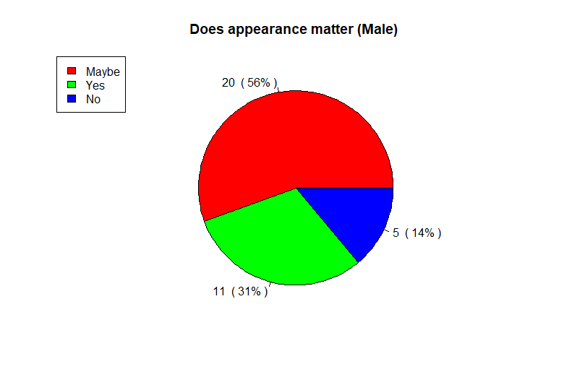
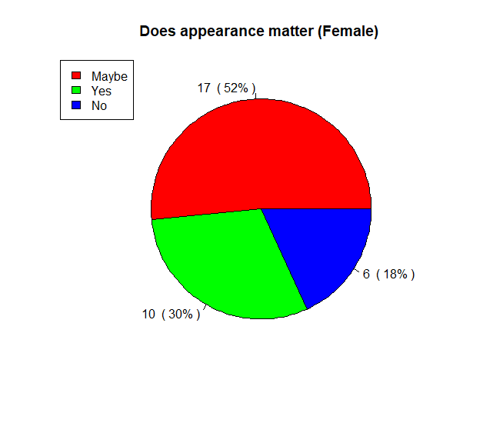
Figure 11.0 Does Appearance Matter by Male and Female
Out of 36 male students, there are only 5 of them (14 %) think physical appearance does not matter to them whereas 11 male students (31%) voted yes for taking physical appearance as a very serious criteria to be evaluated. About 20 respondents or 56 % of them are having a neutral attitude on the appearance of an ideal partner. Moreover ,we evaluate this data from the perspective of UTM female students and obtain a very similar result. Like males, 52% of the female students or 17 of them are having uncertainties against the appearance of an ideal partner.
Most of our group members think that having a good appearance might be able to leave a deep impression by attracting people's attention. There are a total of 10 female students (30%) rated appearance is crucial to them. But only 18 % of female students or 6 , think that appearance does not matter when it comes to an ideal partner.

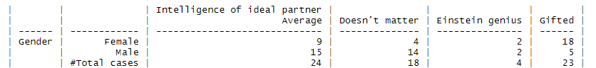
Figure 12.0: Intelligence of Ideal Partner
The frequency distribution above shows the preference of males and females towards the Intelligent of their ideal partner. First, out of 36 males, there are 15 persons (42%) who choose ‘Average’, 14 persons(39%) choose ‘Doesn't Matter’, 5 persons (14%) choose ‘Gifted’ and 2 persons (5%) choose ‘Einstein genius’. Secondly, for females. Out of 33 females, there are 9 persons (27%) who chose ‘Average’, 4 persons(12%) chose ‘Doesn’t matter’, 18 persons(55%) chose ‘Gifted’ and 2 persons(6%) chose ‘Einstein genius’. From the table above, we can see that while compared to male, more females prefer their partner to have an intelligence higher than average. We believe that females consider this characteristic is important for the development of a relationship.

Figure 12.0: Preference race of Ideal Partner
In the case of race preference of an ideal partner, we have provided 6 options for UTM students to select. (Chinese, Doesn't Matter, Indian, Malay, Same Race, Others) Indian, Thailand and Turkish has recorded the lowest race preference which is only 1 respondent voted for these categories of races. Most of us think that the reason for causing the relative low voting might be due to the reason that local UTM students are not interested in the culture or background of these foreign races. Out of 69 respondents, there are a total of 6 UTM students (8.70%) and 10 UTM students (14.49%) think their ideal partner can be in the race of Malay and Chinese respectively. 15 of them (21.74%) think that when it comes to choosing an ideal partner, it is totally fine for them to accept their loved one to be any race as long as the ideal partner is the only right person to them no matter what is the race.
Nearly half of the UTM students in this survey which is 35 (50.72 %) prefer to have a relationship with someone of the same race. We think that the reason for this result might be due to having the same background of culture could make the conversation between the lovers a lot easier and they might be influenced by their parents ever since they were small, they were educated to only have relationship with the same race.

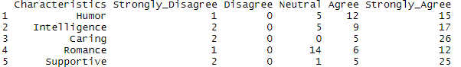
Figure 13.0: Characteristic Rating By Male
Above is a table that shows the rating of each characteristic by male. We have 5 types of characteristic which included Humor, Intelligence, Caring, Romance and Supportive
For every characteristic, only a few respondents chose ‘Strongly Disagree’ or ‘Disagree’. For Humor and Respondents, both characteristics have only 1 respondent(3%) choosing ‘strongly disagree’. Then, for Intelligence, Caring and Supportive, all 3 respondents(8%) chose ‘strongly disagree’. Then, for all characteristics, no male respondents(0%) chose ‘disagree’.
However, the significant thing is a number of 26 male(72%) chose ‘strongly agree’ on Caring and a number of 25 male(69%) chose ‘strongly agree’ on Supportive respectively. This shows that for most of the males, their ideal partner needs to be Caring and Supportive. For the other 2 characteristics which are Intelligence and Humor, a total of 27(75%) chose ‘strongly agree’ or ‘agree’ on Humor and a total of 27 male(75%) chose ‘strongly agree’ or ‘agree’ on Intelligence. From this, we can know that males also prefer a partner with Humor and Intelligence.
Lastly, one significant thing is that 14 males(39%) choose ‘neutral’ on Romance. This is the highest when compared to other characteristics. For other characteristics, there are less than 5 males(14%) who chose ‘neutral’. This shows that men don't really care about this characteristic.

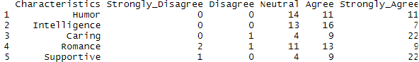
Figure 14.0: Characteristic Rating by Female
Same as male, only a few female respondents chose “strongly disagree” or “disagree” for each characteristic. For Intelligence and Humor, there is no respondent(0%) that chose ‘strongly disagree’ or ‘disagree’. Then for caring, only 1 female (3%) chose ‘disagree’. Then, only 1 person(3%) chose ‘strongly disagree’ on the characteristic supportive. For romance, 2 females(6%) chose ‘strongly disagree’ and 1 female(3%) chose ‘disagree’.
Same as males, females also want their partner to have characteristics of Caring and Supportive. For both characteristics, there are 22 female respondents(67%) who choose ‘strongly agree’ and 9 female respondents(27%) who choose ‘agree’.
For Intelligence, there are more respondents that chose ‘agree’(16, 48%) or ‘strongly agree’(7, 21%) than respondents that chose ‘neutral’(13, 39%). For Romance, there are also more respondents that choose ‘agree’(13, 39%) or ‘strongly agree’(9, 27%) than respondents that choose ‘neutral’(11, 33%). This shows the difference from the male respondents which didn't really stress on Romance characteristics, females will stress on this quality.
Lasty, for Humor, there are more respondents who answered ‘neutral’(14, 42%) than respondents that answered ‘strongly agree’(11, 33%) and 'agree’(11, 33%). This shows that female don't really mind a partner who isn't as funny.

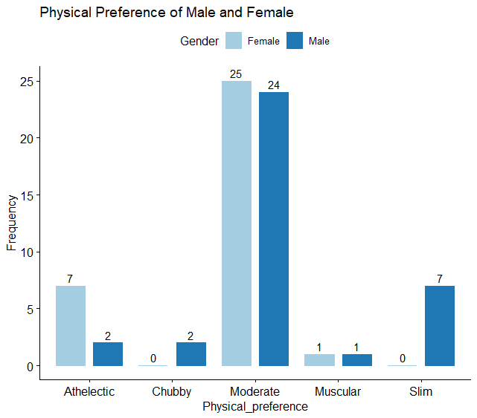
Figure 15.0: Physical Appearance that Male and Female Prefer
More than half of the UTM female students, 25 (75.76%) prefer their ideal partner to have a moderate body size whereas only a total of 7 people (21.21 %) and 1 person (3.03%) wish to have a athletic and muscular body appearance of their partner respectively due to these body sizes are capable of providing the sense of secure , protecting them from any bad guys. No female students choose the selection of chubby and slim. We think the reasons could be these body sizes might not draw most of the female attention or leave them a very good first impression. On the other hand, a very likely result as the female students where the moderate body size has ranked the highest selection again among the male students in UTM. 24 of them (66.67%) think of a moderate body size is what matches the body size of their ideal dream partner the most. Next, the option of slim body size has become the second most pick where a total of 7 (19.44%). There are exactly 1 male student(2.78%) who prefers his ideal partner to have a very muscular body size due to this male student either being very skinny and prefer to have a partner with a contrast body size or have a muscular body size as well. Athletic and chubby body size both are having the same of voting which is 2.

4.0 CONCLUSION
In a nutshell, we can conclude that males and females have different ideas when it comes to their preference for their future partner. For example, most of the males prefer their partner to have a height of around 160 cm, but females prefer their partner to be around 175 cm. Besides, male tend to choose females that are the same age as them, but females tend to choose male that are older than themselves. We can also see that male and females have different views when choosing a partner based on their characteristics, intelligence, physical appearance etc. We truly believe that the result of this study can become a good reference and also motivation to UTM students. They will be motivated to improve themselves in order to become better. They will also learn what kind of persons are suitable for them and how to build a nice relationship with other.

