UNIVERSITI TEKNOLOGI MALAYSIA

SCSI2143 / SCSI2143
Probability & Statistical Data Analysis
2019/2020 – Semester 2

ASSIGNMENT 4
(Group of 2 students)
Due date : 20th May 2020 (Wednesday)
Please submit this assignment in pdf format via your e-learning.

QUESTION 1 [10 MARKS]
(a) An article regarding a survey of drivers admit to having done something dangerous while driving reported the results of 1100 drivers. Of those surveyed, 990 admitted to careless or aggressive driving during the previous 6 months. Assuming that it is reasonable to regard this sample as representative of the population of drivers.
(i) Calculate a point estimate of the population proportion, p. (1 mark)
(ii) Construct a 99% confidence interval to estimate p, the proportion of all drivers who have engaged in careless or aggressive driving the previous 6 months. (4 marks)

(b) The data were collected in the men's 100-meter run of 16 secondary school students, and the mean 18.6 second and standard deviation 9.486 second were recorded. Find the mean time of 80% confidence interval? (5 marks)

QUESTION 2 [15 MARKS]
(a) Suppose that an allergist (a physician specializing in the diagnosis and treatment of allergies) wishes to test the hypothesis that at least 30% of the public is allergic to some cheese products. Explains how the allergist could commit a type I error. (1 mark)

(b) Past experience indicates that the time required for students in a university to complete a standardize test is a normal random variable with a mean of 35 minutes. If a random sample of 20 students took an average of 33.1 minutes to complete the test with a standard deviation of 4.3 minutes, test the hypothesis, that the average time taken is actually less than 35 minutes.
(i) State your hypothesis null, H₀ and hypothesis alternative, H₁. (1 mark)
(ii) Test the hypothesis given in (i) at the 0.05 significance level. Do you reject or fail to reject the H₀? State your conclusion. (5 marks)

(c) Shown below are birth weights (in kilograms) of male babies born to mothers taking a special vitamin supplement. Test the claim that this sample comes from a population with a standard deviation equal to 0.470kg, which is the standard deviation for male birth weights in general. At α = 0.05, does the vitamin supplement appear to affect the variation among birth weights?
3.73 | 4.37 | 3.73 | 4.33 | 3.39 | 2.47 | 4.47 | 3.43
3.68 | 4.68 | 3.52 | 3.02 | 4.09 | 4.13 | 3.22 | 2.54

- State H₀ and H₁. (1 mark)
- Calculate the test statistics. (3 marks)
- Find the critical value. (2 marks)
- Test the claim whether the vitamin supplement appear to affect the variation among birth weights. State your conclusion. (2 marks)

QUESTION 3 [8 MARKS]
In a random sample of 350 food shops, it was found that 130 of them had special offers.
(a) Calculate an approximate 95% confidence interval for the population of all food shops with special offers. (4 marks)

(b) Estimate the new size of a random sample required for an approximate 95% confidence interval for the proportion calculated in (a) that has margin of error of 0.04. (4 marks)

QUESTION 4 [12 MARKS]
(a) A random sample of 6 steel beams has a mean compressive strength of 58392 psi (pound per square inch) with its population standard deviation is 648 psi. Use this information and the level of significance α = 0.05 to test whether the true average compressive strength of steel from which this sample came is 58000 psi. (6 marks)

b) Past data indicate that the variance of measurements made on sheet metal stampings by experienced quality control inspectors is 0.18 (inch)². Such measurements made by an inexperienced inspector could have too large a variance (perhaps because of inability to read instruments properly) or too small a variance (perhaps because unusually high or low measurements are discarded). If a new inspector measures 101 stampings with variance of 0.13 (inch)², test at the 0.05 level of significance whether the inspector is making satisfactory measurements. Assume data is normally distributed. (6 marks)

QUESTION 5 [10 MARKS]
(a) In the February 20th issue of the East Daily Times, it was reported that n = 418 insured patients were surveyed on their opinions about insurance rates. Of the 418 surveyed, Y = 280 blamed rising insurance rates on large court settlements against doctors. With 95% confidence, estimate the parameter p, that is, the proportion of all insured patients who blame rising insurance rates on large court settlements against doctors. (5 marks)

(b) A random sample of 126 police officers subjected to constant inhalation of automobile exhaust fumes in downtown Cairo, had an average blood lead level concentration of 29.2 μg/dl. Assume x, the blood lead level of a randomly selected policeman, is normally distributed with a standard deviation of σ = 7.5 μg/dl. Historically, it is known that the average blood lead level concentration of humans with no exposure to automobile exhaust is 18.2 μg/dl. Construct 90% confidence interval estimator for average blood lead level. (5 marks)

QUESTION 6 [15 MARKS]
(a) In a research report, Richard H. Weindruch of the UCLA Medical School claims that mice with an average life span of 32 months will live to be about 40 months old when 40% of the calories in their diet are replaced by vitamins and protien. Is there any reason to believe that 𝜇 < 40 if 64 mice that are placed on this diet have an average life of 38 months with a standard deviation of 5.8 months? Use a 0.05 level of significance. (5 marks)

(b) Test the hypothesis that the average content of container of a particular lubricant is 10 liters if the contents of a random sample of 10 containers are 10.2, 9.7, 10.1, 10.3, 10.1, 9.8, 9.9, 10.4, 10.3, and 9.8 liters. Use a 0.01 level of significance and assume that the distribution of contents is normal. (10 marks)

QUESTION 7 [10 MARKS]
a) Sample of two different models of cars were selected, and the actual speed for each car was determined when the speedometer registered 50 mph. The resulting 95% confidence intervals for mean actual speed were (50.3, 52.7) and (49.8, 50.6) respectively. Assuming that the two sample standard deviations are equal, which confidence interval is based on the larger sample size? Explain your reasoning. (3 marks)

(b) Three different statistics are being considered for estimating a population characteristic. The sampling distributions of the three statistics are shown in Figure 1. Which statistic would you recommend? Explain your choice. (3 marks)

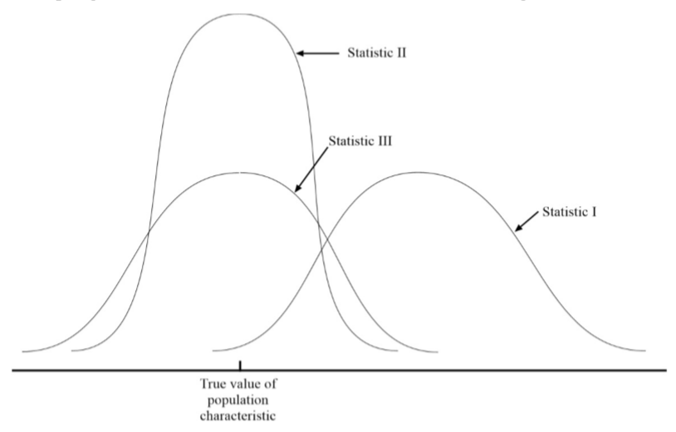
Figure 1

(c) A manufacturer conducted a survey among 500 randomly selected target market households in the test market for its new disposable diapers. The objective of the survey was to determine the market share for its new brand. If the sample point estimate for market share is 15%, develop a 90% confidence interval. (4 marks)

QUESTION 8 [20 MARKS] ( ** THIS QUESTION IS CANCELLED **)
(a) A marketing study found that the mean spending in 15 categories of consumer items for 150 respondents in the 18 to 34 age group was RM75.50 with a standard deviation of RM53.20. For 250 respondents in the 35+ age group, the mean and the standard deviation were RM65.20 and RM46.10, respectively. Test the hypothesis that there is no difference in the mean spending between these two populations. Use a significance level of 0.05.
(Note: Assume that the population variances are not equal). (10 marks)

(b) In a study of memory recall, ten students from a large statistics and data analysis class were selected at random and given 15 minutes to memorize a list of 20 nonsense words. Each was asked to list as many of the words as he or she could remember both 1 hour and 24 hours later. The data are as shown in Table 1. Is there evidence to suggest the mean number of words recalled after 1 hour exceeds the mean recall after 24 hours by more than 3? Use a significance level of 0.05. (10 marks)
Table 1
