
SCHOOL OF COMPUTING
Faculty of Engineering
____________________________________
SECI2143 – PROBABILITY AND STATISTICAL DATA ANALYSIS
_______________________________________
PROJECT 2
__________________________________________

SECTION: 04 – 1SECR

COURSE NAME: BACHELOR OF COMPUTER SCIENCE – NETWORK AND SYSTEM SECURITY

NO. | NAME | STUDENT ID
1 | NICHOLAS PANG JIA CHERN | A19EC0118

LECTURER’S NAME: DR. SUHAILA MOHAMAD YUSUF
DATE OF SUBMISSION:

Contents
Introduction 3
Result From Statistical Analysis 4
Hypothesis Testing 4
Correlation 5
Regression 7
Goodness of Fit Test 9
Discussion 10
Conclusion 10

Introduction
The meaning of obesity is a person having more weight than they should have proportionate to their own height. The rate of obesity has been steadily increasing each day and year. Although being a little overweight is still okay, being obese can bring consequences to a human body. Such consequences would include heart attack, stroke, heart failures and even death. USA have by far the highest rate of obesity among other countries. In this study, I will be looking in the death rate of the population of the state Alabama in the USA. The range of year that I will looking at are from 1999 to 2016 which is the span of 18 years. The data I used is a secondary data done by the US center of Disease Control’s WONDER base. The data given is in raw data and will be needed to be calculated to be useful for out study. The statistical analysis that I will use are hypothesis testing on one sample, correlation, regression and also goodness of fit test. For the hypothesis testing on one sample, the testing is on the data’s mean death rate and the given death rate of the state of Alabama. For the correlation test, it will be the correlation of the population of Alabama and the death rate and is the same to find the regression line. Lastly for the goodness of fit test, the claim is that the death rate for each year is the same proportions.

Result From Statistical Analysis

Hypothesis Testing
The hypothesis testing is a one sample test to determine if the given mean death rate is accurate with the data sample. The mean death rate given for the state of Alabama is 1.45 deaths per 100000 people.

With the calculations, it is proven that we cannot reject the claim of the death rate of Alabama from obesity is different from the data.

Correlation

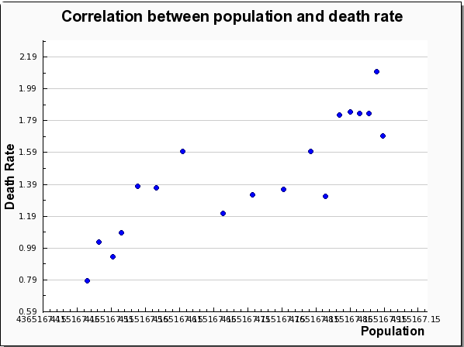
The graph above shows the scatter plot between population and death rate from obesity.
From the scatter plot, it is clear that the relationship of the scatter plot is positive and linear because it is getting higher when the population increase. To know the correlation types, I used the Pearson’s product-moment correlation coefficient. The calculations can be found in the next page.

With the value of r = 08638, it shows that the scatter plot has a strong positive linear relationship.

Regression

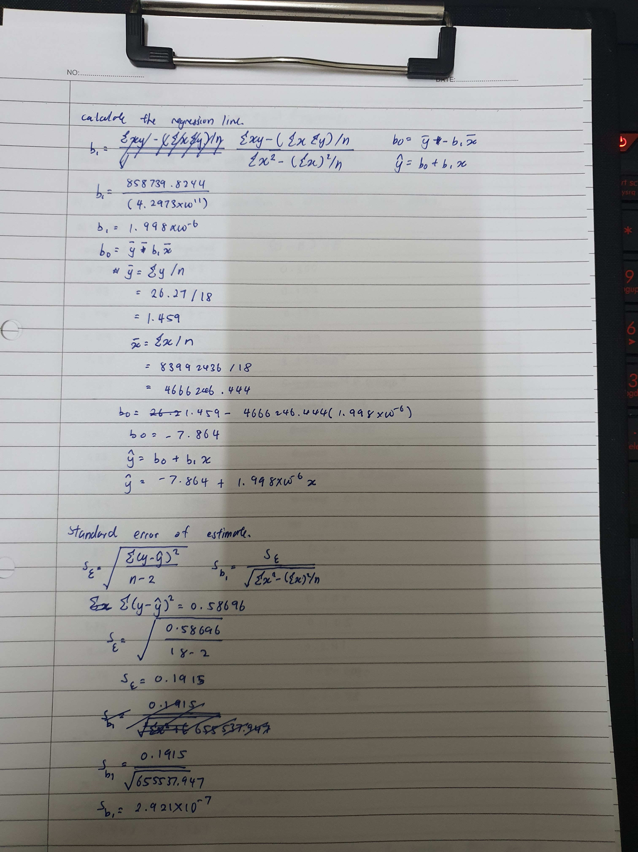
The least squares equation is calculated and it is ŷ = -7.864 + (1.998 * 10^-6)x. when the value of x is zero, the death rate would be a negative value which is impossible as population numbers cannot be negative. The death rate would be positive when the population numbers are 3,935,936 people. .
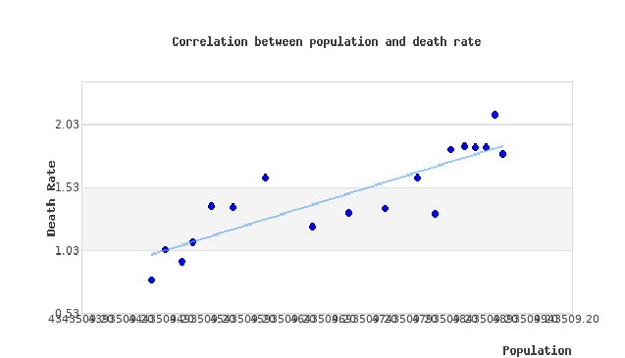
With the equation of the regression line calculated, we can estimate or expect the death rate from obesity with a given population. The graphical representation is shown in the picture above.

Goodness of Fit Test
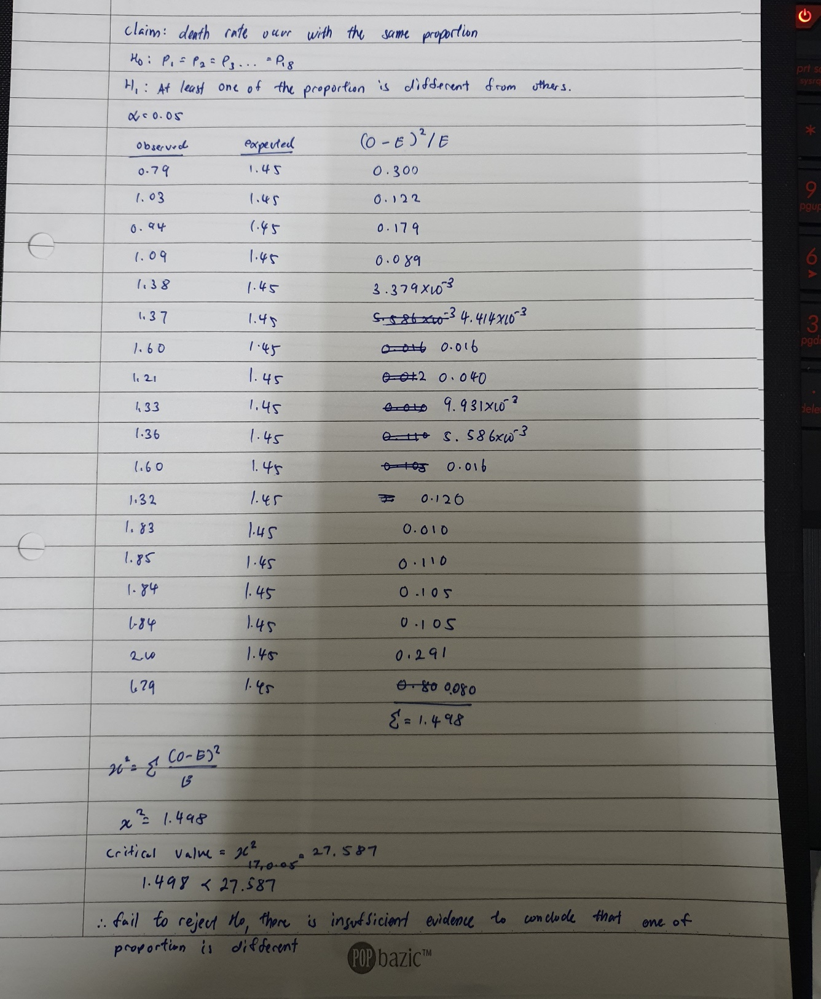
In the second half of the calculations, that is the standard error of estimate. The value is small meaning all of the data is close or on the regression line. This is also the same for the standard deviation o the regression slope. The value is small meaning that the variation of the slope of regression line is small.

Discussion
From this study, we found out that the given mean death rate of the state of Alabama is accurate to the death rate found from the data. Not just that the dispersion of data in the scatter plot is small thus making it having a strong linear relationship that is positive. The goodness of fit test also proved that the death rate from obesity is equal with the same proportion.

Conclusion
As a conclusion, this study helps to conclude and prove the death rate of the data is correct with the death rate given to us. This is true along with other test on statistical analysis on the data found.

