SCSI 2143 PROBABILITY AND STATISTICAL DATA ANALYSIS

The impact of corona (COVID-19) virus outbreak on student’s lifestyle and hygiene at Universiti Teknologi Malaysia.

By: Abdulla Adam Mohamud, Ziyad Wael,
Amjad Parker, Zeyad Mustafa Talaat
Section 5
School of Computing, Faculty of Engineering
University Technology Malaysia

Summary: Initial responses showed no significant change in the life style of UTM students in terms of hand hygiene before and after the COVID outbreak, however halfway through the collection of data, the Malaysian government decided to take drastic measures in the form of a complete lockdown on academic activities as well as imposing a restriction on movement that resulted in responses showing a greater impact across all aspects. After a lockdown was imposed there was a significant increase in their activities buying online rather than the brick and mortar module. Also results show that the majority of students from the sample tested wash their hands less than the recommended standard time set by the WHO (World health organization).
______________________________________________________________________________

- INTRODUCTION

Recently the world plunged into an intense and unpreceded level of panic due to the outbreak of a new strain of a virus that has been called the corona virus or simply referred to as COVID 19. Despite a virus outbreak usually being somewhat common in the recent years like the SARS and the H1N1, this specific outbreak has been showing no signs of slowing down across the region. Our goal from this study was to assess the impact it had on students in terms of changes in hygiene and buying habits as well as their social activities.

- METHODOLOGY

In order to conduct the survey, we selected online forms as our method for data collection. Other than being convenient and efficient, this served an important role since this minimizes the risk of possible infection compared to other methods of collecting primary data such as direct interviews. In our sample the majority of students who responded where from faculty of engineering. This was partially expected given the fact the links to the survey were mainly distributed among their groups. Survey questions were approved by Dr. Sharin Hazlin and ranged in type between ratio, nominal and ordinal scales. They asked for age, study program at UTM, hand washing times before and after the outbreak, the amount spent on online shopping before and after the outbreak, pointer of student and degree of skills are collected and cleansed for further usage. Calculation on central tendency such as mean median and mode as well as Dispersion of data in the form of variance, standard deviation and range were also conducted.

- RESULTS AND DISCUSSION

Total Sample size is 51

The mode for Age is 18 years old.

The mean for the amount spent on Hygiene is MR 7.4 before the outbreak
The mean for the amount spent on Hygiene is MR 11.4 before the outbreak

71.2% of students who responded to the survey are 1st year students at UTM
7.7% of students who responded to the survey are in Foundation/Bridging.
15.4%of students who responded to the survey are 2nd year students at UTM
The remaining responses were from 3rd and 4th year UTM students.

Figure 1. Pie Chart
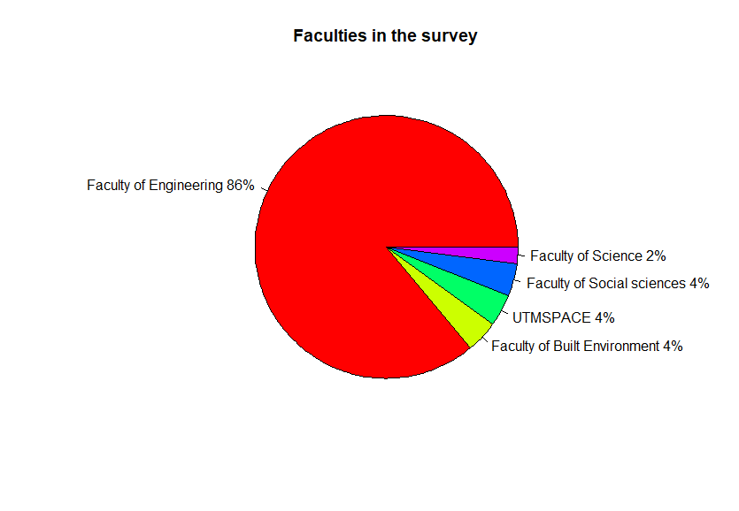
Figure 1. Frequency of respondents across UTM faculties.
According to the pie chart, the highest number of responders was from the faculty of engineering (including school of computing). This is due to the fact the links to the survey were mainly shared among channels with highest concentration of students from the said faculty.

Figure 2. Bar chart

Figure 2and 3. Frequency of amount spent on hygiene products before and after the outbreak
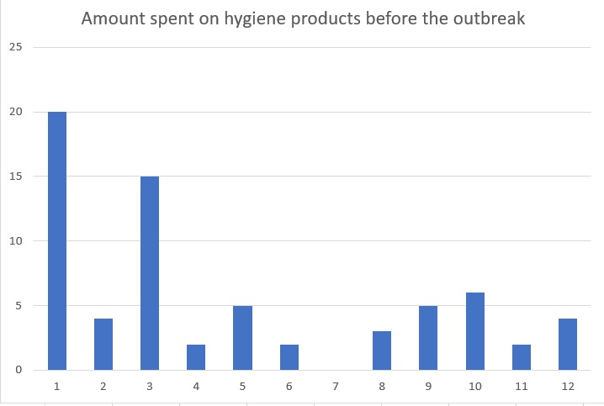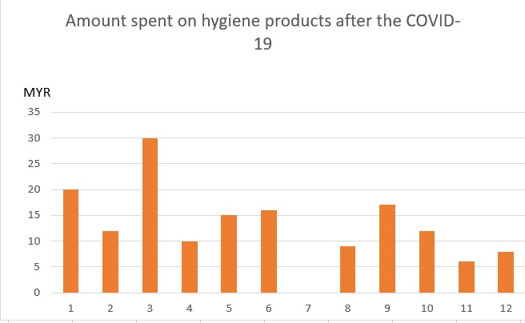

According to the responses, the amount being spent on hygiene before the outbreak has increased over all. By taking a look at the two figures above, at first glance it seems that the spending pattern before the outbreak seems more, after taking a closer look it turns out that the single respondent who has been spending 20 MYR weekly on hygiene products has not changed his/her habits, but the rest of responders have increased their spending which closed the obvious gap between them. Another interesting fact from the graph is the significant number of students who reported not spending any amount on hygiene product. This can be explained in two aspects. The first being that they don’t buy their own hygiene products and are dependent on parents in obtaining them. The other possible reason which would be alarming if proven true, is the fact these students depend on public facilities when it comes to hygiene which would be unlikely.

Figure 4. Histogram
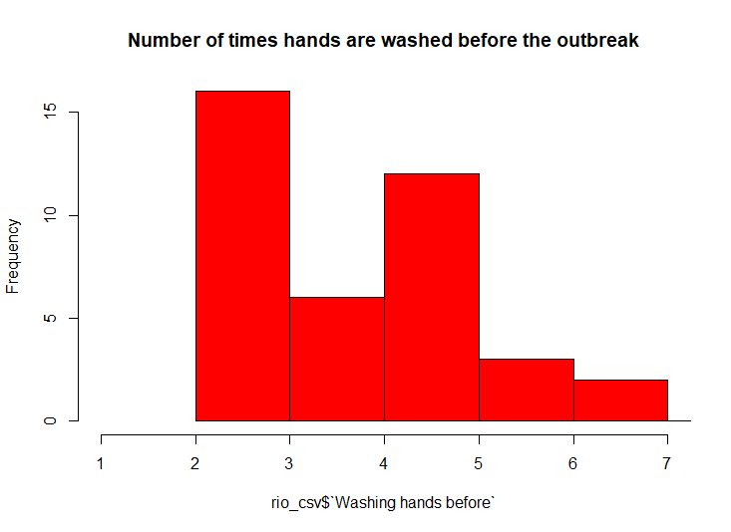
Figure 2. hand washing pattern before the outbreak.

Figure 5. Histogram

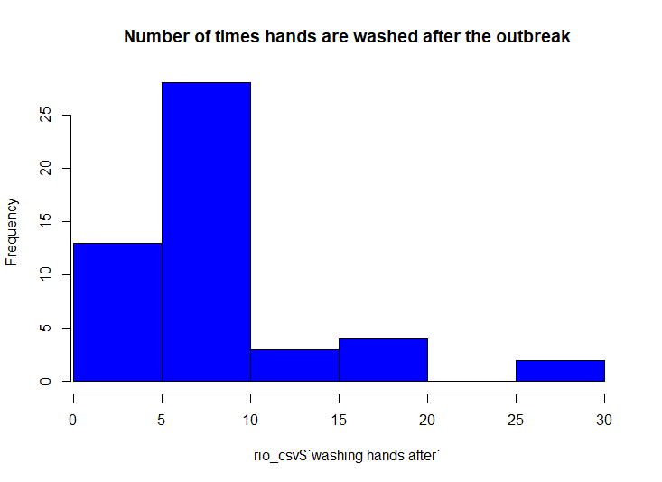
Figure 3. hand washing pattern after the outbreak

The graphs above represent the responses when students were asked about the frequency of hand washing.

Despite the fact we can get some insight from the histograms, its best to
When both graphs were combined utilizing the (GGPLOT) library in R. this was the result
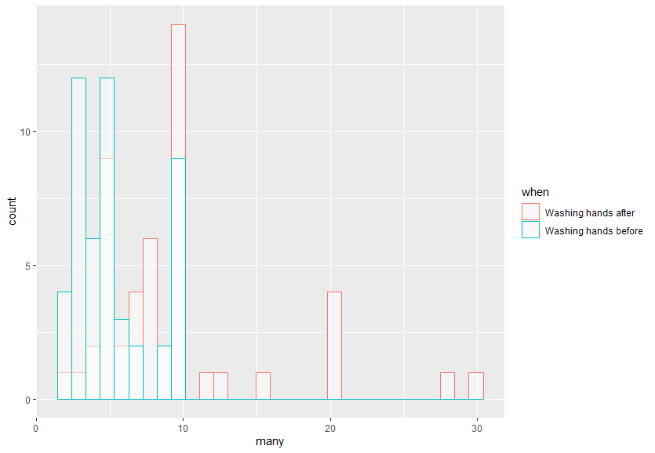
Figure 4. Histogram comparison for the amount of times people washed their hands before and after the outbreak.

Based on the histograms, we can conclude that the number of times students washed their hands has gone up after the outbreak. However, as we can see below in Figure (5), there are obvious outliers in our data presented in having few of the responders reporting to be washing their hands in excess of 20 times a day. A reasonable explanation for the increase would be that the Students got used to proper hand washing techniques and responded to the calls for more frequent hand washing.

Figure 5. Box Plot
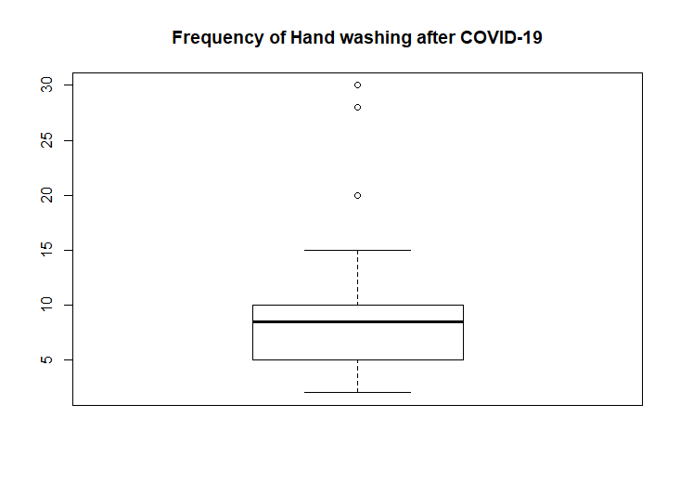
Figure 6. hand washing pattern after the outbreak

Figure 6. Stem-and-leaf (this is a sample)

15 | 00
16|
17| 00
18| 000000000000
19| 0000
20| 0011334556799
21| 00014568
22| 014556888
23|
24|
25|
26|

The decimal point is 1 digit(s) to the left of the |

Figure 5. Frequency of responders age.

The stem-and-leaf indicated the amount of money being spent on hygiene products before the outbreak.

Figure 8. Frequency Distribution

Mean of spending on hygiene products before and after the outbreak were 7.4 and 11.4 (in Malaysian ringgit) and was produced with the following formula.

(Mean formula here)

Figure 6. Box plot

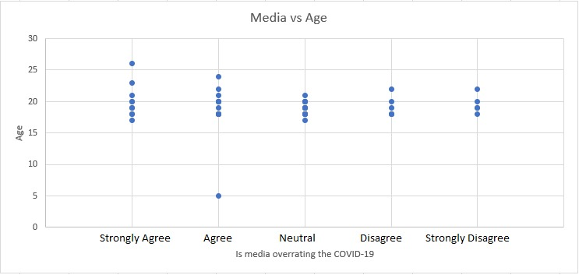

Figure 7. Scattered plot.

Figure 6. Relationship between age and their opinion of the media coverage for COVID-19.

This aspect has been one of the most interesting parts tested when it comes to what students think of the media coverage, we wanted to assess whether students believe that the media is exaggerating the effects of the COVID-19 around the globe. Within the first three days of the survey being conducted the majority of students strongly agreed that the media is exaggerating the effect and risk from COVID-19. In the following days the responses became more uniform according to the figure above. The MCO might be a factor towards this shift where of students saw that the media is not exaggerating their claims about the impact of COVID-19.We can say his shift can be attributed to the growing concerns that the government will impose a lockdown, followed by the actual announcement regarding the restriction of movement and the suspension of studies across the nation. There is an extreme outlier that we decided to keep in the form of a responder who jokingly or due to an error responded they were 5 years old to the question. The goal for leaving it on the infographics is to demonstrate how these graphs can instantly pinpoint an outlier instead of having to sift through the numbers.

Figure 7. Ethnicity among the sample.

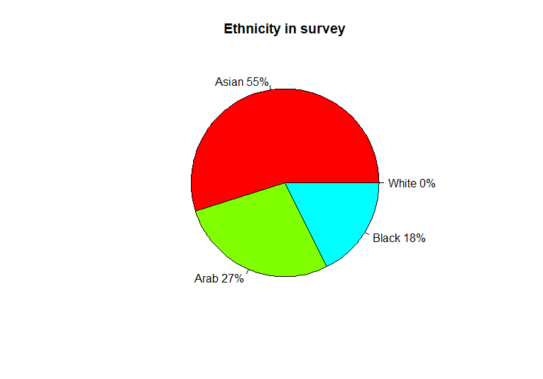

55% of the students in the survey were Asian, (Write something here)

Figure 8. Pie Chart
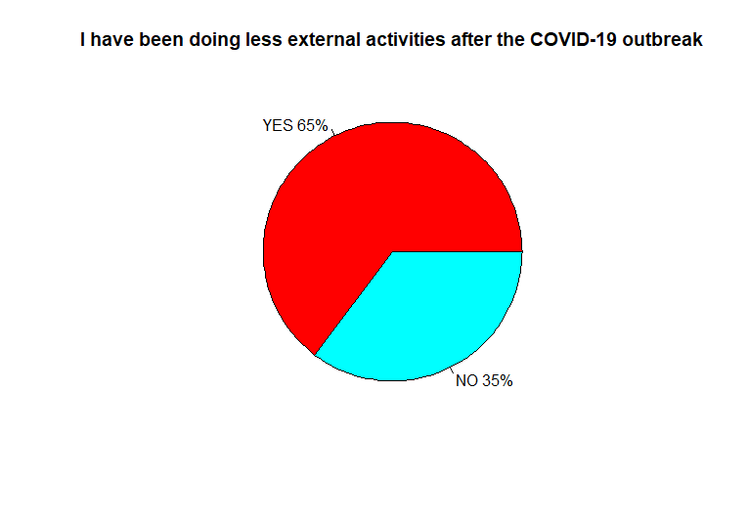

Figure 8. Students response to the Question (I have been doing fewer external activities after the outbreak of COVID-19)

In the responses to this question, responses at first seemed rather equal, then when the restriction of movement order was about to be announced, the responses took a shift indicated by the pie chart above, over all in the initial responses students did not consider the COVID-19 as a factor that would affect their external activities but this has significantly changed following the announcement by the government.

- CONCLUSION

In this statistical analysis project, we conducted a survey from UTM students. The goal was assessing the impact the COVID-19 outbreak had on their life’s and activities including but not limited to their physical activity, spending habits and their view of the media coverage. A variety of tools were used in the analysis phase of this study such as R and RStudio. Over all the results indicate that the students increased their spending on hygiene products post the outbreak. Their external activities have been severely limited due to the restriction of movement order by the government and their general opinion about the media coverage is the fact its exaggerating the risks involved.

