

SUBJECT : ULAB2122 ADVANCED ACADEMIC ENGLISH SKILLS
SECTION : 43
TOPIC : TERM PAPER DRAFT
LECTURER : MDM NUR SHAMSINAR BINTI RAMLI

GROUP MEMBERS :
NO. | NAME | MATRIC NO
1. | NURAMYRA NATASHA BINTI ISMALLUDIN | B19EC0035
2. | NUR FARZANA ALIA BINTI MOHD SANORI | B19EC0045
3. | NUR ATIQAH BINTI MOHD FUA'AD | B19EC0032

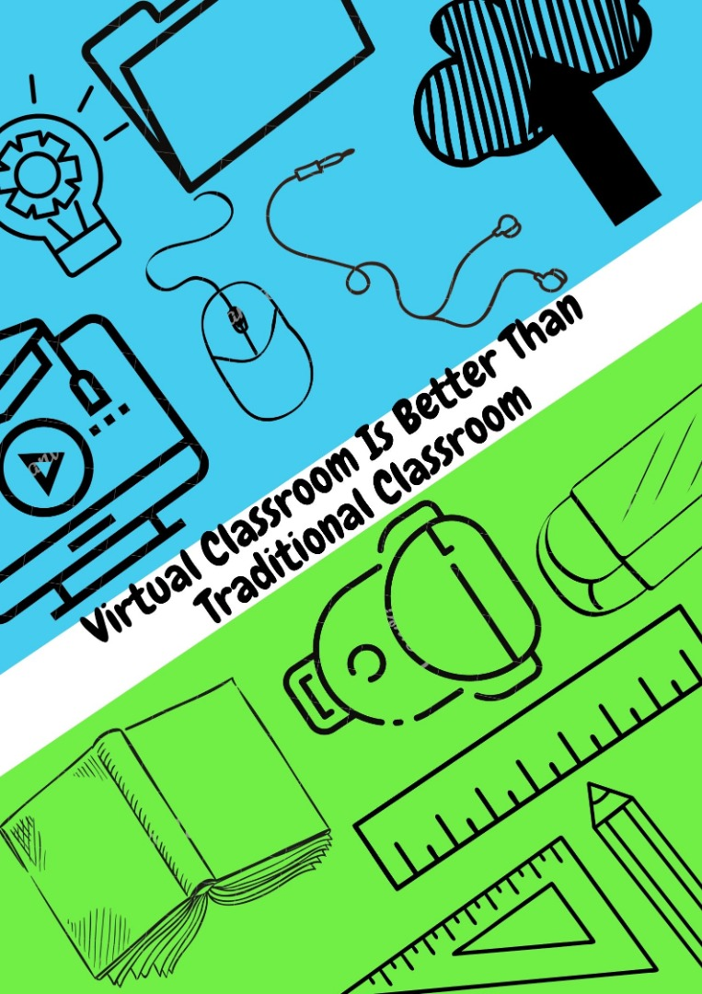
Virtual Classroom is Better Than Traditional Classroom
Virtual classroom is the new normal of technology that enables live interaction between learners and the instructor. Gedera (2014), stated that an environment that provides students with opportunities for flexibility, interaction and collaboration differently from face-to-face learning environments can be achieved by online learning. The online virtual classroom has other advantages as an interaction of learner-content, learner-instructor and learner-learner in the online environment (Hillman et al., 1994; Miltiadou & Savenye, 2003; Moore, 1989; Riel & Harasim, 1994). According to Coates (2006), this technology does not encourage an exodus from or campus transformation. But they do seem to weave important online quality into the more traditional aspects of campus-based university education. Moreover, Yılmaz (2015), stated that “online courses are one of the most dynamic and enriching forms of distance learning that are available today”. As a matter of fact, e-learning makes teaching, learning and assessment processes more straightforward (Conole & Oliver, 2016). Although traditional classrooms provide better understanding to students, virtual classrooms are the alternative method that can be used especially to students earn credits through long distance learning. Virtual classroom is more effective compared to a traditional classroom because it makes learning easier and convenient since it has the best technology to make learning easy to be accessed anytime and anywhere.
Before we go further into the main points, the definition of virtual classroom is a teaching and learning environment located within a computer-mediated communication system (Hiltz,1994). According to Chin (2004), a virtual learning environment is an online (web) environment, where various tools are provided for teachers and students to facilitate the learning experiences (p.107). E-learning or virtual class is the teaching and learning that uses technology, based on sound pedagogical teaching practices. Chin (2004, p.123.), also stated that the facilitated benefits offered by technology are not passive mediums delivering content but also interactive processes between teachers and students. The feature of online courses is the type of distance education that have the delivery format that come in several names such as e-learning, internet learning, distributed learning, networked learning, tele-learning, virtual learning, or web-based learning (WCET, 2004). Therefore, innovation with technology comes from the way it is used and this is what leads to ease of use and how exciting it can be for students to learn (Chin, 2004, p.6). In Malaysia, virtual classrooms in universities are widely known as ‘E-learning’ which can be accessed by every student and lectures.
Learning through a virtual classroom offers many benefits that are not provided by traditional classrooms. Online learning through chat-rooms and forums have the ability to bring self-conscious students who rarely say anything in the class in order to increase their courage and reduce intimidations (O'Donoghue, Singh, & Green, 2004). In the opinion of Shank and Hyder (2016), by using virtual tools, there will be more involvement as it will simply allow polling and quizzing. Moreover, Shank and Hyder (2016) also stated students have the ability to build skills, demonstrate error and model correct behaviours via outstanding platforms such as virtual learning. Dutton, William, and Brian (2005) mentioned that “advanced digital communication and learning technologies enable universities to implement distance education in order to reach a more diverse population and to provide more learning environments accessible twenty-four hours a day, seven days a week” (p. 62). For students who want to study but may be short on money, virtual classrooms may be beneficial choices since they can save accommodation fees, transportation and other living expenses that need to go through traditional college experience (Allisha, 2017).
Another argument is that virtual classrooms are also known to be more effective and efficient compared to Traditional classrooms. As said by Ellis and Goodyear (2013) that “the Virtual Class is a “rolling present” class that runs all the time, 7 days a week. Each student has the ability to review and reread at their leisure and time that is convenient” (p. 6). Moreover, placing teaching materials on the web, and adding a space for several additional online discussion activities, or organise online discussion activities and support with online learning materials, are most e-learning plans originated by people in the past (Ellis and Goodyear, 2013).
It is a fact that traditional education is the best way of learning but it also has some disadvantages which make virtual classrooms bring more benefits than traditional classes. For example, in a traditional classroom environment, it has been found that some children learn better through visuals, others learn better with auditory tools and some learn better with the hands-on approach. However, when the learning environment is not what they want, it can make children bored or angry. (Disadvantages Traditional Classroom, n.d). As mentioned by Liu and Long (2014), they pointed out that the traditional classroom puts students in a passive position that curbs personality and creativity and ignores student initiative and potential. Along with that, students are listeners and place teachers at the center. Key experiences are inadequate or lack subjective experience, which may limit the effectiveness of teaching strategies. Limited knowledge; insufficient resources; learning is passive but knowledge is well formed and departs from real life. (Liu & Long, 2014). To draw your attention, Peter (2019) presented that traditional classrooms are cost demanding. All the textbooks and other school items are quite pricey. Not only that but Hiltz (1994), supports that in the traditional classroom, most interactions take place in talking and listening, even provided by writing and reading from a handout or writing board. Also, the majority of students between the ages of 18 until 12 are able to devote full time to staying on campus and attending courses. However, those students with families and jobs, they have to be traveling or distance education students. The need to provide access to higher education for working adults by mean of providing opportunities for tens of thousands of distance learners.
In the nutshell, virtual classrooms have more benefits than traditional classrooms due to the fact that virtual classrooms make learning an easier and convenient experience for the reason that it has the best of technology to make learning easy to be accessed anytime and anywhere. In other words, it’s flexible. According to Chin (2004), by using e-learning for this teaching and learning, there are many advantages, such as the benefits of general group work already mentioned. In addition, since students can access the resources and activities outside of the classroom, time and space barriers are overreach. These activities help support, motivate and engage students, and as the interactive nature of the work differs from traditional education, there is an increased enthusiasm or passion for the course. Moreover, it tells how the advent of technology is beneficial to students. Innovation with technology comes from the way it is used and this is what leads in order to ease of use and how exciting it can be for students in order to learn. Apart from this, Rafidi (2020) presented that the education and technology revolution has become more versatile and affordable. With the optimum technology and rapidly expanding virtual classroom, it is able to replace the traditional four-walled classroom.

REFERENCES
Allisha, R. (2017). Types of Crypto Currencies You Should Definitely Know About. March 18th 2020, Youth Incorporated Magazine, Retrieved from https://youthincmag.com/crypto-currencies-types
Chin, P. (2004). Using C&IT to support teaching. Routledge.
Coates, H. (2006). Student engagement in campus-based and online education: University connections. Routledge.
Conole, G., & Oliver, M. (Eds.). (2006). Contemporary perspectives in e-learning research: themes, methods and impact on practice(p.221). Routledge.
Disadvantages Traditional Classroom. (n.d). Retrieved from http://wh- magazine.com/alternative-education/disadvantages-traditional-classroom.
Dutton, W. H., & Loader, B. D. (Eds.). (2005). Digital academe: new media in higher education and learning. Routledge.
Gedera, D. (2014). Students’ experiences of learning in a virtual classroom: An Activity Theory perspective. International Journal of Education and Development using ICT, 10(4).
Grey, P. (2019). Advantages and Disadvantages of Traditional Education. Retrieved from https://boredofstudies.org/threads/advantages-and-disadvantages-of-traditional-education.387908/.
Hillman, D.C, Willis, D.J., 7 Gunawardena, C.N. (1994). Learner-Interface Interaction in Distance Education: An Extension of Contemporary Models and Strategies for Practitioners. The American Journal of Distance Education, 8(2), 31-42.
Hiltz, S. R. (1994). The virtual classroom: Learning without limits via computer networks. Intellect Books.
Liu, C. & Long, Fei. (2014). The Discussion of Traditional Teaching and Multimedia Teaching Approach in College English Teaching. doi: https://doi.org/10.2991/icmess-14.2014.9.
Miltiadou M., & Savenye W.C. (2003). Applying Social Cognitive Constructs of Motivation to Enhance Student Success in Online Distance Education, Educational Technology Review, v11, n1.
Moore, M.G (1989). Three Types of Interaction. The American Journal of Distance Education, 3(2), 1-6.
O'Donoghue, J., Singh, G., & Green, C. (2004). A comparison of the advantages and disadvantages of IT based education and the implication upon students. Digital Education Review, (9), 63-76.
Rafidi, R. (2020, February 15). Bringing Learning to Life. New Straits Times. Retrieved from https://www.nst.com.my/education/2020/02/562767/bringing-learning-life.
Riel, M., & Harasim, L. (1994). Research Perspectives on Network Learning. Machine Mediated Learning, 4(2-3), 91-113.
Shank, P. Hyder, K., (2016). Take Advantage of The Virtual Classroom’s Major Advantage. Trainingmag.
Yilmaz, O. (2015). The Effects of" Live Virtual Classroom" on Students' Achievement and Students' Opinions about" Live Virtual Classroom" at Distance Education. Turkish Online Journal of Educational Technology-TOJET, 14(1), 108-115.

