

SUBJECT : ULAB2122 ADVANCED ACADEMIC ENGLISH SKILLS
SECTION : 43
TOPIC : TERM PAPER EXTENDED OUTLINE
LECTURER : NUR SHAMSINAR BINTI RAMLI

GROUP MEMBERS :
NO. | NAME | MATRIC NO
1. | NURAMYRA NATASHA BINTI ISMALLUDIN | B19EC0035
2. | NUR FARZANA ALIA BINTI MOHD SANORI | B19EC0045
3. | NUR ATIQAH BINTI MOHD FUA'AD | B19EC0032

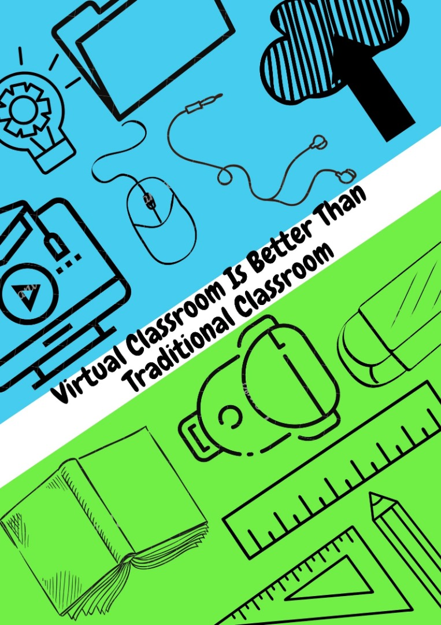
SAMPLE OUTLINE
TOPIC : Virtual Classroom Is Better Than Traditional Classroom
- INTRODUCTION

- An online learning environment can provide students with opportunities for flexibility, interaction and collaboration differently from face-to-face learning environments. (Gedera, D. 2014)

- The online virtual classroom has other advantages as an interaction of learner-content, learner-instructor, and learner-learner in the online environment. (Hillman et al., 1994; Miltiadou & Savenye, 2003; Moore, 1989; Riel & Harasim, 1994)

- Despite many predictions, this technology does not encourage an exodus from or campus transformation. But they do seem to weave important online quality into the more traditional aspects of campus-based university education. (Coates, H (2006). Student engagement in campus-based and online education: University connections (p.3). Routledge.)

- Online courses are one of the most dynamic and enriching forms of distance learning that are available today. (Yılmaz, Özgür. 2015)

- E-learning makes teaching, learning and assessment processes more straightforward. (Conole, G., & Oliver, M. (Eds). (2016). Contemporary perspectives in e-learning research: themes, methods and impact on practice(p.221). Routledge.)

- Thesis Statement : Some thought that students are required to interact with classmates and teachers, virtual classroom make learning an easier and convenient experience because it has the best of technology to make learning easy to be accessed anytime and anywhere.

- BODY
- Definition

- A virtual classroom is a teaching and learning environment located within a computer-mediated communication system. (Hiltz, S. R. (1994). The virtual classroom: Learning without limits via computer networks(p.3). Intellect Books.)

- A VLE is an online (web) environment, where various tools are provided for teachers and students to facilitate the learning experiences. (Chin, P. (2004). Using C&IT to support teaching(p.107). Routledge.)

- What is a virtual classroom? This is the understanding of virtual classrooms.

- E-learning or virtual class is the teaching and learning that uses technology, based on sound pedagogical teaching practices. The facilitated benefits offered by technology are not passive mediums delivering content but also interactive processes between teachers and students.(Chin, P. (2004). Using C&IT to support teaching(p.123). Routledge.)

- The feature of online courses is the type of distance education. Delivery formats come in several names such as e-learning, internet learning, distributed learning, networked learning, tele-learning, virtual learning, or web-based learning. (Western Cooperative for Educational Telecommunications, (2004). Distance education: A consumer’s guide.)

- Therefore, innovation with technology comes from the way it is used and this is what leads to ease of use and how exciting it can be for students to learn. (Chin, P. (2004). Using C&IT to support teaching(p.6). Routledge.)

- Learning through a virtual classroom offers many benefits that traditional classrooms do not provide.

- Introverted students rarely ask or voice their opinions. However, online environmental communication methods, such as student chat-rooms and forums can provide these individuals with increased confidence and less intimidation. (O'Donoghue, J., Singh, G. and Green, C., 2004., (p.63-76).)

- Increase engagement by using virtual tools. It easily allows for polling and quizzing. Virtual training is also an excellent medium for video-based learning to build skills, demonstrate mistakes and model correct behaviours. (Shank, P. Hyder, K. (2016, March 2). Take Advantage of The Virtual Classroom’s Major Advantage. Trainingmag)

- Advanced digital communication and learning technologies enable universities to implement distance education to reach a more diverse population and to provide more learning environments accessible twenty-four hours a day, seven days a week. (Dutton, W. H., & Loader, B. D. (Eds.). (2005). Digital academe: new media in higher education and learning(p.62). Routledge.)

- Students save on room and boarding fees, commuting back and forth and other living expenses that are attached to a traditional college experience, making it an effective choice for students who have the desire to study but may not have the same budget. (Allisha, R. 2017, youthincmag.)

- How effective and efficient the virtual classroom.

- The Virtual Class is a “rolling present” class that runs all the time, 7 days a week. Each student can review and reread at their leisure and time that is convenient. (Ellis, R., & Goodyear, P. (2013). Students' experiences of e-learning in higher education: the ecology of sustainable innovation (p.6). Routledge.)

- Most of the e-learning provision developed by people in the past consists of (a) putting learning materials on the web, and providing a space for some ancillary Web-based discussion activities, or (b) organising Web-based discussion activities, supported by Web-based learning materials. (Ellis, R., & Goodyear, P. (2013). Students' experiences of e-learning in higher education: the ecology of sustainable innovation (p.33). Routledge.)

- Deficiencies in traditional classrooms that benefit the virtual classroom.

- In a traditional classroom environment, it is not rare for children to become bored or frustrated. Some children learn better through visuals, others learn better with auditory tools, and some learn better with a hands-on approach. (“Disadvantages of traditional classroom”, WHmagazine.)

- The traditional classroom puts students in a passive position that curbs personality and creativity and ignores student initiative and potential. (Liu, Chunyang & Long, Fei. (2014). The Discussion of Traditional Teaching and Multimedia Teaching Approach in College English Teaching. 10.2991/icmess-14.2014.9.)

- Students are listeners and put the teacher as the center. The knowledge is limited; the resource is insufficient; the learning is passive but the knowledge is well-formed and departed from real life. The main experience is insufficient or lack of subjective experience, which will limit the effectiveness of learning strategy teaching. (Liu, Chunyang & Long, Fei. (2014). The Discussion of Traditional Teaching and Multimedia Teaching Approach in College English Teaching. 10.2991/icmess-14.2014.9.)

- Traditional classrooms are cost demanding. All the textbooks and other school items are quite pricey. (PeterGrey, 2019.)

- In the traditional classroom, most interactions take place in speaking and listening, though it may be supplemented by writing and reading from a blackboard or handouts. (Hiltz, S. R. (1994). The virtual classroom: Learning without limits via computer networks(p.6). Intellect Books.)

- The majority of students between the ages of 18 until 21 are able to devote full time to staying on a campus and attending courses. However, those students with families and jobs, they have to be traveling or distance education students. The need to provide access to higher education for working adults by providing opportunities for tens of thousands of distance learners. (Hiltz, S. R. (1994). The virtual classroom: Learning without limits via computer networks(p.3). Intellect Books.)

- CONCLUSIONS
- Virtual classrooms have more benefits than traditional classrooms.

- By using e-learning for this teaching and learning, there are many advantages, such as the benefits of general group work already mentioned. In addition, since students can access the resources and activities outside of the classroom, time and space barriers are circumvented. These activities help support, engage and motivate students, and as the interactive nature of the work differs from traditional teaching, there is an increased enthusiasm/passion for the subject. (Chin, P. (2004). Using C&IT to support teaching(p.133). Routledge.)

- It tells how the advent of technology is beneficial to students.

- Therefore, innovation with technology comes from the way it is used and this is what leads to ease of use and how exciting it can be for students to learn. (Chin, P. (2004). Using C&IT to support teaching(p.6). Routledge.)

- The education and technology revolution has become more versatile and affordable. (Rafidi, R. (2020). Bringing Learning to Life. New Straits Times.)

