Lab3: Integrate mouse or keyboard function.
#include <GL/glut.h> // Include the GLUT header file

float xstart, ystart, xend;
float yend, step, xinc, yinc, x, y;
bool check = true;

void keyboard(unsigned char key, int x, int y) {
switch (key)
{
case 'A':
case 'a':

xstart = rand() % 640; //random number
ystart = rand() % 480;

xend = rand() % 640;
yend = rand() % 480;

//r = (rand() % 9) / 8;
//g = (rand() % 9) / 8;
//b = (rand() % 9) / 8;

break;

case 'u': //to undo the drawing

glClearColor(0.0, 0.0, 0.0, 0.0); //Undo background with black
glClear(GL_COLOR_BUFFER_BIT);
check = false;
break;
}
glutPostRedisplay();
}

void display(void) {
glClearColor(1.0f, 1.0f, 0.0f, 1.0f); // Clear the background of our window to yellow
glColor3f(0.0f, 0.5f, 0.5f); //Colour of line
glPointSize(10); //Sets size of points to be drawn
glMatrixMode(GL_PROJECTION); //Clear the colour buffer (more buffers later on)
glLoadIdentity(); // Load the Identity Matrix to reset our drawing locations
gluOrtho2D(0.0, 640.0, 0.0, 480.0);

glBegin(GL_LINES);
glVertex2i(xstart, ystart);
glVertex2i(xend, yend);
glEnd();

glFlush(); // Flush the OpenGL buffers to the window
}

int main(int argc, char **argv) {
glutInit(&argc, argv); // Initialize GLUT
glutInitDisplayMode(GLUT_SINGLE); // Set up a basic display buffer (only single buffered for now)
glutInitWindowSize(500, 500); // Set the width and height of the window
glutInitWindowPosition(100, 100); // Set the position of the window
glutCreateWindow("KEYBOARD FUNCTION | NURAMYRA"); // Set the title for the window

glutDisplayFunc(display); // Tell GLUT to use the method "display" for rendering
glutKeyboardFunc(keyboard);

glutMainLoop(); // Enter GLUT's main loop
}

OUTPUT
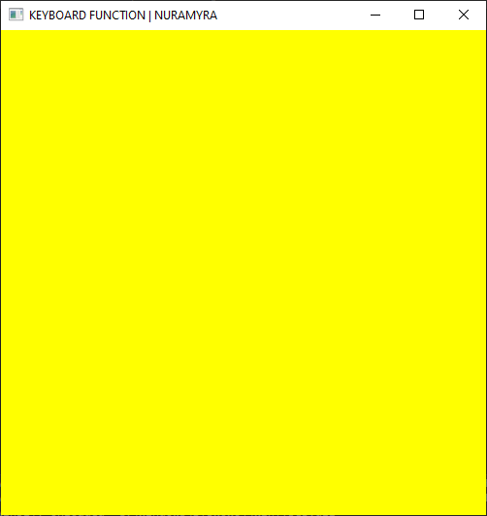  Windows with yellow background. | 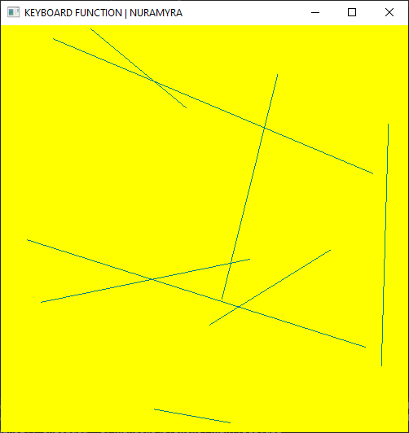  Windows when clicking ‘A’ or ‘a’ on keyboard.
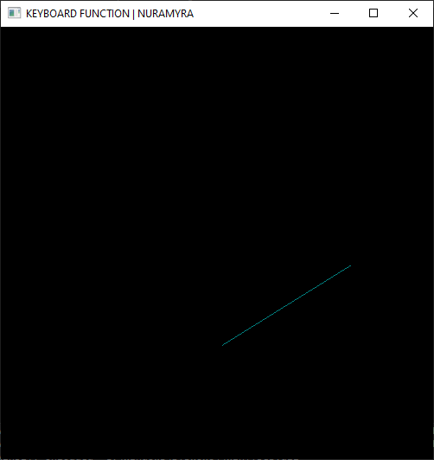
Windows after pressing ‘u’ means undo.

