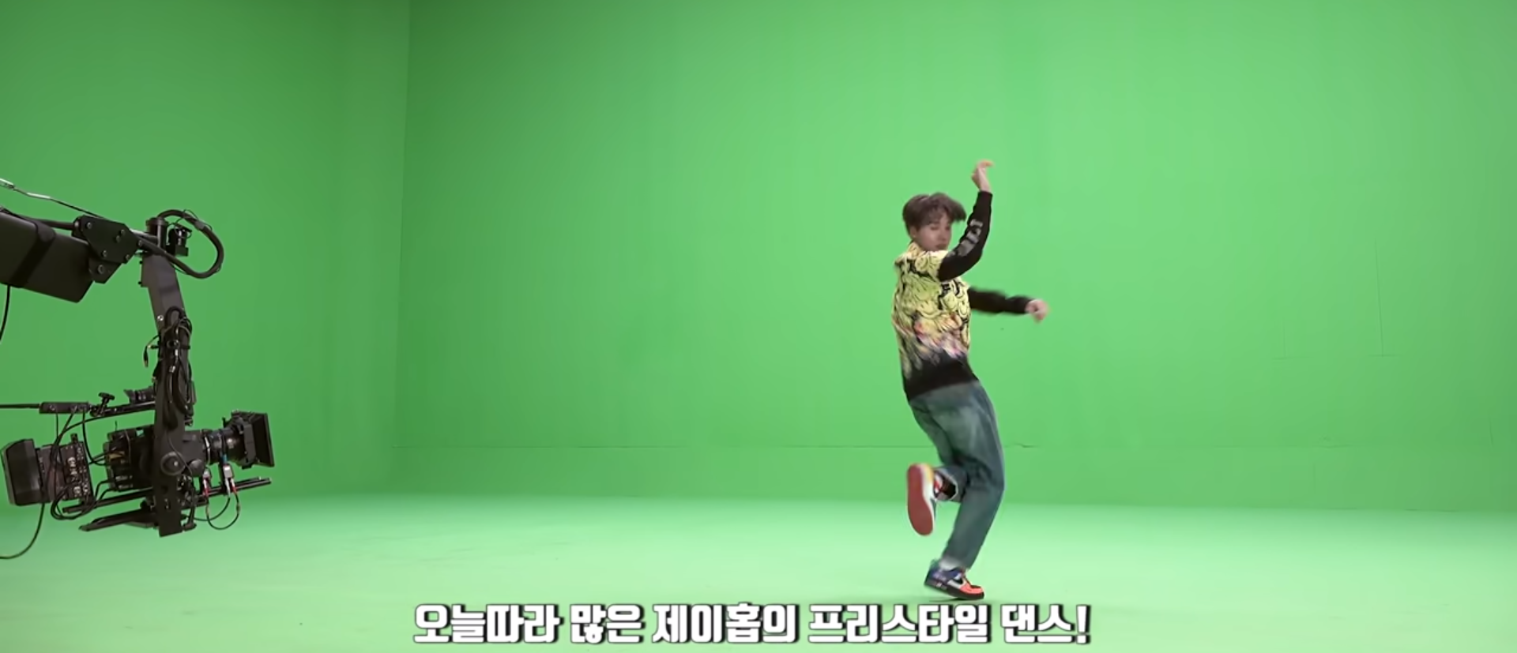

VISUAL EFFECT FOR MUSIC VIDEO – ENTERTAINMENT (GREEN SCREEN)
COMPUTER GRAPHICS APPLICATION

NURUL NAJIHA BINTI HAMDAN (B19EC0047) | NURAMYRA NATASHA BINTI ISMALLUDIN (B19EC0035) | SCSV 2213 (SECTION 01) | FEBRUARY 12, 2020
BIL | CONTENT | PAGE
 | Introduction | 3
 | How computer graphics was used for special effects | 3
 | Advantages and Disadvantages of green screen | 5
 | Computer graphic terms | 5
 | Conclusion | 5
 | References | 6
TABLE OF CONTENT

- INTRODUCTION
This is the first review assignment given for Fundamental of Computer Graphics class (SCSV 2213). In this report, we have selected a sample application of computer graphics in Visual Effect in Music Video from Entertainment category. The objective of music videos in entertainment was always to promote new songs. Additionally, music videos have stories that artist want to tell and convey the meaning of their songs and its purpose producing it.
Among visual effects used in music videos, the green screen is one of the common popular that are used in entertainment industry nowadays. The green screen era began when the first music video that use the green screen was “Don’t Stop ‘Till You Get Enough” by Michael Jackson, released in 1979.
To be specific, we have studied some reference to the making of comeback trailer from BTS, a boy band from South Korea titled ‘Outro: Ego’ music video and we will focus our discussion on how computer graphics was used in the visual effects of green screen production. In this music video, many scenes are taken using the green screen and background scenes have been added to make the music videos look amazing.
- HOW COMPUTER GRAPHIC WAS USED FOR SPECIAL EFFECTS
In the production of modern music videos, the green screen is used to create unrealistic environment or background scenes that you think are impossible. Additionally, it can also be used to bring unique and magical effects to music videos based on video editor ideas. The use of green screens can reduce costs because artists do not have to shoot outside the studio and they do not have to go to great places to shoot. This coloured screen is important when we are working for creative outcomes. Also, the green screen used because it considered the furthest colour corresponding from human skin and a clear contrast can be made between the person and screen. Using green screen need to focus on what is real and what is not in the scene.
Here is the explanation on how the green screen works:
After set up the green screen and put the camera at right position, person or subject were filmed in front of the green screen. Various action and scene were taken. After the filming is wrapped, post-production was taken and the editing of visual scene begins.
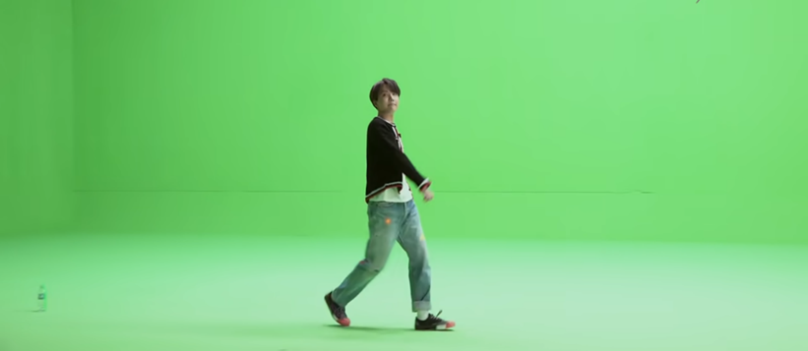
Figure 1: The scene taken in front of the green screen.

The editor takes places to make the background transparent. The process is get the footage of the green screen into the clip of the software tool you are using then adds Ultra Key in the effects panel get into the clip. After that, in the effect control panel, select the colour to change the colour of green screen, leaving the actor and any action in the foreground. Now that the background is removed, it can be added any background you want.
During the editing, footages can be merged during compositing and layered with background after effects. To make the background look good or based on the storyline and creativity you want, trial and error is the best way to try it until it is perfect. Last but not least, adding effects such as colour grading and blurring makes the foreground part of the background.

Figure 2: The scene after adding background.

- ADVANTAGE AND DISADVANTAGE GREEN SCREEN?
There are some of the advantages and disadvantages of the green screen:
The advantages of green screen are illimitable. It allows the process of music video editing can do almost anything to ensure they get it right.
- It allows for exciting and unreal scenes to be produced.
- It can protect actors and green screen can only be shot in the studio.
The disadvantages of green screen is difficult.
- If the lighting is not perfectly balanced, the technique appears artificial and off-putting for audiences.

- COMPUTER GRAPHICS TERM FOUND
There are actually many terms coined with the process involved in visual effects, we selected these terms:
Green Screen – The coloured background that need to make it transparent and remove from our shots. In entertainment industry, there are two screen which are green and blue colours.
Chroma Key – Technique of layering and compositing two images also the process of removing the colour element and replaced with different element.
Keying – Process of removing the green screen background using video editing software during post production.
Spill – It happens when there is too much light on the screen and tries to remove the shadows on the green screen. Too much light can also cause a green reflection to the subject.
Bayer pattern – Filter pattern used for the matrix of CCD (Charge-Coupled Device) sensors in digital camera. More pixels are sensitive to green than red and blue.

- CONCLUSION
Green screen gives great effect in music videos nowadays. Many creative ideas can be contributed to turning a music video into a creative and amazing video. These include shooting in space, fighting aliens that do not exist in the real world, adding song lyrics or words to the background and more. Also, it’s based on the storyline of the songs and how the editor wants the music video to turn. ‘BTS – OUTRO: EGO’ is one of the example of the board of computer graphics in producing music videos visual effect that using green screen.
REFERENCES
- In Wikipedia, the Free Encyclopaedia. Green Screen. Retrieved February 14, 2020, from https://en.wikipedia.org/wiki/Computer_graphics
- Admin Team. Michael Jackson’s First Music Video and The Birth of Green Screen (2014, October 11). Retrieved February 14, 2020, from https://www.mjvibe.com/michael-jacksons-first-music-video-and-the-birth-of-green-screen/
- Margaret Rouse. Green Screen (2016, July). Retrieved February 15, 2020, from https://whatis.techtarget.com/definition/green-screen-blue-screen
- Charles Yeager. Everything You Need to Know About Chroma Key and Green Screen Footage (2019, July 29). Retrieved February 14, 2020, from https://www.premiumbeat.com/blog/chroma-key-green-screen-guide/
- The Computer Language Co Inc. Bayer pattern. Retrieved February 15, 2020, from https://www.pcmag.com/encyclopedia/term/bayer-pattern
- Amino Apps website. BTS MVs 101: Chroma Key (2017, March 10). Retrieved February 15, 2020, from https://aminoapps.com/c/btsarmy/page/blog/bts-mvs-101-chroma-key/n5X7_z5pILuVGZ8BqkM06WP7DkX614MK2Q7
- MasterClass. What is a Green Screen (Film)? Learn about the Advantages and Disadvantages of using Green Screen in Film Production (2019, July 2). Retrieved February 15, 2020, from https://www.masterclass.com/articles/what-is-a-green-screen-film-learn-about-the-advantages-and-disadvantages-of-using-a-green-screen-in-film-production-and-5-tips-for-making-a-green-screen-at-home#why-is-green-screen-used-in-film-production

