Problems
The problems that we encounter while writing by hand are
1) Bad handwriting
Bad handwriting is the worst case for people to read and understand what you are trying to convey the message on the paper. People will take a lot of time to interpret and guest what you had written with the messy handwriting. Bad hanwriting may be due to some factors such as the lecture is too fast and have not enough time to take notes, lazy to write, incorrect griping posture, inconsistent in font size and so on. Some disorder people for instance people with dyspraxia, dyslexia and hypermobility syndrome, they are difficult to write and have poor quality handwriting.

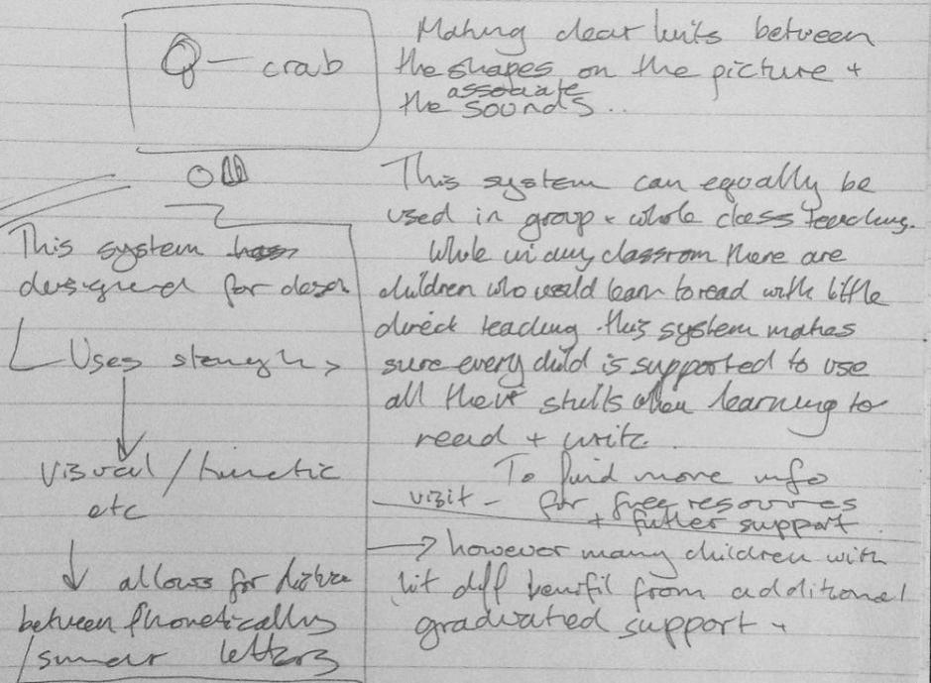

2) It takes a lot of time to write
Writing by hand are inefficient as it takes longer time. Have you ever encounter a problem where your thoughts are faster than your writing. You are writing as fast as you can and your thoughts keep on coming but at last some of your thoughts just disappear before you get to write them down. It is very annoying because your hand is just not fast enough. Also, writing for a long time will lead to complications like hand cramp and back pain.
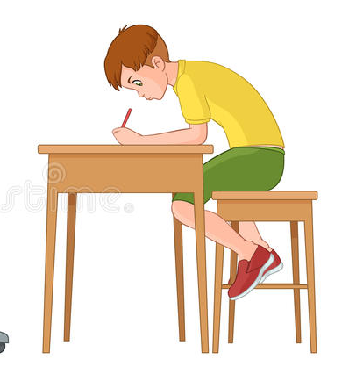

3) Error while writing
We as humans cannot run away from doing mistakes as we do them consciously or unconsciously all the time. This also applies while we are writing. Sometimes we consciously or unconsciously make some errors be it spelling or grammatical, sometimes our thoughts are so fast we even missed some words while writing a sentence. This is very frustrating as a little mistake can change the whole meaning of the sentence and it might send the wrong message to the readers. Also we humans are lazy creatures so sometimes we purposely did not put punctuation marks like commas and apostrophe as we assume that people will still understand the sentence without them. This might not look like a big problem but readers might get confuse while reading a text without proper punctuation marks.

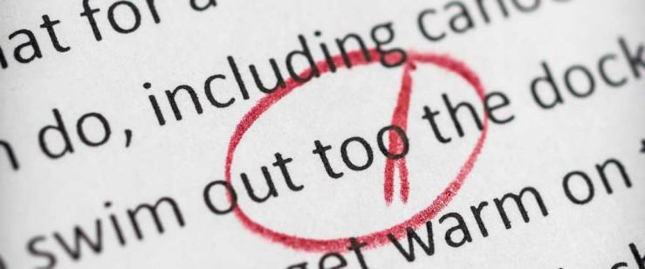

PROPOSED SOLUTION: A-PEN STAND
An A-Pen Stand is a standee that can hold a writing tool to write automatically when a person speaks. It can hold any type of writing tools such as a pen, a pencil or a marker. The standee is named by A-Pen because it is an automatic device with the word ‘automatic’ that starts with the letter ‘A’ and is a product by an A-Team. This product is invented to solve the three usability and user experience problems that has stated above.
The first goal is to solve bad handwriting problem. An A-Pen Stand has a system font size changer. It is a text writing setting default. It enables to change the font and the size of writing. The program is created to control the writing tool to automatically write a text with the chosen font and size according to the suitability of paperwork and size of a paper. Whenever the current line is already full written, the pen holder will move according to the programmed line spacing to the next line by receiving a command from the user with a reserved phrase which is “next line”. This feature helps to display a neat handwriting with a consistent text size in line.
The second problem is writing manually takes a lot of time. In order to overcome this problem, the standee is design to write as fast as the user speaks. It will reduce the usage of time for the users to write a complete text compared to writing manually. Research stated that the writing speed of an adult is 26 to 113 letters per minute while human speaks is obviously faster than when human writes. As we know, if we write using hand as usual, we tend to get tired if we write for too long and we will take some time to rest. However, if we use this creation, we don’t even need to write anymore and our hands are free to settle for other thing.
Furthermore, this invention also can detect errors such as spelling, grammatical and punctuation and autocorrect them. User as a human to make mistake which sometime will leads to misunderstanding. Thus, if the users voice a sentence with the wrong grammar, this pen holder will help to write the sentences with the right grammar. To implement this feature, an A-Pen Stand has a language default option which can set up to two language at once.

In addition, A-Pen Stand is built in a portable size to create convenient for user to carry it around. User can carry it inside their pencil case along with writing tools or in a bag. By having small form factor without decreasing the usage of existence writing tool, thus this product is very effective. Besides, it is efficient since this pen holder will help the users to minimize their work to complete a sentence compared to writing manually. An A-Pen Standee is safe to use because it would not do any harm be it people or environment. It is also good in learnability since the step to use is very simple and it will not take too much time to learn how to use it. Due to the simple step of learning it, it will be easier for the user to remember the step once learnt it.

Target Users
- Students
-Normally, students from all over the world regardless to level of education, primary, secondary or even tertiary students will utilize pen in dealing with most of their daily home works, assignments or even written tests. Hence with what we have mentioned the respective problems, it could greatly help them to ease their jobs. Especially not every student is blessed or trained to have a good writing ever since they were small, hence with our product that could display a neat handwriting in written tests or home works, it could make the examiners to have a better understanding and visually comfortable and pleasure.

- Journalist
-It may seem weird that one of our target users is Journalist, but this is because some of them still prefer writing down their notes, summarizing an interview with some great politician, celebrities or preparing the draft of a news through a pen. Speaking from the perspective of a journalist, time isn’t t always on their side because they might give a very short period and required to finish a very challenging task using an ordinary pen. They might have error in terms of spelling or grammar, with the auto correction function in our product, Journalists would produce a very neat and precise news.

- Book Author
-Some of them still believe that using a pen would contribute more inspirations than typing on a keyboard. If the new inspirations of their new book come, but some authors, their thoughts are way faster than the speed of writing, when they tend to write fast, they could have a bad writing, on the other hand, they tend to forget their ideas, after finish writing things in their mind using their normal speed. With our A pen stand, they could have an increased efficiency, because they would no longer facing the problems of slow hand writing anymore. They could fully reply on the A pen stand, where they only need to talk while the pen will write down everything.

