
SEMESTER 2
SESSION 2019/2020

HUMAN COMPUTER INTERACTION
SECV 2113

ASSIGNMENT 2

NAME | MATRICS NUMBER
MIRZA SABRINA BINTI MOHD SALMI | A19EC0086
NURUL ALIS ALIA BINTI MOHAMAD ZAMRI | A19EC0141
AINA ALIAH BINTI RUSLAN | A19EC0012
KHOR YONG XIN | A19EC0061
ALVIN HEE JUN SHEUNG | A19EC0015

LECTURER’S NAME: DR. AIDA ALI

SUBMISSION DATE: 18 MARCH 2020

Table of Contents
Table of Contents i
Table of Figures i
1.0 Introduction 1
2.0 Instagram Story Advertisement 3
2.1 Ability 3
2.2 Motivation 3
2.3 Trigger 4
3.0 Instagram Shop 5
3.1 Ability 5
3.2 Motivation 5
3.3 Trigger 5
4.0 A feature that fail to persuade a target behaviour: Screencast Security 7

Table of Figures
Figure 1: Instagram Story Advertisement Feature. 2
Figure 2: Instagram Shop Feature. 2
Figure 3: Advertisement on Instagram story. 4
Figure 5: A page that will appear after clicking the price and name pop-up on the picture. 6
Figure 4: A post in Instagram Shop. 6
Figure 6: The screen captured. 7
Figure 7: There is no notification regarding the screen capture in the activity tab. 7

1.0 Introduction
The task that we have to do is to find an example of a persuasive technology that contributes any one of the 17 Sustainable Development Goals. And the technology that we choose is Instagram application. Instagram is a social networking application made for people sharing their photos and videos from a smartphone. Instagram is also similar like Facebook and Twitter where everyone can create their own account for free and it will allow others to follow us and see our posts. We can also interacts with other users on Instagram by following them, commenting and liking on their posts and have a private messaging. Instagram contributes to one of the 17 Sustainable Development Goals which is Goal 8: Decent work and economic growth. This goal promote sustained economic growth, higher level of productivity and technology innovation. As we can see nowadays, there are many people that are still unemployed without having not enough job to keep up with a growing labour force. Encouraging entrepreneurship and job creation are key to solve this problem. Instagram is one of the medium for people to develop their entrepreneurship skill where people can start their own business using Instagram platform. Indirectly, this will reduce the unemployment and the goal to get full and productive employment, and decent work, for all women and men can be achieved by 2030.
Instagram has some good features that follow the principal factors of a behaviour model for persuasive design which is motivation, ability and trigger. First and foremost, if the users click through their Instagram stories, they will occasionally see some sponsored advertisements (refer Figure 1). There are many type of advertisements shown like the awareness ads, health ads and so on. These type of advertisement are one of the features that Instagram provide to the users where users can learn more about the content of the ads by swiping up to view the Instagram profile. Other than that, the second feature that are provided by Instagram is Instagram Shop (refer Figure 2). We can see from the explore feed, there is a shop icon and if you click on that icon, it will show you all posts that selling thing online at Instagram and the users can buy things from it. From the post itself, the users can click at the product shown and it will take the users to the official website of the shop. This function increase the efficiency and effectiveness of the application.
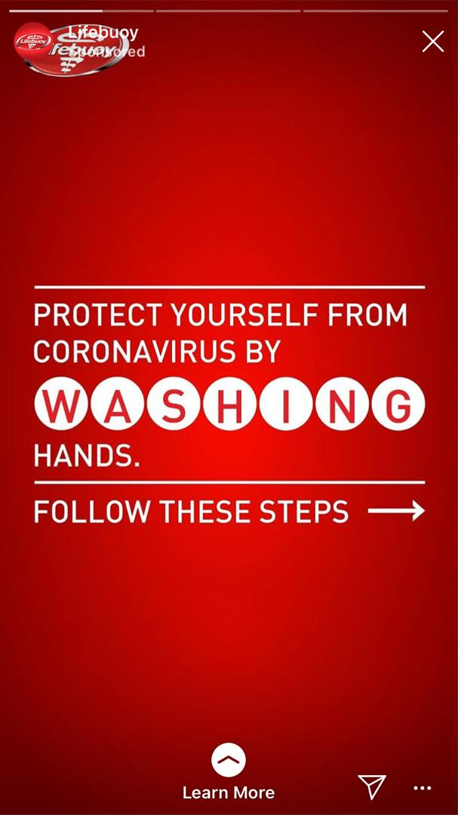
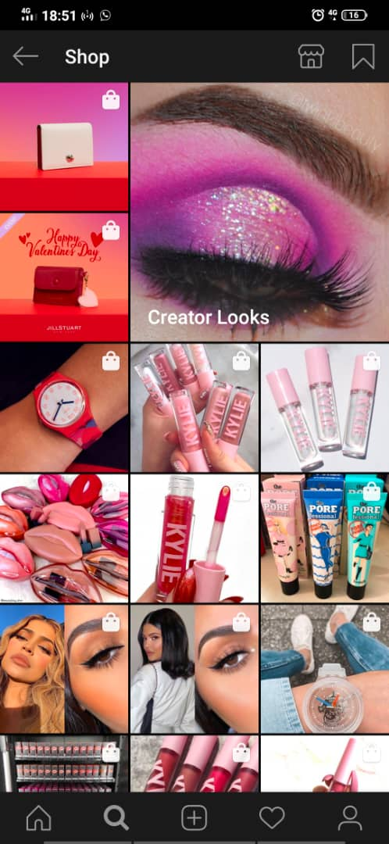
Figure 1: Instagram Story Advertisement Feature.
Figure 2: Instagram Shop Feature.

2.0 Instagram Story Advertisement
The target behaviour for this feature is the user swipe up to visit the Instagram page of the shop.

2.1 Ability
Users have the ability to do this task which is swipe up as it is simple. This design supports ability based on the FBM as it fulfils all 6 parts of simplicity. Swiping up is not time consuming, and it does not require money. Moreover, swiping up does not require users to exert physical effort, to think and it does not cause social deviance. Lastly, the word “Visit Instagram Profile” in white and the arrow pointing up animation (circled in red in Figure 3) brings users attention towards it. The arrow pointing up makes it easier for user to distinguish what needs to be done to visit the Instagram profile which is swiping up.

2.2 Motivation
Users are motivated to swipe up the advertisement when they are driven by pain/pleasure, hope/fear or social acceptance. Advertisement on Instagram story usually varied from food, fashion, groceries, events, beauty and more. The graphic of the advertisement plays an important role to motivate users. For advertisements about food, users are usually motivated by pleasure of eating while advertisements about beauty products and fashion will motivate users with social acceptance to fit with the latest trend. For advertisement in Figure 1, users will be motivated to swipe up because of fear of the coronavirus pandemic. The advertisement in Instagram can give motivation to the users to look at because when the users look the advertisement is interesting and wish to send to their friends or in the other way round, Instagram provide an arrow button (circled in blue in Figure 3) which will motivate the users to use the button to share the advertisement among friends.

2.3 Trigger
In order for users execute the swiping up feature that contains URL link, making it jumps from the respective story to other websites or its IG business account , finding out more details. Usually advertisement stories that appear on IG vary from different users due to having different preference and interested things to see. For an example, one might be a sneakersholic, when he sees the advertisement of Adidas original promoting their latest sneakers, due to the feeling of pleasure seeing this beautiful shoes and the acceptance by the community after buying it that give him a relatively high motivation level and the ability of swiping up to discover more about this sneakers is considerably simple in terms of short period. As a result it triggers him in a form of signal because with both high motivation and high ability, to perform the targeted behaviour-swiping up to learn more details about the sneakers. The word “Swipe up” and the upwards arrow (circled in red in Figure 3) on the bottom of story serve as a facilitator trigger to make the user knows that he/she only needs to swipe up to visit the Instagram page. Sometimes when the graphic of the advertisement did not raise the motivation of the users, the highlighted text (circled in green in Figure 3) on the advertisement serves as trigger to ignite the pleasure/pain, hope/fear or social acceptance.
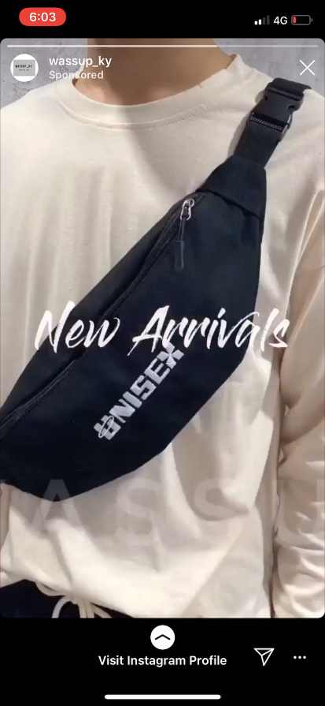
Figure 3: Advertisement on Instagram story.

3.0 Instagram Shop
The target behaviour for this feature is the user click the link to visit the website of the product.

3.1 Ability
This feature is simple as when the user click the post, the pop-up of the name and price of the item will be shown on the picture (refer Figure 4). After clicking the pop-up of the of a particular item, a bigger picture of that individual item will pop out and there will be a “View on Website” button right under the picture (refer Figure 5). Users only need to click the button to be redirected to the product’s website. This design supports ability based on the FBM as it fulfils all 6 parts of simplicity. Clicking the “View on Website” button is not time consuming, and it does not require money, does not require users to exert physical effort, to think and it does not cause social deviance. Moreover, the contrasting colour of the black background and white wording of the pop-up of the item and the blue coloured “View on Website” button bring users’ attention to it. This makes it easier for user to spot the clickable part of the post.

3.2 Motivation
The verified badges next to an Instagram’s account name (circled in red in Figure 4) on the profile have successfully motivate the users to shop on their profile. This verified badges mean Instagram has confirmed that the account is unique, notable and authentic presence of the public figure, celebrities and global brands. This icon will motivate the users to shop in their profile because they are more confident and less fear to their products as the products are authentic. The users will be motivated by social acceptance as they can fit in with the crowd by buying from popular authentic brands. The pictures of products with stunning models also motivates user to go to the official visit as it ignites the hope of the user to look as beautiful as the models. Besides, sellers can upload their attractive product’s photos on Instagram to attract the users’ attention and motivate them to shop on their profile.

3.3 Trigger
IG shop triggers users in the form of spark to execute the target behaviour because normally merchant would promote their products through story, post to their IG feed, or even letting users that are interested to their products to discover from the search & explore. When users see the respective promoting posts, stories even though they lack of motivation to perform the target behaviour due to not interested in the respective promoting merchandises but because of the caption on the posts or stories serves as trigger, they will visit the website. For an example, one might see a picture of a model using the latest Charles and Keith handbag that they have no intention of buying and suddenly the caption on the post is written that the product is limited edition. This will ignites the pleasure of receiving compliments from the community by owning a limited edition products thus making her to click on the link to visit the website of Charles and Keith despite having low motivation before. The pop-up of the product’s name and price (refer Figure 4) when the picture is clicked serves as a trigger in the form of signal.

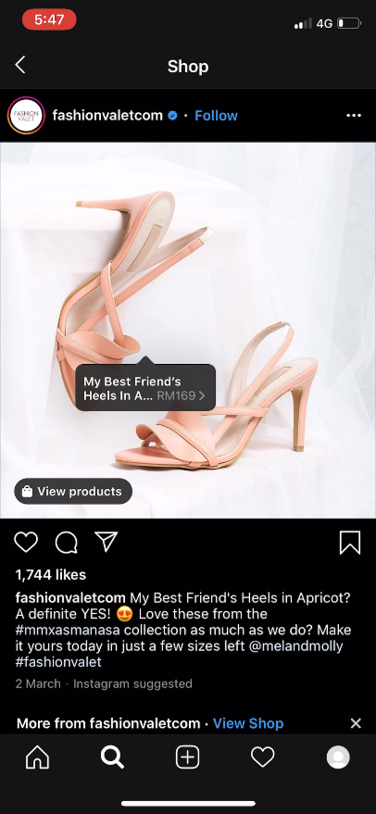
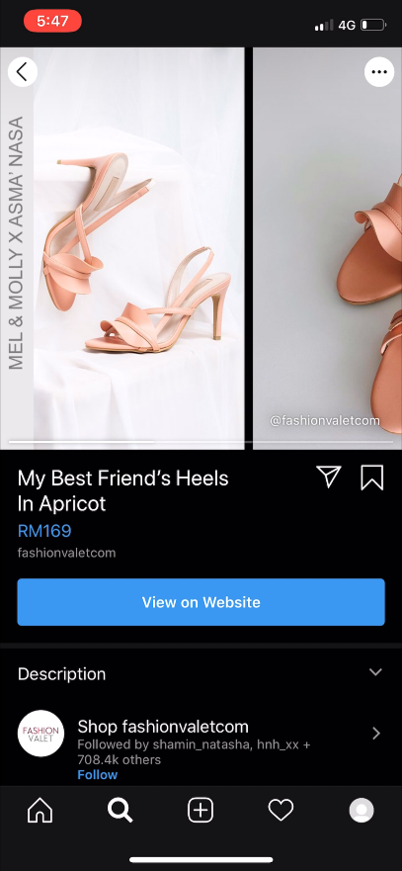
Figure 5: A page that will appear after clicking the price and name pop-up on the picture.

Figure 4: A post in Instagram Shop.

4.0 A feature that fail to persuade a target behaviour: Screencast Security
Instagram provides a medium which user can confidently shares videos and photos but nowadays with the emergence of unethical groups that have been secretly screencast other people’s videos and photos for their own sake is considered a cyber-fraud. These groups took the opportunity that Instagram application does not have a screencast security. They save the screencasted video and photo without the owner’s consent to sell them. The lack of Instagram’s security can be shown whenever someone is screencasting while using the application but it does not notify the owner. Therefore, Instagram has an inappropriate trigger on their security feature. According to FBM, a target behaviour will only occur if the three factors which are trigger, motivation and ability are exist at the same moment. Thus, the security feature on Instagram fails to persuade a user to execute the target behaviour because it does not notify the screencasting activity at the activity tab. Unlike Instagram, Snapchat will notify the user whenever screencasting activity is happening. In order to improve the security feature, Instagram should provide screencast default. However, if the user decided to turn on the default, Instagram should notify the owner whenever someone else is screencasting theirs pictures and videos.
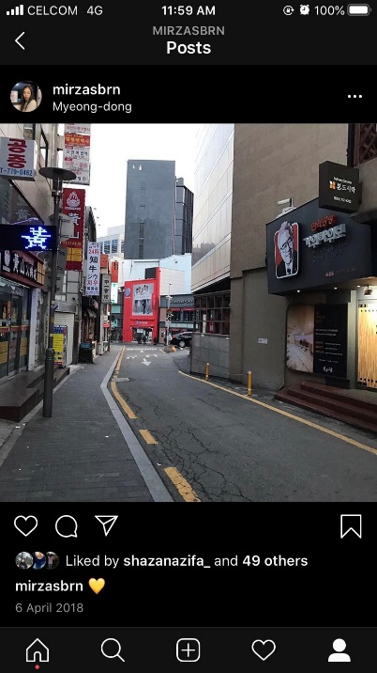
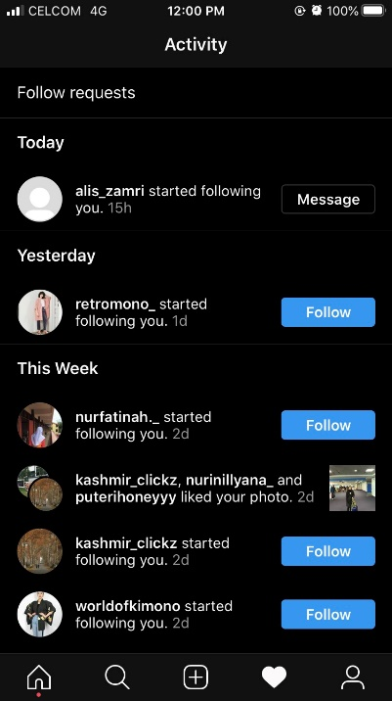

Figure 6: The screen captured.
Figure 7: There is no notification regarding the screen capture in the activity tab.

