UNIVERSITI TEKNOLOGI MALAYSIA
SCHOOL OF COMPUTING
SESSION 2019/2020 SEMESTER 2

COURSE CODE
SCSV 2113 – Human Computer Interaction

LECTURE’S NAME
Dr. Aida Ali

T1-INDIVIDUAL ASSIGNMENT

TITLE
Good and Bad User Interface Design

STUDENT’S NAME
Khor Yong Xin

MATRIC NO
A19EC0061

SECTION
01

Mi Fit App
Mi Fit app is an application to make use of a Mi Band. MI Band with a bracelet that can be worn on wrist to track the steps, measure heart rate, show total number of calories burned as well as display an icon to show notifications for calls and other application that has selected in Mi Fit app. Furthermore, Mi Band can also be worn to monitor sleep status in terms of how long we are in deep sleep, light sleep, in bed for how many hours, time awake an so on which will be shown in Mi Fit app. Mi Fit app is available on Google Play and IOS app stores. Mi Fit app can be used to track all the information and data captured by a Mi band and display them in an easier way to improve the user’s fitness regime. Mi Fit app can keep the records of our steps, heart rate, sleep data and others. Figure 1 show the Mi Band 2 while Figure 2 shows the application named Mi Fit.

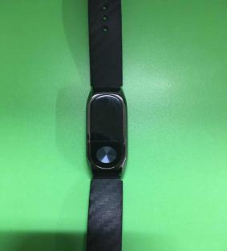
Figure 1
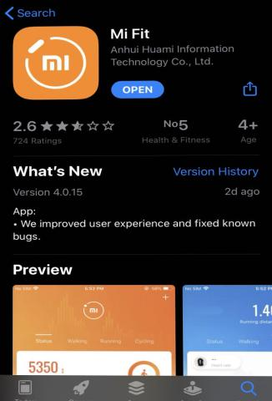
Figure 2

Mi Fit app has a good design because it uses different colour theme for different aspect in the application. This has increased the memorability of the user once they learn due to the colour theme to represent the aspect respectively. This may also increase the efficiency as the user just need to refer to the colour theme and select the function. Figure 3 shows the heart rate with orange theme, Figure 4 shows the sleep analysis with blue colour theme while Figure 5 shows the steps tracker with purple theme.

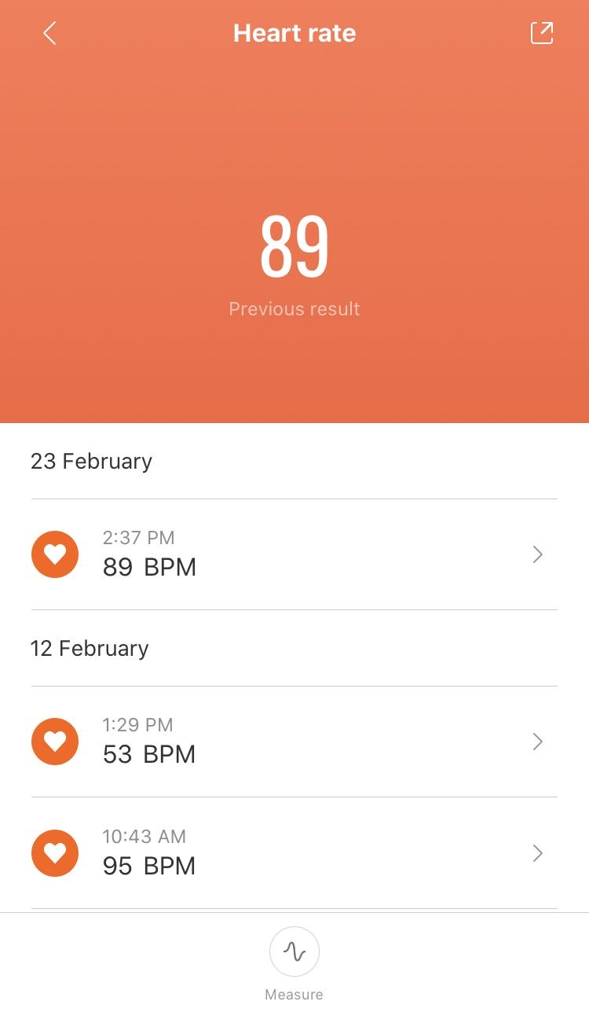
Figure 3
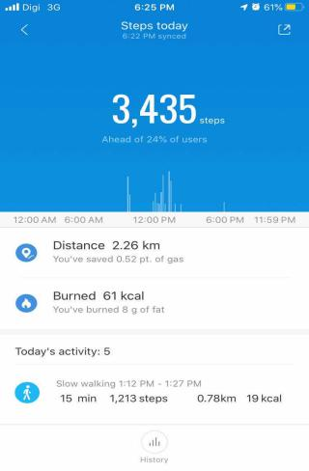
Figure 4
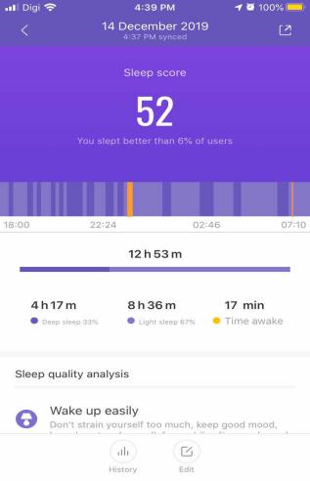
Figure 5

Mi Fit app is good in the design because it displays feedback to the user according to their sleeping status. Hence, the user may follow the advice to improve their life style. For instance “Wake up easily” which circled in Figure 6 while “Fell asleep late” which circled in Figure 7. Furthermore the visibility is high for the user to look at their sleep data because Mi Fit app use different colour to represent their sleep status so that it is very obvious. For instance, dark purple is for deep sleep, light purple is for light sleep and orange is for the time awake. This aspect is said as a good design because it helps the user to look at the sleep status in an easier way and save their time. Figure 6 and Figure 7 show the different colour to represent their sleep status.

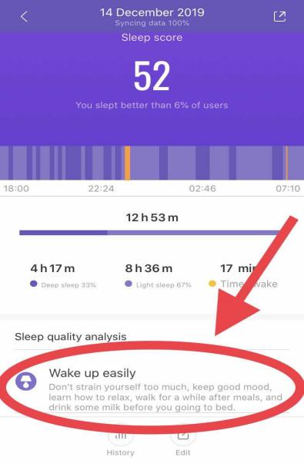
Figure 6
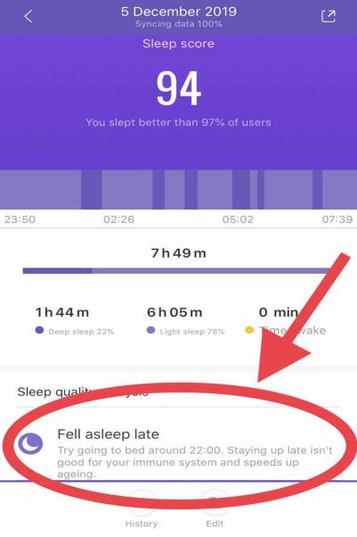
Figure 7

The behavior tagging in Mi Fit app are very attractive due to it’s icon. This aspect can increase the memorability of an user and satisfy the user who may not understand words. Figure 8 shows the behavior tagging in Mi Fit app.

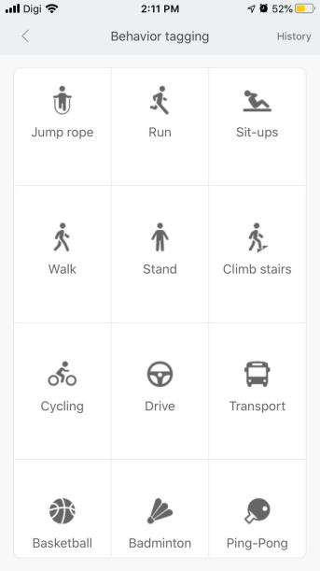
Figure 8

The bad design of the Mi Fit app is that it cannot update the data by itself and need the user’s action to sync the data into the app. This show that it is not the efficient on data collection automatically. The user need to reload the data by pulling down the screen if not the data cannot be read and analyse.

Philips dry iron
An dry iron is used to remove creases as well as kill the bacteria on the fabric which may cause infectious disease when it is heated. This process is called ironing or smoothing. When the user carry out this process on an ironing board, the combination of heat and pressure will remove wrinkles on the fabric. The design of the iron is good because the soleplate of an dry iron are in triangular shape is to have a slim tip to easily reach the tricky areas such as between the bottons and so on. The temperature light is used to indicate the iron is hot enough or not. Figure 9 shows Philips dry iron with it’s features while Figure 10 shows the triangular shape of the soleplate with slim tip.

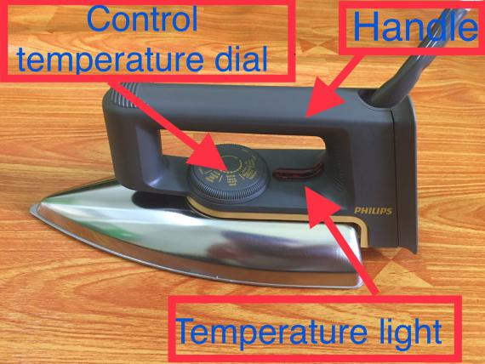
Figure 9
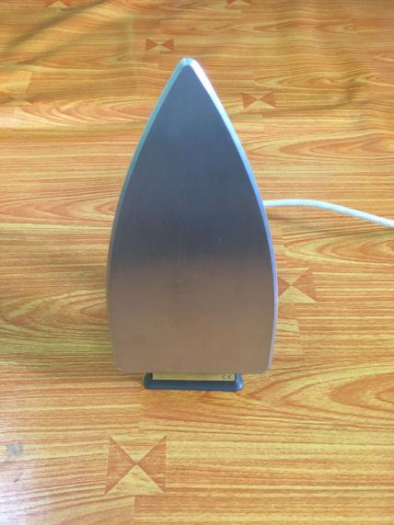
Figure 10

The design of the iron is good because it has a flat surface to set down without the hot soleplate placing on anything that can be destroyed. This design shows how safety the iron can be positioned when it is set down so that to prevent the burning of fabric or others. Figure 11 shows the set down position of an iron with flat surface.

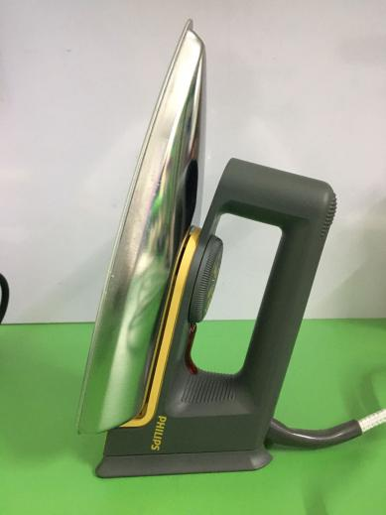
Figure 11

The good design of the iron is that it has specify the option of temperature by printing the type of materials on the temperature controlling dial. This has the constraint to prevent the user from selecting the wrong temperature. The dry iron reaches the usability goals in the aspects of learnability and memorability. It is easy to control the temperature by referring to the marking on temperature controlling dial and select it. It is memorable because it only need the user to switch on the dry iron and turn to the temperature they want. It is affordance bacause the temperature light has an arrow shape to indicate the position of the temperature it pointed to. Figure 12 shows the several types of temperatures for instance, “silk”, “nylon”, “wool”, “cotton” and “linen” as well as the arrow shape of the temperature light on the dry iron.

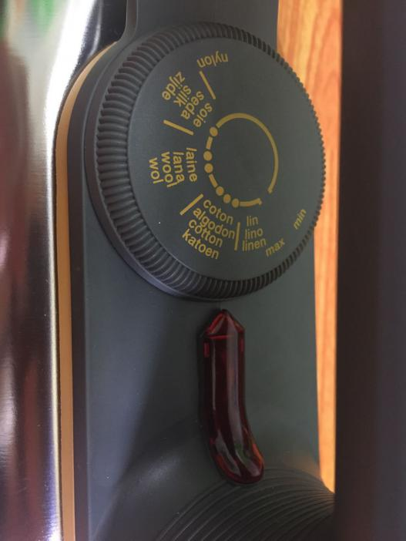
Figure 12

The dry iron has good design on temperature control because it can detect the temperature on the soleplate effectively. When the soleplate temperature has reached the selected temperature by the user, the temperature light goes off while when the temperature of the soleplate drops, the temperature light goes on and heat up. The temperature light is very obvious because it uses a red light to indicate the user that the temperature had reached. Figure 13 shows the red temperature light of the iron.

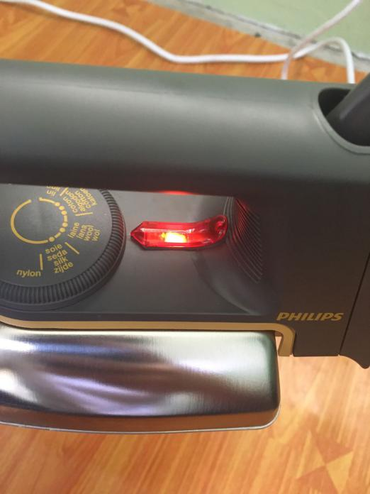
Figure 13

The bad design of the dry iron is that it cannot satisfy a traveller’s need to bring it along. Dry iron are too big and heavy to be carry in the luggage. Besides, this dry iron are not foldable and need more space to keep it. Dry iron are less efficient compare to a steam iron. Dry iron take more time to remove the wrinkles on the clothes. Dry iron is not safety because when it is too hot, it may burn or ignite the fabric.

