

DESIGN THINKING PRESESNTATION REPORT

TOPIC: SYSTEM SOFTWARE
DUE DATE: 14 OCTOBER 2019

PREPARED BY:
Name | Matric No
MUHAMMAD FIKRI BIN ABDULLAMIN | A19EC0096
ABDELRAHMAN RASHAD ALI AHMED ELBARAKAWI | A193C4001
SITI NAJWA BINTI APANDI | A19EC0163
MD SHADMAN SAKIB | A18CS4062

PREPARED FOR: DR HASWADI HASSAN

TABLE OF CONTENT
Contents
TABLE OF CONTENT 1
1.0 Introduction 2
2.0 Detail step and description in design thinking and evidence for each phase 3
3.0 Detail description include problem, solution and team working 4
4.0 Design thinking assessment point 5
5.0 design thinking evidence 5
5.1 Empathy 5
5.2 Define 6
5.3 Ideate 7
5.4 Prototype 8
5.5 Test 8
6.0 Reflection 9
7.0 The task for each member 9

1.0 Introduction
Computer is a powerful system that can analyze and calculate pretty much everything in a short of time computer to human that need time and thought to do the task. It’s an intelligence system that helps us do most of our task now days. For example, Bank now mostly use internet banking as a platform to do transaction compare to old day where people need to go to the bank and do the transfer. They are great as long as they working. So, what are the component that is need for computer to work properly? One of the components is System Software. System software is a collection of programs where its handle all the technical details. There are four type of programs. Operating system, utilities, device driver and language translator. All of these programs help computer to communicate with the hardware to perform task. In contrast, the application software focus on the end user, where user have the option to install software to do specific thing like for example Microsoft Word to write report or Spotify to listen to music. In general, users do not interact with system software as it works in the background whereas users interact with application software while doing different activities. Computer still can work normally without application software but fail to operate normally without systems software. Our team are now working to use system software to solve problems according to client’s need by using a design thinking process.

2.0 Detail step and description in design thinking and evidence for each phase
Testing
The last one is Testing which is we get the feedback or review from the client about the prototype. This will help us to recognize the mistake inside the prototype and correct it immediately. All this process may be repeated until it satisfied the client needs.
Prototype
We will build the product using suitable material just to express the idea physically so that people can see it clearly how the products work.
Ideate
Moving on to the next process which is ideate, this a process where the team has to brain storm ideas on how to solve client’s problem. The team also has to make sure that they fulfil all the extra needs by the clients. The process of converting idea to product is prototype.
Define
After that, we go to define process. This step is crucial to identify what exactly the client’s problem. This a process where team has to work on the information gather to locate the client’s problem. If the problem still ambiguous, step 1 may be repeat until the problem is crystal clear.
Empathy
In this process, a person will try to inquire all the possible problem and information from the client. This is because we want to make sure there will be no problem anymore after we already working with the solution. There’s a variety of way to extract information from client. One of the ways is through interviews where we have a normal conversation with clients to listen to their problem

3.0 Detail description include problem, solution and team working
Our project is focusing on education. So, we asked the clients about their problems when in lecture session. As we gathered all the data and information, we identify that the client doesn’t see the slide at the front clearly due to the reflection of light. Apart from that, the client also stated that the projector system was not user friendly. What it means is that the client cannot jot down all the notes and working properly when the lecturer going too fast. And lastly, we identify that the lecture session was not effective enough because of sometimes the lecturer had to wipe all the thing on the whiteboard and it could consume a lot of time. This will make students has to wait for it and as a result, the focus is taken away by talking with their friends. Our team working together to solve this problem by inventing the “Digital Board”. Digital board is basically a touch screen board with a new operating system in it to do multiple task at once. This operating system is focusing on education learning systems where presentation slide can be made side to side with board as a place to write anything. Student who doesn’t catch up with the lecture can ask the lecturer to push the slide or working to side of the screen. By this way, the slow student can jot down the notes properly while other can still continue to learn others thing. Apart from that, the screen use for the digital board is IPS panel with high resolution as this will prevent the glaring to the eyes of students at the side and back of the class. We also add several features that will help to make the lecture class more efficient like one push button to erase everything on the board and switch that automatically off the light and air conditioning when there are no people inside the class.
Problem | Solve?
Student have problem to see the slide at the front clearly | ✓
Student cannot jot down all the work show by lecturer when he/she go to fast | ✓
Lecture session is not time efficient enough | ✓

4.0 Design thinking assessment point
Based on discussion with the team, we think that design thinking process should be access after the end of the project. This is because the process has to be repeated again and again until it’s resolves client’s problems. Assessing during the process will disturb the overall project and prevent the student to do what they want to do. This prevent them from generating vital idea that might be the solution of the problem.

5.0 design thinking evidence

5.1 Empathy
Our team inquired the information from clients by interviewing. We target peoples with different background from information technology as we want to get different perspective and opinion from them. We decided to choose three candidates ages around 19 years old inside UTM. The first question we asked from them was “What is the main problem you face during lecture session nowadays?”. The second question was “What other problem you may face while in lecture session?”. The reason we ask this question is to get in depth about what is the actual problem of our clients. Lastly, we asked “Do you think the class session efficient?” to get overall view whether our client actually satisfied with current ways of lecture nowadays. The first candidates tell us that sometimes when he seats at the side or at the back, he cannot see the slide clearly. The second candidate told that he cannot jot down all the notes properly when the lecturer going too fast. The third candidate complain about the difficulty using Windows operating system to do something. Our interview session was done on 9th October 2019.
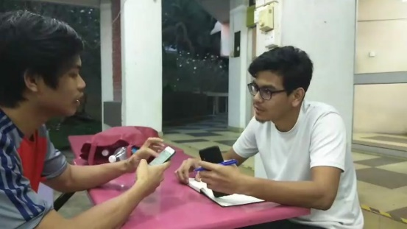

5.2 Define
The replies are quite confusing. So, we try to relate the answers back and forth to get the idea on what is the main problem of our clients. We come up with different possibilities of the problem, the first one is the low resolutions projector. Other than that, we found that it might be a lighting problem as it made the glare problem. Lastly, we come out with maybe the computer system itself is not user friendly for students and lecturer. This discussion meeting was done on 10th October 2019.
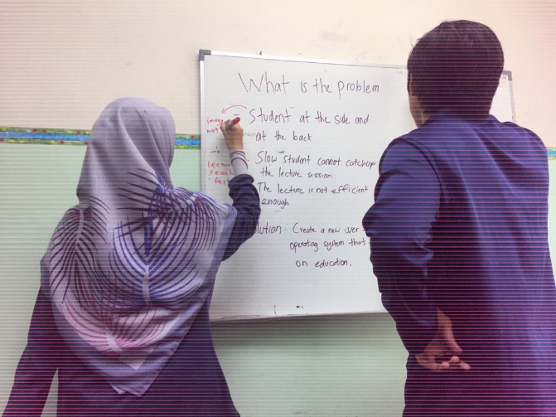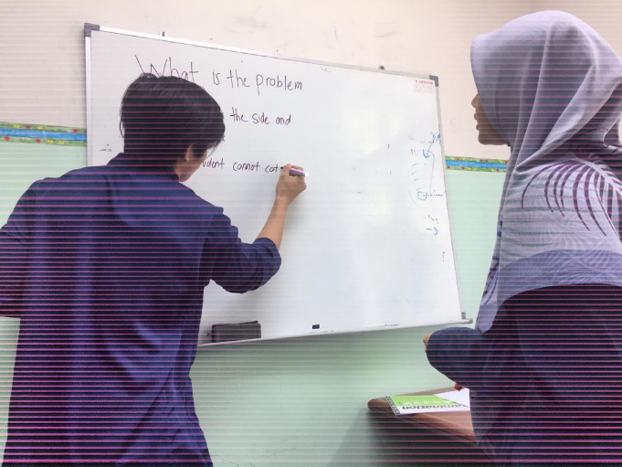

5.3 Ideate
We come up with a new operating system in it that are user friendly and focusing on lecturer and student to do daily task related to lecture session. The way how this board worked is lecturer has to scan QR code on the screen before the lecture start. After that, the board will show all the lecturer folder’s and lecturer can choose which slide they want to teach. The board will make half space for the slide to be presented while the other half worked as a board that can be used to show working or drawing. Using this way, student who’s late at writing noted have a chance to write the notes properly as lecturer just push the notes or drawing to the side of the board instead of wipe it like usually in class. Digital board was built using high resolution panel that will provide true color of the content. This was to help students that having difficulty seeing the slide at the front. Lastly, A new operating system will make the task running smoothly as it created only for the digital board. The reason we create a new operating system instead of using the present one is because we identify that present operating system have a lot of problem. One of the problems are security. To ensure the software is protected, the developer will try to push the update as frequent as they can so that the user’s file will always be protected. This will make the system run a bit lagging and disturb the overall quality of the lecture.
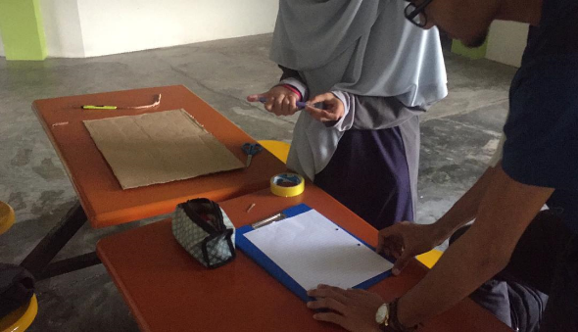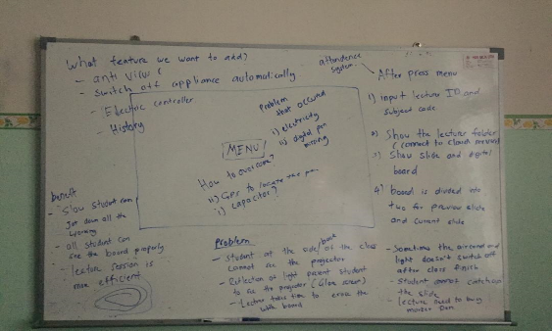

5.4 Prototype
Our prototype was built using a carton box, paper, spray paint and software to helped us with the design of our digital board. First, we cut the carton box into a rectangular shape to mimic the board. We created two board so it’s easier for us to explain to the client how the digital board works. We color the board with white and black spray. Adobe photoshop software was used to design the board. The design then being printed and paste on the board. Apart from digital board, we also create a digital pen that work just like marker pen. This way lecturer doesn’t have to buy a new marker every 3 or 4 months as digital pen doesn’t contain any liquid form. It was built using a hard plastic.
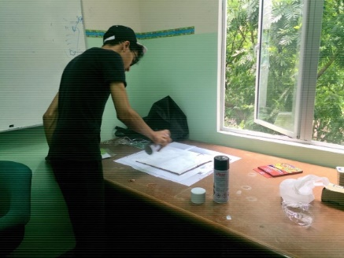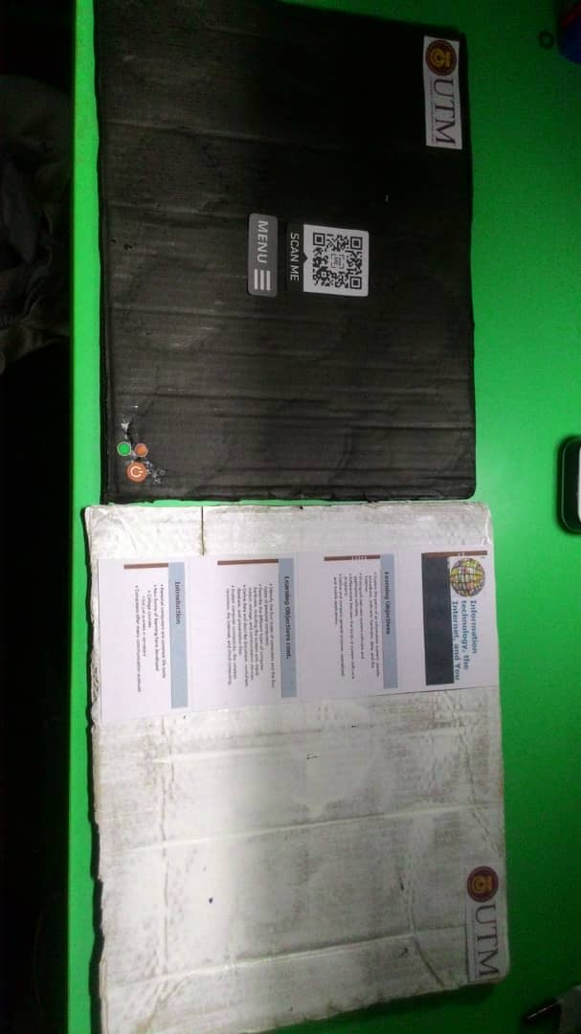

5.5 Test
We ask the review from the clients and the feedback was quite good as they satisfy with our prototype. The only main consent was security. Security was a big issue since the born of operating system. Many people try to hack into other people system whenever they see a vulnerable option. To overcome this problem, we add anti-virus within the system itself. This means, the system is well protected without the help of third-party agency. Another thing that consent the client is how the board to be functioning when there is no electricity. A simple solution to the problem was we add a capacitor that act like a battery at the back of the board. The way capacitor works was capacitor will discharge electricity to the board whenever there is no electricity around and charge back when electricity available back.
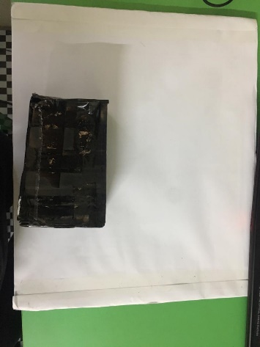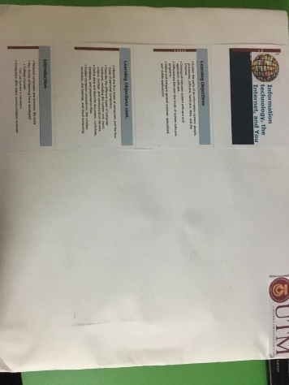

6.0 Reflection
Our goal with regard to this subject is to continuously innovate thing especially in a computer field with a vision to help community improve their life every day. Design thinking has help us a lot in achieving the goal we want. It teaches us to be a critical thinker as well as be open minded to the crazy idea. It also teaches us the soft skill needed to engage with the clients and this for sure can helps us to get the job we wanted in the future. We will try to improve our team working in the future, so that we have a good social skill and communication with each other.

7.0 The task for each member
Name | Task
Muhammad Fikri | Report
Abdelrahman | Interview/Prototype
Siti Najwa | Interview/Prototype
MD Shadman | Slide presentation

