

SCHOOL OF COMPUTING
FACULTY OF ENGINEERING

ROBOCAR WORKSHOP

PREPARED BY:
NAME | MATRIC NUMBER
AMIRUL SYAFIQ BIN MOHD QISTI | A19EC0020
AMIR HAKIM BIN AHMED MAHIR | A19EC0018
MUHAMMAD KHAIRUL AMIRIN BIN KHAIRIL | A19EC0100
NUR AIN BINTI MAHAMAD SALLEH | A19EC0126
ANIS FARZANA BINTI ISMAIL | A19EC0182
SITI NAJWA BINTI APANDI | A19EC0163

Table of Contents
List of Figures 2
1. Introduction 3
2. Detailed Descriptions 4
2.1.Details of the club 4
2.2.Learning and Practical Session 4
2.3.Game 6
3. Reflection 7
4. Tasks for each member 8

List of Figures
Figure 1 Discussion on how to do the code 5
Figure 2 Coding the Robocar 5
Figure 3 Robocar competition in the game 6

Introduction
On 9th December 2019, section 3 of Technology Information course had a robotic workshop at Interactive Learning Room, Level 3, N28, School of Computing. The workshop started at 2.00 PM and ended at 4.30 PM. In the workshop, we were divided into six groups whereas each group consisted of six to seven students. The workshop was conducted by Robocar Team which is a club established in School of Computing. The club had organized a lot of workshops before involving primary and secondary school students. The robot used in this workshop is called Robocar, which used Arduino Uno as the microprocessor. Arduino is an open-source software and hardware company. It can be used as a CPU or so called brain for a robot. It supports languages C and C++ using special rules of code structuring. The main objective of this workshop is to gain knowledge as well as experience in robotic programming

Detailed Descriptions

Details of the club
There are some info regarding the RoboCar activities. The RoboCar program activities started since 2012 and were involved by more than 1000 participant from different level of education. Basically they focused on school and students. They propose to teach the robotic subject to the undergraduate students since 2007 until now. There are three parts that RoboCar aim to do with the community and the undergraduate students. Undergraduate student like us will divide into two part which are the expert in robotic programming and robotic development will teach us how we need to teach the school student. The other part is for RTSE subject which use Robotar. RTSE is Real Time Software Engineering which we will registered the subject during fourth year.

Learning and Practical Session
The facilitators explain a bit on how to do programming to make the robocar move. We learn about function and understand each of the function to control the movement of robot. One laptop is needed for each group to create our own programming. We have six group and we need to compete with other group to see which robocar will move with a short time to reach the end point of track. Based on the programming that have been show by the facilitator, we try to make our own programming. There is already some built-in function to make the RoboCar interact such as Roboforward, Roboreverse and Robohonk. The front part at the bottom of the robocar have sensors to detect the black line on the track. The sensors use binary code to get decimal number. They told us that decimal 5 is not required in coding because it is impossible to trace the track at that situation. Based on that information, we do try and error in order to get the best result for the Robocar.
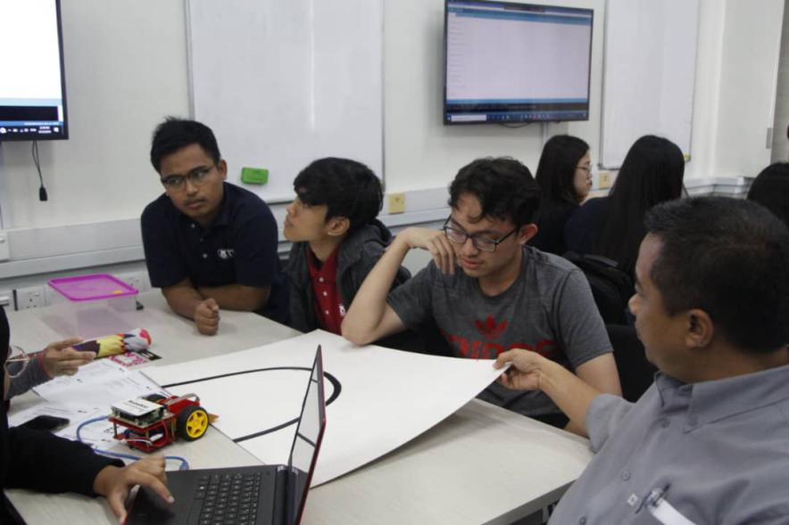
We are able to make the robocar move but at the same time the robocar did not move at the right track. However, we try to fix the problem and do the correct programming. We often ask from the facilitator to help us in finding the problem of our programming. We managed to move the RoboCar on the curved track pretty easily. The biggest challenge that we faced is when the robocar did not follow the track especially when there is a junction and sharp corner on the track. However, we managed to make the correction on the programming and the robocar finally can move according to the track given. After the robocar are able to move correctly, we have to make sure our robocar are able to move at high speed in order to compete with other team’s Robocar.
Figure 1 Discussion on how to do the code

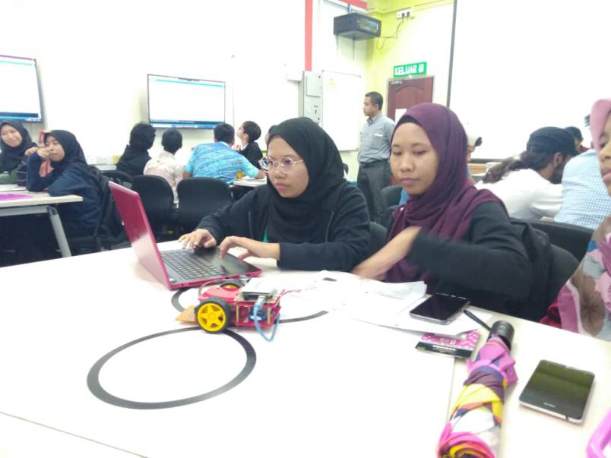
Figure 2 Coding the Robocar

Game
When the time for us to prepare the best coding for the robocar is over, all of us have to go to the competition at the second floor at N28. In this competition we have to compete and fight with other six group to see which finish the fastest. Every team will be given 3 minutes to finish all the checkpoint. The track is not so very different with the one we have tried when preparing the robocar. When the time for us to show to everyone, our robocar move smoothly in every checkpoint, but the only problem we faced is our robocar is not as fast as other team. The total time that our robocar took to finish all the checkpoint of the course is around 2 minutes and 30 seconds
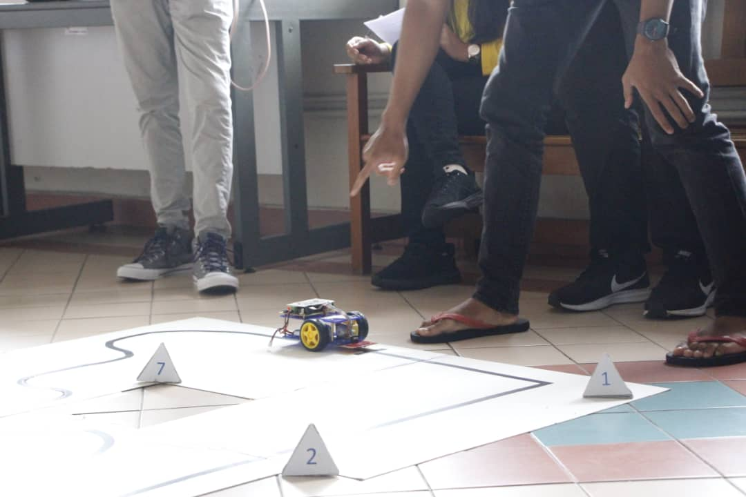
After all team have finished compete their Robocar on the course, it was time for Dr Haswadi Hasan to give his speech and award the top 2 fastest Robocar. Unfortunately, our team did not manage to won as we were at the fifth place. But we were very grateful because our RoboCar worked very fine and managed to complete all the checkpoints without any complications. It was our first time to do programming and testing this RoboCar and we know for sure that we can do better in the future if we get the chance to do it again.
Figure 3 Robocar competition in the game

Reflection

On 9th December 2019, we attended a Robokar Workshop that had been held at Active Learning Lab N28. This workshop was organized by the Robokar’s representative. Throughout the workshop, Dr.Haswadi supervised all of us in the lab to ensure that all of us involved actively in the workshop. The Robokar’s representative introduced us about their organization and taught us of the basic skills in doing Arduino. The moment we were informed that we were going to attend the workshop, we were super excited to experience and learn new knowledge that we have never been exposed to. Not to forget, this new knowledge and skills could be use after we graduate from UTM which will help us in the future industries. After we attended the workshop, we found it is important to gain new knowledge and skills because it will surely beneficial to us.
This workshop also gives a good impact to us as we were introduced about the RoboKar model and the way to code to run the program. Firstly, the representative introduced us about some of the codes that will make the model move. At this point, the model use sensor and the code of ReadLineSensor will activate the sensor which will finally move the model according to the value read in binary. We were also exposed to new problem solving skills that needed to think as creative as we can so that it would work properly. The moment we finished encoded our program, we have some competitions with the other group to test our model and we found out that our model work properly but it was not fast enough as other group.
In conclusion, we realized that critical way of thinking will improve our program not only that but we also knew that it would help us in so many other ways. This encouraged us to have the urge to reach our goal and dreams passionately. Some of us also interested to become one of the members of the Robokar. This shown this workshop successfully attract the student’s interest thus the generation will always continue with more bombastic ideas and products. Lastly, we would like to thank Dr.Haswadi Hassan also the Robokar’s representative that guided us throughout this workshop.

- Tasks for each member
Names | Task
Anis Farzana Binti Ismail | Make reflection
Nur Ain Binti Mahamad Salleh | Make reflection and compile the report
Amir Hakim Bin Ahmed Mahir | Record down what we have learned during the workshop
Amirul Syafiq Bin Mohd Qisti | Do the introduction of the report
Siti Najwa Binti Apandi | Record down what we have learned during the workshop
Muhammad Khairul Amirin Bin Khairil | Take photos during the workshop

