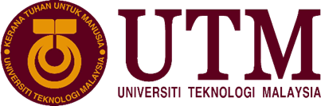

Name | Matric No
MUHAMMAD FIKRI BIN ABDULLAMIN | A19EC0096
SITI NAJWA BINTI APANDI | A19EC0163
MD SHADMAN SAKIB | A18CS4062
ABDELRAHMAN RASHID | A19EC4001

School of Computing
Faculty of Engineering

Industrial Center for Information and Communication Technology (C.I.C.T) visit report

Prepared for: Dr Haswadi Hassan

Prepared by:
A visit was made to Sultanah Zanariah Library on 21th October by section 03 Technology Information system class to see the Gallerium which is a place where C.I.C.T place all their old computer equipment. The person in charged for this visit is our beloved lecturer Dr Haswadi Hassan. The objectives of this visit are to introduce all the old computer equipment to the first year's student from school of computing as well as to give a short lecture on computer part and technology that has been used in the past century. The lecture has been organized by a well computer literate educator from C.I.C.T.
As soon as we step into Gallerium, we were amazed by all the equipment show there, it was such an eye opening to see how computer equipment change compares to present one. For example, the first personal computer which is “Altair 8800” are so heavy and bulky compare to current personal computer which are lighter and compact. We can see equipment like the old mainframe, first personal computer and the old keyboard that has been used back then. At first, we were brief about the mainframe of the computer and how it worked, then the educator brief about the basic component of the computer like CPU, RAM and so on. Throughout the lecture session, we have learned a lot about all the technology that has been used until now. We also took some picture of the equipment as well as the description of it.
The Mainframe PCs and its various parts were shown at the primary spot. As a first year student we were truly stunned after discovered the IBM Mainframe PC before us. All things considered those are various parts of various IBM Mainframe PCs as it is truly elusive them together as one. The information window of IBM 3471 was the first shown thing. We truly stunned in the wake of being realize that this window needed to open through a key. At that time these key things are extremely exceptional. Adjacent to the window there was a controller of IBM 3274 41D. There was likewise the Mainframe CPU of IBM 9672 R21 and Mainframe information stockpiling of IBM 9394 2. We were stunned for the second time when we heard that an enormous machine can just process 4 MB information at that point. It sounds ordinary when you read in the book yet you will truly ponder when you see the monster machine before you. There also shows an Apple Macintosh Classic Computer. It was equipped with a software memory of 1 MB of RAM and 2 MB to 4 MB of hard disk. With its large capacity at the time, the computer was used in the library along with the Lotus 123 and Word Star application for work and calculation.
There were likewise IBM attractive tape unit of IBM 3420, tape control unit of IBM 3803 and tape gadget arrangement of IBM 3490E A10. Once more, in the event that anybody contrasted those attractive gadgets with the present attractive gadgets that individual can barely accept that. There was likewise the effect printer of IBM 4245 12. The printer was enormous in size. There was control edge of tower server and COM-shake of Back mount server. Be that as it may, the Mainframe fundamental framework intensity of IBM 9303 2 and Mainframe tape subsystem control gadget of IBM 3422 A01 was likewise appeared there. There was one educator of C.I.C.T who portrayed every one of the things and included halfway data for the students to think all the more profoundly. Another astonishing certainty is there was a 4 MB floppy circle. We need to concur that UTM spent a great deal of cash to gather them and store them in their places.
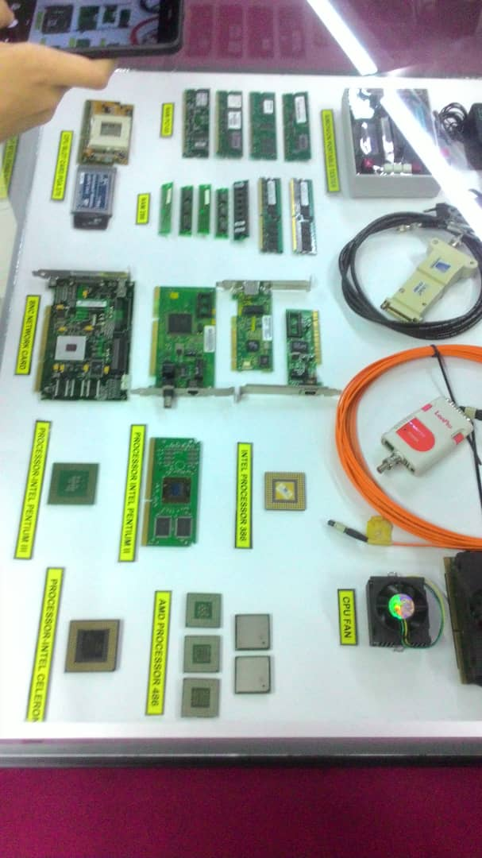
Aside from the centralized computer PCs there was additionally some old age PCs. Among of them the eye getting was Macintosh-Power bank 170, work station 286, CRT MONOCHROME Monitor, PC Pentium, etc. These are the old 1970's PC. Moreover, there was likewise recurrence analyzer and Simcheck compact analyzer. At the primary spot we did not get those gadgets yet after the clarification of the regarded instructor we at long last locate that out. Furthermore, there were likewise some various pieces of various old PCs. The old age RAM (Random-Access-Memory) RAM-286 and RAM Pc133 was shown there as well. There were likewise significant pieces of old registers like CPU space card PGA 370, intel processor 360, processor intel Pentium iii, processor intel Celeron, AMD processor 486, old motherboard, IDE link and numerous sorts of old hard-drives. Next, we additionally visited the sight and sound lab of UTM. The lab visit was additionally decent and delightful. In the interactive media lab there was a set to record sound and there was additionally a blue screen set to record the sound.

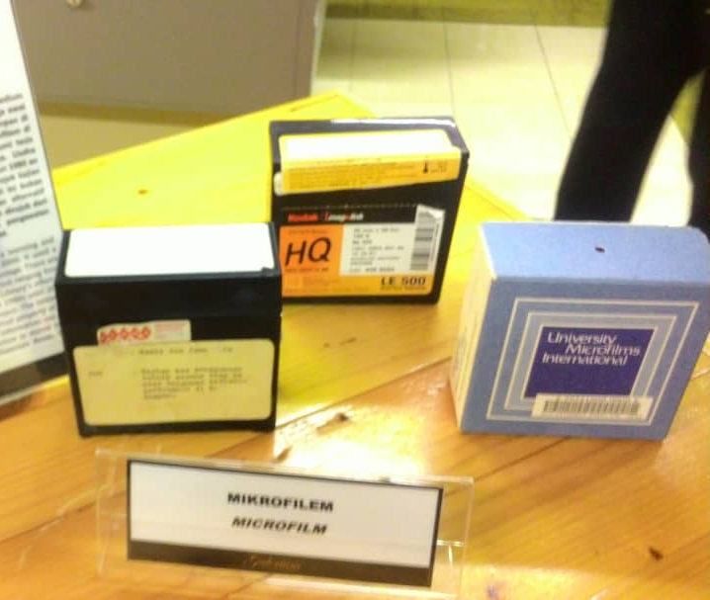
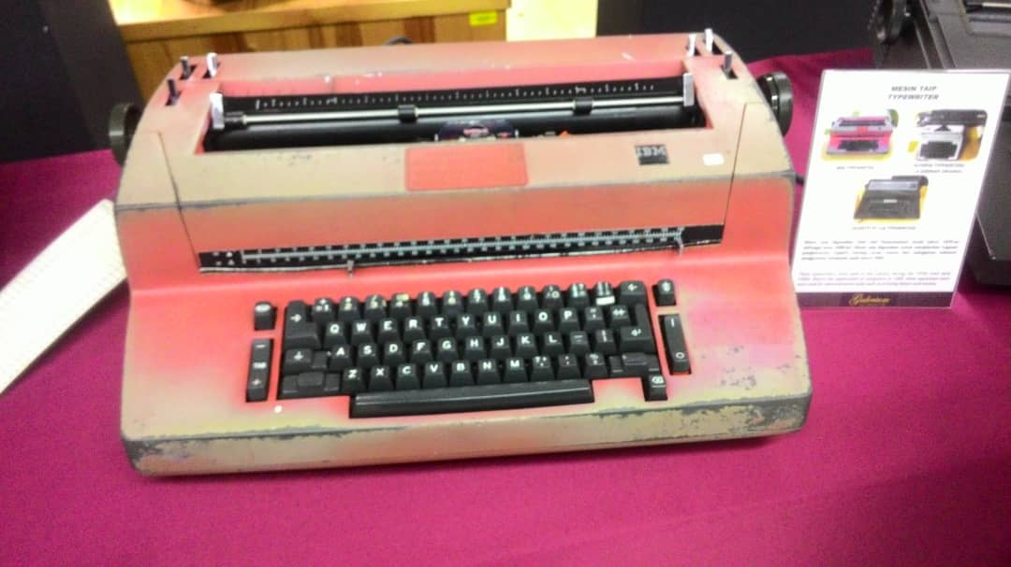
There also shows various type of typewriter that were used by Library staff during 1970s. At that time, the uses of computer are not widely used yet. The typewriter that they used were IBM Typewriter, Olympia Typewriters which is a German Original and Olivetti ET 116 Typewriter. These things were once used for administration tasks such as printing letters and memos and after that the typewriter was replaced with computer in 1985. The next component that was displayed there is microfilm. Microfilm is a media item which was heavily used as a learning and reference medium in UTM back in the 1980’s until early 2000. It used a special 35 mm size file and was stored in boxes for easy storage. One roll of 35 mm film may carry 600 images of large engineering drawings or 800 images of broadsheet newspaper pages. Basically the functions of microfilm are for transmission, storage, reading and printing. In UTM Library collection, there are almost 15, 000 titles of microfilms consist ranging from theses, international journals, acts and newspaper. In Early 1980s until 2007, the library’s staff began to carry out microfilming process and it focused on duplication of theses and research project. The purpose is to preserve the security of the intellectual property of the University and to ensure that this primary source of information can still be referred from time to time. Then, UTM Library used the ‘Recordak Micro-File’ machine around early 1980s until 2007. This machine was used to capture small images of UTM theses. The images were recorded into microfilms or microfiche. It utilized a special film, the ‘Kodak Ektacrhome’ which was 35 mm in size and with a capacity of 100 feet per film roll. UTM Library also used Microfilm Camera Zeutschel OK 102 in 1986 until 2007. This type of microfilm is a high accuracy camera used to photograph small images of UTM theses. Same goes like Recordak Micro-File, the images were recorded into microfilms or microfiche.
Typewriter
Microfilm
So, from the visited, we have gained a lot of information and saw a ton of things before our eyes. Beforehand, our insight about computer was limit in the book and internet yet during the visit we encountered everything that make us questions our self, how can technology change very rapidly? It is really amazing to see the huge different between the past and the current technology. Other than that, we also question our self on how can we make use the technology to help us achieving our goal? Since most of our team member was majoring in software engineering course, our goal was to create a good software and we think in order to create the best software for the community is to have a high-end computer that can run smoothly so that it will not interrupt our work. To have a good a computer, you have to know the basic component of the computer and this is where the educator has taught us on what are the best component needed to build a computer. Once more, the educator was extremely useful and exceptionally entertaining individual. We are very grateful because has been given a chance to visit the Gallerium. It was truly astounding and mind-blowing visit for us. Particular much gratitude goes to our regarded lecturer to make the visit the possible. Surely the knowledge that has been gained from this visit will be use in the future.

The task for each member
Name | Task
Muhammad Fikri Bin Abdullamin | Report
Siti Najwa Binti Apandi | Report/Taking notes
Abdelrahman Rashad Ali Ahmed Elbarakawi | Taking picture of the equipment
MD Shadman Sakib | Report

