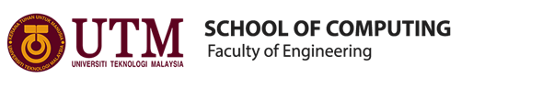
TECHNOLOGY AND INFORMATION SYSTEM
SEMESTER 1 2019/2020
SECP1513-04
Industrial Visit 1 – CICT UTM
NAME OF STUDENTS | MATRIC NO.
IZZAH FATINI BINTI MOHD NASRI | A19EC0055
MAIZATULHAZA BINTI ROHANI | A19EC0082
IZZATUL KAMILATUN NISA | A19EC0242
ANIKA RAHMAN ANTU | A19EC0223

LECTURER : DR. RUHAIDAH BINTI SAMSUDIN
SUBMISSION DATE : 28th OCTOBER 2019

TABLE OF CONTENT

Table of Contents i
1.0 Introduction 1
2.0 Detailed Descriptions 2
2.1 Organization Structure, Services, Achievements 2
2.2 History Component Related To Computing 4
3.0 Reflections 6
4.0 Task for Each Member 7
4.1 Izzah Fatini binti Mohd Nasri 7
4.2 Maizatulhaza binti Sobri 7
4.3 Izzatul Kamilatun Nisa 7
4.4 Anika Rahman Antu 7

1.0 INTRODUCTION

On Monday, 21 October 2019, we were visiting the Galerium UTM in the Sultanah Zanariah Library, one of the library located in UTM for the Industrial Visit Program, under Technology and Information System course. Galerium UTM is a gallery and museum for UTM where this is the place which used to keep University’s historical heritage under the governance of UTM’s library. This industrial visit programme involved all the first year student from School of Computing. During the visit, students were divided into two groups for two sessions which the first session was on 3’clock and the next session was on 4’clock. Our section were in the second session. As we enter the Gallerium, we were given talks on CICT UTM technology by En Mohd Zahari bin Zainal Abidin, Assistant Chief Information Technology Officer Kup(F32), Infrastructure and Operations Management, Department of Information and Communication Technology. Then, we are given the opportunity to take a look the historic stuffs in the gallery. As a conclusion, we can say that this exhibition was more likely to expose the evolution of technology industry and identify the changes in productivity in the aspect of communications, digital, design, data storage and others.

2.0 DETAILED DESCRIPTION
2.1 ORGANIZATION STRUCTURE, SERVICE AND ARCHIVEMENT
UTM GALERIUM
UTM GALERIUM is one of the portfolios in the UTM Library management system from 2007 until now. It is managed under the leadership of the Head Librarian with a management team comprising the Deputy Head Librarian (Galerium), two main sections and several related units.

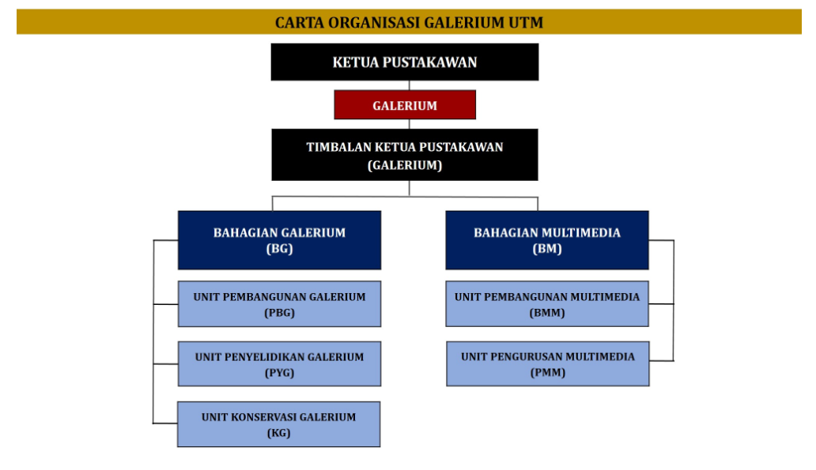
Source: http://library.utm.my/utmgallerium/management-structure/

UTM CICT
UTM CICT is a support unit that provide ICT services for the university staffs and students. It also offers and deliver the services especially in ICT infrastructure, system development and academic / administrative activities.
The organisation structure in CICT, six sections under Prof Madya Dr Mohd Shahizan bin Othman as the Director.
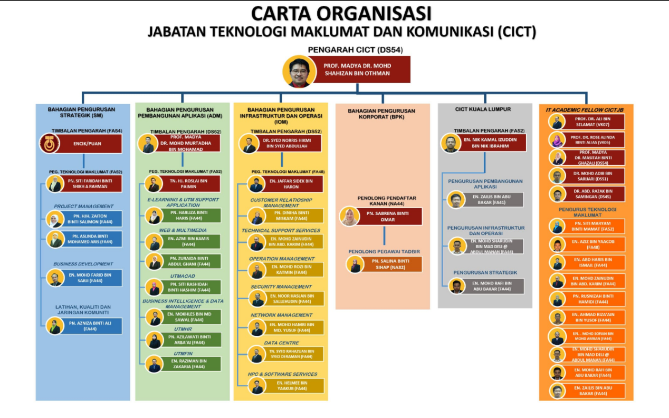
Source: https://cict.utm.my/organization-structure/
CICT provides the Internet, infrastructure and security, application development, web management, software and ICT support as service. These service are provided for the students and staffs use.
UTM CICT also has provided the best technical documents and led universities to receive Standard Accounting System For Government Agencies 2017 which is given by Jabatan Akauntan Negara Malaysia in 22th November 2017. UTM also one of 59 out of 419 agencies that are receive a certificate of Standard Accounting System For Government Agencies, just like other universities which are USM, UPSI, UMP, UPNM, UNISZA, UTHM and UPM.
2.2 THE HISTORY COMPONENT RELATED TO COMPUTING
Based on the talk given by En Mohd Zahari bin Zainal Abidin, the computer technology has been changed drastically and the recent technology is more complex and user-friendly. He told us about the changes in technology for the computer devices and component such as microprocessor, mother board, mainframe and also the presentation of the computer itself in term of weight and size.
As for mainframe technology used before, there are two types of mainframe which are mainframe tape subsystem and mainframe data storage. The mainframe tape subsystem was used as a ‘back up’ for mainframe system and information database of staff and students as well as other University’s information system during the year 1987 until 1995. This model used a square shape tape after the round shape tape was no longer use. While, the usage of Mainframe Data Storage at UTM began in the 1970s at Computer Centre, UTM campus, Kuala Lumpur. It served as a data control of students and staff information. The mainframe has been used for almost 20 years for various components and functions such as processing, storing, securing and printing the University’s information data.
Based on the explanation from one of the CICT staff, mainframe is a one computer but is a separate type which different to the laptop. Nowadays, student has smartphone and laptop but before only some student were afford to have them. According to the staff, the reason we need a big amount of storage were the multimedia era factor where the graphic must be beautiful and it need a big data. That’s why the laptop need a big data and storage, 1Tb or 2Tb.In mainframe, there was hard disk where it was very big. The capacity for hard disk is very big about 4.3Gb. there were PC hard disk and bigfoot hard disk. Quantum Bigfoot hard disk is very hard.
In real life, some banks use this hard disk to find data. They use branch network which different to the comman network we use daily. This is to prevent hacking and other network criminals. Besides, there was CPU in mainframe. The CPU is very big and high. The price is about 2 million. Before that, UTM got four mainframe . It was separated using terminal technology. Why terminal technology? As we know it contained CPU, hard disk, mega system and so on which are separated. So, terminal technology is more likely to guide us what we want to do. For example, before, in programming, students used to type and all is command. That’s why UTM student before were mastered in programming.
In addition, there was diskette. There were three types of diskette which are 3 inches diskette, 5 inches diskette and 8 inches diskette. Only three pieces of paper of words can be saved in 8 inches diskette before. The capacity of diskette is 1.44Mg before. Mainframe also include motherboard. There were two types of motherboard which are PC motherboard and server motherboard. For server motherboard, it has over 1 socket for the CPU. It different to the PC motherboard like laptop and desktop which only has 1 socket for the CPU. This differences is because most of the applications, systems, data and software go to the server to be processed. Server also can be accessed by student. For example, the UTM portal which can be accessed by students through the link my.utm.my
3.0 REFLECTION

Our goal is to become a successful software engineer who are able to create systems and develop a wonderful network with secure security and also able to improve the software systems technology by applying the techniques that we learn from this course.

This visit help us visualize our dream on how we should improve our skills and knowledge in recent technology systems. The invention of the technology system nowadays become a competition between country and government in order to build and improve its economy. From this visit, we can see the invention of computer and computer devices that have been used before such as microfilm, monitor, mouse, mainframe, magnetic tape unit and personal computer. There are also a few other technology such as impact printer, multi tv-vcr combination, time control device, camera microfilm and typewriter. So, from this visit we realized that the invention of technology is very important for our industry development.

As a software engineering student, which our course is very close to the technology in our industries we plan to improve our knowledge of Artificial Intelligence(AI). As we know, AI is a simulation of human intelligence where it’s include learning, reasoning and self-correction processes. One of the main function of this simulation is it’s allow machine to make the best decision based on the rules and information programmed to it to make an approximate conclusion. By combining, this new technology with our industry, surely it will improve the Information and Communication Technology(ICT) system in Malaysia.

4.0 TASK FOR EACH MEMBER

4.1 Izzah Fatini binti Mohd Nasri
- Finishing the report
- Record the information during the visit
- Explain Details Description : Organization Structure, Services, Achievements
- Reflection

4.2 Maizatulhaza binti Rohani
- Record the information during the visit
- Indroduction and Details of Visit
- Explain Details Description: The History Component Related To Computing

4.3 Izzatul Kamilatun Nisa
- Record the information during visit
- Explain Details Description

4.4 Anika Rahman Antu
- Record the information during visit
- Explain Details Description

