Graduate attributes are knowledge, personal qualities, and understanding of learning, economic, and professional development. We can say in one word that graduate attributes mean universally being created. Only knowledge and skills are not sufficient in this current competitive world to land an individual to that dream job or to achieve a meritorious career. Success requires more than understanding. It needs a graduate to have some other personal attributes in order to distinguish him/her among others and be known as a substance individual. Attributes of graduation bring us success. And in the' Graduate Success Attributes(GSA) study, we know how to get to the peak of the performance slope. We are learning and developing in the GSA class in Communication, Extempore speech, Report writing, Essay writing, Working on Terms, Presentations, Leadership, Teamwork, Disciplinary Knowledge, Lifelong Learning, Global Citizen Engagement, Society Membership.
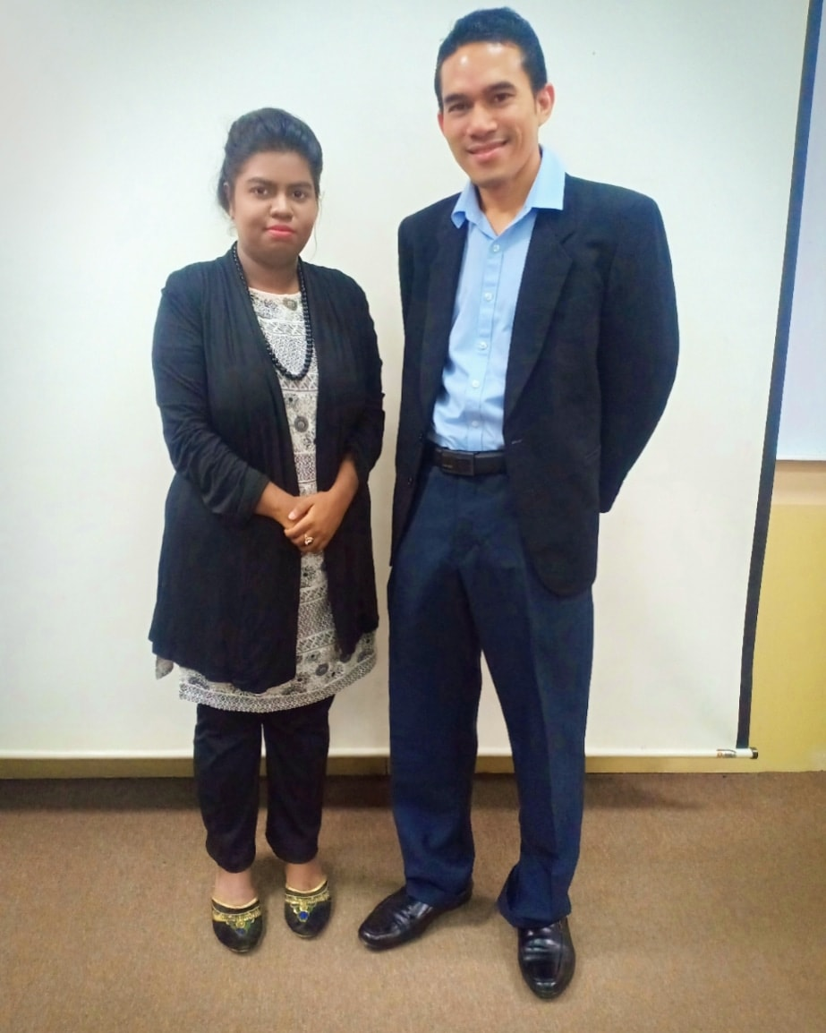

We are so lucky that we have got “Dr. MUHAMMAD ABD HADI BIN BUNYAMIN” as our GSA Instructor. Our GSA class is like a global village. We have classmates from seven different countries. We are learning new things in every single class of GSA. It is developing my communication skills, writing skills, creative thinking skills also Leadership skills. Now I can speak fluently moreover I feel comfortable when I have conversations with foreigners, now I don't get frustrated either get nervous when I get something difficult I am going deep into it with my thinking skills. Interestingly my writing skills also developing as we had to go through assignment and reflection. And as we are supposed to make a group in every class we need to select a leader that’s also teaching us leadership. In one sentence we can say GSA making our academic and future career both perfect.

Our first activity was to give out our thoughts about Dr. Hadi's video. It was a funny video with a lot of knowledge. This video was about an interview. We have noticed people used to get frightened when they are giving an interview where the interviewer looks for someone who has confidence and self-esteem. In the end, in the video interviewer choose the one, who was being real. This video taught us keeping belief in ourselves and not to change our own personality for any reason. Next activity making a group of 5-6 members. Later on, we exchanged our name, age and also background. We got to know there were few students who are younger than 19-year-old. Then each group sent a pair of members and told about others, about the background of those members that we just knew and get to know each other in that particular time given. By did those activities, we got to realize, communicating skills is a need in order to work in a group, it makes us improve our team working if we can tolerate each other by exchanging and accepting others’ opinions on any particular topic or task given.

In the very next class, we learned about employability and soft skills. Companies used to observe each and every candidate before a company hired their work so that they would pick and select the most qualified to be hired so that they would have the workers who would do their job and work very well. Not only an organization want an applicant with a great educational result, but also they want their workers to have extra skills so that their staff can provide the business with many incentives and advantages. High situations, fresh graduates are seeking high wages and are calling for unfair employment, in some instances they have no work experience. New graduates should take every opportunity to gain as much experience as possible. We also talked about the types of soft skills lacking in new graduates. We addressed the main soft skills of new graduates in a pair and expressed our thoughts with others. There were different answers and opinions on each pair, but some of us agreed to the answers of others. We have had a great time and from that day we have experienced so much.

We were taught about the scholarship the next day. We have been taught that scholarship skills are the management of information and lifelong learning qualifications. There are six qualities that warrant the talents of academics that are a good researcher, good thinker, good writer/author, good reader, good presenter, and good reviewer/evaluator. Dr. Hadi asked us to connect all the characteristics and describe the key skills we need for the bursary. I discovered through this experience how talents and qualities are all related to scholarship skills.

Last week 15th October was my favorite class, where every student was given 3 minutes and we must talk about any topic we want or we can say "public speaking." I have been able to discuss myself and my family, which I am sure everybody in the class can probably relate to themselves. It was one of the reasons that could improve our self-assurance to speak to many others in the Student performance class. It is an introduction to the students about how we can actually interact with other people in a true "work world." Public speaking is a necessity in order to be outstanding, otherwise, some contact difficulties can be found. A good public speaker is an individual who has great confidence to speak about these particular topics.

I am an international student here moreover it is only a month and above I came here in Malaysia, I had a few challenges to face. But Dr. Hadi’s friendly and helping attitude helped me to get my best. In fact, for me, this is the second time I am writing this reflection, the first time I couldn’t do well and Dr. Hadi texted me about that and gave me one more opportunity for fixing it. This is just like unbelievable but it is damn true for Dr. Hadi. And I didn’t write reflection before this also but I get it better than other formal writing. In addition, it's not so normal. And GSA has helped me to be attitude-friendly. It will help me with the topics I am going to study. And InshaAllah I will keep giving my best for bringing the best for me.

In conclusion, I want to say I am in love with the GSA class. And I will miss my GSA class a lot. Here I am learning with joy. This is the class I have enjoyed the most. And Dr. Hadi is one of the best. His friendly attitude and experience made us more interested in the GSA class. It is especially helping me for future career and all other subjects. Now I look forward to opportunities such as scholarship on the internet. I'm working and upgrading myself after the latest technology. The core of academic learning is public speaking, writing, creative thinking all included in GSA and helped me to improve. It also encourages me to lead a life in my way, which also helps me to live this beautiful life. Now I'm really optimistic about my future.

