

SCHOOL OF COMPUTING

SECP1513 – TECHNOLOGY & INFORMATION SYSTEM

ROBOKAR REPORT

SECTION : 08 – 1SECR
COURSE NAME : BACHELOR OF COMPUTER SCIENCE – COMPUTER
NETWORK SECURITY

Members:
- ABIEL PUTRA DIMYATI A19EC0214
- AFIQ NAZRIE RABBANI A19EC0216
- ATIFAH QOTHRUNNADA SUPIANTO A19EC0226
- HUDAN ARYAJUDANTA A19EC0240
- MUHAMMAD KEVIN REZZA RAMADAN A19EC0264
- MUHAMMAD SUHAIL A19EC0269
- Introduction
  - Introduction
Coding has become one of the most important skills for current and future generations. Many have argued that it should form part of a national curriculum on par with a native language, the sciences, and math. We are surrounded with uncountable numbers of software and hardware that run using code. Our modern world is also required to be more and more computer literate with each passing year, and we can learn basic coding by using RoboKar.
RoboKar is an automobile that is navigated and maneuvered by a computer without a need for human control or intervention under a range of driving situations and conditions by using C language. The purpose of RoboKar is to give opportunity for people to gain basic experience in practical computer programming by using C language. In this case the RoboKar will be programmed to trace or follow black lines by using sensor that has been embedded to the RoboKar

  - Details of the visit
Sunday, 8 December 2019 at 2.00PM we are School of Computing’s student from subject Technology and Information System have an agenda to attend RoboKar: ROBOT PROGRAMMING WORKSHOP at Active Learning Lab (351-01) in N28. This workshop is aimed to teach us how to control a robot using our settings applied. Session is divided into 3 sessions, first is introduction then programming, and last is game session. First, when we came to Active Learning Lab our senior gave us attendance and instruct us to scan barcode at the table, after we scanned it we directed to a questioner with some questions about robot’s basic knowledge. Each table get one robot with a connector cable and a USB pen drive. After all the participants came, they start to introduce RoboKar and explaining about how to program this robot briefly. They spread a guiding booklet that contain some command for the robot. After explanation finish, they told us we do it with our laptop. We started installed IDE from pen drive for this robot, and then write some codes, when codes already finish then we insert to the robot through cable connector. If codes finished, we can turn on the robot and try it to make sure everything is working properly. After programming session finish, we go downstairs to level 2 to do game session. We compete with each other, there is a track that our robot should finish all the checkpoint, and they count time for each robot to complete all the checkpoints.

- Description
  - Background
Basically, RoboKar is intended to provide an opportunity for students to gain basic experience in practical computer programming.
The use of technology in learning can inspire students to think critically about problem solving and encourage creativity to come up with innovative solutions. Robotics is a technology that enables students to actively participate in teaching. Early exposure to ICT technology at school or pre-university allows students to relate the relationship between theory and practical use in problem solving. Robotics is therefore a great teaching tool for creative problem solving and critical thinking topics. In addition, soft skills are also practiced among students through teamwork in solving problems.
The development of robotic systems in teaching and learning in schools and universities has increased, as this technology meets educational needs, especially to solve problems. In Malaysia the National Robotic Competition (NRC) is one of the co-curriculum activities under the Ministry of Education that uses LEGO robots. The purpose of the competition is to provide a learning platform that allows school children to learn four generic skills, namely problem solving, creative thinking, interpersonal communication and teamwork. Competitions like these create an atmosphere of fun and engaging teaching and learning while increasing confidence in communication among school students.
Realizing the benefits of robotic technology in teaching, a small mobile robot, called RoboKar, was developed at Universiti Teknologi Malaysia (UTM) for the purpose of teaching problem solving topics through computer software programming. The same robot has been used for teaching courses at UTM and in schools. These robots provide a practical platform to teach real-time programming concepts for computer science and student of software engineering at UTM. It's cheap and this small-scale mobile robot, and it's easy to use by programmers without a hardware background for robot software programs.
Apart from the exposure of technology to school students, the application of soft skills is also emphasized. This is to ensure that the students have the best knowledge and skills for the preparation of employment in various occupations. For example, effective communication skills can give students high confidence when they enter the workforce in addition to being able to use information communication technology (ICT) well, students also have the ability to think creatively and critically and to act rationally. Communication between team members is crucial to solving a problem, it can indirectly foster teamwork among school students and can foster leadership qualities at school, in the family, and in the community.

2.2. Objectives
- Provide students with the opportunity to gain basic experience in practical computer programming developers.
- To increase interest among students in the field related to programming.
- Promoting UTM as the best option for furthering education in engineering and engineering technology.
2.3. Purpose
- Encourages human capital development
  - Providing a school learning platform enables school students to learn four generic skills, problem solving, creative thinking, interpersonal communication and teamwork.
  - Foster creativity and innovation among high school students.
2.4. Benefits
- Troubleshoot problems with computer programming methods.
- Provides a conducive learning platform.
- Encourages human capital development.
- Foster a creative and innovative culture.

- Reflection
  - Reflection

As students studying in the course of Computer Network and Security, we all have a dream to make a better and safer network for everyone.
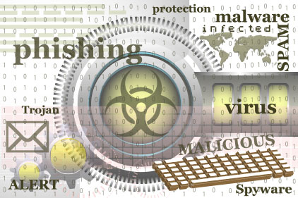
The world in this information age is highly dependent on the networking system, especially the internet. Nowadays everyone does almost everything with Internet, from working, socializing with people, even simple things like finding recipes for food. Unfortunately, the internet isnot always safe. Many threats like viruses and hackers appears on the internet and causes problems for internet users that have weak protection.
Our goal is to minimize these threats and/or strengthen the protection for the internet users. As the rise of threats in the internet many companies emerged to fight against these threats and protect the internet users from attacks like malware or viruses. We aim to be able to at least be at the same level as the people in those companies or better if possible, the best, so we can help make the internet safer for everyone.
In order for us to obtain our goal we need to study very hard about computer network & security in UTM and get good grades as proof that we are capable of being the next protector of the internet. To be able to be the best in this field just studying won’t suffice, we need to gain experience from competition and such and also hands on experience from working or in one of the companies.

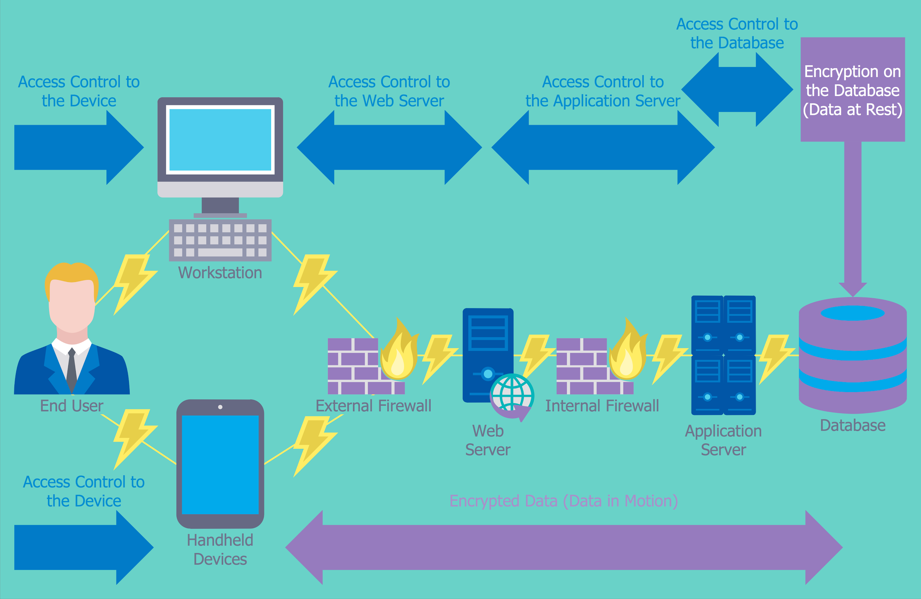
With the RoboKar workshop that we attended we were able to learn about how to program a simple robot to do what we want. By learning how to program a robot we also learn one of the ways how a simple programming can be applied. By learning this we are now more aware of what programming can do and how can we apply it. By participating in the mini competition that was held we feel motivated and challenged to program the robot more efficient and to be competitive in doing so.

As stated in several paragraphs above, for us to be able to improve ourselves we need to study very hard. In the world of computer network and security there’s so much to learn. First thing, we need to learn about programming like coding in C++ as basic and stepping up to Python or Java language next as these two is the most commonly used language in programming nowadays. Next, we also need to learn about computer networking itself and also how to make networking secure.
In our opinion only studying is not enough for us to improve to be one of the best. We think to become the best we also need hands on experience in computer networking and security. These hands-on experiences can be obtained from joining competition about computer network and security, or working in the field of network and security in forms of internship or projects. We can also get this hands-on experience from seminars or special course and security which usually give practical lessons about computer networking which will definitely improve our knowledge and potential in this field.

- Tasks
- Abiel : Reflection
- Afiq : Description
- Atifa : Details
- Hudan : Description
- Kevin : Introduction
- Suhail : Introduction

Image Source
https://www.conceptdraw.com/How-To-Guide/picture/Computer-and-Networks-Network-Security-Diagrams-Access-Control-and-Encryption.png
https://st3.depositphotos.com/2885805/18938/v/1600/depositphotos_189386738-stock-illustration-cyber-security-infographics.jpg
https://www.reveantivirus.com/blog/wp-content/uploads/2017/03/computer-security-threats.jpg

