
SCHOOL OF COMPUTING
Faculty of Engineering

DESIGN THINKING REPORT

SECP1513
TECHNOLOGY AND INFORMATION SYSTEM

SECTION : 08- 1SECR
COURSE : BACHELOR OF COMPUTER SCIENCE - COMPUTER NETWORKS AND SECURITY

No. | NAME | STUDENT ID
1 | ABIEL PUTRA DIMYATI | A19EC0214
2 | CHUA KEK AN | A19EC0039
3 | MUHAMMAD KEVIN REZZA RAMADAN | A19EC0264
4 | SYAHMINA FA’IZUN WAZIEN BINTI AMLAN | A19EC0166

LECTURER-IN-CHARGE : DR HASAWADI HASAN
DATE OF SUBMISSION : 13th OCTOBER 2019
INTRODUCTION
Design Thinking is a methodology used by designers to solve complex problems, and find desirable solutions for clients. A design mindset is not problem-focused, it's solution focused and action oriented towards creating a preferred future. Design thinking is very vital in this current era as it is able to solve various problems through creative means, meaning new products and solutions can be created at any time.
We were introduced to design thinking and was given a problem in the learning field to solve in a given period of time. We planned and acted by following the 4 steps in design planning – empathize, define, ideate, prototype and test.

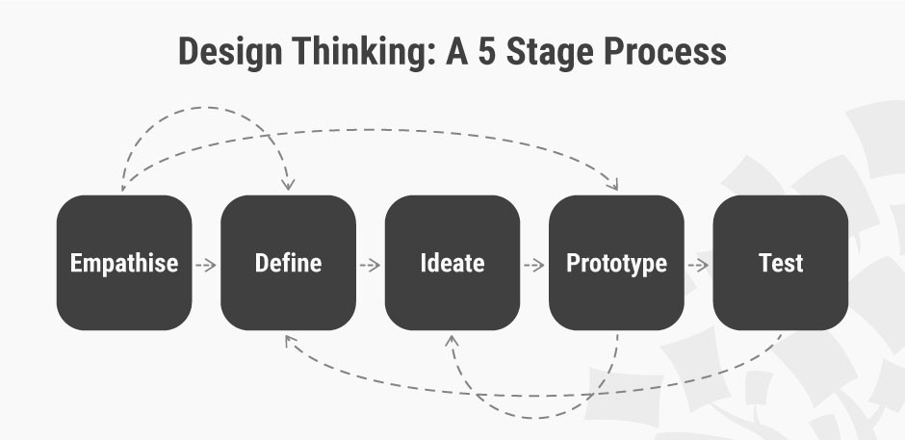

STEPS AND DESCRIPTION IN DESIGN THINKING

The first step to develop design thinking is to gain an empathic understanding of the problem we are trying to solve. Empathy is crucial to a human-centered design process such as Design Thinking and empathy allows design thinkers to set aside our own assumptions about the world in order to gain insight into users and their needs. In order to gain those information, we held an interview to ask the users regarding the problem that they encounter while using windows and IOS operating systems.

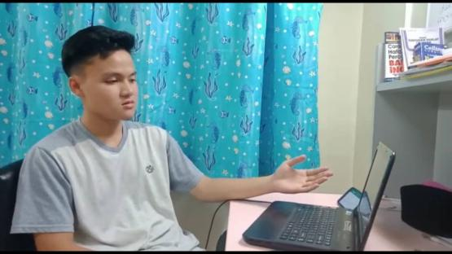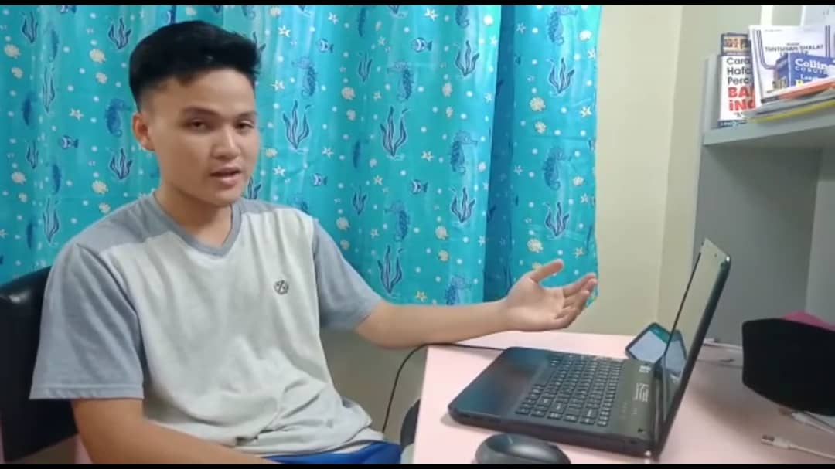
Attachment 1: Interview session Attachment 2: Interview session

Second step is to define where we gather all information that we gained from the interview session and from a few websites that are related to system software. After the discussion, we found out that for mac operating system, the battery drains quite fast. Also, for windows operating system, the junk files take up so much spaces in terms of storage and it makes the computer runs slower. Other than that, for android users, the problem is the quality of picture or video on Instagram is bad when the user directly capture or record using Instagram’s feature itself. Meanwhile for iPhone users, often after iPhone jailbreak or updating to a new version, the users tend to lose iPhone videos, photos, contacts, or chat messages, etc.

Third, we did brainstorm on great ideas to establish features, functions, and any other elements that will allow the user to solve the problems or at the very least, allow users to resolve issues themselves with the minimum of difficulty. The result of the discussion are as follow:

System software | Problems | Solutions
Mac operating system | The battery drains quite fast. | Auto detect which application that makes the battery to drain faster then ask permission whether to close it or not.
Windows operating system | The junk files take up so much spaces in terms of storage and it makes the computer runs slower. | To imply a system which delete all the cache files or application that is no longer used after permission is granted.
Android | The bad quality of picture or video on Instagram when the user directly capture or record using Instagram’s feature itself | Capture the picture or video before hand using android’s camera itself. Only then, the picture or video can maintain its quality when uploaded on Instagram.
iPhone | After iPhone jailbreak or updating to a new version, the users tend to lose iPhone videos, photos, contacts, or chat messages, etc. | Ensure to back up all data on iCloud or Google drive so that the data can be obtained again after updating the new version of operating system.
Table 1: The problems and solution regarding different types of operating systems
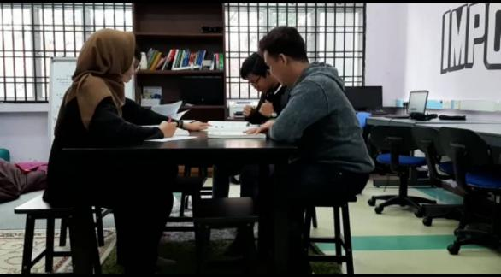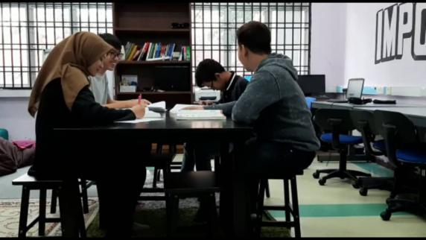
Attachment 3: Brainstorming session Attachment 4: Brainstorming session

Next is the process of prototype making. We used some used boxes to build 2 smart phones and 2 laptops representing windows and IOS. They are inexpensive, scaled down versions of the product or specific features found within the product. This way, we can investigate the solutions to the problem generated in the previous stages.
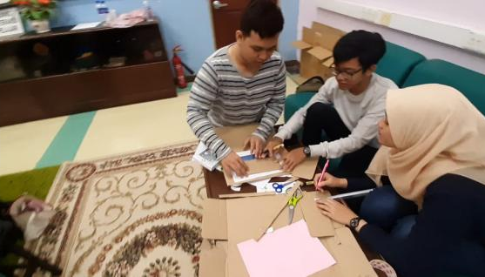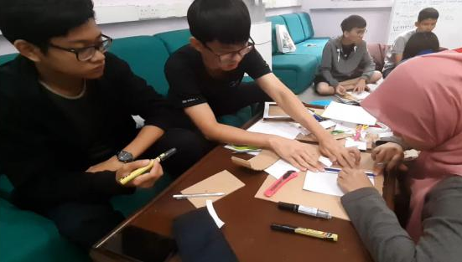
Attachment 5: Creating the prototype Attachment 6: Creating the prototype

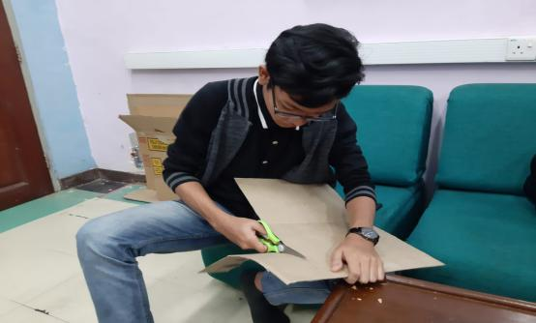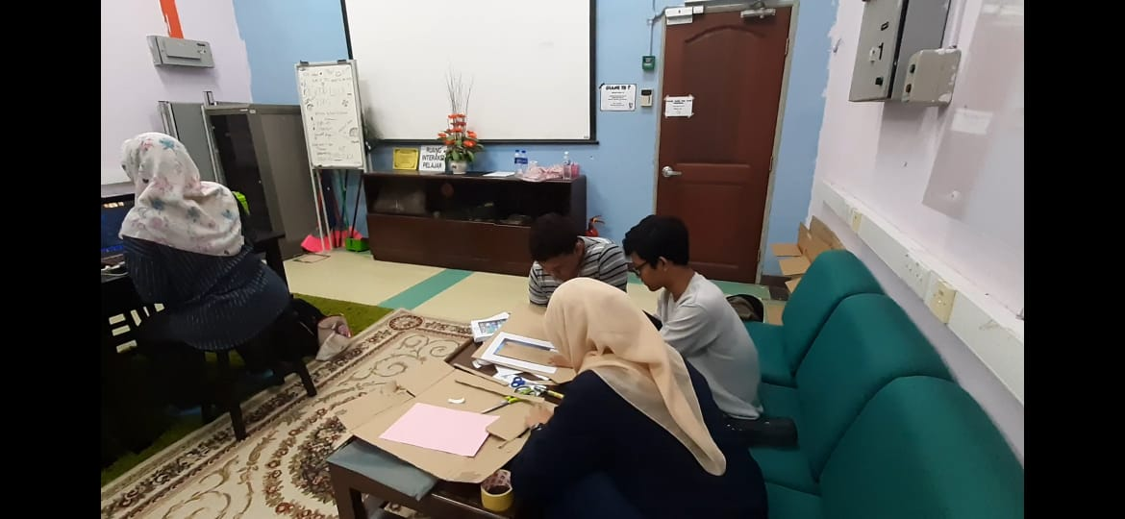
Attachment 7: Creating the prototype Attachment 8: Creating the prototype

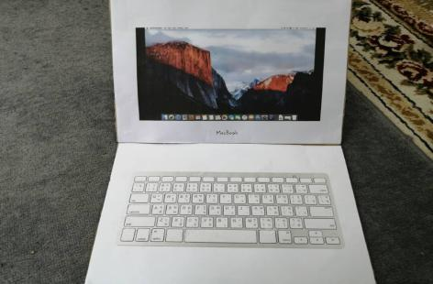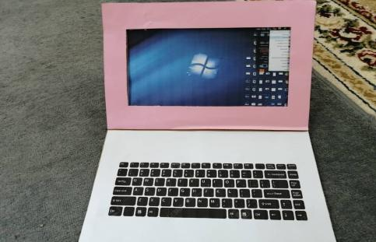
Attachment 9: IOS Macbook Attachment 10: Windows laptop

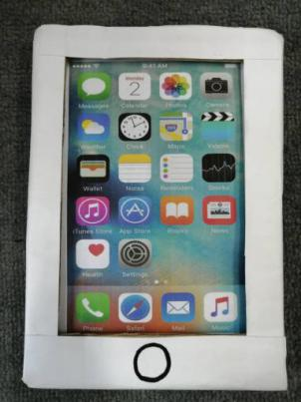
Attachment 11: IOS smart phone Attachment 12: Android smart phone

Last but not least, the prototypes are shared and tested within the team and other users. The solutions are implemented within the prototypes, and, one by one, they are investigated and either accepted, improved and re-examined, or rejected on the basis of the users’ experiences. By the end of this stage, we had a better idea of the constraints inherent to the product.
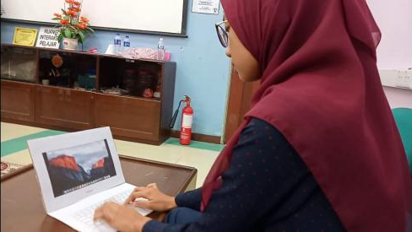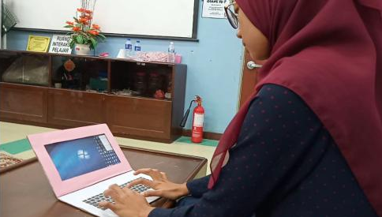
Attachment 13: Testing the prototype Attachment 14: Testing the prototype

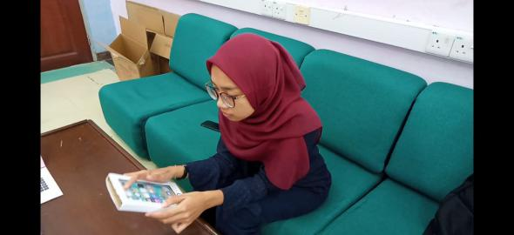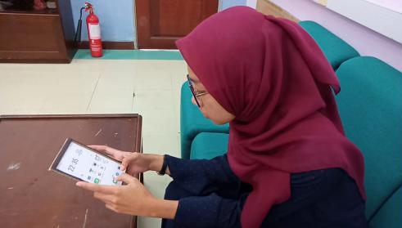
Attachment 15: Testing the prototype Attachment 16: Testing the prototype

DESIGN THINKING ASSESMENT POINTS

When a group of people is working in a team work, they are vulnerable to a psychological phenomenon called groupthink. Groupthink happens when the group members are desired for harmony in the group and result in dysfunctional decision-making outcome. In the case of design thinking, groupthink can cause a team to make irrational decision which does not align to the original problem statement.
Thus, in order to avoid this phenomenon in our group during Design Thinking process, allocation of assessment point is crucial. Assessment point can be conducted during the end of the project demonstration or the transition between design thinking phases. For us, assessment point was carried out constantly during the transition between design thinking phases. We always assess our idea so that it is a rational decision which aligns to the original problem statement. Questions like: “Is this idea possible to carry out in real life?”, “What is the purpose of this decision?”, “Is this the most effective solution to this problem?”, “Can we achieve our objectives and solve our problem statement with this decision?” are always considered in the process of design thinking so that our decision is always aligned to the original problem statement. Consequently, this helps us to prevent phenomenon groupthink happens in our group.
During ideate phase, assessment point was conducted to filter off the irrational ideas, so that our final idea is relevant to the problem statement, whereas during prototype phase, assessment point was carried out to check if the prototype functioned according to our idea or not. The prototype was then modified so that it can solve the problem statement effectively and for better user experience. Furthermore, at the end of the project, reflection was carried out to verify whether the original problem statement had been solved.
In conclusion, assessment point is essential in our design thinking project as it serves as a guideline for us to make sure we are on the right track.

DESIGN THINKING EVIDENCE

Before we launch a design, we need to consider what kind of problem our team is trying to solve and who we are designing for. After all the discussion, our final topic is “system software”.
In the first phrase, which is Empathy phase, we focused on the needs of the students by understanding their experiences through interviews and survey launched by internet. We asked question about the topic we had focused earlier. Below are some of the questions we asked and answers given by the users.
“May I know why do you use windows?”
User: it’s more flexible than any other OS, and also have the most hardware and software support.
“what problems do you encounter while using windows?”
User: i find junk files and it taking up so much spaces and making my pc so slow
Table: Dialogues from the interviews
During the second phase-Define phrase, we narrowed from all the information to a specific statement according to the needs of the users. We found out that for MacOS, the battery drains quite fast. Also, for Windows OS, the junk files take up so much spaces in terms of storage and it makes the computer runs slower. Other than that, for android users, the problem is the quality of picture or video on Instagram is bad when the user directly capture or record using Instagram’s feature itself. Meanwhile for iPhone users, often after iPhone jailbreak or updating to a new version, the users tend to lose iPhone videos, photos, contacts, or chat messages, etc.
Next, under the Ideate phrase, we focused on generating as many solutions as possible for the problem on. We hosted a brainstorming section during our discussion meet.
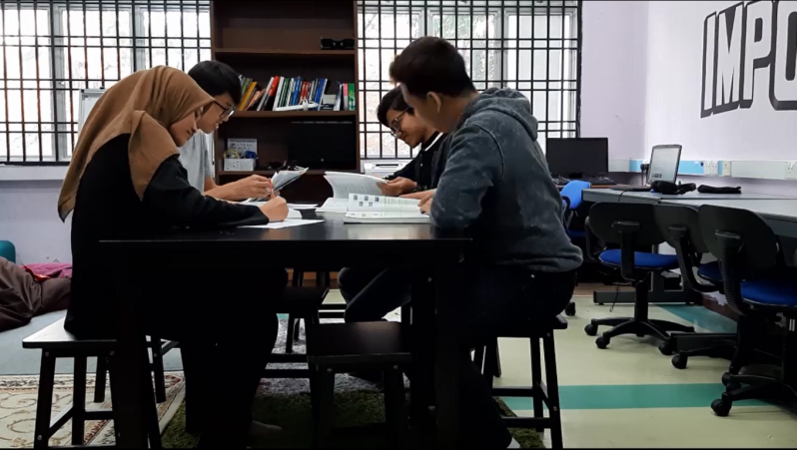
On the Prototype phase. We decided to create a smartphone and laptop prototype by using cardboards to simulate our ideas for the system software.
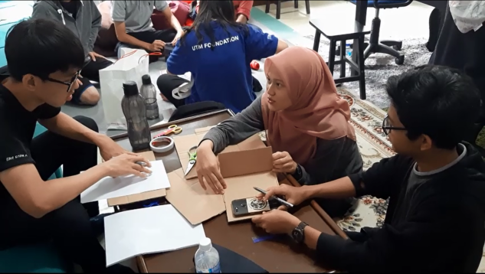

As for the Test phase, we tested our prototype.

REFLECTION
As students studying in the course of Computer Network and Security we all have a dream to make a better and safer network for everyone.

The world in this information age is highly dependent on the networking system especially the internet. Nowadays everyone do almost everything with Internet, from working, socializing with people, to even simple things like finding recipes for food. Unfortunately the internet isn’t always safe. Many threats like viruses and hackers appears on the internet and causes problems for internet users that have weak protection.

Our goal is to minimalize these threats and/or strengthen the protection for the internet users. As the rise of threats in the internet many company emerged to fight against these threats and protect the internet users from attacks like malware or viruses. We aim to be able to at least be at the same level as the people in those companies or better if possible the best, so we can help make the internet safer for everyone.
In order for us to obtain our goal we need to study very hard about computer network & security in UTM and get good grades as proof that we are capable on being the next protector of the internet. To be able to be the best in this field just studying won’t suffice, we need to gain experience from competition and such and also hands on experience from working or in one of the companies.
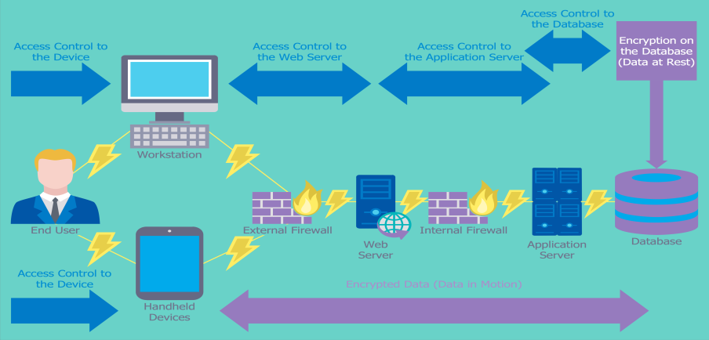
Design thinking is a new concept for us, it’s a new and revolutionary way of thinking for us. Design thinking helps us for solving problems effectively and efficiently because it really helps us locate the real problem and how to solve it. Design thinking helps us to view a problem differently, like who is affected by the problem, how the users are affected, and where the problem exist or come from. By knowing those things it’s easier for us to find a solution and solve the problem.
We believe design thinking will help us greatly in our line of work in the future. In our field of work there’s bound to exist problems from malware attack to someone hacking the internet. Most of the problems will affect large number of internet users and consumers. With the help of design thinking we will able to solve problems like this effectively and efficiently that will benefit the users and consumers.
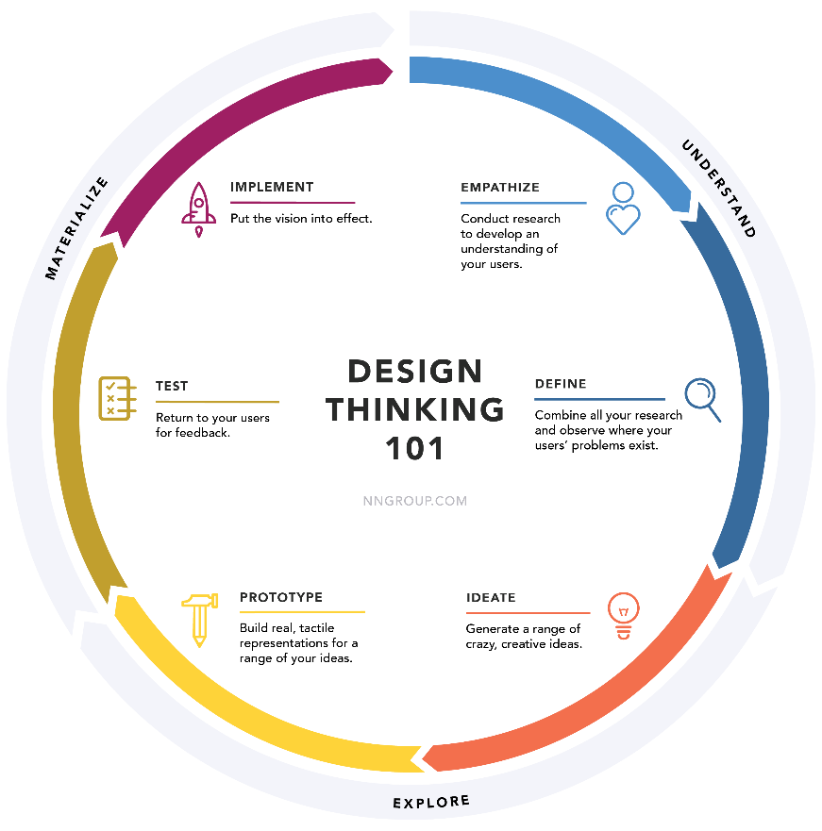
As stated in several paragraph above, for us to be able to improve ourselves we need to study very hard. In the world of computer network and security there’s so much to learn. First thing, we need to learn about programming like coding in C++ as basic and stepping up to Python or Java language next as these two is the most commonly used language in programming nowadays. Next, we also need to learn about computer networking itself and also how to make networking secure.
In our opinion only studying is not enough for us to improve to be one of the best. We think to become the best we also need hands on experience in computer networking and security. These hands on experience can be obtained from joining competition about computer network and security, or working in the field of network and security in forms of internship or projects. We can also get this hands on experience from seminars or special course and security which usually give practical lessons about computer networking which will definitely improve our knowledge and potential in this field.

Source
https://www.conceptdraw.com/How-To-Guide/picture/Computer-and-Networks-Network-Security-Diagrams-Access-Control-and-Encryption.png
https://st3.depositphotos.com/2885805/18938/v/1600/depositphotos_189386738-stock-illustration-cyber-security-infographics.jpg
https://www.reveantivirus.com/blog/wp-content/uploads/2017/03/computer-security-threats.jpg
https://miro.medium.com/max/6000/1*7qt8qxFMJM12R7IHl9z4Ww.png

Task for each member
Group members :
- CHUA KEK AN
- SYAHMINA FA'IZUN WAZIEN BINTI AMLAN
- MUHAMMAD KEVIN REZZA RAMADAN
- ABIEL PUTRA DIMYATI
All of us has given cooperation and contributes to this design thinking process. We are able to produce a video and report due to everyone’s effort and teamwork. Everyone in our group participates in this project actively and every meeting was attended by everyone.
- CHUA KEK AN
- Director of video
- Provide idea on how to do the prototype
- Provide idea on solution for the problem statement

- SYAHMINA FA'IZUN WAZIEN BINTI AMLAN
- Assistant Director
- Identify the problem statement
- Provide material to make prototype

- MUHAMMAD KEVIN REZZA RAMADAN
- Actor ( Interviewer )
- Video editor

- ABIEL PUTRA DIMYATI
- Videographer
- Assistant video editor

