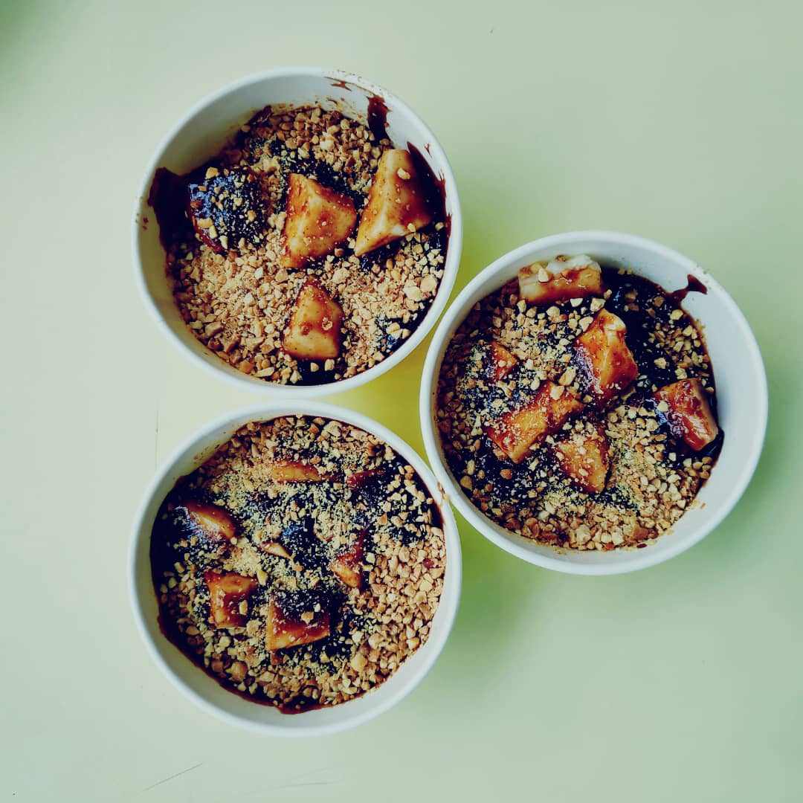
Rojak petis is a local salad of mixed vegetables, fruits, and dough fritters that is covered in a sticky black sauce and garnished with chopped peanuts and finely-cut fragrant ginger flowers for a piquant taste. The mark of a good rojak is its sauce, made up of fermented prawn paste, sugar, lime and chilli paste. And usually Malay people have Rojak Petis in dinner.

I am in group no 6 and I have tasted Rojak Petis from Aeon Food court. Traditionally It is served in banana leaf but its usually served in bowl or something like that and our one was also served in bowl. For me it taste good but if I comparing to Nasi Ambang and my favorite Roti canai these got better taste than Rojak Petis. As Rojak Petis is combination of peanuts, fruits I like it.

Procedure of making Rojak Petis
❖ We need to prepare ingredients like Petis (2 tablespoons), Sand Sugar (1½-2 tablespoons), Melaka Sugar or Black Sugar (1 tbsp), chilli powder according to their respective flavors, a little bit of baking soda, a little bit of acidic water. concentrate and salt if necessary.
❖ Take a slice of wood and all the fruit ingredients like pineapple, mango, cucumber, gourd and so on.
❖ Next is we need to put the ingredients, the chilli powder, the sugar, the black sugar in a suitable container and stir until the sugar is dissolved. Once the sugar has dissolved, add the acidic water to the appropriate amount and stir until smooth.
❖ Next the main ingredients are fruits, tempeh, tofu and vegetables and spices then stir until smooth and flat. We need to add some peas that have been crushed and they need to be mixed again.

Thank You
Maidul Hasan Masum A19EC4011

