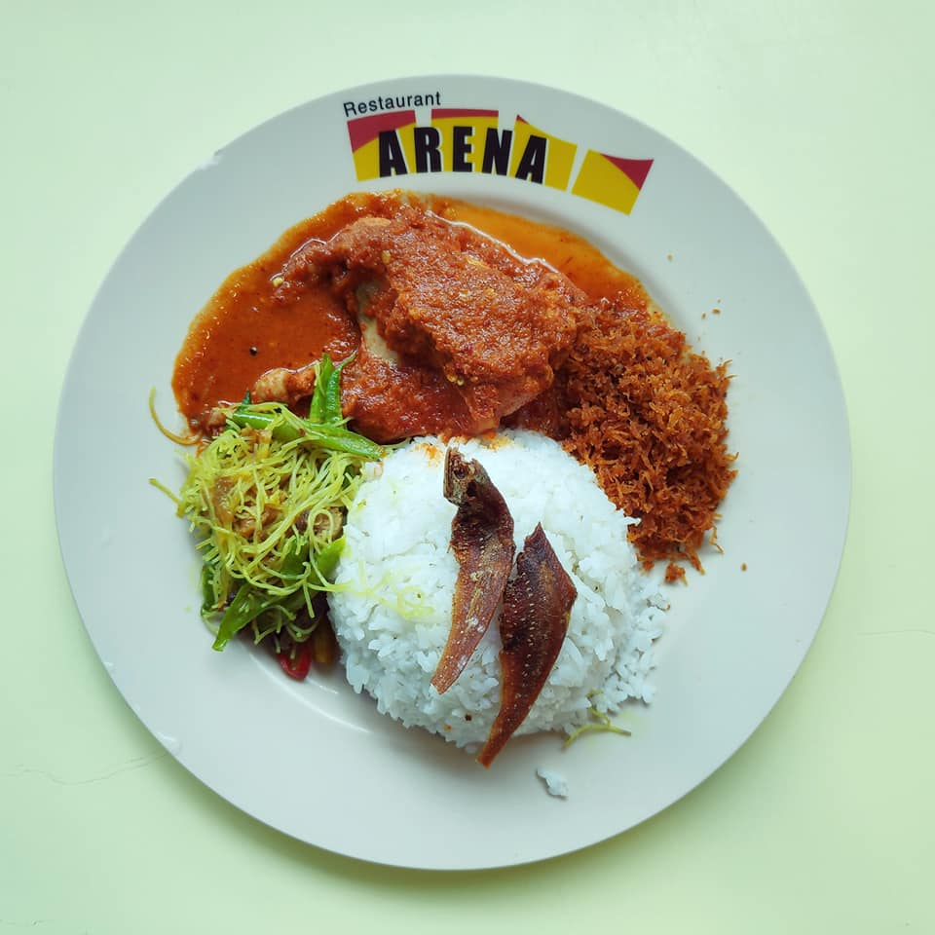
Nasi ambang is a fragrant rice dish that consists steamed white rice, chicken curry or chicken curry or soy sauce based, fried coconut flesh, salted fish, vegetables and lots more. It is a popular Javanese cuisine, especially within the Javanese communities of Malaysia, Malaysian states of Selangor and Johor moreover in Singapore as well as in Java, Indonesia. Usually they enjoy Nasi Ambang on festival times like kendur. Otherwise maximum cases Nasi Ambang served in Breakfast but some people took it on lunch and also in dinner also.
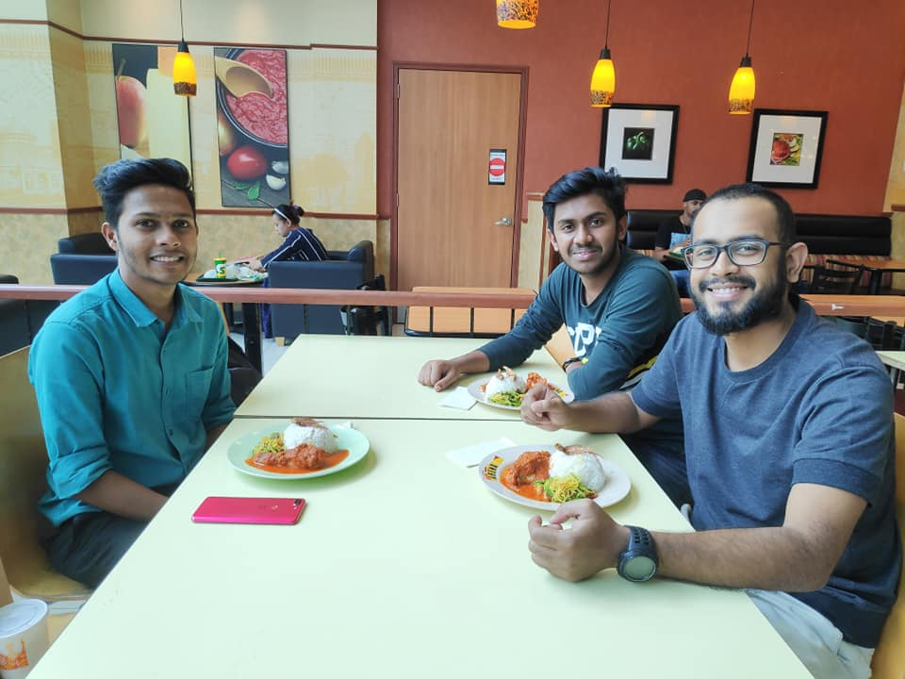

I am in group no 6 and I have tasted Nasi Ambang from Aeon Food court. It is served in communal dining style on a platter like Rice in middle salted fiah on top of it and chicken, vegetables, coconut flesh, vegetables and others surrounding rice. We Bangladeshi people are quite familiar with rice, chicken and vegetables and a lot people from Bangladesh likes salted fish so it was little similar with our cuisine and when it is about rice and chicken then it is always nice to me.

So in conclusion I would love to say Nasi Ambang is not totally new for as I have tasted pretty similar food and I am in love with it because I love to take chicken and rice maximum time and it was with vegetables and fish, it means all in one. Most importantly Nasi Ambang is very nutritious food in one serving plate it got almost 330 calories that’s just amazing so its also maintain our good health besides taste and tradition.

Thank You
Maidul Hasan Masum A19EC4011

