Roti canai can be among the most popular breakfast dishes. Roti canai refers to roti parotta or roti cane also. It is very popular in South Asian countries. In South Asia what we call parota in Malaysia we call it roti canai, in Indonesia we call it roti cane or sometimes roti konde on the other hand in Singapore people call it roti prata. It is called that roti canai mainly South Asian food and Indian Tamil race people brought this roti in this southeast part of Asia, also said that Indian Muslim people brought it here. That is why it is called Malaysian Indian cuisine. Now roti canai becomes very popular here. Maximum Malay people love to take roti canai as a breakfast. I have checked it a lot of times. They have own cultural way to serve roti canai. They offer their typical different types of daal and sambal with it. A lot of people love to have roti canai with tea.

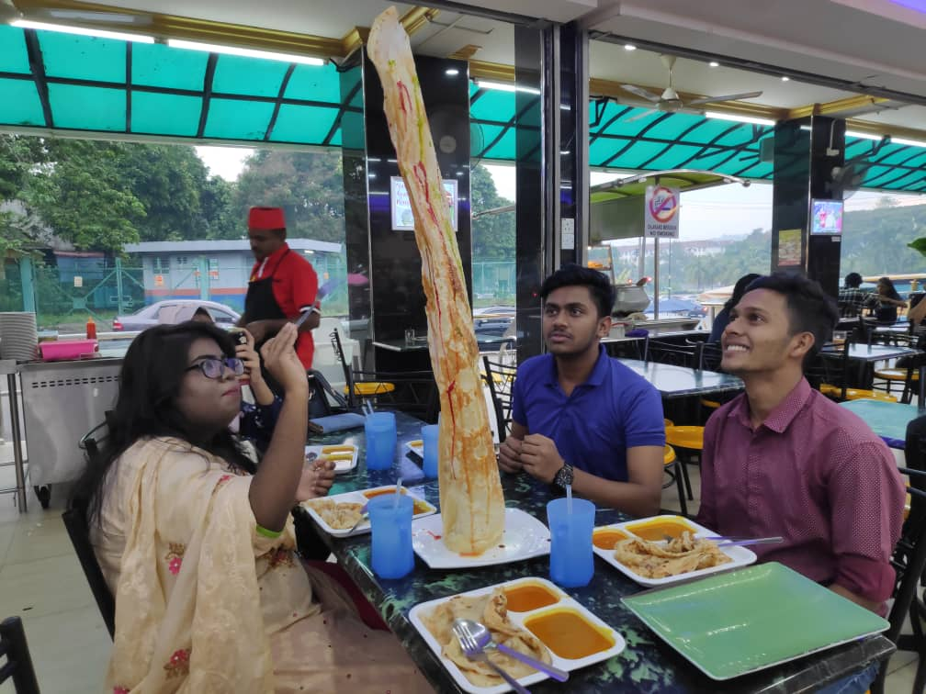

I am in group no 06 and I have tasted Roti Canai in Siri Mutiyara restaurant outside of Kolej Dato Onn Jaafar. It was served with traditional Malaysian daal and soup curry. I just love Roti Canai for breakfast parota is my all-time favorite. And Roti canai is almost same and almost Bangladeshi loves daal so it is roti canai is my favorite dish for break fast here I have tasted it a lot time after I am here in Malaysia.

Roti canai made from dough. This dough is composed of flour, water, salt, and fat. Sometimes people use extra milk for extra taste. And It is very easy to make roti canai. For making roti canai we can follow this procedure
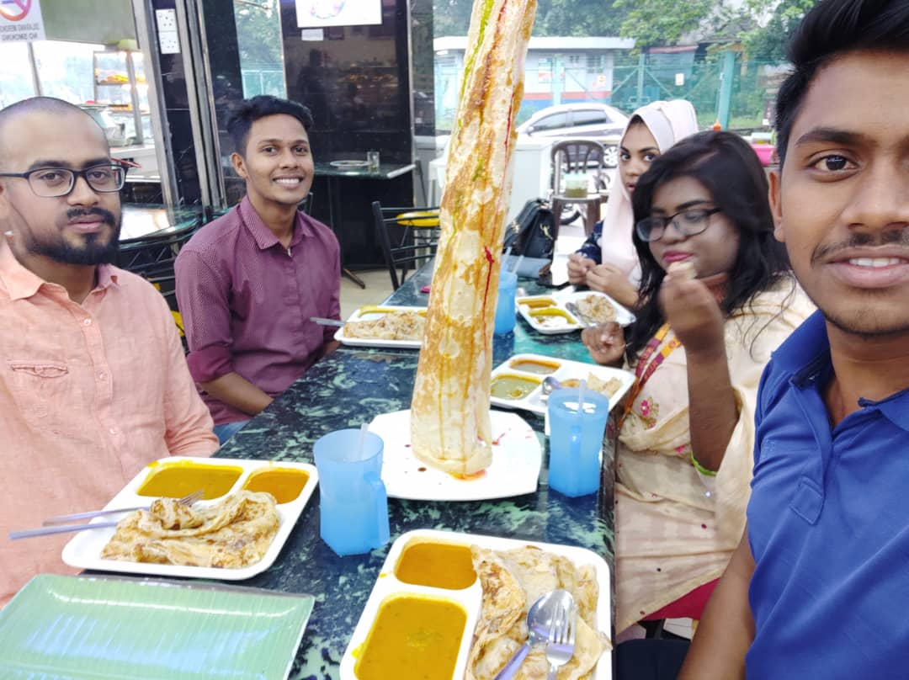
INGREDIANTS: 2 cups of wheat flour, half a teaspoon of salt, one cup of boiling water, 3 cups of oil.

COOKING METHOD:
1. Mix the flour well with salt and water. Make a dough with salt and water in a bowl and mix it well.
2. keep it mixing until the dough is not sticky. Then keep it in rest for 20 minutes.
3. Divide the dough into small pieces, make it like half of the shape of tennis balls.
4. give oil in the dough and need to make sure it is well mixed and leave it for until oil is soaked.
5. After the oil is soaked take a piece of dough and spread the flour.
6. Start spreading the flour into a larger circle. Pull the flour slowly. Be patient, try to do it smoothly.
7. After spreading in large shape, fold it in four directions.
8. Now just fry it in a pan and after frying, it is done.

Now we can enjoy it with daal, sambal or tea or condense milk if we want then with honey or like that.

The most interesting part is we can make it to lot more varieties by adding some more things like,

- We can make roti telur by adding Egg in roti canai.
- Roti jantan is roti telur with extra Egg.
- It will be roti telur bawang when we will add Egg and Onions in it.
- Roti boom is a smaller but thicker roti, with the dough wound in a spiral.
- Roti tisu, a tissue paper-thin, and flaky roti, usually with sprinkled sugar and condensed milk. This usually gets a Triangle, we can say it looks like mathematical conics.
- Another very popular dish is murtabak. It is a mixture of Meat, Egg, Onion and some other species. It can be chicken murtabak, beef murtabak depends on the meat we are giving with it.

These are the most popular transformation of roti canai. Without these, It can be updated into lot more different types of roti like roti sardine, roti planta, roti pisang, roti sayur, roti kaya, roti salad, roti tampal or plaster, roti maggi, roti cheese, roti milo, roti kobra, roti tsunami and so on. Roti banjir another popular form of roti canai, if we cut roti canai into several pieces and put curry on top of it, it becomes roti banjir.

Malaysia is a country of heritage and roti canai is one of them. It is also common to form me as I am from the south part of Asia, I mean from Bangladesh. We usually take almost these kinds of roti, what we call parata, moreover our taste is the same and same as Malaysia we also serve roti with daal sometime with meat. Maximum Bangladeshi people take roti parata as their breakfast. So we can say Malaysia and our Bangladesh have a good number of similarities.

