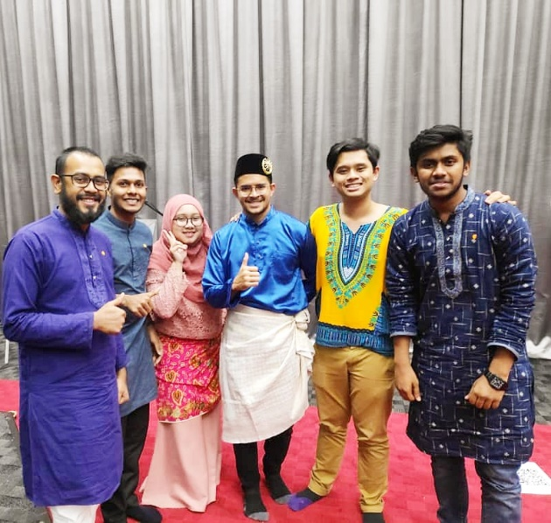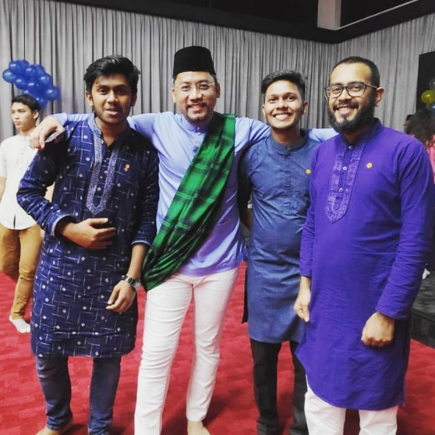
Assalamu Alaikum. This is Maidul Hasan Masum. I am in the group no 6. Our Traditional Attire was Panjabi. Well, this is Indian Malay attire. In the ancient Panjabi region, people wore cotton clothing. The tops for both genders reached to the knees. A scarf was worn over the tops which would be draped over the left shoulder and under the right. A large sheet would be further draped over one shoulder which would hang loosely towards the knees. Both sexes wore a dhoti around the waist. Modern Punjabi dress has retained this outfit but over its long history has added other forms of dress.
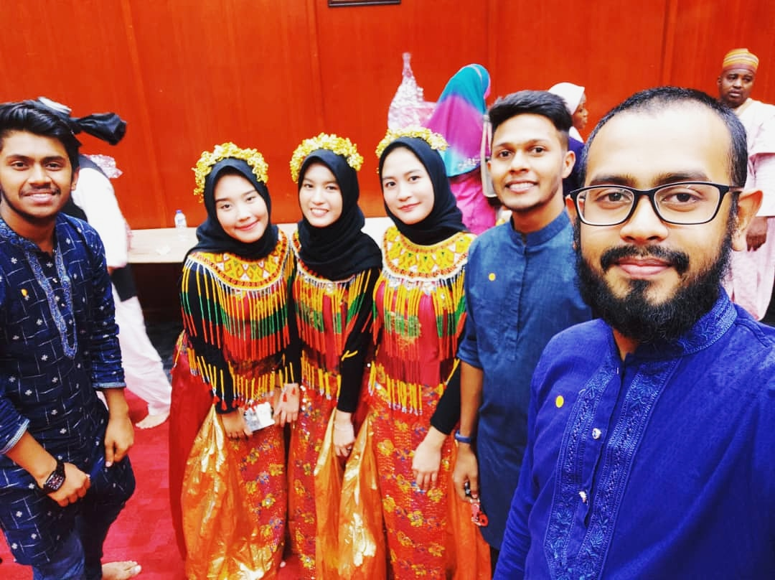

Nowadays Indian Malay people mostly wear Panjabi in festivals. Muslim people wear Panjabi on Eid festivals moreover In south Asia people used to wear Panjabi for saying the prayer. Well, Panjabi is the male outlook for the female they used to wear "sari" or "salwar kameez" with the "Panjabi guy". In South Asia, it is a very popular dress, especially in Muslim countries. As I am from Bangladesh we are used to with it and the Panjabi I have taken a picture with that’s mine. And as our topic, we boys of our team had to wear Panjabi and this picture was taken in Cultural Corner 2.0 program.

