UTM SEVEN GRADUATE ATTRIBUTES AND GENERIC SKILLS, AND HOW IT COULD AFFECT ON YOUR STUDY AND YOUR CAREER.

Content:
- Introduction
- UTM seven (7) Graduate Attributes *Design
- How they can affect on our study and our career
- conclusion

- Introduction:
Getting the certificate and complete the study in the college is not enough for your future career they are some skills that are important to qualified you to find a job.
With global change in the world economy, the companies these days are not looking for just your certificate or how much you got in your CGPA , they look at your life skills , your leadership skills , your communications skills , your teamworking skills and the list is not finished .
The universities around the world have started noticing this issues , and they have started focusing on how to develop the students life skills so that the chance of getting a job increase.

So what is the meaning of GENERIC SKILLS??
generic skills are the general skills, knowledge , abilities and traits that a person should possess to succeed in his or her study and career.

2.UTM seven (7) Graduate Attributes:
So therefore UTM has seven main GENERIC SKILLS which they are :

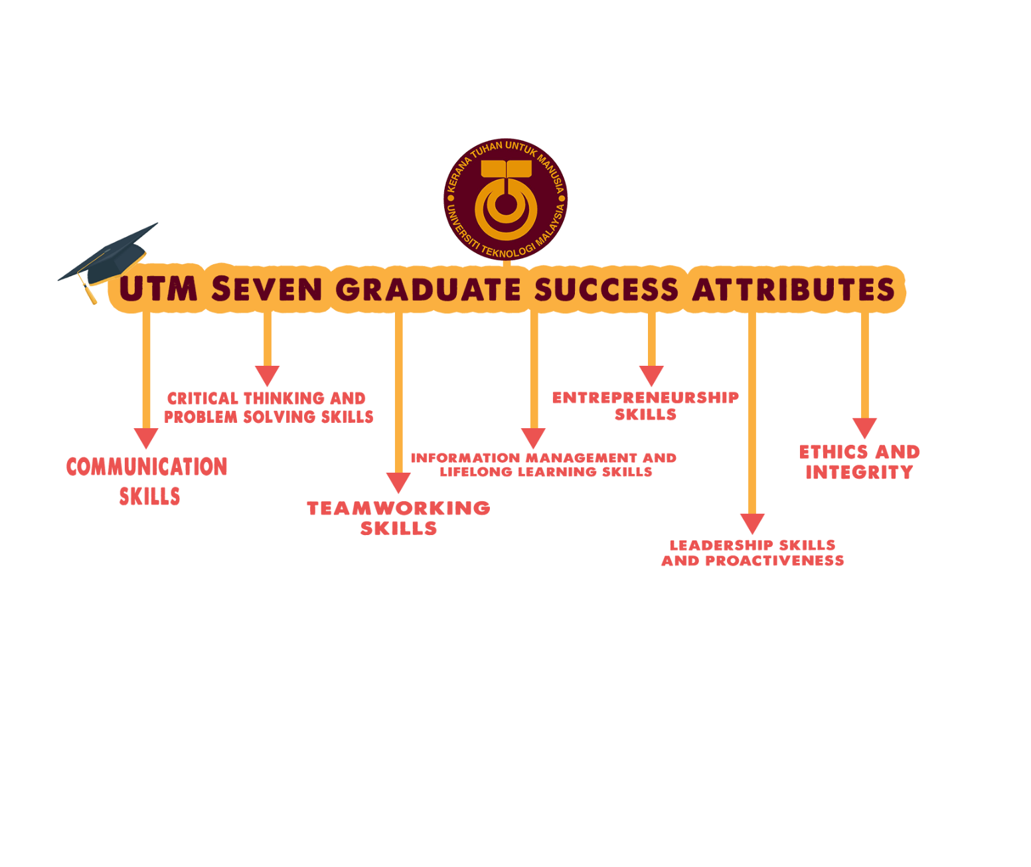

3.How they can affect on our study and our career??

No doubt that GENERIC SKILLS have a huge effect on our life beginning from our study ending to our careers .
The a skills can make a great benefit to daily life , a good person with good communication skill can have more relationships and can make the people make a positive impression about him at the first time they meet him . and for a student who can have a lot of friends in the college this will affect on his study especially if he need someone to explain to him or if he had a presentation or if he has a study group.
Communication skills can help the person the deliver his idea more clearly than someone who is shay all the time .
The team leader must have a strong background about Communication skills ,because he is the one how control the team and direct them to what to do. If he can’t make the missions clearly who could the team members understand the mission!?!?
Problem solving make the impossible possible . every organization has their own problems and the employees must have the ability to solve these problem .
It make the company more productivity and it decrease the money the usually cost the company to solve these problem.
Been able to solve the problems is one of the important skills that everyone should have, the ability to create a solution for a problem especially for software students. Since the students always work on problem solving if they have a strong background on problem solving and how to analyze could make him more successful in his field also in his career.

Humans are social creatures and teamworking was one of the qualities that is a part of any human , we love to work together and do thing together.
in work , companies and organizations are made of communities of groups like beehive , and teamworking is the most traits that be seen .
Doing things in groups can make the things easier and can reduce the effort and time they take, also can make the person learn new things form his partners.
In the college it’s difficult to handle everything alone and will increase the pressure on the student.

The experiences don’t come in one time ,it’s with time.
Lifelong learning is a process that will never because every day we learn new things.
Learning new things will increase your knowledge ,will change you thoughts about much things in this life . it will help during your study journey, in your job, in your social life.

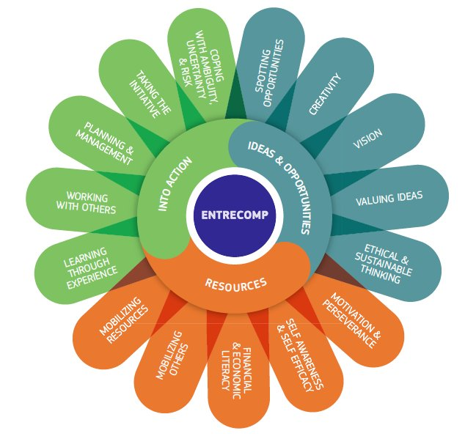

If you are afraid form taking decisions you will not learn new stuffs in your life .
Entrepreneurship involves a considerable amount of risk.
Entrepreneurship skills will help to start your own business ,not to work for others and take the risks and face problems and solve them.
And One of the biggest and most significant benefits of entrepreneurship is that it helps in the identification and development of managerial talent.

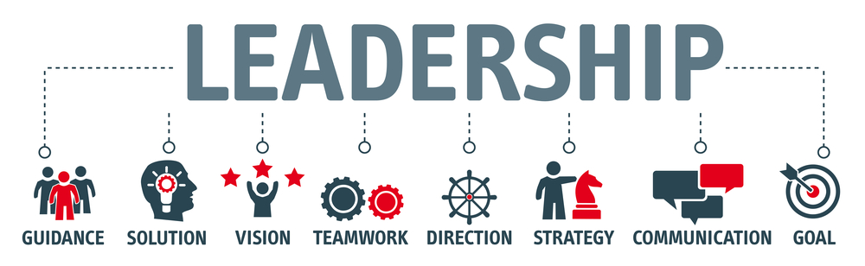

The leadership skills have a lot benefit on your life that we can’t count them .but these few thing how can it affect on your life
- Increased emotional intelligence
- Growth in confidence in your team
- Improved listening and communication skills

Your ethics is also important in daily life in college in your work.
You ethics is is a mirror for your real personality how do you treat people , how you treat your friends. All these are important if you want to success in your life .
As I mentioned before all is about your relationships and your friends and the people around you, imagine you they will trust you if you steal them our speak on them in front other when they are not there . how they can trust you ,help ,believe in you .?!?!

4. Conclusion

To be successful in you life they are rules to follow ,
Rules of success, succession is not easy to get you have to work hardly to achieve it . and the all successes come with support of people, our friends our team.
And GENERIC SKILLS are just simple rules for succession they are other rule and the list doesn’t stop here.

Hamzeh Wahed Bajbouj
A19EC4009

