

UNIVERSITI TEKNOLOGI MALAYSIA
SCHOOL OF COMPUTING
FACULTY OF ENGINEERING

Group Members | NALINI A/P VIJAYAN | A19EC0112
 | LOH YEW CHONG | A19EC0076
Tittle | PHOTOCOPYING(XEROX ) MACHINE PROJECT (LAB 4 MINI PROJECT ) REPORT
Name of Lecturer | Dr RASHIDAH BINTI KADIR
Subject | SECR1013-02 LOGIK DIGITAL (DIGITAL LOGIC)
Section | 02
Semester | 1 2019/2020

Dedication and Acknowledgement
Dedication
We would like to thank to Jayaneysanraj and his group member, Herthik for helping us when we faced problem in both part III and part IV . Besides that , we also would like to thank Chua Chen Wei , Lee Sze Yuan and also Tee Hui whom lend us a hand when we were having little troubles with our part IV.

Acknowledgment
Our hearty thank you and gratitude to the lecturer for teaching us on how to do this practical lab and taught us what need to prepare for our practical lab. We also would like to thank the lecturer and technicians that guided us along the practical lab test. They gave us helping hands along some thoughtful advice. They also taught us some extra knowledge. They showed us how to identify the blunders that we made which caused us not getting the results we’re supposed too.Thankfully,we got the correct results in the end after correcting our mistakes.

Table of Contents
Bil | Contents | Pages
1. | Dedication & Acknowledgement | 2
2. | Report Content | 4
2. | Background | 4
2. | Problem | 4
2. | Objectives | 4
2. | Flowchart | 4
2. | Components | 5
2. | Materials and Software’s Used | 5
2. | Circuit Implementation | 6-7
2. | Physical System Implementation | 7
2. | Discussion | 7
2. | Conclusion | 7-8
2. | Reference | 8
2. | Appendix | 8-11

Report Contents

Background
We implemented five different components which is 2-bit Count Up Counter, 3-bit Count Up Counter ,2-bit Comparator , 3-bit Comparator and Clock Disabler on a single DAL device in N28-328-02 Digital Teaching Lab DTL.

Problem
User will initially enter amount of copies, the counter will count the number of copies that has been photocopied. The machine will stop once the required number of copies produced.

Objectives
The objectives of this laboratory are to introduce the students to the development of a PLD device and a simple Hardware Description Language.

Flowchart
Download and install WinCUPL on laptop using the installer on e-learning.

Code for 3-bit comparator and saved it in JDEC format
Code for the 2-bit comparator, save it in JDEC format and transfer it into pendrive.

Open software > place ic on reader > Select > search “ATMEL” and “ATF22V10CQ/CQZ”
> choose PLD > Load > choose JDEC file
>Read>Edit>Erase >Read>Blank>Edit>Program

No
Whether both 2-bit xerox system been approved ?

Yes
Build our circuit with the integrated circuit that already program just now.
Done

Ask lecture or technician to check and approve our xerox system

Components
1.Switches : used to set the required number of copies.
2.Counter : used to count the number of copies that has been made.
3.Comparator : used to compare the number of copies required with the number of copies produced.
4.Clock disabler : used to stop the operation of the counter.

Materials and Software’s Used
- Breadboard
A breadboard is a solderless device for temporary prototype with electronics and test circuit designs.We just need to connect the electronic components with a wire and without having to solder it using soldering guns and leads.
- GAL 22V10
Its a programmable integrated circuits with 24 pins. It consist of a series of programmable-logic devices. It is implemented as CMOS-based generic array logic integrated circuits.
- ETS-5000 Digital Training Kit
It is designed for the beginners to enhance the comprehension of advance digital theory. The solderless breadboard on it can be easily put into and taken off. It has stabilized DC power supply with short circuit protection to it . It consist of pulse generator , pulse switches, 8 switches , 8 LEDs , 2 seven-segment displays with binary code input,TTL/CMOS logic switch,digital probe and detachable breadboard
- Wellon Universal Programmer & Test
It was used to program or burn codes into a programmable integrated circuits or Programmable Logic Device(PLD).
- WinCupl 5.30.4 Software
It is a software to write codes that need to instruct a integrated circuits to function according to our own desire.

Circuit Implementation
Clock
5VV
Output
1

SWITCH

Q1
LED
Input
Q0
A0
Output
A1
GAL22V10
L
B0
H
B1
Output
Input

Input
GND
Vcc
CLK
Figure above is the labelling of our 2-bit comparator. Pin numbering is started from the left side of the notch in the direction of anticlockwise and the last pin located at the right of the notch.We connected the pulser to the clock or pin 1.Q0 and Q1 are connected to the binary code input while B0 and B2 are connected to another binary code input .L and H connected to LED.We can change the input value A0 and A1 to set how much we want to print out. When we switched on the print switch , we pressed the pulser to count up the value.
5V
pulser
Q2
reset
Q1
preset
A111
A0
Q0
A2

Output
LED
GAL22V100
B0
SWITCH
L
B1
H
Output
GND
B2
Input
Input

Figure above is the labelling for our 3-bit comparator. We can control the value we want by adjusting the A0,A1 and A2 pin.The Q0,Q1,Q2 connected to one of the binary code input and B0,B1and B2 connected to another . L and H connected to the LED.
Physical System Implementation
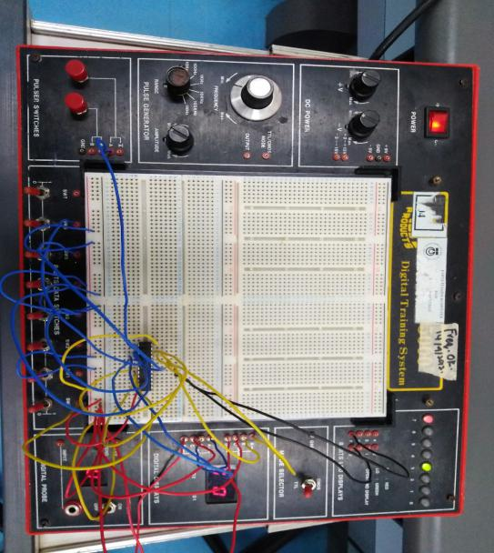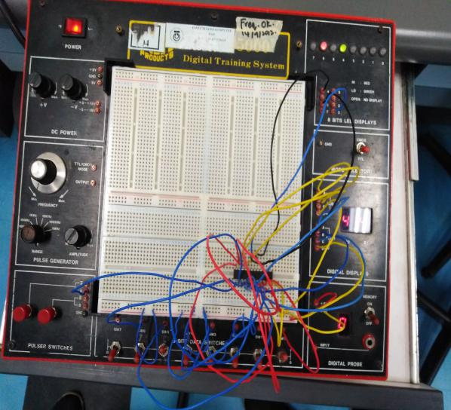
2-bit circuit 3-bit circuit
We took the ETS5000 prepared for us and chipped in the programmed WinCUPL into the breadboard and did the test for the 2 -bits up counter.When we adjust the switch, the digital display will show the value we want.We press the pulser to count up to that value. Then ,we switch preset and try another value. After the test , the WinCUPL was reprogrammed for 3-bits up counter and chipped into the breadboard. Some modifications done from the previous 2-bits up counter to make it as 3-bits up counter and it was functioning and popped out the result that we were expecting.
Discussion
Our project was a success. Thankfully we managed to make it on time.Our strength is that we connected the circuit correctly without correcting it. During the lab section we couldn’t obtain the expected result.Then we managed to recognize that we programmed wrongly due to the different results we obtained.We reprogrammed and get the result it we wanted. For improvement , we both should know which is the correct file to be programmed. Besides that , we have to be reconfirm the file to be load to program.

Conclusion
In this mini project, we learned to program a programmable logic device. Besides that , we did improve some soft skills such as teamwork and communication skills . When we discuss in the mini project about the project , we become more understand about what we are doing and how the things work . Digital logic subject is very important for our future learning and advancement as a Computer Science student. This is because it is a fundamental of a computer science. Digital logic introduce us to digital electronics which is the foundation of all microprocessor-based systems found in computers,robots, automobiles, and industrial control systems. With the fundamental knowledge , then we can have better progress in the future and used the basic knowledge to do something extraordinary or high in advance.
References
- Abd.Bahrim Yusoff, Mazleena Salleh, Mohd Fo’ad Rohani, Ismail Fauz Isnin (2018)Digital Logic fifth edition, johor bahru,johor:DESKTOP PUBLISHER
Appendix
Program source codes for 2-bit XEROX system :
Name Xerox Machine 2bit ;
PartNo 00 ;
Date 17/12/2017 ;
Revision 01 ;
Designer Engineer ;
Company UTM ;
Assembly None ;
Location ;
Device G22V10 ;

/* *************** INPUT PINS *********************/
PIN 1 = clk ; /* clock */
PIN 2 = reset ; /* reset */
PIN 3 = preset ; /* preset */
PIN 4 = a0 ; /* Comparator A */
PIN 5 = a1 ; /* */
PIN 7 = b0 ; /* Comparator B */
PIN 8 = b1 ; /* */
PIN 10 = startPrt ; /* Start Printing */

/* *************** OUTPUT PINS *********************/
PIN 17 = diffCmp ; /* XOR (A B not equal HIGH) */
PIN 18 = sameCmp ; /* XNOR (A B equal HIGH) */
PIN 21 = q0 ; /* output counter */
PIN 22 = q1 ; /* output counter */

/***** Function Comparator************************/
sameCmp = !(a0$b0)&!(a1$b1);
diffCmp = !sameCmp ;

/**** Function Clock Enabler *********************/
clkEn=startPrt & diffCmp;

/*** Function Counter 2 Bit UP *******************/
field count =[q1..0];
$define s0 'b' 00
$define s1 'b' 01
$define s2 'b' 10
$define s3 'b' 11

count.ar=reset; /* connect reg AR to reset (Asyn Mode) */
count.sp=preset; /* connect reg AR to preset (Syn Mode) */

sequence count{
present s0 if clkEn next s1;
default next s0;
present s1 if clkEn next s2;
default next s1;
present s2 if clkEn next s3;
default next s2;
present s3 if clkEn next s3;
default next s3;
}
Program source codes for 3-bit XEROX system
Name Xerox Machine 3bit ;
PartNo 00 ;
Date 17/12/2019 ;
Revision 01 ;
Designer Engineer ;
Company UTM ;
Assembly None ;
Location ;
Device G22V10 ;
/* *************** INPUT PINS *********************/
PIN 1 = clk ; /* clock */
PIN 2 = reset ; /* reset */
PIN 3 = preset ; /* preset */
PIN 4 = a0 ; /* Comparator A */
PIN 5 = a1 ; /* */
PIN 6 = a2 ; /* */
PIN 7 = b0 ; /* Comparator B */
PIN 8 = b1 ; /* */
PIN 9 = b2 ;
PIN 10 = startPrt ; /* Start Printing */
/* *************** OUTPUT PINS *********************/
PIN 17 = diffCmp ; /* XOR (A B not equal HIGH) */
PIN 18 = sameCmp ; /* XNOR (A B equal HIGH) */
PIN 21 = q0 ; /* output counter */
PIN 22 = q1 ; /* output counter */
PIN 23 = q2 ;
/***** Function Comparator************************/
sameCmp = !(a0$b0)&!(a1$b1)&!(a2$b2);
diffCmp = !sameCmp ;
/**** Function Clock Enabler *********************/
clkEn=startPrt & diffCmp;
/*** Function Counter 2 Bit UP *******************/
field count =[q2..0];
$define s0 'b' 000
$define s1 'b' 001
$define s2 'b' 010
$define s3 'b' 011
$define s4 'b' 100
$define s5 'b' 101
$define s6 'b' 110
$define s7 'b' 111
count.ar=reset; /* connect reg AR to reset (Asyn Mode) */
count.sp=preset; /* connect reg AR to preset (Syn Mode) */
sequence count {
present s0 if clkEn next s1;
default next s0;
present s1 if clkEn next s2;
default next s1;
present s2 if clkEn next s3;
default next s2;
present s3 if clkEn next s4;
default next s3;
present s4 if clkEn next s5;
default next s4;
present s5 if clkEn next s6;
default next s5;
present s6 if clkEn next s7;
default next s6;
present s7 if clkEn next s7;
default next s7;
}

