
SEMESTER 1
SESSION 2019/2020

DIGITAL LOGIC
SECR 1013

LAB 4 : MINI PROJECT REPORT

NAME | MATRICS NUMBER
MIRZA SABRINA BINTI MOHD SALMI | A19EC0086
NURUL ALIS ALIA BINTI MOHAMAD ZAMRI | A19EC0141

LECTURER’S NAME: DR. RASHIDAH BINTI KADIR

SUBMISSION DATE: 1 JANUARY 2020

Dedication and Acknowledgement

First of all, we would like to express our special thanks of gratitude to our lecturer Dr. Rashidah binti Kadir for her guidance and support for this project. We would also like to dedicate this project to her. She provided us with a lot of useful knowledge on how to use the components and software so that we were able to complete this project on time.

Next, we would like to extend our sincere to gratitude towards the technicians who helped us so much in the lab. Their help, guidance and expertise allowed us to complete this project without encountering any problem.

We would also like to thank our classmate for sharing their knowledge and ideas with us to make this project easier to do.

Lastly, we would like to express our gratitude to School of Computing, UTM for providing us the materials, components and software for this project.

Table of Contents
Dedication and Acknowledgement i
Table of Contents ii
Table of Figures ii
1.0 Background 1
2.0 Problem 1
3.0 Objectives 1
4.0 Flowchart 1
5.0 Components 1
6.0 Materials and Software Used 2
7.0 Circuit Implementation 2
8.0 Physical System Implementation 4
9.0 Discussion 5
10.0 Conclusion 6
11.0 References 6
Appendix 7

Table of Figures
Figure 1: Block drawing of the pin number of 3-bit Xerox Machine. 2
Figure 2 : Block drawing of the pin number of 2-bit Xerox Machine. 2
Figure 4: 2-bit Xerox System. 4
Figure 3: 3-bit Xerox System. 4

Background
This mini project will implement 3 different components on a single GAL device, those components are 2-bit/3-bit Count Up Counter, 2-bit/3-bit Comparator and Clock Disabler.

Problem
User will initially enter amount of copies, the counter will count the number of copies that has been photocopied. The machine will stop once the required number of copies produced.

Objectives
The objectives of this mini project are to introduce us to the development of a PLD device and simple Hardware Description Language.

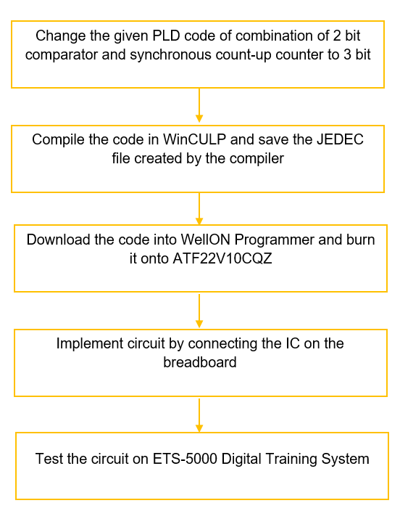
Flowchart

Components
The components used in this project are listed below.
- Switches : Switches are used to set the required number of copies in binary.
- 2-bit/3-bit count up Counter : Counter are used to count the number of copies that has been made.
- 2-bit/3-bit Comparator : Comparator are used to compare the number of copies required with the number of copies produced.
- Clock Disabler : Clock Disabler are used to stop the operation of counter.

Materials and Software Used
Materials used are breadboard, GAL 22V10 and ETS-5000 Digital Training Kit. Softwares that we used are Wellon Universal Programmer & Tester and WinCUPL 5.0 Software. The WinCUPL 5.0 Software was used to generate code that can be burn into the GAL22V10 using Wellon Universal Programmer & Tester. The Wellon Universal Programmer & Tester was used to burn or erase code in the GAL22V10.
We also refer to the handouts below:
- “WinCUPL user manual”
- “GAL22V10 Data Sheet”
- “How to use Wellon Programmer”
- “How to use WinCUPL5”

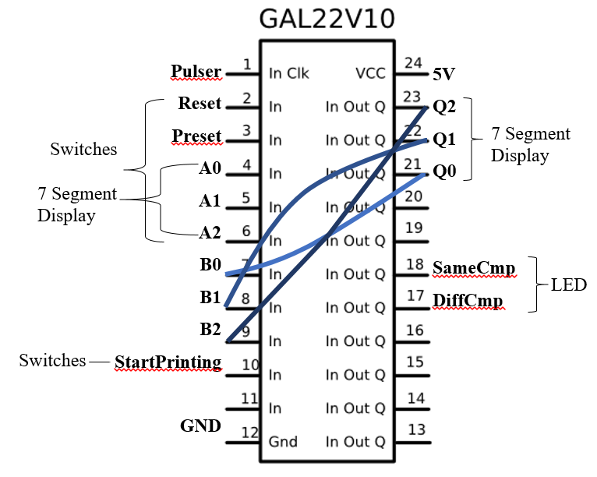
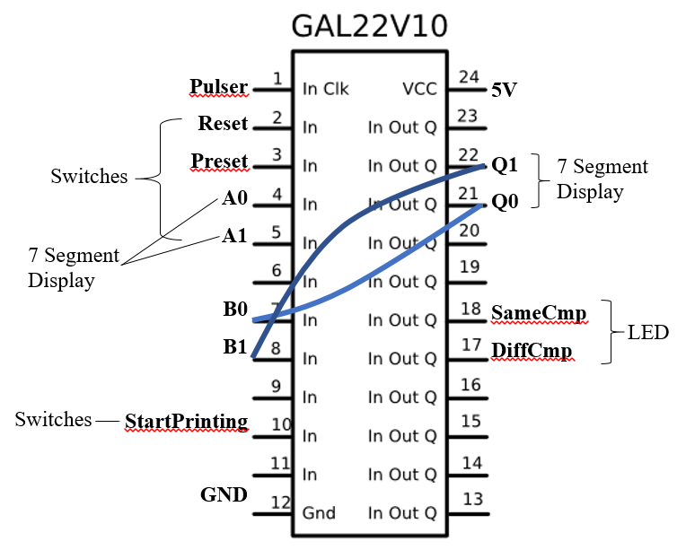
Circuit Implementation
Figure 1: Block drawing of the pin number of 3-bit Xerox Machine.
Figure 2 : Block drawing of the pin number of 2-bit Xerox Machine.

All these functions of the pins are programmed with codes written in WINCUPL into the PLD ATMEL 22V10 by using Wellon Universal Programmer.
- Switches
Pin 4 (A0) and 5 (A1) are connected to the switches for the user to input the number of copies they need in binary. For 3-bit, pin 6 (A2) are added and connected to the switch. Pin 4 (A0) and 5 (A1) (and 6 (A2) for 3-bit) are connected to the 7-segment display to show the number of copies required.

- 2-bit/3-bit count up counter
The counter that are implemented into the PLD device is JK count-up counter. Pin 1 is implemented as the clock and was connected to the pulser. Pin 2 and 3 that are connected to the switches act as RESET and PRESET (Asynchronous input) of the counter. The counter starts to count based on the clock enabler programmed into the PLD device. It will start counting if the J and K input are connected to high input (toggle state). In this case pin 10 which is StartPrinting are used to implement the active high input. Pin 21(Q0) and 22 (Q1) are the output of the counter. For 3-bit, pin 23 will be Q2.
- 2-bit /3-bit comparator
The output of the counter which is Q0, Q1 (and Q2 for 3-bit) are connected to pin 7, 8 and (9 for 3-bit) to be the input of the comparator. Pin 4, 5 and 6 are the number of copies required and pin 7, 8 and 9 are the number of copies currently made are implemented as the input of the comparator. Pin 18 (SameCmp) and 17 (DiffCmp) are implemented as the output of the comparator. Pin 18 which is SameCmp are programmed with XNOR gates and AND gate that compared A0 to B0, A1 to B1 (and for 3-bit, A2 to B2). SameCmp will be high if all comparison are the same. Pin 19 which is DiffCmp are the opposite of SameCmp, it will be high if any of the comparisons are different. Pin 17 and 18 are also connected to the LED to show user the progress of the printing.
- Clock Disabler
AND gate are implemented in the clock enabler, only if StartPrinting is high and DiffCmp is high will the clock enabler be active. Once DiffCmp becomes low which means the number of copies made are the same as number of copies required, the clock will be disabled and the counter will stop counting.

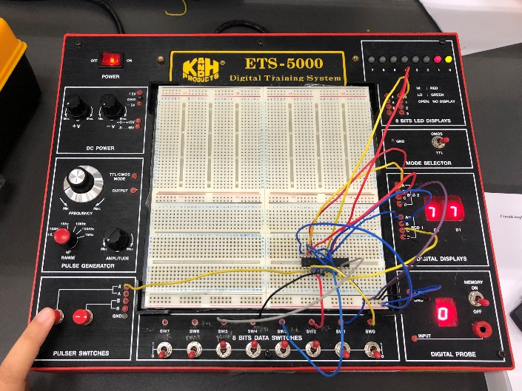
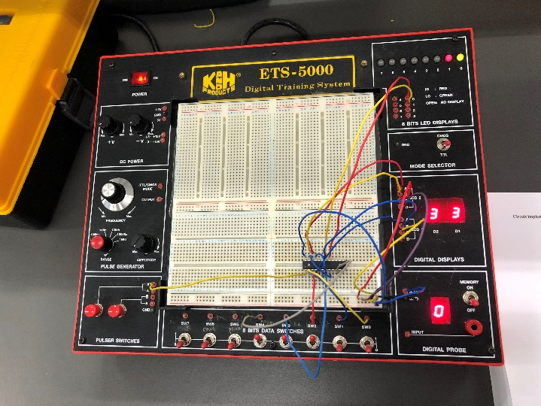
Physical System Implementation
Figure 4: 2-bit Xerox System.
Figure 3: 3-bit Xerox System.
- Input Switch
As our project required us to implement 2-bit and 3-bits count-up counter, firstly we install 2 switches for user to enter an input and then add one more for 3-bit. The input represented the required number of copies entered by user. Each of the switches represents a single bit which are SW4, SW3 and SW2 respectively. For 3-bit, we install SW4 as MSB and SW2 as LSB while for 2-bit SW3 as MSB. Since 3-bits only can input 000 to 111 and 2-bits can input 00 to 11, hence the user can only input value ranging from 0 to 7 for 3-bit and 0 to 3 for 2-bit. The output of input switch is connected BCD 1 digital display and comparator.
- 2-bit/3-bit Count-up Counter
We use 2-bit and 3-bit JK positive edge count-up counter as the counter to count the number of copies that has been made. We connect RESET input at SW0 and SET input at switch SW1. In order for JK counter to count, we need to connect both J and K input to HIGH. The JK input (also StartPrinting switch) are connected to SW5. The JK counter counts based on the clock enabler and it will stop counting when it reaches the number of counts initialised by the user on the input switch. The output of the counter which is the amount of copies made are connected to BCD 2.
- 2-bit/3-bit Comparator
The comparator is used to compare the number of copies required with the number of copies printed. We connect the diffCmp output to LED 0 and sameCmp output to LED 1. When the number of copies wanted and the number of copies made are different LED 0 will be red (high) and LED 1 will be green (low).

- Clock Disabler
When SW5 (StartPrinting switch) is high and DiffCmp (LED 0) is red will the clock enabler will be active. Once DiffCmp becomes green which means the amount of entered copies and printed copies are the same, it will stop counting.

Discussion
In short, in this project we implement 3 different components on a single GAL device, those components are 2-bit/3-bit Count Up Counter, 2-bit/3-bit Comparator and Clock Disabler to make a Xerox machine.
While doing this project in the lab, we discovered our strength which is we always came to the lab prepared. In our class, we are the first one that completed this project and we get to go back an hour early. This is because before this lab session we studied and tried to understand the coding and the device so that everything will go smoothly. We also watched YouTube videos on how to connect the circuit on the ETS-5000 Digital Training kit to prevent us from making any mistakes. Since we understood the code and how to connect the circuit, modifying the Xerox machine from 2-bit to 3-bit is not challenging to us.
The problem that we faced while doing this project was we got confused while connecting the pin to the ETS-5000 Digital Training kit since the pins were closely placed and the wires were criss-crossing everywhere. One wrong connection will cause the whole circuit to fail to function how it was supposed to so we had to be very careful. Next, the software used to burn the GAL device are very complicated to use and it is not user-friendly. There are a lot of steps that we have to follow just to burn the device and it took a very long time.
New functions that can improve this system are the counter and comparator can be upgraded to 4-bit. Next, the system should allow the user to choose either black and white printing or colour printing. This function can be implemented by using multiplexer. Lastly, the user need to enter the password in 4-bit binary before being able to start the machine.

Conclusion
In conclusion, we realise that learn practically give us better understanding than only learn theoretically in class. We manage to apply the theory on conducting practical circuit as our circuit can function well. Although a real Xerox machine is invented by complex circuit design inside it but this project gives us an idea on how does the photocopying machine work by implement simple circuit to simulate basic process of photocopying machine.
In order to ensure our project run smoothly, we need to make an early preparation even though we only required to change the given 2-bits code to 3-bits. We compile the PLD code using WinCUPL and save the JEDEC file created by the compiler into pen drive and bring it to the lab. During lab session, we only need to burn the code onto an IC using WellON Programmer and start implement the circuit. This preparation made us the first group to finish our project without any problem.
We also gained a lot of experience from this project. We are given a chance to use all the facilities provided in Digital Logic Lab. We experience how to program the IC and built our own circuit, besides we get to learn on how to use WinCUPL software and Wellon Universal Programmer. This project also enhanced our knowledge that the main components of photocopying machine are input switches, counter, comparator and clock enabler.
Lastly, as a Computer Science student, we realise that it is important for us to know both on how to program a software and design hardware component of a computer. For our future learning and advancement, Digital Logic subject teaches us about the designing of combinational and sequential logic circuits which is the hardware components of a computer. Moreover, basic gates and boolean algebra are the backbone in designing a computer hardware.

References
Abd. Bahrim Yusoff, Mazleena Salleh, Mohd Fo’ad Rohani, Ismail Fauzi Isnin. (2018). Digital
Logic (Fifth Edition). Johor Bahru: Desktop Publisher.

Appendix
Code of 2-bit Xerox Machine
Name LAB4 PART3 ;
PartNo 00 ;
Date 17/12/2019 ;
Revision 01 ;
Designer Engineer ;
Company UTM ;
Assembly None ;
Location DIGITAL LOGIC LAB ;
Device G22V10 ;

/* *************** INPUT PINS *********************/
PIN 1 = clk ; /* clock */
PIN 2 = reset ; /* reset */
PIN 3 = preset ; /* preset */
PIN 4 = a0 ; /* Comparator A LSB*/
PIN 5 = a1 ; /* Comparator A MSB*/
PIN 7 = b0 ; /* Comparator B LSB*/
PIN 8 = b1 ; /* Comparator B LSB */
PIN 10 = startPrt ; /* Start Printing */

/* *************** OUTPUT PINS *********************/
PIN 17 = diffCmp ; /* XOR (A B not equal HIGH) */
PIN 18 = sameCmp ; /* XNOR (A B equal HIGH) */
PIN 21 = q0 ; /* output counter LSB*/
PIN 22 = q1 ; /* output counter MSB*/

/***** Function Comparator************************/
sameCmp = !(a0$b0)&!(a1$b1); /* XNOR (A B equal HIGH) */
diffCmp = !sameCmp ; /* XOR (A B not equal HIGH) */

/**** Function Clock Enabler *********************/
clkEn=startPrt & diffCmp; /* AND (startPrt diffCmp 1 1 HIGH) */

/*** Function Counter 2 Bit UP *******************/
field count =[q1..0];
$define s0 'b' 00
$define s1 'b' 01
$define s2 'b' 10
$define s3 'b' 11

count.ar=reset; /* connect reg AR to reset (Asyn Mode) */
count.sp=preset; /* connect reg AR to preset (Syn Mode) */

sequence count{
present s0 if clkEn next s1; /*00 to 01*/
default next s0; /*if clock disable stay 00*/
present s1 if clkEn next s2; /*01 to 10*/
default next s1; /*if clock disable stay 01*/
present s2 if clkEn next s3; /*10 to 11*/
default next s2; /*if clock disable stay 10*/
present s3 if clkEn next s3; /*11 to 11*/
default next s3;} /*if clock disable stay 11*/

Code of 3-bit Xerox Machine
Name LAB4 PART4;
PartNo 04 ;
Date 17/12/2019 ;
Revision 01 ;
Designer Engineer ;
Company UTM ;
Assembly None ;
Location DIGITAL LOGIC LAB ;
Device G22V10 ;

/* *************** INPUT PINS *********************/
PIN 1 = clk ; /* clock */
PIN 2 = reset ; /* reset */
PIN 3 = preset ; /* preset */
PIN 4 = a0 ; /* Comparator A LSB*/
PIN 5 = a1 ; /* Comparator A */
PIN 6 = a2 ; /* Comparator A MSB*/
PIN 7 = b0 ; /* Comparator B LSB*/
PIN 8 = b1 ; /* Comparator B */
PIN 9 = b2 ; /* Comparator B MSB*/
PIN 10 = startPrt ; /* Start Printing */

/* *************** OUTPUT PINS *********************/
PIN 17 = diffCmp ; /* XOR (A B not equal HIGH) */
PIN 18 = sameCmp ; /* XNOR (A B equal HIGH) */
PIN 21 = q0 ; /* output counter */
PIN 22 = q1 ; /* output counter */
PIN 23 = q2 ; /* output counter */

/***** Function Comparator************************/
sameCmp = !(a0$b0)&!(a1$b1)&!(a2$b2); /* XNOR (A B equal HIGH) */
diffCmp = !sameCmp ; /* XOR (A B not equal HIGH) */

/**** Function Clock Enabler *********************/
clkEn=startPrt & diffCmp; /* AND (startPrt diffCmp 1 1 HIGH) */

/*** Function Counter 2 Bit UP *******************/
field count =[q2..0];
$define s0 'b' 000
$define s1 'b' 001
$define s2 'b' 010
$define s3 'b' 011
$define s4 'b' 100
$define s5 'b' 101
$define s6 'b' 110
$define s7 'b' 111

count.ar=reset; /* connect reg AR to reset (Asyn Mode) */
count.sp=preset; /* connect reg AR to preset (Syn Mode) */

sequence count{
present s0 if clkEn next s1; /*000 to 001*/
default next s0; /*if clock disable stay 000*/
present s1 if clkEn next s2; /*001 to 010*/
default next s1; /*if clock disable stay 001*/
present s2 if clkEn next s3; /*010 to 011*/
default next s2; /*if clock disable stay 010*/
present s3 if clkEn next s4; /*011 to 100*/
default next s3; /*if clock disable stay 011*/
present s4 if clkEn next s5; /*100 to 101*/
default next s4; /*if clock disable stay 100*/
present s5 if clkEn next s6; /*101 to 110*/
default next s5; /*if clock disable stay 101*/
present s6 if clkEn next s7; /*110 to 111*/
default next s6; /*if clock disable stay 110*/
present s7 if clkEn next s7; /*111 to 111*/
default next s7;} /*if clock disable stay 111*/

