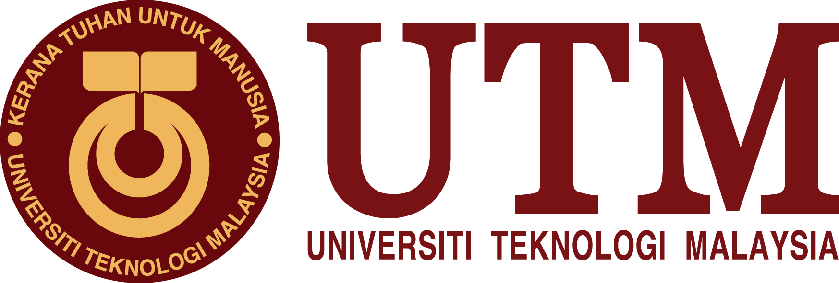

SCHOOL OF COMPUTING
SESSION 2019/202 SEMESTER 2

MALAYSIAN STUDIES 3
UHMS1022-07
UHAK1022-10
National holidays and festive celebration in Malaysia
Group: 06
Group Members:
Maidul Hasan Masum(A19EC4011)
Bayes Ahmed Shohanto (A18CS4051)
Md Shakil Chowdhurry (A18CS4047)
Elinor Aluge Osei Amaka (A19EC4005)
Anika Shahzad(A19EC4007)
Anika Rahman Antu (A19EC0223)
Lecturer:
DR Ana Haziqah A Rashid

Submission Date:
19th December 2019 (Thursday)

Table of contents

I. Introduction 3
II. Holidays 4
III. Types of Holidays 5
IV. National Holidays and regional holidays 5-6
V. Festivals 7
VI. Types of Festivals 7-10
VI. Conclusion 10
VI. Reference 11
VI. Appendix 11-13
VI. Task For Each Member 14

INTRODUCTION
Malaysia is a tropical country which is located in southeast Asia between Singapore, Thailand and Indonesia.
Malaysia has a very diverse population and a variety of indigenous groups that make up 58% of the population which explains why it is a multicultural country. There are two major regions in Malaysia, the Peninsular Malaysia and East Malaysia which is part of the island of Borneo. It is estimated that over 70 percent of the population will live in urban areas, and preside mostly in the Peninsular Malaysia, within the next 10 to 15 years. According to the recent amplification done by Worldometer on the latest United Nations data, Malaysia is home to about 32,142,385 people.
Furthermore, this population exhibits disparity in culture, religion, languages, and traditional patterns/ ways of life. The major ethnics are the malay, Chinese, and Indian people, these ethnic groups have different cultures and religious beliefs, hence celebrate a variety of festivals and holidays.
Certain holidays in Malaysia may be National celebrations or State celebrations. These holidays whether religious or cultural differ amongst states depending on the value of the holiday to the population in the state.

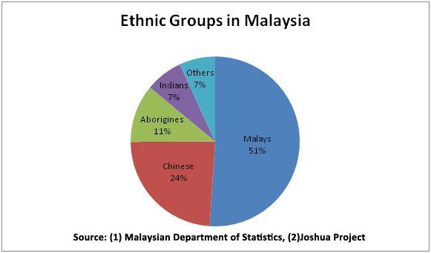

HOLIDAYS
Holidays are typically the off period. Daily activities are suspended or reduced in holidays, particularly business or work, school, college. The major aim of holidays is to encourage everyone to celebrate or recall a cultural or religious event or activity. State, religious groups or other organizations may occasionally announce their vacations.
Holidays may depend on customs, local laws, type of job and also on personal choices. The concept of holidays also connects with religious observances. The purpose of holidays was typical to allow everyone to perform their religious duties following important calendar dates. There are significant differences in many cultures between holidays designated by the state and holidays designated by religious institutions. The word holiday has different reflections across different states and regions. For example, in the USA, the term holiday refers to the days of rest or celebration observed globally or religiously or sometimes historically, whereas, in the UK and other Commonwealth nations, the word may refer to the time period when the departure of one's duties has been decided and is used as a synonym for the preferred United States holidays.
In addition to, the pattern of celebration of holidays also differs from place to place and man to man. In some cases, service holder likes to take rest on their weekly holidays whereas students love to play around or roam around with friends, people also like to take a tour or be involved in different programs.
Nevertheless, there can be religious holidays, national holidays, cultural holidays and in Malaysia, there are specific holidays for a specific region. For example, in Kuala-Lumpur Saturday and Sunday are weekly holidays but in Johor, it is Friday and Saturday. Therefore we can add religious and cultural holidays with national holidays and another one can be regional holidays in Malaysia.

Types of Holidays
There are two major types of holidays in Malaysia, and they are:
- National Holidays
- Regional Holidays

National Holidays
A National holiday is a holiday which is celebrated by the nation throughout the year. In Malaysia, the national holiday is governed at both federal and state levels. This type of holiday is often categorized as a mixture of holidays honoring the nation and its heritage.
The national holidays often celebrated in Malaysia:
- New Year
- Chinese _New_ Year
- Labour_Day
- Wesak _Day
- Nuzul-ul-Quran _Day
- Hari Raya Aidilfitri
- Installation of YDP Agong
- Hari Raya Hajj
- Merdeka_Day
- Awal-Muharram
- Agong’s Birthday
- Malaysia_Day
- Dewali
- Birthday of Prophet Muhammad(PBUH)
- Christmas _Day

Regional Holiday
In addition to National holidays, Malaysia also has holidays at the state level.
Some of the holidays celebrated by states are as follows:
- Installation of Sultan Terengganu (Terengganu)
- Sultan of Terengganu Birthday (Terengganu)
- Birthday of Johor’s Sultan (Johor)
- Malaysia Cup Holiday (Johor)
- Hari Hol Pahang (Pahang)
- Hari Gawai (Sarawak)
- Birthday Of Sabah Governor (Sabah)
- Birthday Of Malacca Governor (Malacca )
- Birthday Of Kelantan’s Sultan (Kelantan)
- Birthday Of Perak’s Sultan (Perak)
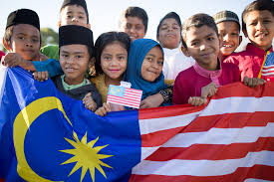

FESTIVALS

A festival is an occasion that a nation usually celebrates and focuses on some characteristic aspect of such a nation and its religion or cultures. Festivals usually serve specific popular objectives, particularly in memorizing or thanking gods.
Both tourists and locals, luxuriate themselves in festivals almost every month of the year, thanks to Malaysia's different cultural practices. Some of the festivities done for the benefit of foreign friends as well locals are listed below:
- Thaipusam
Thaipusam or Thaipoosam, which is also known as Thaipooyam, is celebrated in the month of January/February(Tamil month of Thai) on the full moon and is marked by the Tamil and other Malaysian communities as well as in Sri Lanka, Mauritius and the countries where Tamil is significantly present.
- Chinese New Year
The most important Chinese festival is a 15-day Chinese New Year celebration for the Chinese and Malaysian populace. In the course of the event, family reunion dinner, exchange of pleasant greeting cards for the new year take place to commemorate the season and bad language and critical conversation are discouraged during these gatherings. On Chinese New Year's Day, there are a number of events including the duilian decoration, (a pair of scrolls written with poetry), taking cash to red or angpau(angpow), visiting friends and families, family meals, and so on.
- Malaysia Water Festival
Malaysia hosts the “Malaysia Water Festival” that take place in the month of April every year. A variety of water sports are available. Other thrilling activities include;
- kayaking
- fishing
- cross-channel swimming pledge

- Harvest Festival
The state of Sabah in May annually commemorates the thanksgiving festival known as Harvest festival. The Kadazan-Dusun ethnic group, as well as other related ethnic groups celebrate this festival which lasts for a month and ends with a public holiday in which the priestess popularly known as “bobohizan” chose. The popular drinks taken during this festive period are Tapai and Kinomol(traditional alak drink).
- Hari Gawai
In Sarawak, Malaysia and West Kalimantan, Dayak people celebrate Hari Gawai(Gawai Dayak) festival. It is a public holiday in Sarawak. It is celebrated in Sarawak by Dayak people and marks the new season of planting and the end of the harvesting season. In the longhouses, it has activities like dancing, singing, and a considerable amount of rice wine (drinking tuak).
- Dragon Boat Festival
Chang or Duanwu is another name for this Festival. It pays homage to a patriotic poet in China named Qu Yuan. On a large scale, this festival takes place in Penang which is the best place to watch the festivities. Rowers in the annual dragon boat race in Penang. Participants from different countries are attracted to this thrilling event where there are 12 racers and 22 racers in five events, and 85 teams competed over a 200 m or 500 m game.
Other activities include:
- Hanging Zhong Kui icons
- mugwort and calamus hanging
- long walks
- Spelling writing
- Wearing perfumed medicine bags.

- Rainforest World Music Festival
Every year, the states of Sarawak and Kuching celebrate a 3-days music festival called “The Rainforest World Music Festival” abbreviated as RWMF which is commenced in order to celebrate the diversity of music. On the main, it has music workshops, cultural and art exhibition, food stalls and evening concerts.

Independence Day
Hari Merdeka(Independence Day) is Malaysia's official independence day on 31 August. A logo and theme is given to each Independence Day in Malaysia, that encourages ethnic unity. Hari Merdeka is watched enthusiastically with a Merdeka parade on August 31. A royal procession, cultural exhibits, military displays, sporting events, and fascinating entertainment fills the day.
- Hari_Raya Aidilfitri
Hari Raya Aidilfitri is a religious holiday that Muslims throughout the world observe in the holy month of Ramadan, the holy month of Islamic fasting. Prior to this day, Muslims located in the cities typically balik kampung (return to their home towns) in order to celebrate Hari Raya with their families. This day is usually also a national holiday, so school children and working adults can spend time with their family without worrying about formal obligations.
- Hungry Ghost Festival
The Chinese celebrated holiday celebrates the opening of the gates of hell for the lower world's souls to roam freely for a month. The Chinese opera and Ko-Tai figures and events that are larger than life-paper-making are items to remember during the festival.Tai Su Yeah (or King of Hades) will be "cast back" to hell at the end of the festival in the form of paper effigies after the effigies are burned.

- Malaysia Day
Malaysia Day is a celebration of the establishment of the Malaysian. The holiday celebrates the unification of Malaya, North Borneo, Sarawak and Singapore into Malaysia's Federation. Cultural performances include very own Boria showcase by Penang, Sabah and Sarawak ethnic dance and a special Gamelan performance.
- Mid_Autumn Festival
Fondly regarded as the Festival of Tanglung or Mooncake, Chinese celebrate at the end of the harvest season.Kuala Lumpur, Malaysia's capital, is home to the country's most plentiful and vibrant mid-autumn festival events, including lantern parades, traditional Chinese opera performances, dragon dance and lion dance, and puppet shows.

- Hajj Raya Hajj
The closing of the annual Haj is most apparent in marking the Islamic holiday of Eid al-Adha.Sacrificial slaughtering or korban slaughtering happens in mosques and distributes food to the vulnerable and the sick.

- Deepavali
Diwali, Divali, Deepavali or Deepawali is the Hindu lights festival which usually lasts five days. Diwali, one of the most prominent festivals of Hinduism. Oil lamps are lit to fight against darkness and evil and open houses are held in Malaysia like every other major cultural festival.
- Christmas
A religious holiday for Christians to celebrate the birth of Jesus Christ, observed as a religious and cultural event by billions of people around the world on December 25. The preparation is started from the beginning of the month of December. People decorate their house and the Christmas tree.

CONCLUSION
Holidays and festivals are closely related. When there is a festival then there is a holiday. Malaysia is a multi-racial country, which clarifies why they have more festivals and thus brings more holidays. One of the most important things to note is that these festivals are celebrated with one another and the foreigners are warmly welcomed to join in marking these great events. There is no discrimination of races, and during these festive seasons everyone comes together in harmony and have a blast/ wonderful time together. Holidays bring alliance among them, and this is how a festival makes a bond with everyone.
Furthermore, it also refreshes our mind as we are not robots and require rest in order to get a boost to go for a regular schedule again. For this reason the importance of holidays and festivities in Malaysia and in the world at large cannot be over emphasized, moreover it is making a friendship over races, countries that is also a sign of prosperity.

REFERENCE
- Malaysia Public Holiday 2019. Retrieved from: https://publicholidays.com.my/2019-dates/
- Nelly Soh.(Nov 9, 2012). Festivals and Celebration in Malaysia.Retrieved from: https://www.thestar.com.my/travel/malaysia/2012/11/12/festivals-and-celebrations-in-malaysia
- https://en.wikipedia.org/wiki/Malaysia
- Mani Arora.14 Top Festivals in 2020 to Witness its Vibrant Culture and Rich Traditions. Retrieved from:https://traveltriangle.com/blog/festivals-in-malaysia/

APPENDIX

PICTURE SECTION
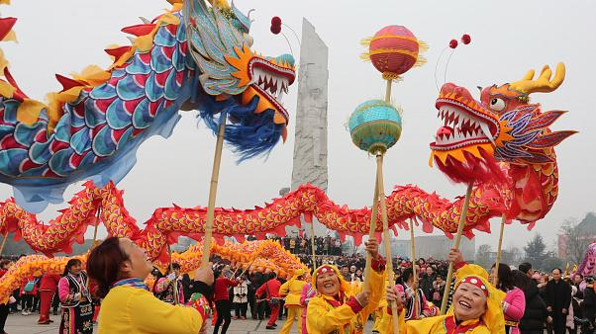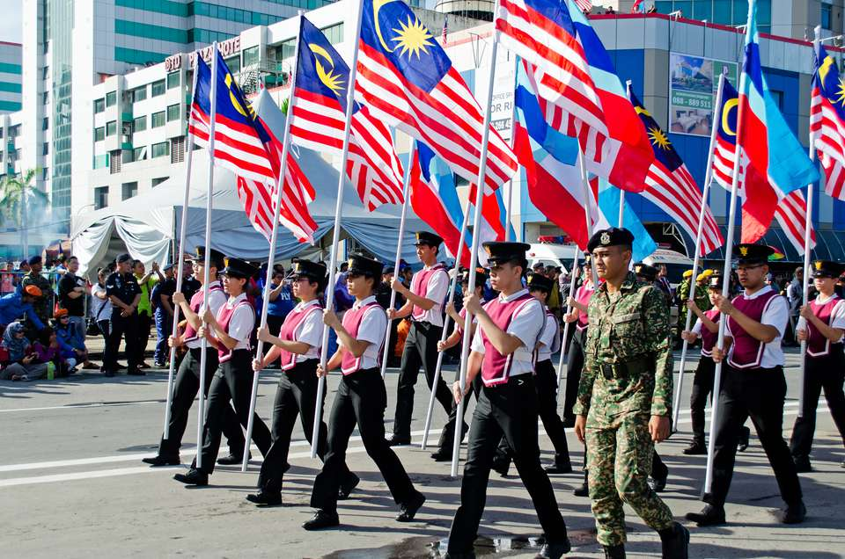
Image of the Chinese new year celebration Image of the commemoration of hari merdeka in Malaysia

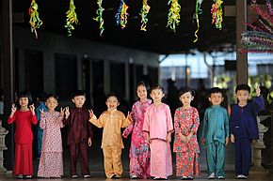
Little children having a taste of the hari raya festival

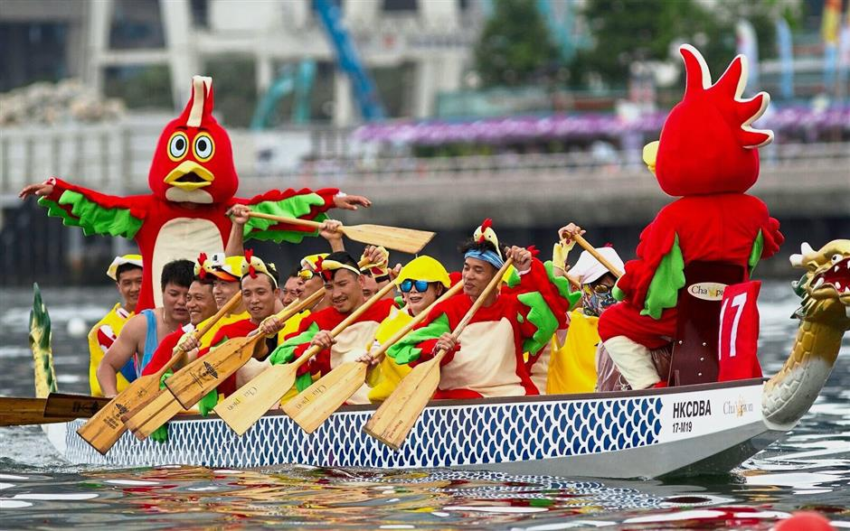
Picture capturing a thrilling time of the Dragon boat festival in style.

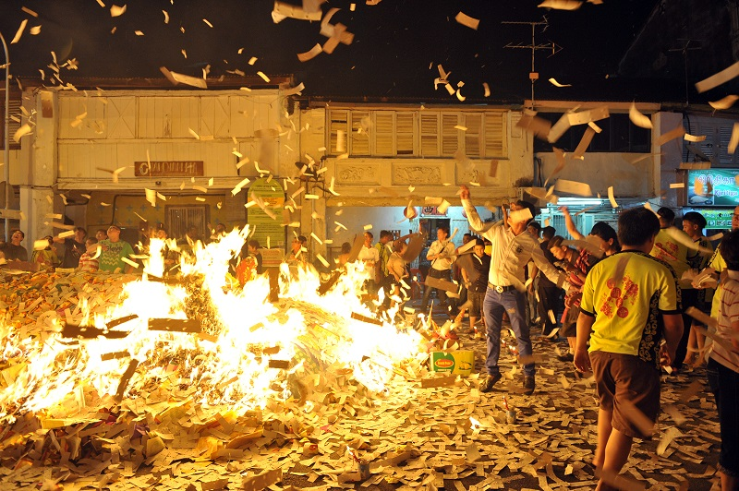
Mind dazzling image of the hungry ghost festival

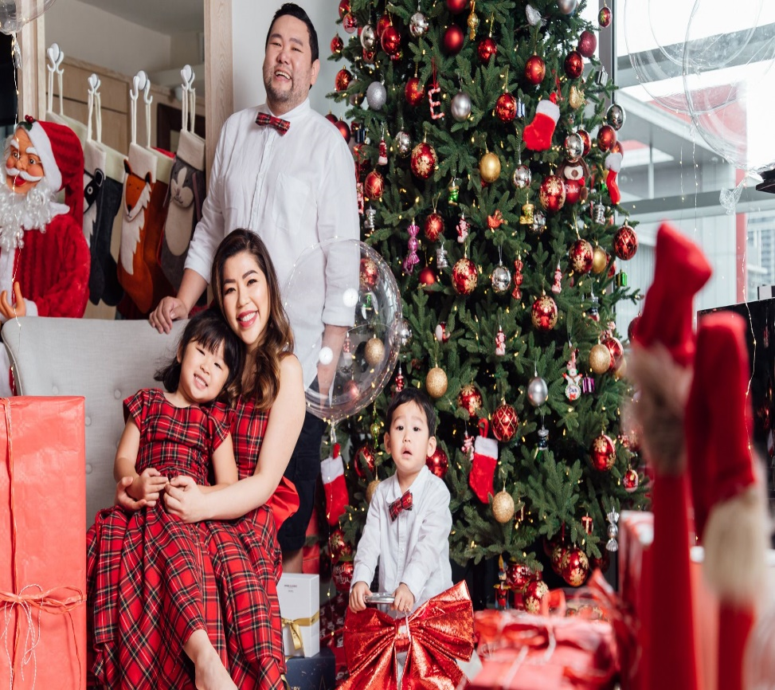
Beautiful Malaysian family mark Christmas day

TASK FOR EACH MEMBER

S/N | Name Of Member | Task
1. | Bayes Ahmed Shoharto  (A18CS4051) | Report Writing  Idea generation  Making presentation slides
2. | Md Shakil Chowdhurry  (A18CS4047) | Idea generation  Making presentation slides
3. | Maidul Hasan Masum  (A19EC4011) | Report Writing  Idea generation  Making presentation slides
4. | Anika Rahman Antu  (A19EC0223) | Idea generation  Making presentation slides
5. | Anika Shahzad  (A19EC4007) | Report Writing  Idea generation  Making presentation slides
6. | Elinor Aluge Osei Amaka  (A19EC4005) | Report Writing  Idea generation  Making presentation slides

Thank you

