Tis Gallerium Day
Another main exhibition in the galleria was some of the typewriters were mainly used back in the day. They were three typewriters that were put on show in the galleria; the IBM typewriter(red), Olympia Typewriter(white) and the Olivetti ET 116 Typewriter(black).
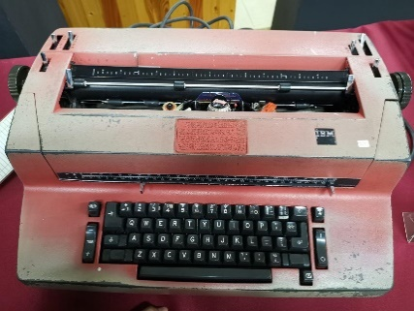
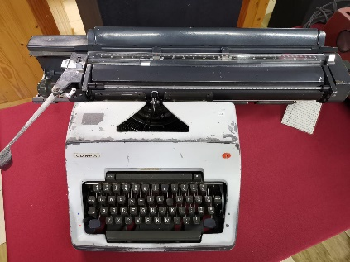
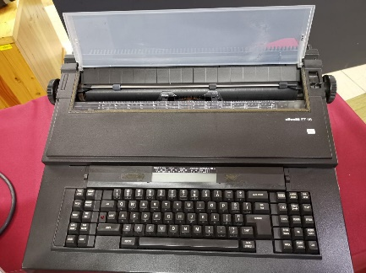

Typewriters were introduced to the PRZS staff in the 1970s. They were widely used throughout the 1970s to the early 1980s, before the introduction of computer to the PRZS staff in 1985. They were mainly used for administrative tasks such as printing letters and memos.

Moving onto another type of technology that was showcased in the galleria, were the various types of technology that was used for data storage in UTM. These are some of the data storage technology that were used.
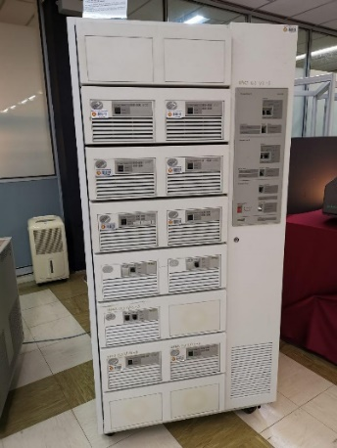
This is an example of a mainframe data storage; the exact model being IBM (9345B22). Being first used in 1970s at UTM’s Computer Centre, UTM campus in Kuala Lumpur. The primary use of the mainframe was to control the data of students and staff of UTM. Some other functions of the mainframe were processing, storing, securing, and printing the University’s information and data. Mainframe technology has now been used for almost 20 years in UTM.

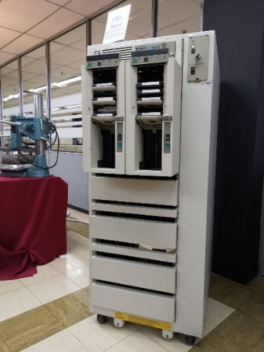
This is the mainframe tape subsystem, specifically the IBM 9309. Being the complement of the mainframe that was used to store and process data. The tape subsystem primarily functioned as the ‘back up’ for the mainframe system and the information database for UTM students and staff as well as other universities (NOT SURE ABOUT THIS ONE) information systems through the years 1987 to 1995. This particular model used squared shaped tapes as the circular shaped tapes were no longer used at the time.

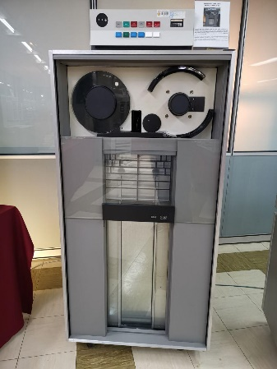
This is the IBM (3420) Magnetic Tape Unit. Similar in function to the mainframe tape subsystem; it was used as a ‘back up’ to the mainframe data storage. Storing and controlling the information database of students and staff of UTM alike, as well as other information system of the university, from the year 1976 until 2010(ye ke ni). This particular model unlike the tape subsystem used circular shaped tapes, which would later be swapped out for squared shaped tapes.

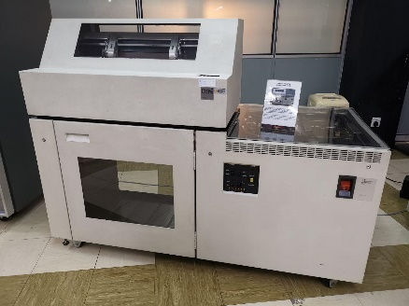
The IBM (4245) Impact Printer was one of the models of printers that were used in UTM. Also known as the Dot Matrix Printer it was used in UTM in the 1990s until 2011. The main usage of this machine was to print out the data information of students and staff that met University’s targeted requirements. This printer was capable of printing out high volumes of data and do it non-stop for 48 hours.

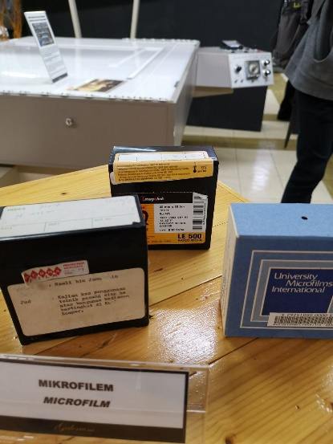
Microfilms were scale-down item for documentation, commonly films or paper. They were typically used for transmission, storage, reading, and printing. Primarily used as a medium for learning and for reference in UTM in the 1980s until the early 2000s. Microfilms utilised special 35mm size film and were easily stored in boxes. In the UTM library collection, there are almost 15,000 titles of microfilms, among them are these, international journals, acts, newspapers etc. There are numerous efforts done by the Library in carrying out microfilming process, focusing on duplication of these and research project, began as early as the 1980s until 2007. The main initiative of this was carried out to preserve the security of the intellectual property of the University, also ensuring that this once primary source of information can still be referred from time to time. The microfilms are stored in a tight environmentally controlled storage at the Media Materials Room, UTM Library.
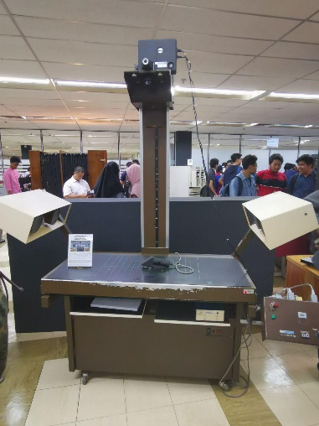
This is one of the microfilm cameras that UTM owns and exhibits, being first used in 1986. The Microfilm Camera Zeutschel OK 102 is a high accuracy camera primarily used to capture small images of UTM theses, which these images are captured in microfilms (refer above) or microfiche. Utilising a special film; the ‘Kodak Ektachrome’ , 35mm in size, with a capacity of 100 feet per film roll.
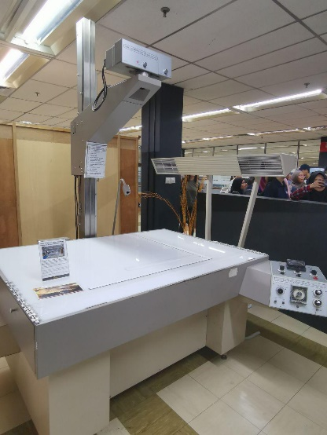
Another Microfilm machine/camera that was exhibited at the library was Recordak Model. Being similar in function as the Zeutschel Model; capturing small images of UTM these. Also utilising the Kodak Ektachrome. This machine was first used in UTM Library around the early 1980s until 2007.

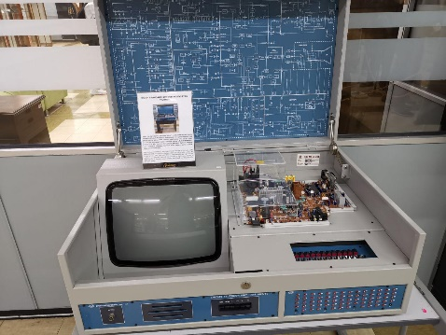
The Multi Standard Colour Television Trainer functioned as a teaching medium and aid at the Faculty of Education in UTM. Before Liquid Crystal Display (LCD) and monitor displays period, this device around 2005 until early 2015 to study the software and hardware of a television system manually. Also being used by UTM Diploma students to study aspects of lighting, colour, camera, data signal, and frequency of television system.
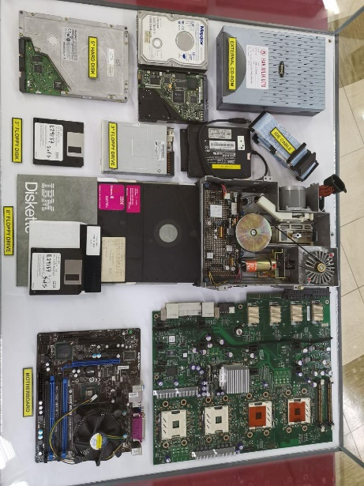

There were also some used Hard Disk Drives or HDD for short that were exhibited in a glass case. They were shown alongside some floppy disk, floppy drives, external CD-ROM, IDE cables, IDE cables and some motherboards. There were 3inch and 5inch hard disk were the variety of sizes that were shown. Hard Disk Drives are devices which are used to store data and information, usually one can see them in PCs and smaller ones being used in laptops. A HDD’s one of the main components are the platters, spindles, read\write arm and the actuator. Even now, HDD are still being used to this day, can be found in any PC, as an important device for storage alongside the (faster) Solid State Drive, which HDD are increasing in size tremendously. And to connect these HDD (storage devices) was the Integrated Drive Electronics (IDE) or also known as Parallel ATA (PATA). They were commonly used to connect HDD to the PC’s motherboard back in day, but now a faster variant is now commonly and widely used today, which is the Serial ATA cables.

Next up is the various CPUs that were put on display, ranging from AMD and Intel. Both respected household names in the CPU manufacturing business. A central processesing unitc or more commonly known as CPU, is the main brain of any PC. As suggested in the name it takes instruction from a program or application and preforms a calculation. The CPU fetches the instruction from a system’s RAM, then it decodes what the instruction actually is, before it is executed by the relevant parts of the CPU. On the intel side, there was the Intel Proccesor 386, a 32-bit processor which was introduced in 198, manufacturing began in 1986. The Intel Pentium 2 was introduced in 1997, refering to Intel’s sixth-generation microarchitecture P6 and x86-compatible microporcessors. It featured an improved version of the first P6 generation core of the Pentium Pro, with max CPU clock speeds of 233 MHz to 450MHz. Its replacement later down the line; the Pentium 3 was a near identical to the Pentium 2, which it only added the then new Streaming SIMD Extension instruction set. On low cost end of the Intel spectrum was the Intel Celeron which was microprocessors models that targeted at low-cost personel computers. On the AMD side the was the AMD 486 produced in the 1990s. Eventhough, Intel beat AMD to the market by 4 years they offered better performance for the same price. They are some CPU cooler fans that were shown were used to cool the CPU.

