

SEMESTER 1
SESSION 2019/2020
SECP1513

Industrial Visit 1 MAGICX UTM

PREPARED BY:
- IMRAN HAKIM BIN NORASMADI (A19EC0189)
- Tee Hui You (A19EC0170)
- Lee Tong Ming(A19EC0069)
- Nur Shuhada Binti Abdul Hakim(A19EC0202)

LECTURER'S NAME: DR. ARYATI BINTI BAKRI
SUBMITTED ON: 18/10/2019

TABLE OF CONTENTS
INTRODUCTION………………………………………………………………………2
MAGICX BACKGROUND………………………………………………………3-4
KINECT INTERACTIVE WALL……………………………………………………5
AUGMENTED REALITY……………………………………………………………6
VIRTUAL REALITY……………………………………………………………………7
3D PRINTER……………………………………………………………………………8
DRVING CAR SIMULATION…………………………………………………….9
REFLECTION…………………………………………………………………….10-11
TASK OF EACH MEMBER………………………………………………………12
REFERENCES………………………………………………………………………13

Introduction
On 7th October 2019, our group had visited the Media and Game Innovation Centre of Excellence (MAGICX) UTM. We departed from Kolej Tun Dr. Ismail at 2pm and the visit ended at 4pm. The purposes of the visit were to tour at the MAGICX’s facilities and listen to a talk about the current projects conducted by MAGICX.
The event started at 2.30pm and we were given a talk about short introduction of MAGICX and the technologies demonstrated such as 3D printer, Driving Car Simulation, Kinect Interactive Wall, Virtual Reality of Oculus Quest and Augmented Reality. After that, we were given the opportunity to get the first-hand experience about the technologies and facilities developed by MAGICX.
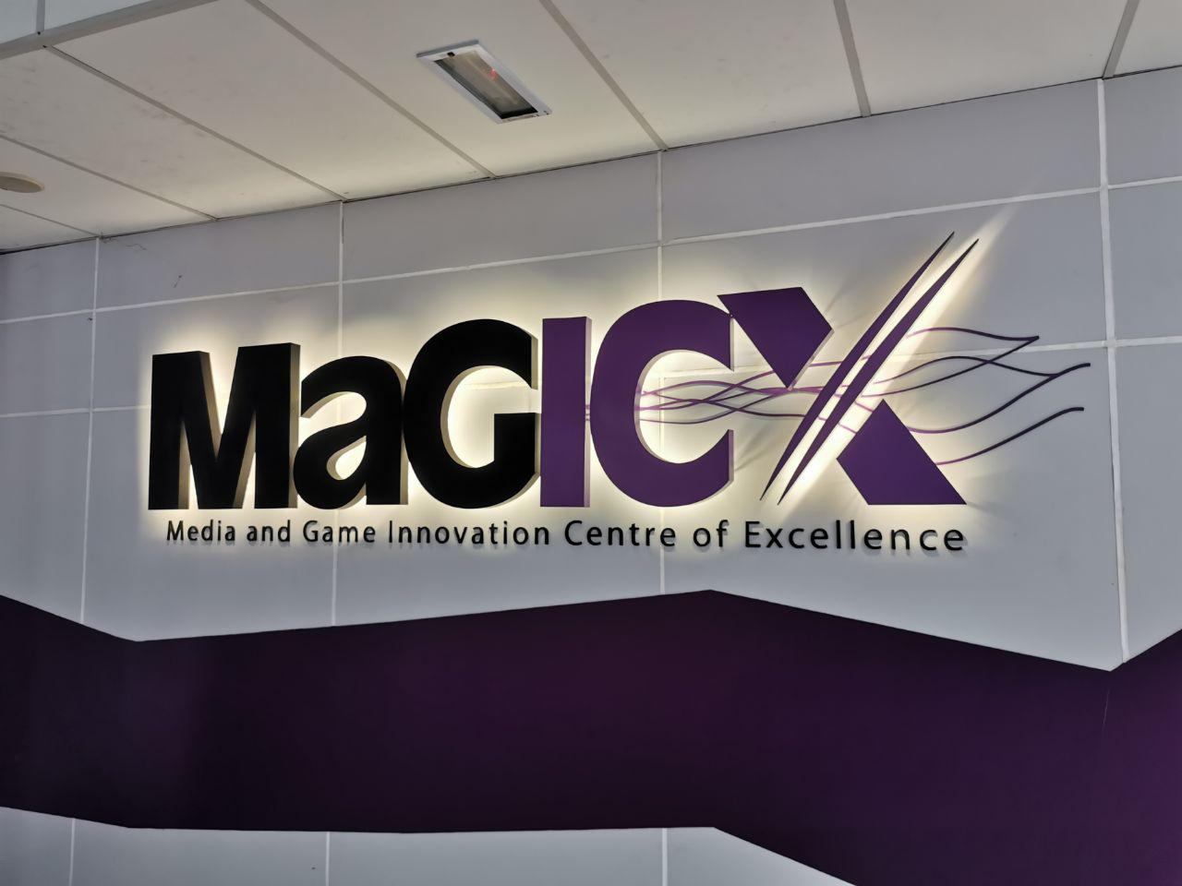

MaGICX Background
MAGICX was established on 2013 under corporation between Universiti Teknologi Malaysia (UTM) and Iskandar Regional Development Authority (IRDA) to promote the development of creative industry that focuses on gamification and enrichment of digital content. The vision of MAGICX is to be the anchor for Games and Gamification industry & the nucleus for Iskandar Malaysia Innovation Valley. The example of MaGICX products are iZikir, Didi & Friends Playtown, Mosti Interactive Walls and more.
There are 4 branches provided by MAGICX which is MaGICXcel, MaGICXplore, MaGICXpert and MAGICXpose. MAGICXcel allow us to create our own startup under MaGICX incubator with their expert mentorship guidance and top-notch facilities. MaGICXplore allows public to learn from their network of expert inventors from their latest and revolutionary research and publications. Moreover, MaGICXpert encourages public to join their training & professional courses, workshops & seminars and competitions to be an expert. Lastly, MaGICXpose guide clients through the intricacies of the business aspect in commercialization of their products & services. (4)

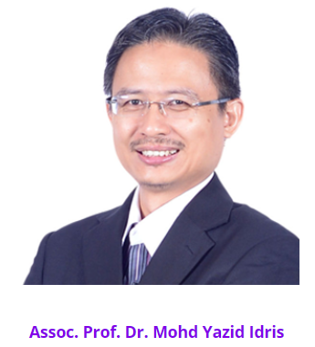

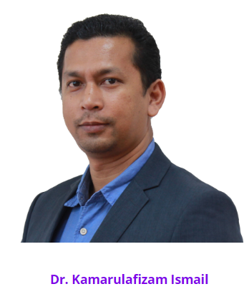
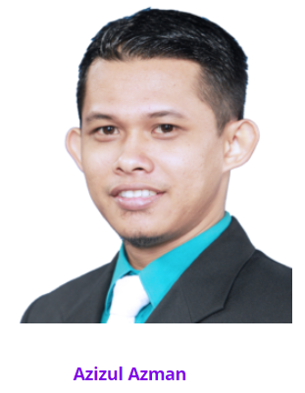


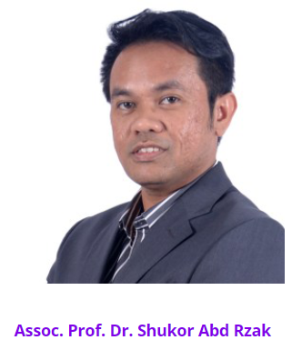
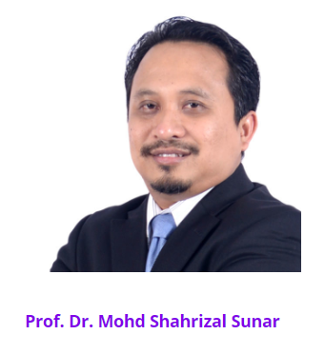
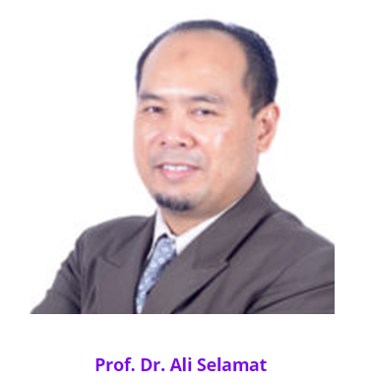
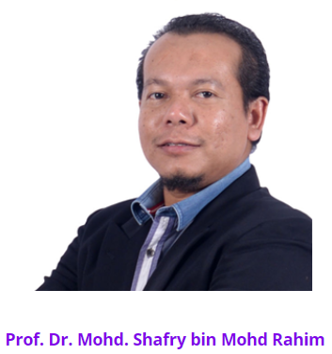

The main researchers at MagicX.

Kinect Interact Wall
Kinect Interactive Wall is used at facilities of MaGICX to diplay information of MaGICX. It uses Xbox technology which allows MaGICX to develop certain apps regarding movement. It uses camera to detect the movement of users standing in front of the screen. To control it, users have to stand in front of the screen, move the palm roundly and grip the palm to select. A wall can be used by 15-20 person simultaneously but it can be adjusted to be used by only one person too.
This software allows users to do whatever they want interactively without any input hardware such as remote control, keyboard and mouse. It can be used in not only television but is also applicable to laptop and other devices as long as it is connected to the Kinect device. The device uses C sharp programming language and can also be used in other fields such as in video games by reprogramming it.
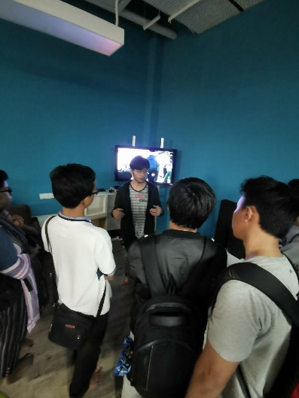
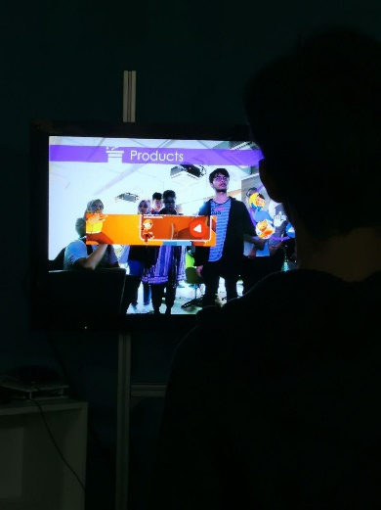

Magicx : Augmented Reality
Augmented reality (AR) is a type of interactive, reality-based display environment that takes the capabilities of computer-generated display, sound, text and effects to enhance the user’s real-world experience (1). Unlike Virtual Reality, AR combines real and computer-based scenes and images to deliver a unified but enhanced view of the world.
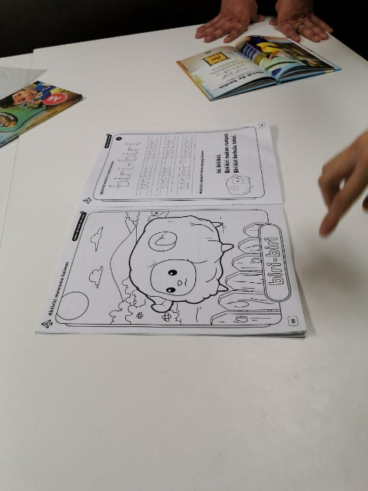
At MagicX, the main application of AR was its use in making applications that were aimed in educating children. One of the examples, was the usage of apps that interacts with a colouring book. The colouring book that was shown was filled with numerous colourless drawings of various animals.
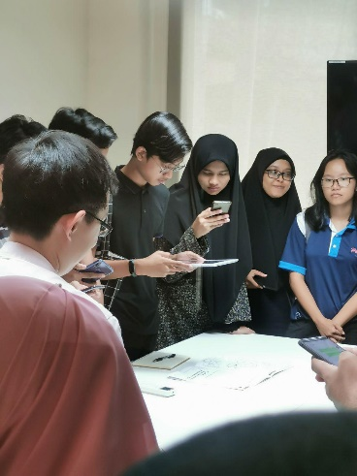

To use the AR technology, the app waRna that is readily available on Google Play and the iOS Appstore. To fully optimise the AR tech, the user will have to open up the app, holding the device over any picture in the book. A 3D model of the animal will pop up onto the screen, whereby you can rotate it around seeing the whole body. But the true magic comes from when the animal is coloured. Holding the device over a coloured animal will make the 3D model to appear coloured in exactly the way that you have coloured. This is even possible with just using any coloured pencils, as the app is able to recognise and distinguish colours accurately.
This type of technology in my opinion will be greatly useful and impactful in the education sector, especially with young children. This is because it will make teaching more interactive and fun for them.

Virtual Reality

The next booth that we went to was the Virtual Reality (VR) demonstration. (Put definition). Virtual Reality is a simulation in which computer graphics is used to create a realistic-looking world; this synthetic world is not static, but responds to the user’s input (gesture, verbal command, etc.)
The booth showcased the Oculus Quest, which is a VR tech product commercialised by the company Oculus. They gave students the opportunity to test out the Oculus Quest through a couple of games that were pre-installed. One of the games needed the user to pick up a ping pong racket and ball in the other hand. Using the both of the right and left controllers which were the Oculus Touch Controllers, the player had to try and hit the ball with racket. The actions done by the player not only could be seen by the player in the headset but also displayed on the screen, which happened in real time. This is due to the Oculus Quest’s in-built tracker; Oculus Insight Tracking, that could translate real time movement and had room-scaling.To display the VR world a certain programme had to be installed, which means that it could be displayed anywhere compatible. For example, a TV, laptop or PC.Even though, the Oculus Quest wasn’t created by MagicX, the team researches at MagicX use the Oculus quest to develop and experiment applications that were for VR.

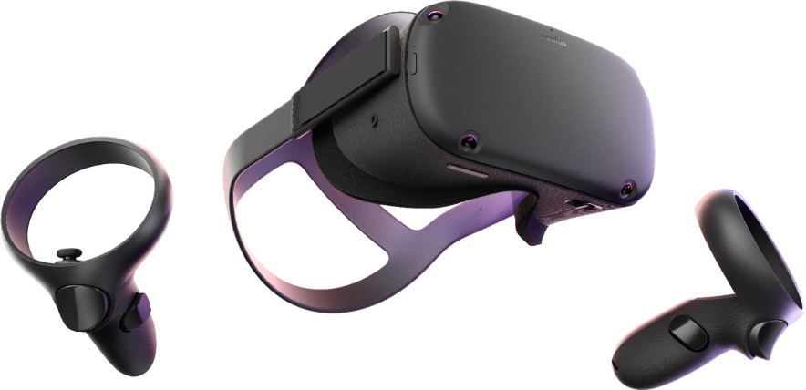
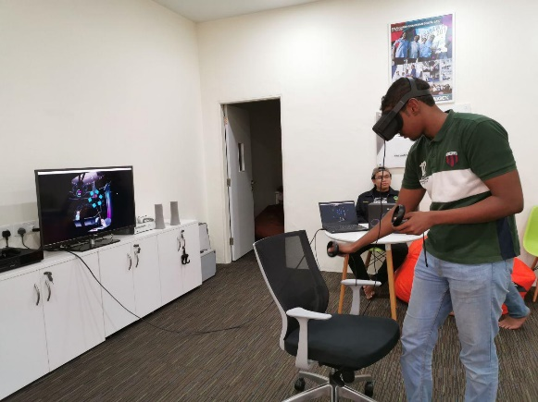
3D Printer
Moving on to the next booth, the team visited the 3D printer booth. A 3D printer is a type of material design printer that designs and builds 3D models and products of devices and components using additive manufacturing process. They design three-dimensional prototypes and create the end product by directly building them using computer aided design or software-created 3D design diagrams, figures and patterns. (3)
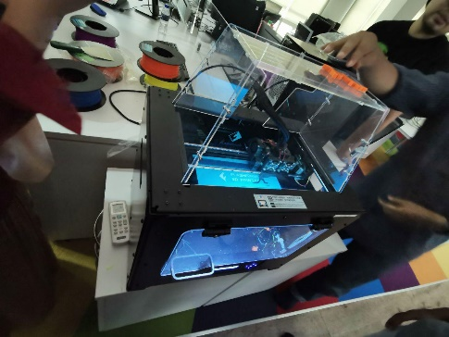
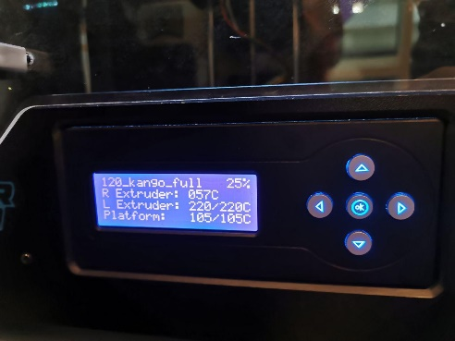

This booth showcased a Flash Forge 3D printer, manufactured and commercialised by FlashForge a company that supplies 3D printers globally. There were several pre-printed models of small models of animals like a giraffe and lizard. They were made from filaments that were made from specially made material, ABS plastic. Some other materials are PLA, polyamide(nylon), glass filled, stereolithography materials and etc. But these materials are available in bundle cords in e-shops such as Lazada and Shopee for reasonable prices as told by the researcher at the booth. Not only that, the researcher listed the many practicalities and benefits that have arisen from the 3D printers. 3D printers have enabled manufacturing to have faster production as compared to traditional designing that could up days and weeks, a 3D printer only takes a couple of hours to produce. 3D printing has also made the product increase in quality, as 3D printing allows the step by step assembly of the object which further enhances designs extremely. 3D printers have made manufacturing more cost effective and lessen waste production. But 3D printing isn’t limited to manufacturing products such as car and motorcycle parts, prosthetics and etc. Hopefully in the near future, 3D printers may be able to be used in hospitals to 3D print and produce human organs that can replace failed ones.

Driving Simulator

The Driving Car Simulation by MagicX is a VR-based simulator that predicts the vehicle motion caused by the driver input and feeding back the corresponding visual, audio and proprioceptive cues to the driver. In short, drivers will feel that they are driving a real vehicle in an actual driving environment. Drivers are able to drive in the virtual environment by controlling the steering wheel, the accelerator and brake paddle. Thus simulation is very useful to provide training for drivers, for analysis of driver responses and evaluating user performances in different conditions.
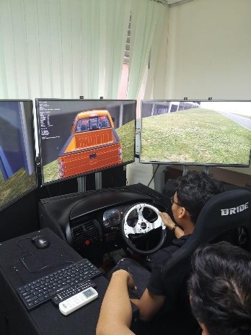
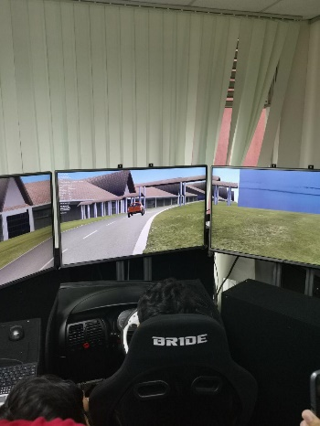

From our visit there, one of the persons in charge, Imran who works as a research assistant in MagicX, explained to us that the visual database built for the simulation is actually a roadmap of Universiti Teknologi Malaysia (UTM) Johor Bahru campus. This simulation was developed using Unity software for the graphics, the surrounding buildings, tones and colours, while for the integration of steering, wheel, gear and handbrakes, Arduino software is used. The graphics includes facilities for real-time rendering and animation, and extensive functions for the creation and management of 3D graphic objects to create a realistic driving environment. The visual scene rendering includes full texturing, shading, fog, and lighting effects capable of producing high-resolution simulation environment spread across two computers or projected screens. There is a button to be pressed if accident happened or player wants to restart. Imran also told us that when there is a potential crash or collision incoming, the system will inform the drivers. Another feature of this simulation is that when drivers move the steering, coordinates will be signalled to the driver. However, there are still limitations to the simulation as the project is still a work in progress and has room for improvement according to Imran. For example, the steering is too sensitive, so this makes the drivers hard to have full control of the simulation. There is no doubt that the car driving simulation is an essential and powerful tool for the future in-vehicle technologies, and will certainly contribute to the virtual experience researches in the country.

Reflection
My goal is to become a professional data engineer that have the abilities to produce various system that can benefits wide range of industries/companies. I plan to train myself with the ability to make short term critical decisions which is very crucial in nowadays industrial field. I very much admire a few data engineers that I have come across, how they are highly trained and equipped with a very special level of skills.
This visit to MagicX has given me the exposure of how there are this kind of institutions such as MagicX that provides professional training and high-quality tools which can help boost the student’s hands on skills in implementing what they have learnt in class. The existence of this MagicX in overall is very helpful and very crucial in producing highly trained workforces which are hope to help improve the current industry technology.
I plan to be a committed person and always try my best in everything that I face daily. I also will make sure that everything that I learnt in class, I will try my best to understand it that I can easily applies it when needed in certain situation.
As a freshie of Data Engineering and Computer Science, I hope that I can enhance my personal capacity in Data Engineering field to improve my competitiveness in future workspace. This visit impact me in the sense of uses of technologies by the researchers and developers to fulfil their product requirement. Technologies nowadays are getting more and more portable as a single technology can be used in different devices by an easy connection of network access or a cable. I had also realized that creativity and innovation skills are very important to industries’ problem solving. Hence, I would like to focus on developments of creative and innovative thinking on the next few years spent in UTM before I graduate. I believe that a creative and innovative Data Engineer would be more preferable by either the companies in Malaysia or companies abroad.
This visit to MagicX has been a real eye opener for me to the various innovative products that are at MagicX. This has sparked a fire of inspiration in me to do the same; create innovative products that will probably shape the world in a new way technologically. Synonymous, with my goal towards this program, Technology and Information Science which is; which is to able to become capable and competent graduates that are able to surpass the requirements set by employers; being able to be a part of the workforce. This dream can be achieved through the experience gained through the multiple assignments and group work that were assigned to us. Hopefully, the experience gained will be more than sufficient for us to be ready for going into the workplace and most importantly be acknowledged by the employers.
Therefore, the next step for to me improve is to further sharpen my critical thinking and creative thinking. This is can be done by me participating in competitions that require high level thinking skills and teamwork.
As a data engineering student, I hope to be highly trained and learn various types of skills regarding to technologies, data analysis and many more. I plan to use the knowledge I have studied to contribute to the community and develop projects and researches that will benefit the country in various fields. The visit to Magicx was truly eye-opening and an enriching experience for me personally. I was really surprised to see how science and technology has developed throughout the years, especially in our countries. The development of 3D printers is one great invention that will certainly be beneficial for various fields such as medical field where they can print out prosthetics at affordable prices, this will truly help people from all over the world. I am motivated and inspired by the researchers at Magicx and their abilities to develop projects like car driving simulation, interactive walls and 3D printers. I am proud to have visited Magicx and see how they provide training for the younger generations and nurture the future generations to keep improving our society. For me to improve my potential in this rapidly growing industry, I will keep working and studying hard to achieve excellence in my studies, as well as develop soft skills such as communication skills which is an essential ingredient for life after university. I will try my best to understand everything and equip myself with special skills needed to succeed in the big data industries.

TASK OF EACH MEMBER

NO. | NAME OF MEMBER | TASK
1 | Imran Hakim Norasmadi | - Augmented Reality & Reflection
2 | Tee Hui You | - Introduction of Kinetic Interactive Wall and Reflection
3 | Lee Tong Ming | - Driving Car Simulation and Reflection
4 | Nur Shuhada Binti Abdul Hakim | - Virtual Reality / Oculus and Reflection

References
  - https://www.techopedia.com/definition/4776/augmented-reality-ar
  - [BOOK] Virtual reality technology GC Burdea, P Coiffet - 2003 - books.google.com)
  - (https://www.techopedia.com/definition/28405/3d-printer)
  - https://ihumen.utm.my/magicx/about-us/

