

UNIVERSITI TEKNOLOGI MALAYSIA
JOHOR BAHRU (UTM JB),
81300 JOHOR BAHRU,
JOHOR

SCHOOL OF COMPUTING
FACULTY OF ENGINEERING
Charity Games
“Run for Caring, Exercise for Sharing”

Name | Muhammad Rafiy Athalla | A19EC0267
Name | Lim Sin Jie | A19EC0073
Name | Anis Farzana Binti Ismail | A19EC0182
Name | Yong Jing Xuan | A19EC0177
Name | Amr Abdel Meniem Mohamed | A19EC0221
Course Code & Name | UHMT-1012 (GRADUATE SUCCESS ATTRIBUTES)
Lecturer | Dr Muhammad Abd Hadi Bunyamin

Table of Contents
- Introduction 3
- Objectives 4
- Problem Statement 5
- Event Details 6
  - The Marathon 6
  - The Games 6-8
  - Food Festival 8
  - The Charity 9
- Organizational Structure 10-11
- Duty and Responsibilities of Committee Member 12-14
- Budget 15-19
- Estimated Date, Time, Venue 20
- Program Schedule 21
- Safety and Security of Event 22
- Conclusion 23
- Self-Reflection for Each Member 24-29
- Reference 30
- Appendix 31
- Minutes of Meeting 32-34

- INTRODUCTION

According to the statistics by World Health Organization (WHO), it had elucidated that Malaysia has the highest rate of overweight and obesity among the Asian countries in which 64% of male and 65% of female are either overweight or obese. Also, lack of physical activity is attributed as one of the major factors which contributes to the prevalence of obesity issues in Malaysia that may lead to adverse consequences such as plethora of chronic diseases. Since exercise is part and parcel of our everyday lives, it is vital to inculcate the awareness in public about the predominant role of exercise in daily lives in order to promote a healthy lifestyle in modern society.
Hence, we have planned to host a charity sports event to incorporate the purpose of instilling the interest of exercise in people while lending a helping hand to those who are in need and our target group would be the orphanages from Orphan Care Foundation in Johor Bahru. Through this program, it is hoped that more people will be willing to render help and support to the disadvantaged and vulnerable groups in the society to make their lives better.
This event would be named as Charity Games, in which the games pertaining to sports are to be held in the purpose of raising funds and boosting people’s motivation to start an exercise routine as people who do not exercise can have fun when joining the event as well. Not only for UTM staffs and students, but public is welcomed to participate in the event so that different categories of people can be involved in our event.


- OBJECTIVES

- To increase public awareness of the effects of lifestyle on health
- To educate the students about the benefits of exercise
- To motivate students especially the groups that do not exercise to start an exercise routine
- To encourage bonding between students in UTM
- To raise fund for Orphan Care Foundation
- To help vulnerable groups in society
- To encourage students to put their attention on charity events in society
- To educate students about the long-term effects of not doing exercise on health
- To discover talented students for UTM
- To build a healthy lifestyle among UTM students
- To provide sports couching to students who are interested but no experience
- To provide a chance to students to show and present themselves

- PROBLEM STATEMENT

There are several problems that had been faced by all of us when carrying out this project. First of all, lack of experience and soft skills was the major problem that we encountered during preparation for the event. Since all of us had never been involved in setting up a big event like this, it was challenging for us to tackle the problems efficiently and effectively during the progress of the event. For instance, we found out that we could not make a quick and precise decision even when dealing with some trivial problems, which in turn lead to a low productivity in accomplishing our tasks.
Furthermore, we had faced a few problems when finding the sponsorships. Due to the limited funds that we had, it was a must for us to find sponsorship for our event. However, we were worn out when finding the sponsorships as there were lots of things to do within a limited time. For example, we had to create a list of ideal sponsors, spending lots of efforts in doing sponsorship proposals and finally contact and convince them that we could bring benefits for them in order to get the sponsorships. Hence, prior to contacting the sponsor, we need to plan everything that are going to be explained about the ways that we can do good for them, including the social media promotion and so on.
Moreover, we had difficulty in providing transportation for our participants because for some UTM students, the venue is far away from the colleges where they stay in and unfortunately bus services in UTM were not available during weekends. Last but not least, ineffective communication among group members had caused some adverse effects such as a major slowdown in the progress of this project. For instance, despite tasks are well-distributed, there are some urgent situations that we did things on our own, but we ended up forgetting to acknowledge the others because of the jam-packed schedule, which resulted in more issues to be addressed and more time was spent to fix those problems.

- EVENT DETAILS

4.1.The Marathon
For the beginning of the charity games there will be some a marathon for the participant that will start at 7.00 am in the morning at Azman Hashim Stadium, Universiti Teknologi Malaysia, Johor Bahru. The marathon is one of the main events that we will conducted for this Charity Games because people of all ages can take part in the marathon, and it is considered as a warming up activity as the games will be conducted after the marathon. The marathon is held not only to target and aim for those who seldom do exercises in their daily lives, but also raise funds for those in need. The marathon will start at Azman Hashim Stadium as stated earlier and then the participant will pass through Scholar Inn, UTM International then KTC, and finally go to the Padang Kawad in the UTM as the ending point.

4.2. The Games
The Games consist of five sports that will be played that day which are basketball, futsal, badminton, ping pong and tennis. The interesting part of the Charity games which is the sports that are going to be played are not selected by the participant themselves but chosen randomly by OCM of each sport. In addition, the explanation for the details of each part will be written below:

4.2.1. Basketball
For the basketball, we are planning to held a 3 on 3 basketball game as one of our charity games. We choose 3 on 3 to make a lot of team so the time will not be too fast since the participant will be divided into 4 different games that will be played at the same time. The rules that willbe used are the international rules with 7 minutes each game. The basketball games will be held at the K9 basketball court.
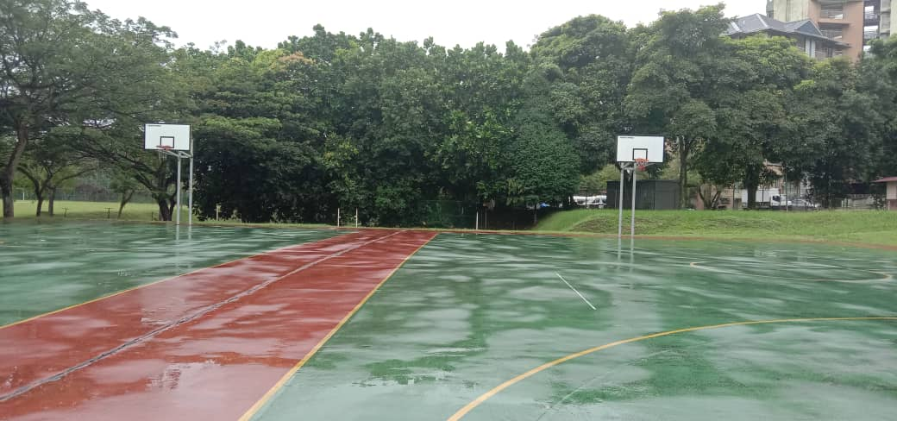
This the picture of K9 basketball court.

4.2.2. Futsal
The futsal games will be held at K9 futsal court. A team of 9 with 4 substitute players will be chosen for a team. For the time each game will be about 8 minutes per round.
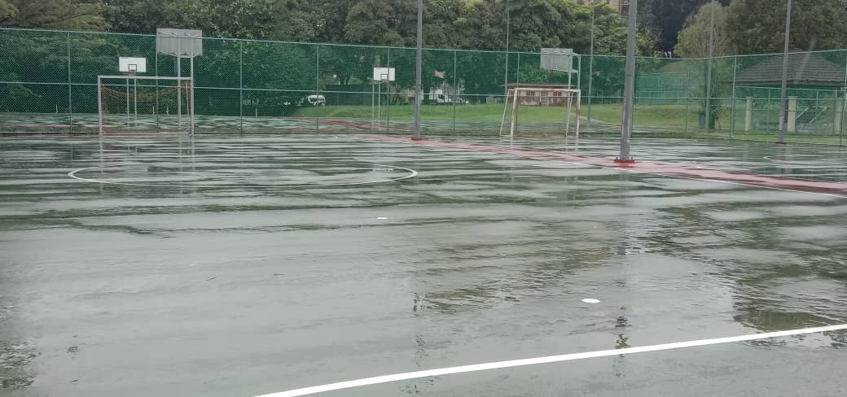
This is the picture of K9 futsal court

4.2.3 Tennis
Tennis is one of other kind of sports that we will hold for the Charity games. To make the games more fun and more excited and also more competitive, there will be both single and double for the tennis. And the tennis game will take place at the KTC tennis court.

4.2.4 Badminton
For badminton games, we are going to make the single and the double for the games. The groups of the badminton will be arranged as soon as the name of the participant of the charity game are ready. There will be both men’s doubles and women’s doubles for badminton.

4.2.5 Ping Pong
The Ping Pong is one of the unique games that are to be held for the Charity Games. One of the reasons that we choose the ping pong as one of the charity games is due to the consideration for the elderly that would like to join us in the games. Thus, we make the Ping Pong as one of our games to create a win-win solution for this problem.

4.3. Food festival
We would plan to organize a food festival during the sports event. Because after a tiring run and after the games there will be some of the participant that are hungry or need more water. Also, we would like to invite a maximum number of 20 food sellers because we will only provide 20 places at most. The invitation letters will be sent to the food sellers. And the food sellers that want to contribute in our event are requested to prepare all the information including the food menu, total cost and the number of workers and their details in case of security. For joining our event, each of the food seller will be requested to pay RM90 as a fee for the stall. And in return, we will prepare a facilitator for each of the stall to help the food seller throughout the event and coordinate the venue.
In order to promote this Food Festival, we will make an online advertisement and we will share the advertisement through all of the social media platforms that we have such as Instragam, Facebook, twitter and so on.

4.4. The charity
The charity is one of our main purpose in holding this event. The money that will be given for the charity will be taken from 30% of our income that we get by holding this event, starting from the registration fee until the food festival. The charity will be given to those in need and as stated before the target group of our event is the orphanages from the Orphan Care foundation in Johor Bahru. The Charity program will be held the next day after the sports event is all cleared. The participant will gather at the same checkpoint which is Padang Kawad in the UTM to get in the bus and go to the Orphan Care foundation in Johor Bahru. There all of the participant may join and help to give the charity and play along with the kids during the visit.

- ORGANIZATIONAL STRUCTURE

Member of the executive committee
-Program Manager: Muhammad Rafiy Athalla
-Secretary: Lim Sin Jie
-Treasurer: Anis Farzana Binti Ismail

Ordinary Committee Member
-OCM Venue: Yong Jing Xuan
Muhammad Izwan Bin Molpie
Soo Toh Xin Hui

-OCM Safety & Security: Amr Abdel Meniem Mohamed
Matthew Paul Jaunis
Jazio Bede Jaunis

-OCM Registration: Mohommad Hilmi Bin Sapri
Dabreena David

-OCM Basketball: Mohammad Rahmat Bin Abdullah
Mohammad Ikmal Hisham Bin Ismail
Vernord Musran

-OCM Futsal: Allfian Handry
Bernard Agong Sinawat
Winnie Wong Shi En

-OCM Ping Pong: Mohammad Danial Haiqal Bin Hasbollah
Aainaa Aliah Binti Abdullah
Edith Britney Patieh

-OCM Tennis: Rozellyn Simon
Tan Chiaw Torng
Vivienne Ak Harry

-OCM Badminton: Jeehoe Sinua Yamposong
Olleary Chai Hon
Jennie Liew Kah Nie

6) DUTY AND RESPONSIBILITY OF COMMITTEE MEMBER

Program Manager
-Organizing programs and activities according to what the committee have agreed
-Manage the risks and issues that might happen during the event with the help of all committees

Secretary
-Ensure all the event are all organize
-Send an invitation for all the committee member if there is a meeting
-Take note for every meeting

Treasurer
-Prepare the budget for the program
-Manage all of the spending that has been done for the event
-Make a financial report for the event after it is held

OCM Venue
-Ensure that the venue is available during the event and book all the venues that are required for the event
-Arrange the place, the stalls, chairs and tables which will be used during the program
-Maintain the cleanliness of the venue during the event

OCM Multimedia
-Take the photo and record the video during the event for documentation purpose

OCM Safety and Security
-Keep people calm and maintain the situations when accidents occur during the event
-Provide medical treatment for those are injured

OCM Registration
-Register all the participants for the charity games
-Take notes either the participant joins the Games or the marathon only

OCM Basketball
-Be the referee for each game for the basketball
-Count the minutes and score for each game
-Be the commentator during the games

OCM Futsal
-Be the referee for each game for the Futsal
-Count the minutes and score for each game
-Be the commentator during the games

OCM Ping Pong
-Be the referee for each game
-Count the score during the games
OCM Tennis
-Be the referee for each game
-Count the score during the games

OCM Badminton
-Be the referee for each game
-Count the score during the games

7)BUDGET

ESTIMATED INCOME

Sponsorship | Amount (RM)
Cash Sponsorship  - Student Affair UTM & Majlis Perwakilan Mahasiswa UTM (MPM UTM)  - Pusat Islam - Zakat | 2000  2000
Products Sponsorship  - Corporate Company  - Dasani Mineral Water Sdn Bhd  - Mighty White Sdn Bhd  - Eco Shop | 675  675  450
Participants Fee  - Marathon  - Food Seller | 40 (per person)  90 (per food stall)
Total Income | 25,600

ESTIMATED EXPENDITURE

Activity | Amount (RM)
- Food & Beverage  - For participants (RM3*450 persons) (sponsored) | 1350
- Program  - Prizes (RM250 each game)  - Prizes for Marathon  - Set up  - Food Stall (RM50*20 stalls) | 1250  1800  300  1000
- Gift & Souvenir  - Medals (RM15*450 persons)  - Goodies bags (RM1*450) (sponsored) | 6750  450
- Shirts  - T-shirts for members and participants (RM20*450 persons) | 9000
- Publicity  - Banner (RM20*10 pieces) | 200
Total Expenditures | 20,300

Profit = RM 25,600 – RM 20,300
= RM 5300

SPONSORSHIP PACKAGE

- Pre-Event

Marketing Communications

- Include the logo of the sponsors and any promotional materials on our social media pages for both advertisement of our events and sponsors.
- Invitation emails sent to the UTM students and staffs for the purpose of promoting events and sponsors’ logo will be included at the bottom of the emails.

- On-site

- shirt design

- Sponsor’s logos are included in the design of the T-shirts for the members and participants.

Giveaway and souvenir

- Sponsor’s logos are printed on the goodies bags.

- Post-Event

- Mention the name of the sponsors as well as the logos in the post-event email.

SAMPLE OF SPONSORSHIP LETTER

11th December 2019

Anis Farzana Binti Ismail,
Treasurer,
Program “Charity Games”,
School of Computing, Faculty of Engineering,
Universiti Teknologi Malaysia, Johor Bahru
012-3456789 | a@gmail.com

Dear (recipient name),

Warm greetings from Universiti Teknologi Malaysia (UTM). I hope this message finds you well.

First of all, I would like to introduce myself. My name is Anis Farzana Binti Ismail, this "Charity Games" event's treasurer. It is a great pleasure for us to offer a nice opportunity for your company to cooperate with us and become a valued sponsor of the event that will take place on the 10 April 2020-11 April 2020.
For your information, this event is a 2-day event of charity sports event with purpose of encourage people to exercise while raising funds for those who are in need which takes place in some place like Azman Hashim Stadium, K9 futsal and basket court, and Sport hall. Through this program, 30% of our total profit will be donated to the orphanages from Orphan Care Foundation in Johor Bahru on the second day.

We would really like to invite you to come forward and contribute not only to monetary fund but also regarding to items and food and beverages. We would be really grateful if you could cooperate with us in order to make this event a success. This would be an honor to be associated with a known organization such as your company.
Within a week, I will follow up with you by phone to see if you are interested in being an official sponsor of the event but do not hesitate to contact us in the meantime if you have any inquiries and wish to proceed.
Thank you so much for your time, and we look forward to hear from you!

Sincerely,

----------------------
Anis Farzana Binti Ismail
Treasurer of program “Charity Games”

8) Estimated Date, Time, Venue

Date: 10 April 2020(Friday) - 11 April 2020(Saturday)
Time: 7.00 a.m. - 3.00 p.m.
Venue: Azman Hashim Stadium(Friday), Padang Kawad UTM(Saturday)

For those who have read this are recommended to participate in this event. And this event, the charity games event is open for all ages including for those who are outside of UTM. We are recommending this event because the program aims to help who those are not capable to do exercises in their daily routines. And for those who have not played such sports games before, here we will teach you about the rules of the sports as well as some techniques to learn the basic skills to play certain kind of sports because we will select the type of sports for the participants randomly. Also, there will be some little prizes for the winner as rewards and encouragement to them who is brave to step out from their comfort zone to be involved in a new sport activity.
Not only that, the main reason that we recommend to join this program is that the main purpose of this program is to raise funds and give to charities for those who are in need.
Nowadays, there are still lots of people who live in impoverished conditions and at the same times striving hard to seek financial improvement, so there is a dire need for us to lend a helping hand to them to reduce the number of poor in society. In our case, we are targeting an orphanage named the Orphan Care Foundation in Johor Bahru. We will give 30% of our incomes to the children to improve their living conditions. Thus, we decided to do a sport games to make this event more excited and meaningful while gathering money for the charity.

9) Program Schedule

Day | Time Event Venue
Friday,  10 April  2020 | 7.00 a.m. Marathon Azman Hashim Stadium  8.30 a.m. Break & food fest Padang Kawad UTM  9.00 a.m. Charity Games (Depend on the sports)*  4.00pm Prize distribution Padang Kawad UTM  4.30pm Certificate and medal distribution Padang Kawad UTM  5.00pm End
Saturday,  11 April  2020 | 7.00 a.m. Goes to Orphan Care Padang Kawad UTM  (Gather)  7.45am Bus leave  8.30am Arrive at the orphan Orphan Care Foundation  8.45am Play along with the orphan Orphan Care Foundation  12.00pm Give them the charity Orphan Care Foundation  12.30pm End

*
Sports | Venue
Basketball | K9 Basketball Court
Futsal | K9 Futsal Court
Badminton | Sport Hall
Tennis | KTC Tennis Court
Ping Pong | Sport Hall

10) Safety and Security of Event

For the safety and security of this event, we will be requesting the voluntary services from St. John Ambulance of Malaysia for the first aid standby and the ambulance services. The first aid standby is needed from the St. John Ambulance of Malaysia for the first aid treatment for the sick and injured people that occurs during the event with the help from the OCM safety and security of this event. Another reason would be the assistance of the St. John Ambulance is necessary for the immediate medical treatment in case if there are some incidents that people are injured or faint during the event.
Beside the first aid standby, the ambulance service is needed for this event. The ambulance service will be used to provide transportations for the sick and the people that are injured to send people from the accident site to the hospital in urgent situations. And the services had to be provided immediately if there is any accident that happens during the event. A total of twenty volunteers and two ambulances from the institution are required so as to make sure that we can deal with some sorts of accidental situations efficiently. Last, in order to lighten up the works of the St. John ambulance services, we will assign some team members from our OCM safety and security to assist them throughout the event.

11) Conclusion

In overall, the primary objective of the project is to encourage people especially UTM students to involve themselves in sports and exercise and simultaneously raise fund for Orphan Care Foundation.
The project can bring tons of advantage to all parts of UTM and that is why we attempt to promote our proposal. It can develop a healthy lifestyle in UTM and present a good image to the public.
Besides, our project aims to raise fund for vulnerable groups in society such as orphans and it shows to the public that a big educational organization like UTM encourage her students to do charity and serve to the society. It would make a great influence to others to show their caring on charity.
Last but not least, our project can help UTM to discover talented athletes through a series of sports game such as basketball, futsal, badminton, tennis and ping pong. The talented players can represent UTM to participate sports activities in different levels even an international level sports activity. It can grab attention of public and make them remember the name of UTM.
Our project can make such of advantages as mentioned above to UTM and hopefully it can be approved. We need to initiate the project by 10 April 2020 and the detail budget would be presented once project is approved, and your funding and support is essential.

12) SELF-REFLECTION FOR EACH MEMBER
SELF-REFLECTION (LIM SIN JIE)

First and foremost, I would like to say that I feel honored and grateful for being a part of this program and also being a member of this team. Not only had I gained the extra knowledge, but I had also broadened my horizon during the progress of this doing the program proposal. It was my first experience involving in a big project and cooperating with others in order to make a complete program proposal. Since I am a person who always avails of every opportunity given to me, thus, without a shadow of a doubt, I had put my maximum efforts into this project as I hope that I could leave no regrets in my first experience of doing organizing a big event. During the first minutes meeting, we discussed the topic of the proposal and finally, we had decided to do a program on charity games related to sports. It is because we hope to do a program that is beneficial to people, so we think that it is a good choice as doing this program can help the orphanage in need and meanwhile, expose more people about the importance of sports due to the facts that there are lots of people who do not realize that exercise plays a predominant role in our daily lives.
Furthermore, I had a profound change in myself as I honed my logical thinking skills and sharpen my communication skills throughout this doing the proposal. It is because logical and critical thinking is a must whenever there is a problem to be addressed and solved. Being involved in the program requires me to become a person who can figure out the most effective way to tackle the problems efficiently in a short period so as to maximize productivity when doing this project proposal. Also, I had improved my communication skills in order to build rapport with other members so that we can work together to overcome the challenges. And I realized how mastering communication skills can empower us in reaching our goals as we need this skill to persuade and convince people to listen to our proposals and pieces of advice. Throughout the journey of doing this project proposal, I had learned how to take every aspect of the things into account when making decisions and also keep things in perspective especially when the others in the group express their point of view. Thus, this project had helped me to improve myself in many ways as I needed to probe deeper into the problems encountered instead of just scratching the surface.
Last but not least, I would like to express my gratitude to all people that had assisted me in this project, especially to my lecturer who is Dr. Muhammad Abd Hadi Bin Bunyamin as he always gave us some sound advices whenever we had encountered some problems when making our group proposal. It made me realize that sometimes we cannot accomplish some tasks on our own and we must seek help from people in certain circumstances. Thus, good teamwork is a key to the success of the event as we need to work hand in hand through those tough moments in this project proposal. Also, having a good leader goes a long way towards organizing the event as he always listens to our different opinions and try his best to boost our team morale whenever there are problems. Also, each of us always took full responsibilities on our own tasks and no one had tried to pass the buck. There are many things that I had learned from this project, especially when I know that I must equip myself with soft skills for my future pathway. To recapitulate, I appreciate the efforts of all members who make the project proposal successful and I know that the challenges that I had faced are just the tip of the iceberg, so it is pivotal for me to mould myself into a well-rounded person to ride the ups and downs in the future.

SELF-REFLECTION (ANIS FARZANA BINTI ISMAIL)

Through the process of completing this project, the most important thing that I discovered was the advantage of working as part of a group. When the time and resources are limited, I learned that a good teamwork is the key to successfully planning and designing activities. Other than that, we gained a lot of ideas and suggestions as everyone had their own point of view and way of thinking. I also found the energy of group member’s participation made me feel more energetic to contribute something for the group work. Then, I discovered that the simplest things we do could be improved and turned into something big if we put enough effort and creativity while working on it.
Although our group members were pretty quiet at the beginning of the project, we became more comfortable as the time went on and we started to contribute our views and ideas to the group discussion until the project was completed. This initial silence, I believe, was a phase where we were searching for good ideas to be shared with the group members. Not only that, I also found that we developed a good decision-making process whereby we were able to come to a mutually agreed conclusion on majority of things that we discussed.
Of course, in most group works, there must be certain conflicts happened as the consequence of group members having different point of views, skills and experience. From this, my group members and I take this as an experience. I think that a bit of element of disagreement throughout the process is the best way to complete and improvise our work. This is because we can see the pros and cons of each of the ideas presented and it will make us motivated to discuss and choose the best decision for our work.
In conclusion, I learned that the group work is a very educational and beneficial experience concerning the importance of being able to work well in a team. The main aspect that I would to improvise is my personality and confidence as I see myself as a person with not great communication skill, which will enable me to contribute more of my ideas to group work. Lastly, I would like to thank my lecturer Dr. Muhammad Abd Hadi Bunyamin who gave us the opportunity to do this task and provide us with a lot of information and guides throughout the process of carrying out the proposal. I would also like to thank my group member because they gave their cooperation and helped each other to finish this work.

SELF-REFLECTION (YONG JING XUAN)

It was a great cooperation with my group members throughout the progress to build a proposal of a charity event. Everyone in the group played different kind of roles. Our leader, Rafiy has a great team management skill. He had divided the tasks to every group member and ensure everyone is clear about the tasks given. Rafiy has provided some good ideas too based on his former experiences. Next is Sin Jie, a shy and quiet girl but she could give some constructive suggestions on the proposal. Ahmad, an executor has taken a lot of actions such as designing the logo and the t-shirt. Last is Anis, she is a good communicator and always take the role to lighten the atmosphere among the group members when there is an argument between them.
In overall, I would like to thank my group members again for giving full cooperation to make a perfect proposal. It cannot be done without any parts of the members. A good proposal is a mixture and product of ideas from every member with different kind of thinking and perspective.

SELF-REFLECTION(MUHAMMAD RAFIY ATHALLA)

For the first thing I want to thank you for this great team and it's an honor to work with all of the team members. The truth is this still the second time that I work on something with someone that have such different background. Starting from different countries, and this diversity had led toward even more difference like the tradition, the way of thinking or you can say the point of view is different, the experience that each of us has face before is different and etc. But, by working together I figured that diversity is not such a bad thing. By working with all the group members, I figured that diversity is not a weakness, diversity is not useless, and I discovered that diversity is power, diversity is weapon to face all kind of problems that might happen. It is because as I state before that every member have faced different problem, and so is that they have counter different solution too. As some wise word said "Don't run from your weakness, but make it your strength". And I'll state that I believed all of my group member that they can do more than what anyone will expected.
This is the story from the start. For the first meeting, the truth for me it was a really awkward meeting. Because you have just been put into a group where you did not know well any of the group member and you are seldom to talk or even have never been not talking to them. It is like you have been put in the middle of nowhere. On that moment we just do a little talk like introduction and discussing about the group name. But in the next meeting, we tried to open ourselves to each other. And we really tried to start discussing about what event should we held, and at that moment we choose this Charity Games as our event. And more importantly at that moment, I really feel this group is amazing and really friendly. My hope for the group did not just stop on that. In the group chat, there is even more suggestion that are given by the members. And all the suggestion is all awesome, their idea is totally something that come out from another view. As the time keep going, so is our group process making this proposal, and not less, so is the relation between each of the group member.

Last but not least, I want to say THANK YOU for all of the group member.

SELF-REFLECTION(AMR ABDEL MENIEM MOHAMED)

I want to thanks them all because they helped each other and they helpd me in all the work that’s because my leg is broken and I hope you like this event because we are so exited to see your opinion and tell us what do you think and what should be changed an ithink you like it like us.

13)REFERENCE

- NarwantK.(2019, April 8). Malaysia and WHO Call for More Investment in Primary Health Care the 21st century. World Health Organization. Retrieved September 10, 2019 from
https://www.who.int/malaysia/news/detail/08-04-2019-malaysia-and-who-call-for-more-investment-in-primary-health-care-the-21st-century

- Liyana H. (2019, July 31). Obesity in the Rise in Asean. The Asean Post. Retrieved September 10, 2019 from
https://theaseanpost.com/article/obesity-rise-asean

- Milton L. (2018, August 14). Malaysia is Asia’s Fattest Country. The Star Online. Retrieved September 11, 2019 from
https://www.thestar.com.my/lifestyle/health/2018/08/14/fat-state-of-affairs

- Eng Bee T. (2019, November 21). We Don’t Exercise and Have Bad Eating Habits. New Straits Times. Retrieved November 23, 2019 from https://www.nst.com.my/opinion/letters/2019/11/540561/we-dont-exercise-and-have-bad-eating-habits

14) APPENDIX

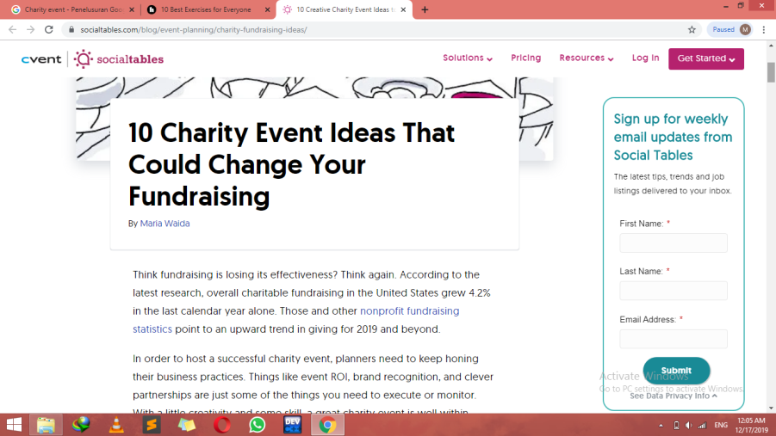
https://www.socialtables.com/blog/event-planning/charity-fundraising-ideas/
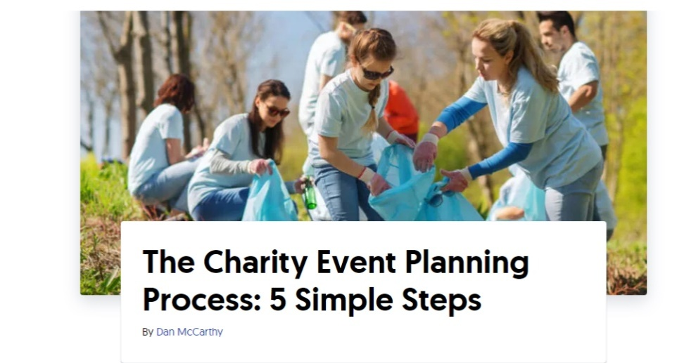
https://www.socialtables.com/blog/event-planning/charity-event-planning/
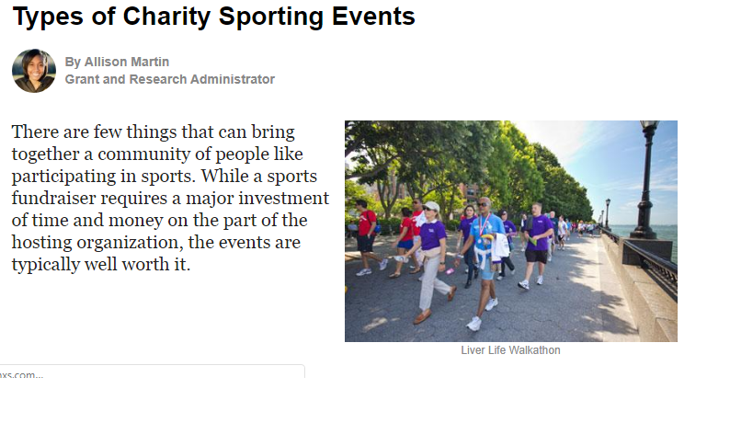https://charity.lovetoknow.com/fundraising-ideas/types-charity-sporting-events

15) MINUTESOF MEETING
First Meeting:
No. | Group Members | Time Arrival with Signature | Time Finish with Signature | Group Meeting Agenda |  |  |  | Other Remarks  e.g potential problems/ difficulties
 |  |  |  | Date: 26/11/2019  Time: 10.00am-11.00am |  | Who took the notes?  Name: Lim Sin Jie | Who is leading the discussion?  Name: Muhammad Rafiy Athalla | To get more participants for this event, the event needs to be more attractive and well- planed
 |  |  |  | No. | Agenda Items  What are the things discussed at the meeting? | Who is talking/giving ideas? | What action needs to be taken? What do we need to bring?
1 | Muhammad Rafiy Athalla | 10.00am | 11.00am | 1 | Decide the type of event that will we held | Group decision | Some sorts of charity event but must be more attractive by adding some sport in it
2 | Lim Sin Jie | 10.00am | 11.00am | 2 | Decide this event is for who | Lim Sin Jie | The child in the Orphan care foundation and the sport is for those who are seldom to exercise
3 | Anis Farzana Binti Ismail | 10.00am | 11.00am | 3 | Decide what will be held in the event | Muhammad Rafiy Athalla | For the sports, we mayorganize a marathon, basketball,futsal,badminon,Ping Pong, Tennis
4 | Yong Jing Xuan | 10.00am | 11.00am | 4 | Decide the name of the event | Anis Farzana Bnti Ismail | The name for this event is Charity Games
5 | Amr Abdel Meniem Mohamed | 10.00am | 11.00am | 5 | Decide the location for some part of the event | Yong Jing Xuan | The location for the basketball and the futsal is at the K9 court

Second Meeting:
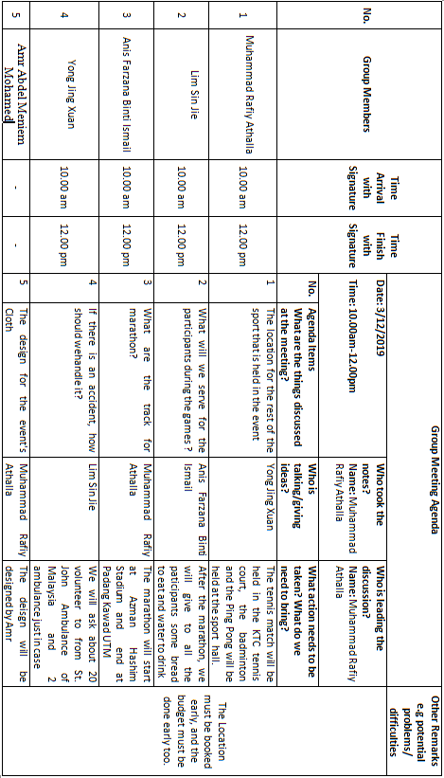

Third Meeting:
