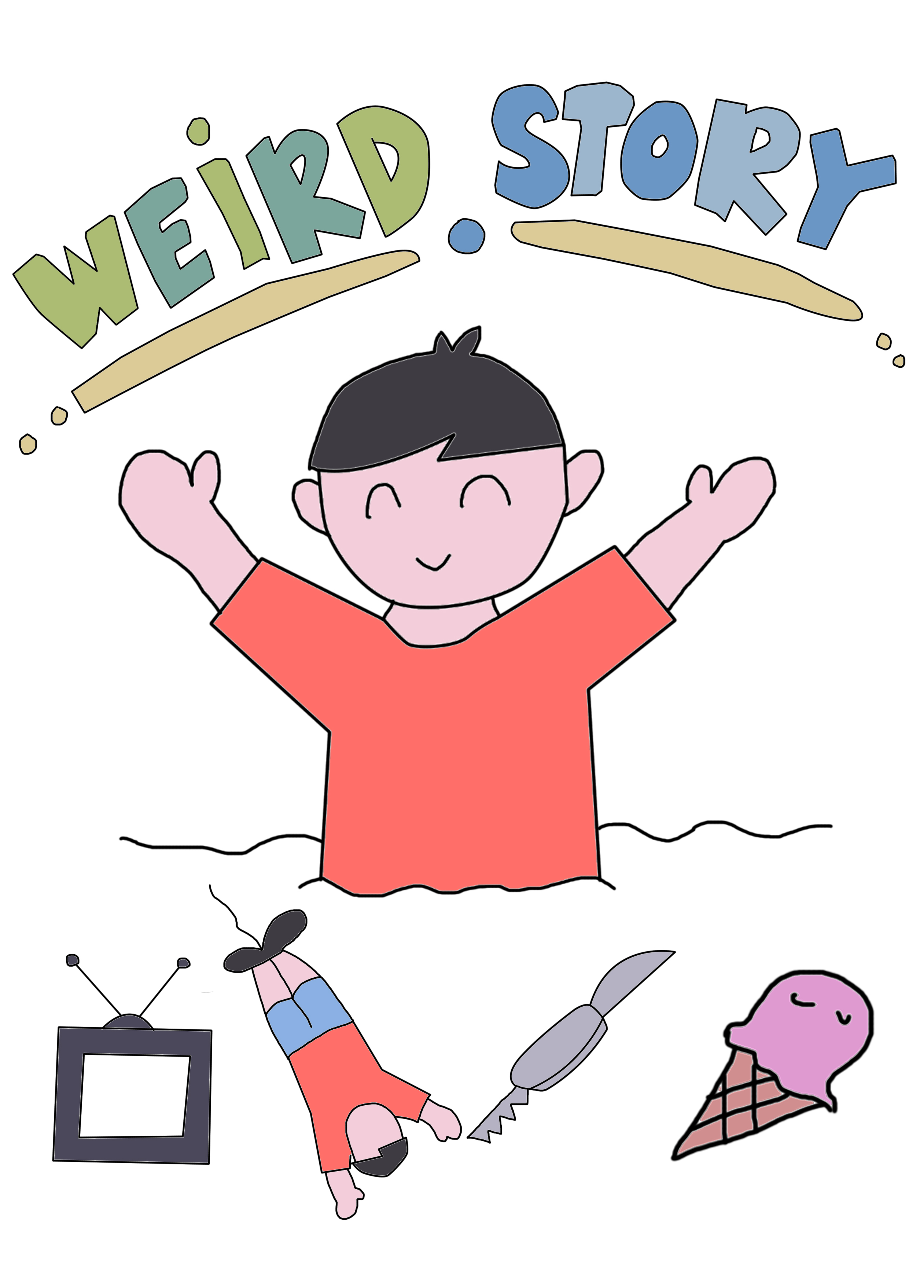
KUTTY MAMMI DATE OF SUBMISSION : 11th December 2019
what will you do, if you noticed an ice-cream store while doing a bungee jump?

This story about how a lovely boy named Andy react in this situation.

Weird Story
Illustrated by Farahziba, Ameenuddin
Written by Low, Adam, Weng Tze
designed by Kevin Rezza

Typeset by Comic Sans MS

This storybook was for Graduate Success Attribute (UHMT1012) assignment.

Group Member:
Farahziba binti Hamadun A19EC0264
Ameenuddin bin ismail A19EC0016
Muhammad Kevin Rezza Ramadan A19EEC0264
Adam Mostafa Shebani A19EC4026
Siah Weng Tze A19EC0161
Eyu Si Xiong A19EC0044
Low Wei Chieh A19EC0079
Muhammad Dimas Adityo A19EC0259
Attariq Airiel Rachman A19EC0227

a

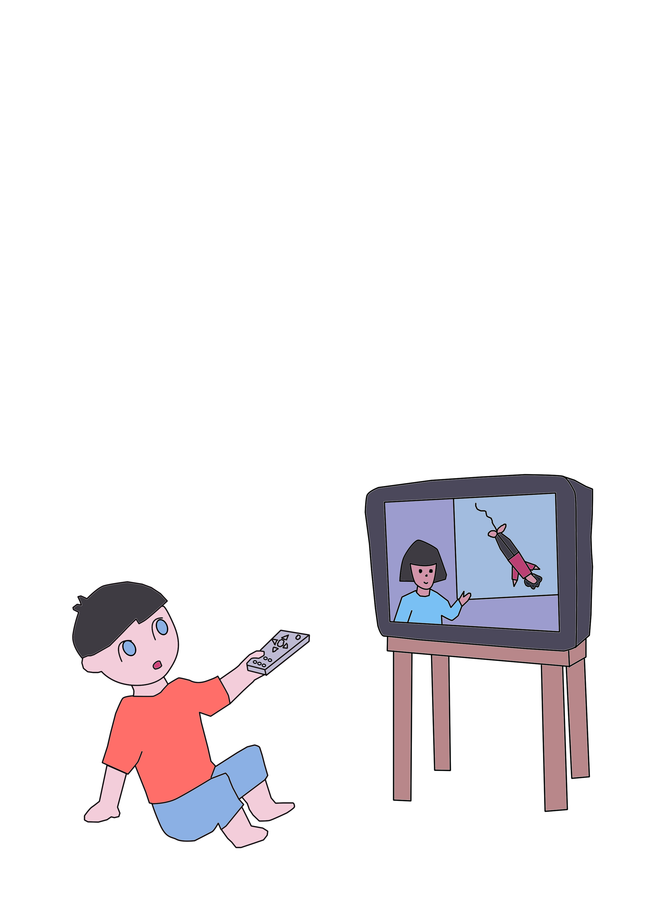

Once upon a time, there was a boy called Andy who was switching between the channels on TV until he saw a documentary on the history of bungee jumping. So, the boy was amazed at this activity and decided to give it a try.

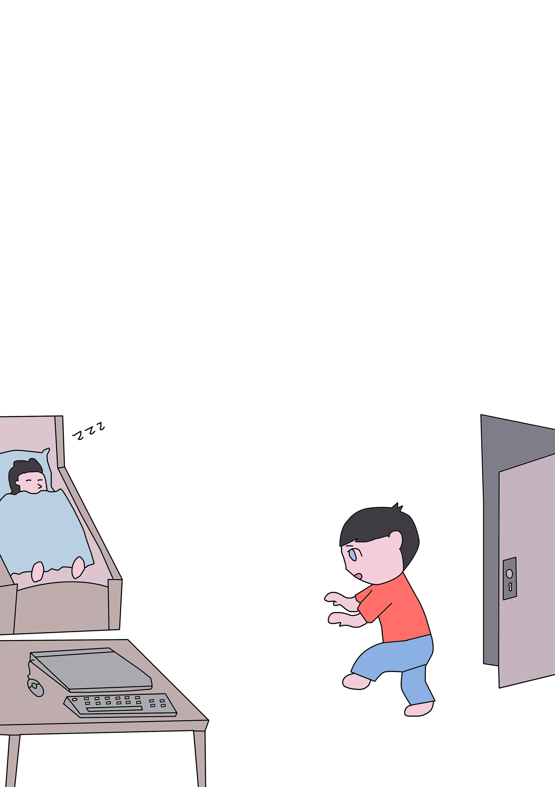

He stole his brother's laptop and started to search online for the nearest place for bungee jumping and how to get there.
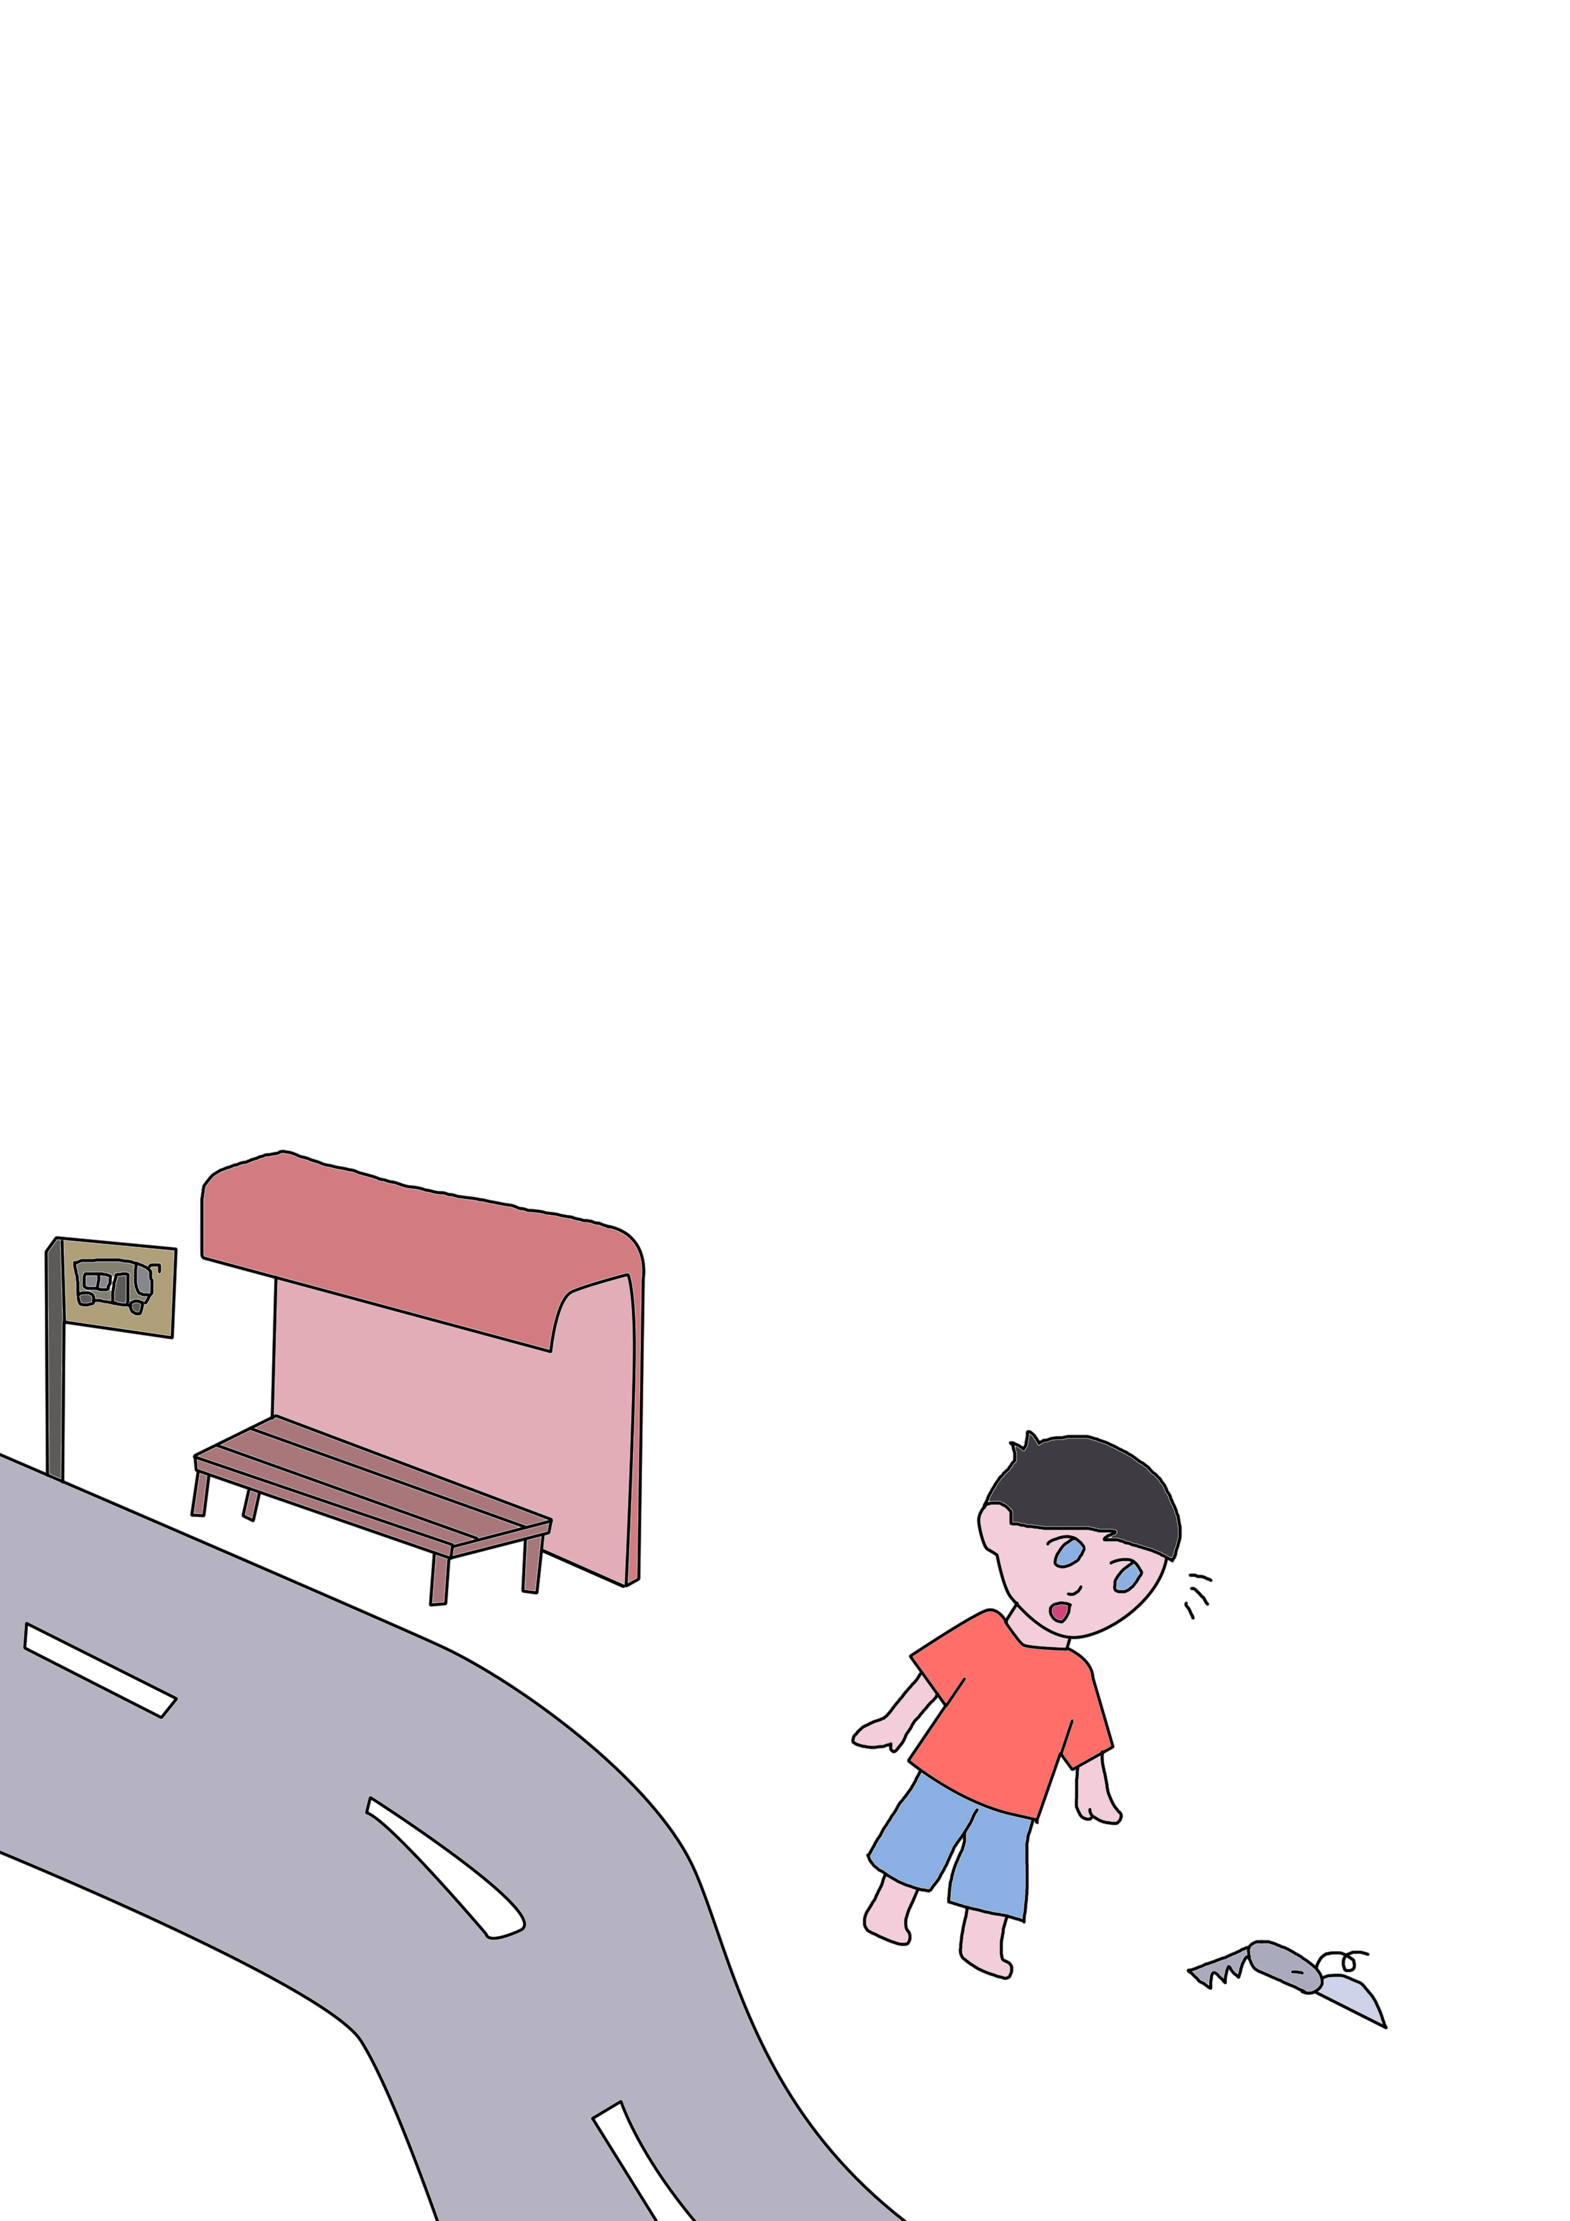
The next day, Andy took a bus to the nearest station to IScream Valley and then continued on foot. Along the way he found a pen knife laying on the floor, so he took it and put it in his pocket.

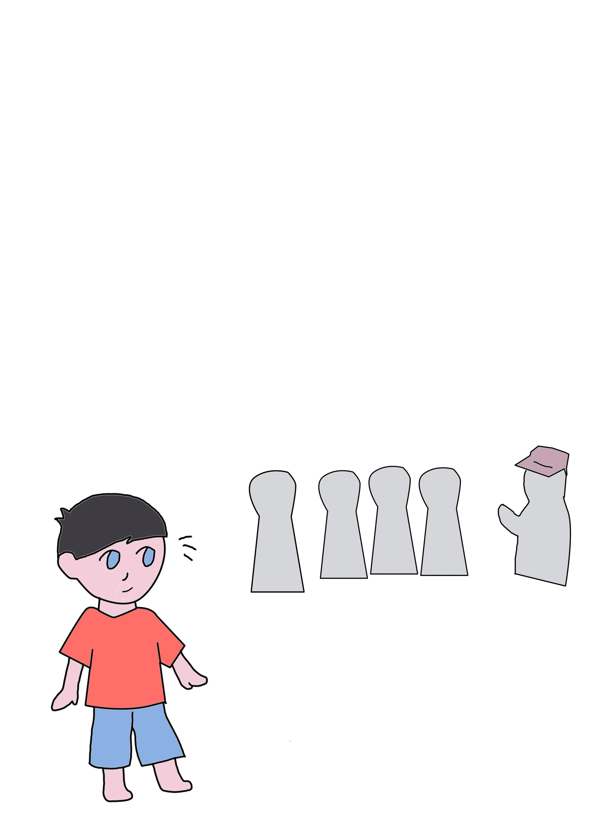

After a long 10 minute climb, he finally got to where he could jump and he took a ticket and waited for his turn.

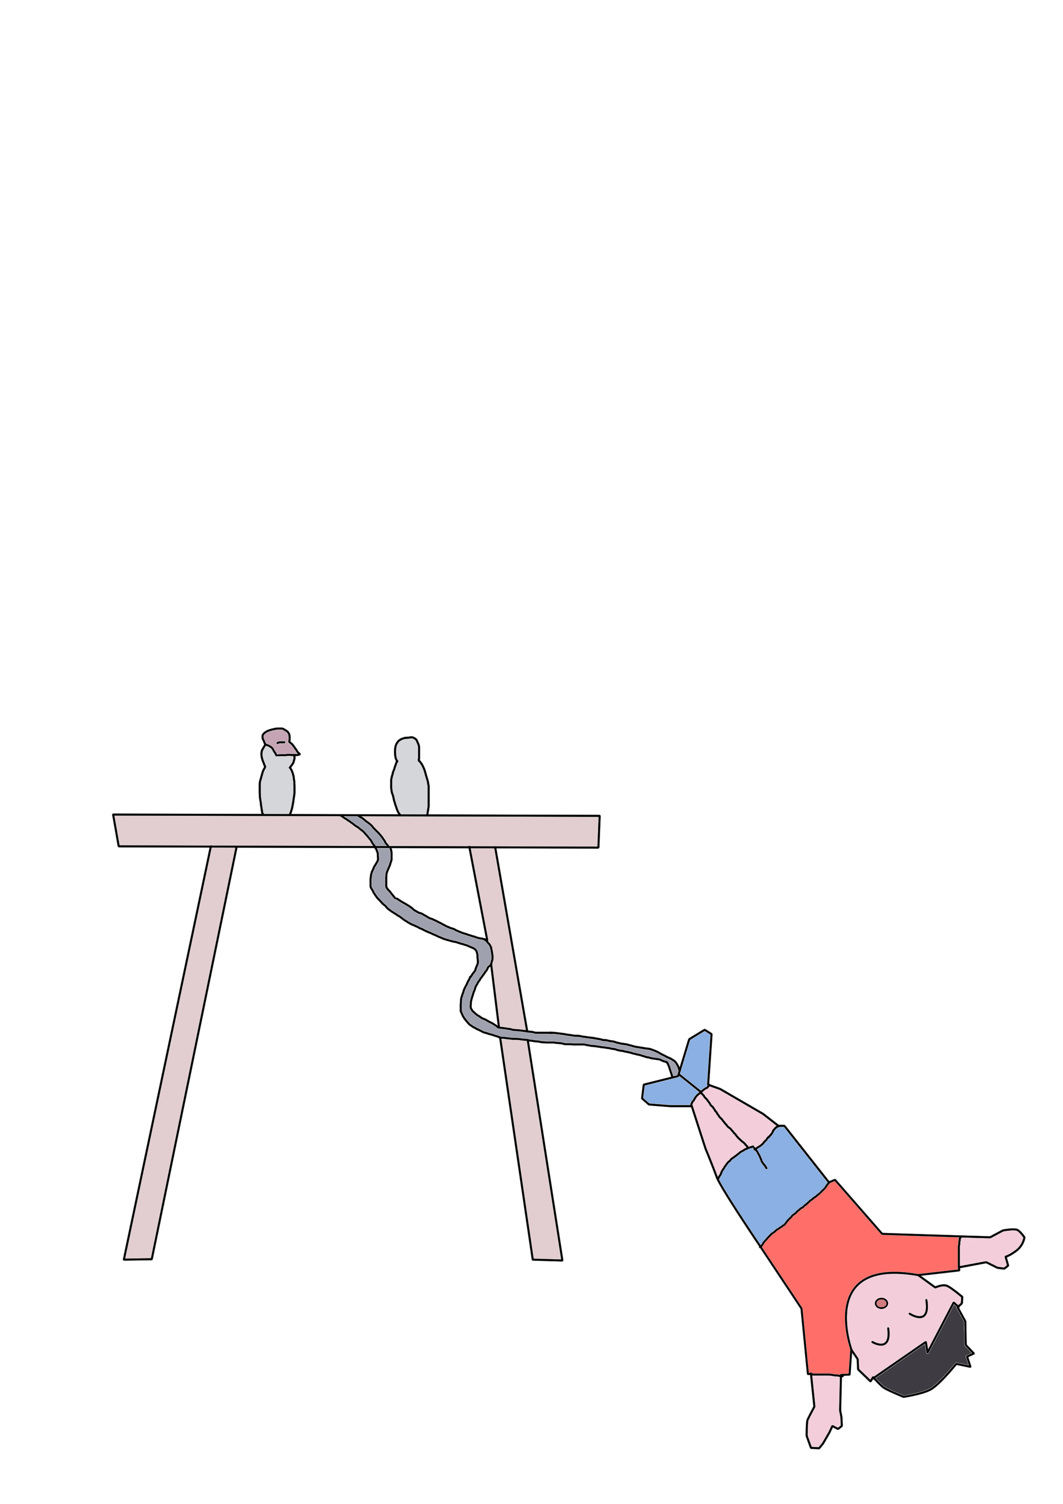
When it was his turn, the boy was hooked up to the rope and with all excitement leaped from the bridge.

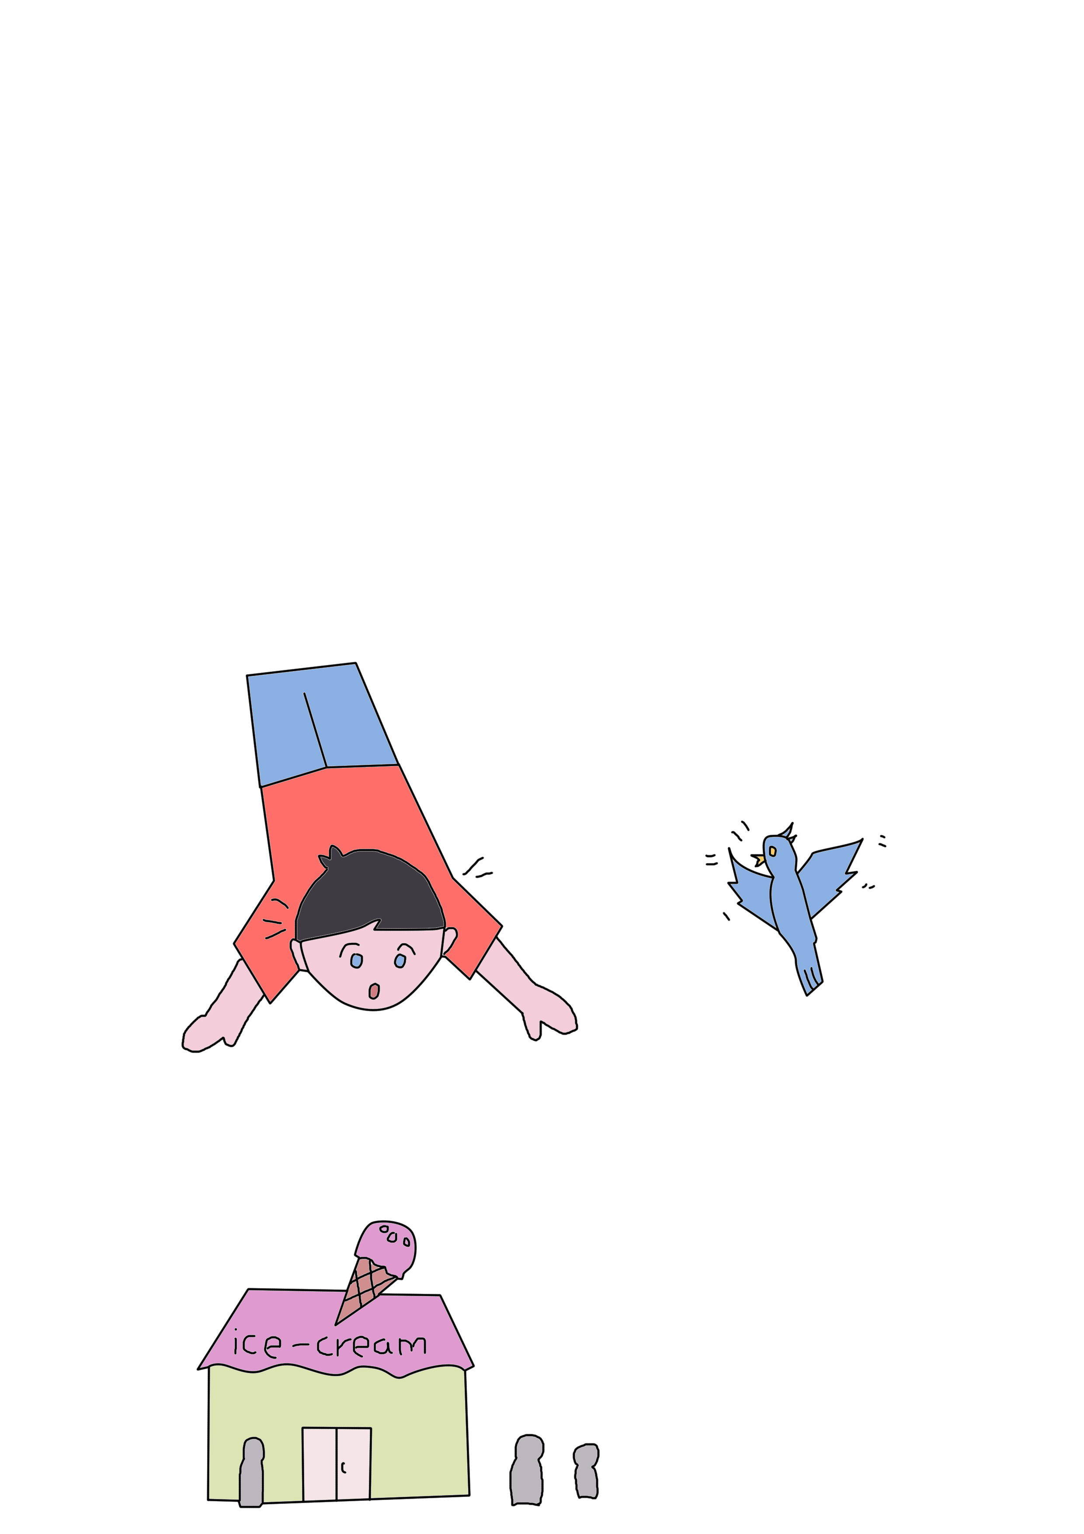
As he was dropping, he noticed an ice-cream store at the bottom just under him.
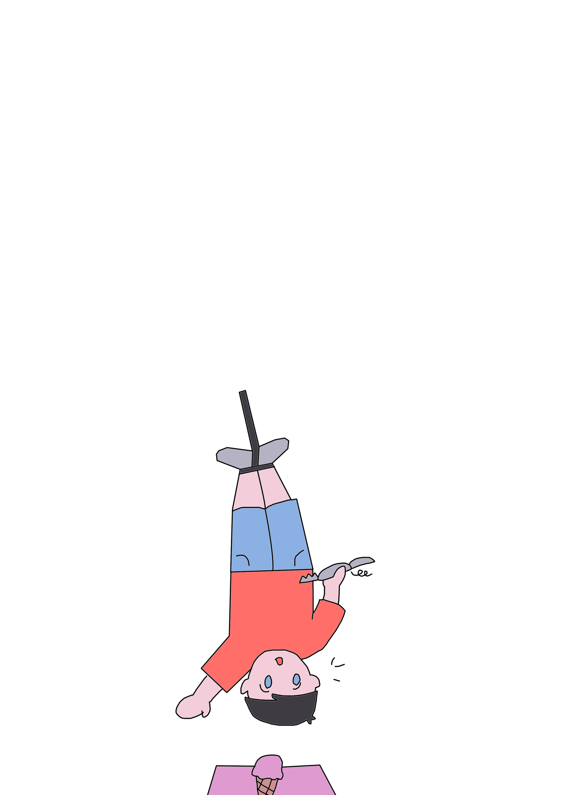
Andy couldn't resist and he tried with all his power to get himself loose from the rope to get himself some mouth-watering ice-cream until he remembers the pen-knife which he had found earlier.

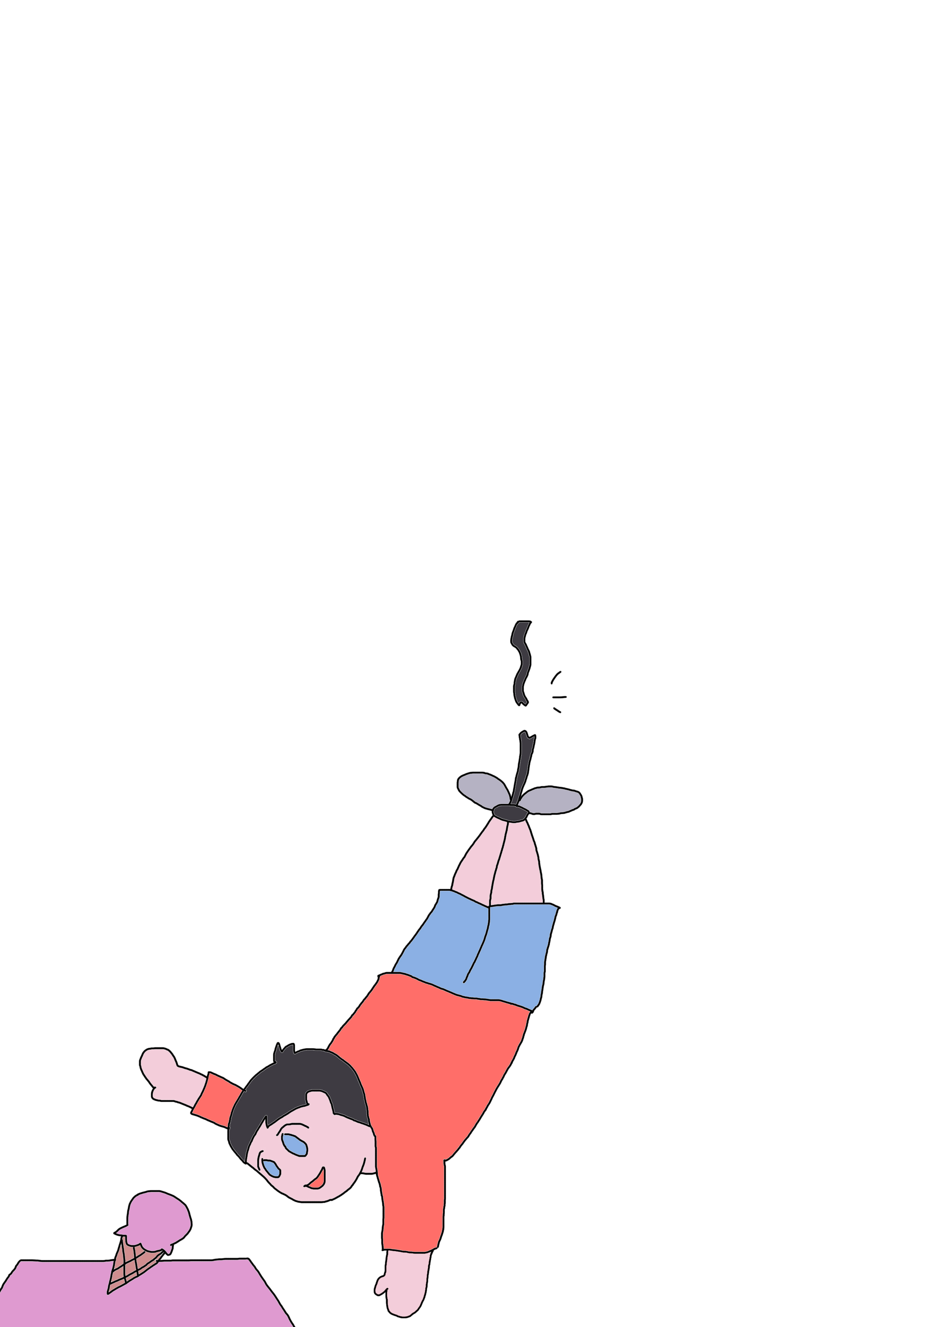

He took the knife out and quickly cut the rope and dropped all the way down to the chimney of the ice-cream store.
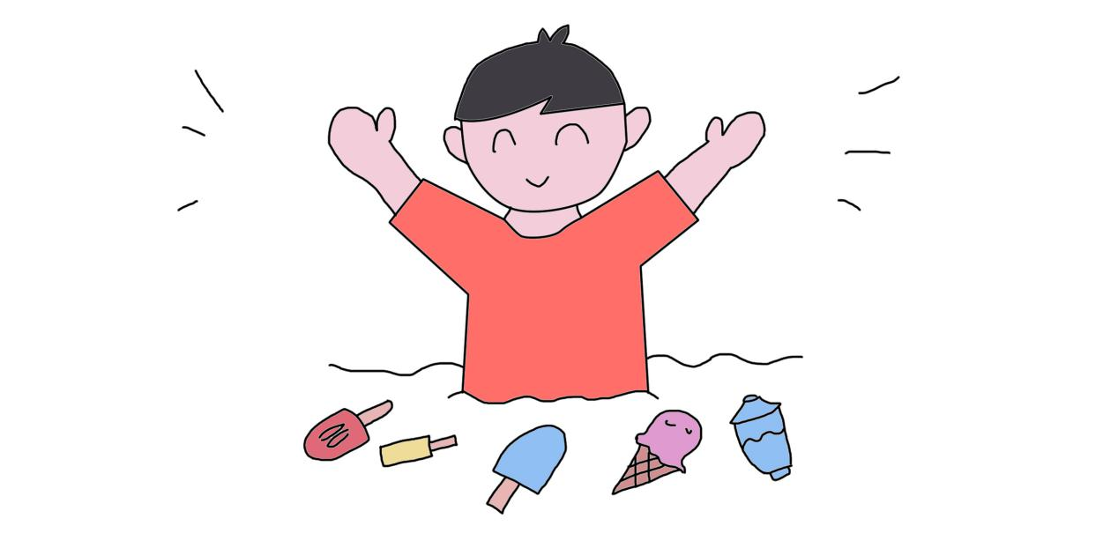

Landed in a giant bowl of ice-cream. "Piak!" Andy thought to himself that it was the happiest day of his life. Not only did he try bungee jumping, but also he got himself all the ice-cream that he could wish for.

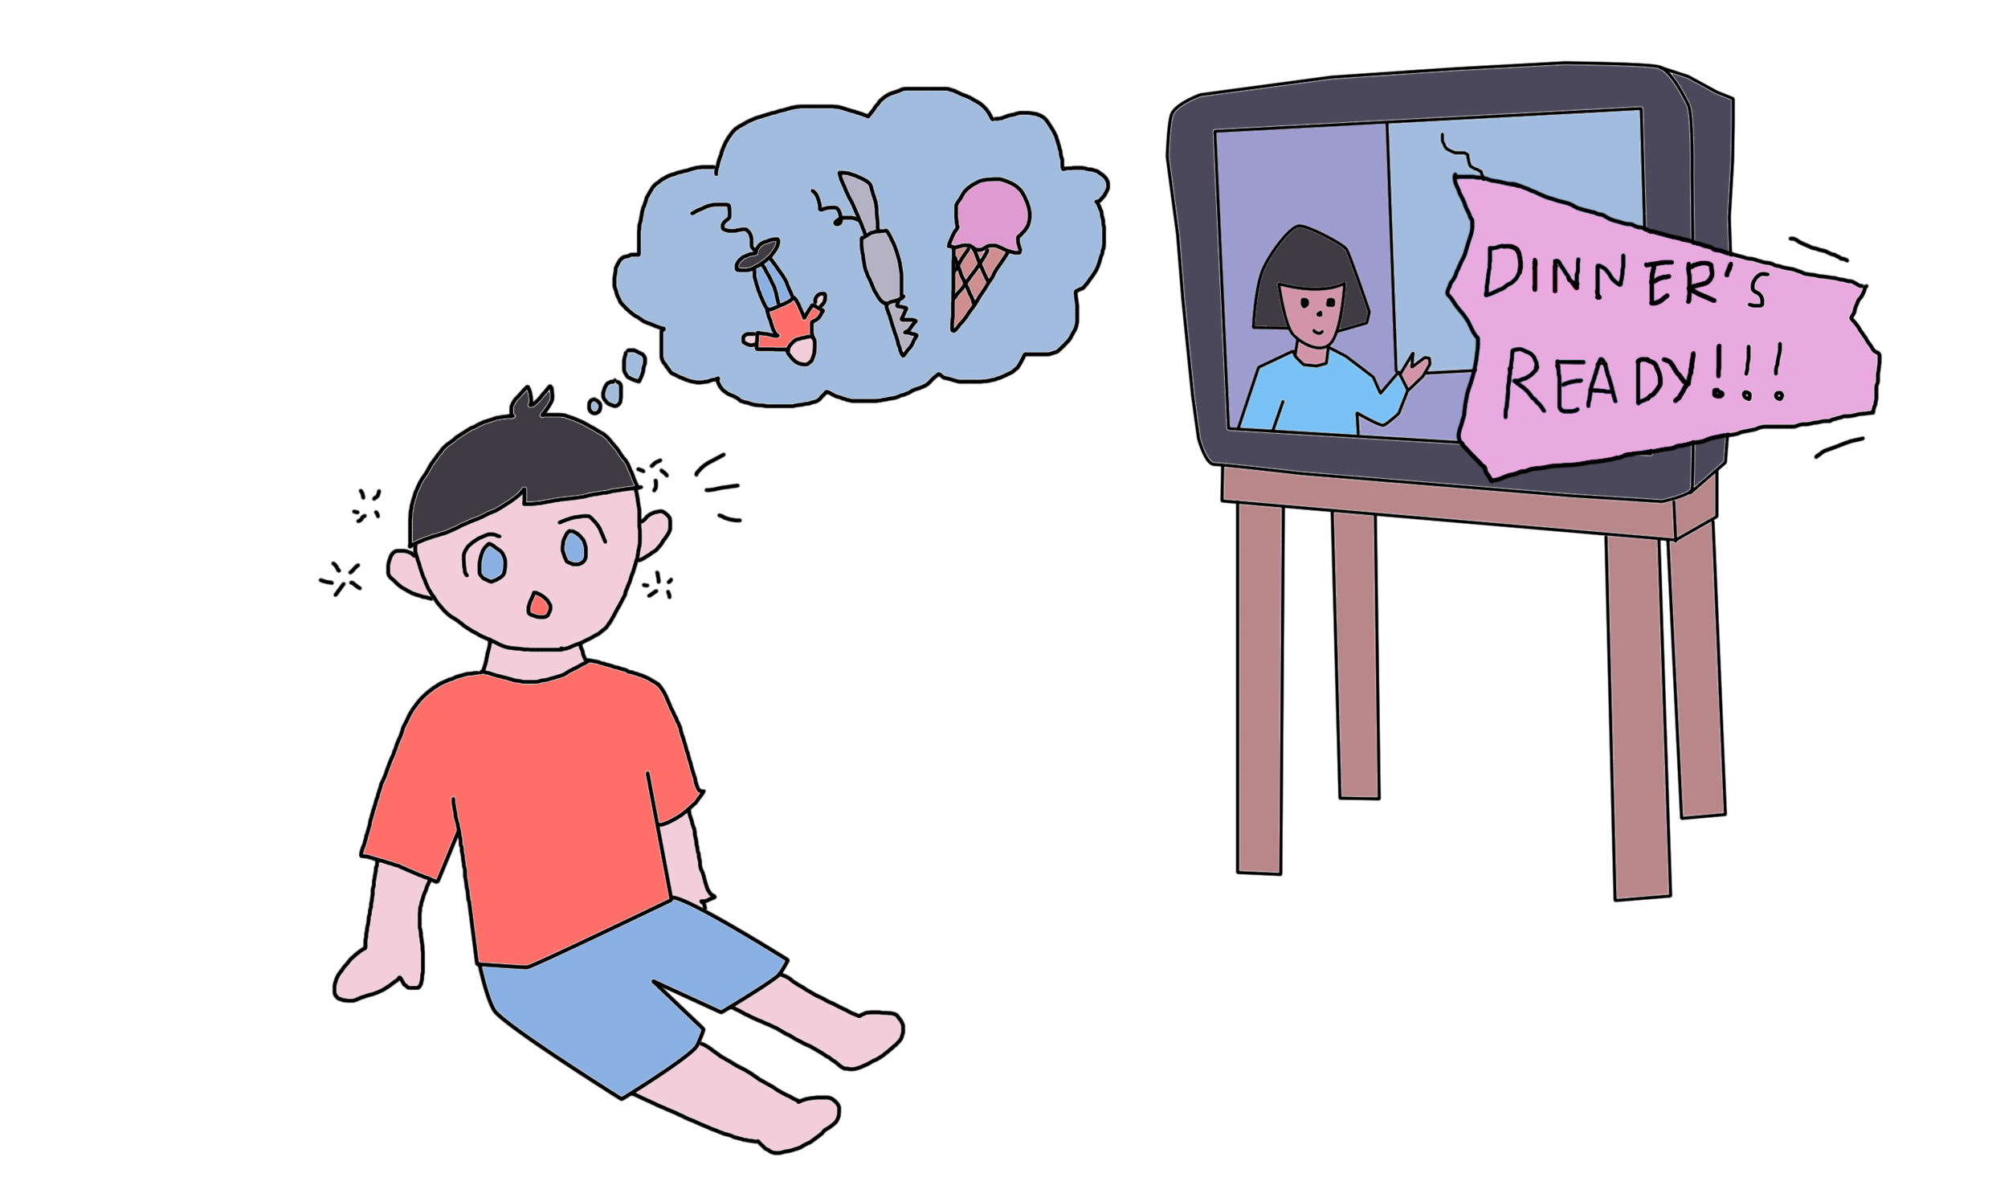

Until he heard his mother calling "DINNER'S READY!!!" and woke up only to realize that he had fallen asleep from getting bored of watching the documentary.

~THE END~

Acknowledgment

In preparation of our assignment, we had to take the help and guidance of some respected persons, who deserve our deepest gratitude. As the completion of this assignment gave us much pleasure, we would like to show our gratitude to Ms. Hazinah binti Kutty Mammi, Course Instructor, for giving us good guidelines for assignment.

In addition, a thank you to all team members because willing to work hard to finish this storybook.

