
SEMESTER 1
SESSION 2019/2020
SECP1513

GALLERIUM REPORT

Prepared By :
Muhammad Mukhlis Bin Mohd Feris Halmy (A19EC5225)
Rifadul Islam ( A18CS4050)
Md Shakil Chowdhury (A18CS4047)
Section 6
Lecturer: Dr. Aryati Binti Bakri
Contents
INTRODUCTION 3
TECHNOLGY HISTORY 4
Reflection 12
TASK OF EACH MEMBER 13

INTRODUCTION
CICT is a support unit that offers and delivers ICT services for the university (staff and students) especially in ICT infrastructure, system development and academic or administrative activities. As we all know, CICT is introduced here in UTM. CICT was also known as the computer as the Computer Centre back in 1975, and then it became the Institute of Computer Science in 1984. They changed the name to Computer Centre UTM (PKUTM) in 1991. At last, the name CICT was chosen in the year of 2004 until today.

There are some facilities that CICT provides which are internet & WIFI, CRM, web management, infrastructure & security, ID account & access, application development, multimedia, software and ICT facilities. And importantly, all these facilities listed benefitting the students and also the staff of UTM.

TECHNOLGY HISTORY
Typewriter
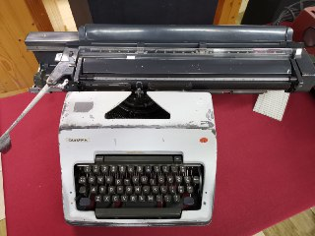
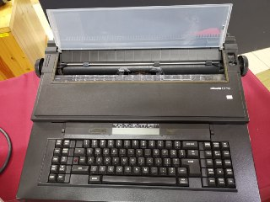
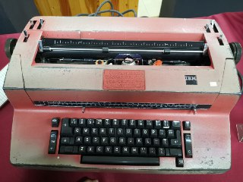

Figure 1: Figure 2: Figure 3:
IBM Selectric Olympia Typewriter: Olivetti ET 116
Typewriter A German Original Typewriter

Typewriter is what its stands for. It is a device where we use it to make our writing more beautiful and neater. The first typewriter in was invented in 1867 by Christopher Latham Sholes and William Austin Burt. The above pictures are the typewriter used in the library during the 1970s until the early 1980s. Before the application of computers in 1985, these apparatuses were once used for administrative tasks such as printing letters and memos. As what have been said, this machine is to make our work become faster and more efficient. Figure 1 above is IBM Selectric typewriter where it’s using mechanical binary coding and two mechanical digitals to analog converters. Figure 2 is Olympia Typewriter also have been using in UTM Library.
Last is Olivetti ET 116 Typewriter (Figure 3) create by Olivetti company and also one of famous typewriter. It also one of the competitors to the IBM Typewriter.

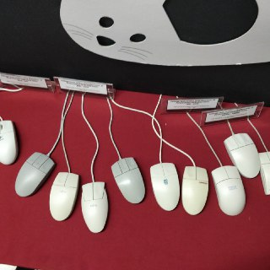
Mouse
Old mouse made by IBM, Apple, Fujitsu and Logitech.

All mouse above has been use by UTM from range 1990 to 2000. Mouse function is a handheld output device used to position a cursor on a computer screen. With this featured is made easy for user to user to select items or do anything that can be done using a mouse. Mouse in the picture above is using trackball, where the ball in the mouse is moving and track the movement and transfer to the cursor on the computer. That is how the trackball in mouse is used.
After many changes, mouse this has been upgraded to use laser and optical. Using this laser and optical, it is more precise and faster than using trackball. Other than, we can also see that the design of mouse also evolves. The design become more comfortable and easier for us to use. Moreover, there exist gaming mouse where it has more powerful specs than normal mouse. This what we can see based on the gallerium visit.

MAINFRAME & SUPERCOMPUTERS

The Mainframe Tape Subsystem was used as a ‘back up’ for mainframe system and information database of staff and students as other University’s information system during the year 1987 model used a square shape tape after the round shape tape was no longer in use.
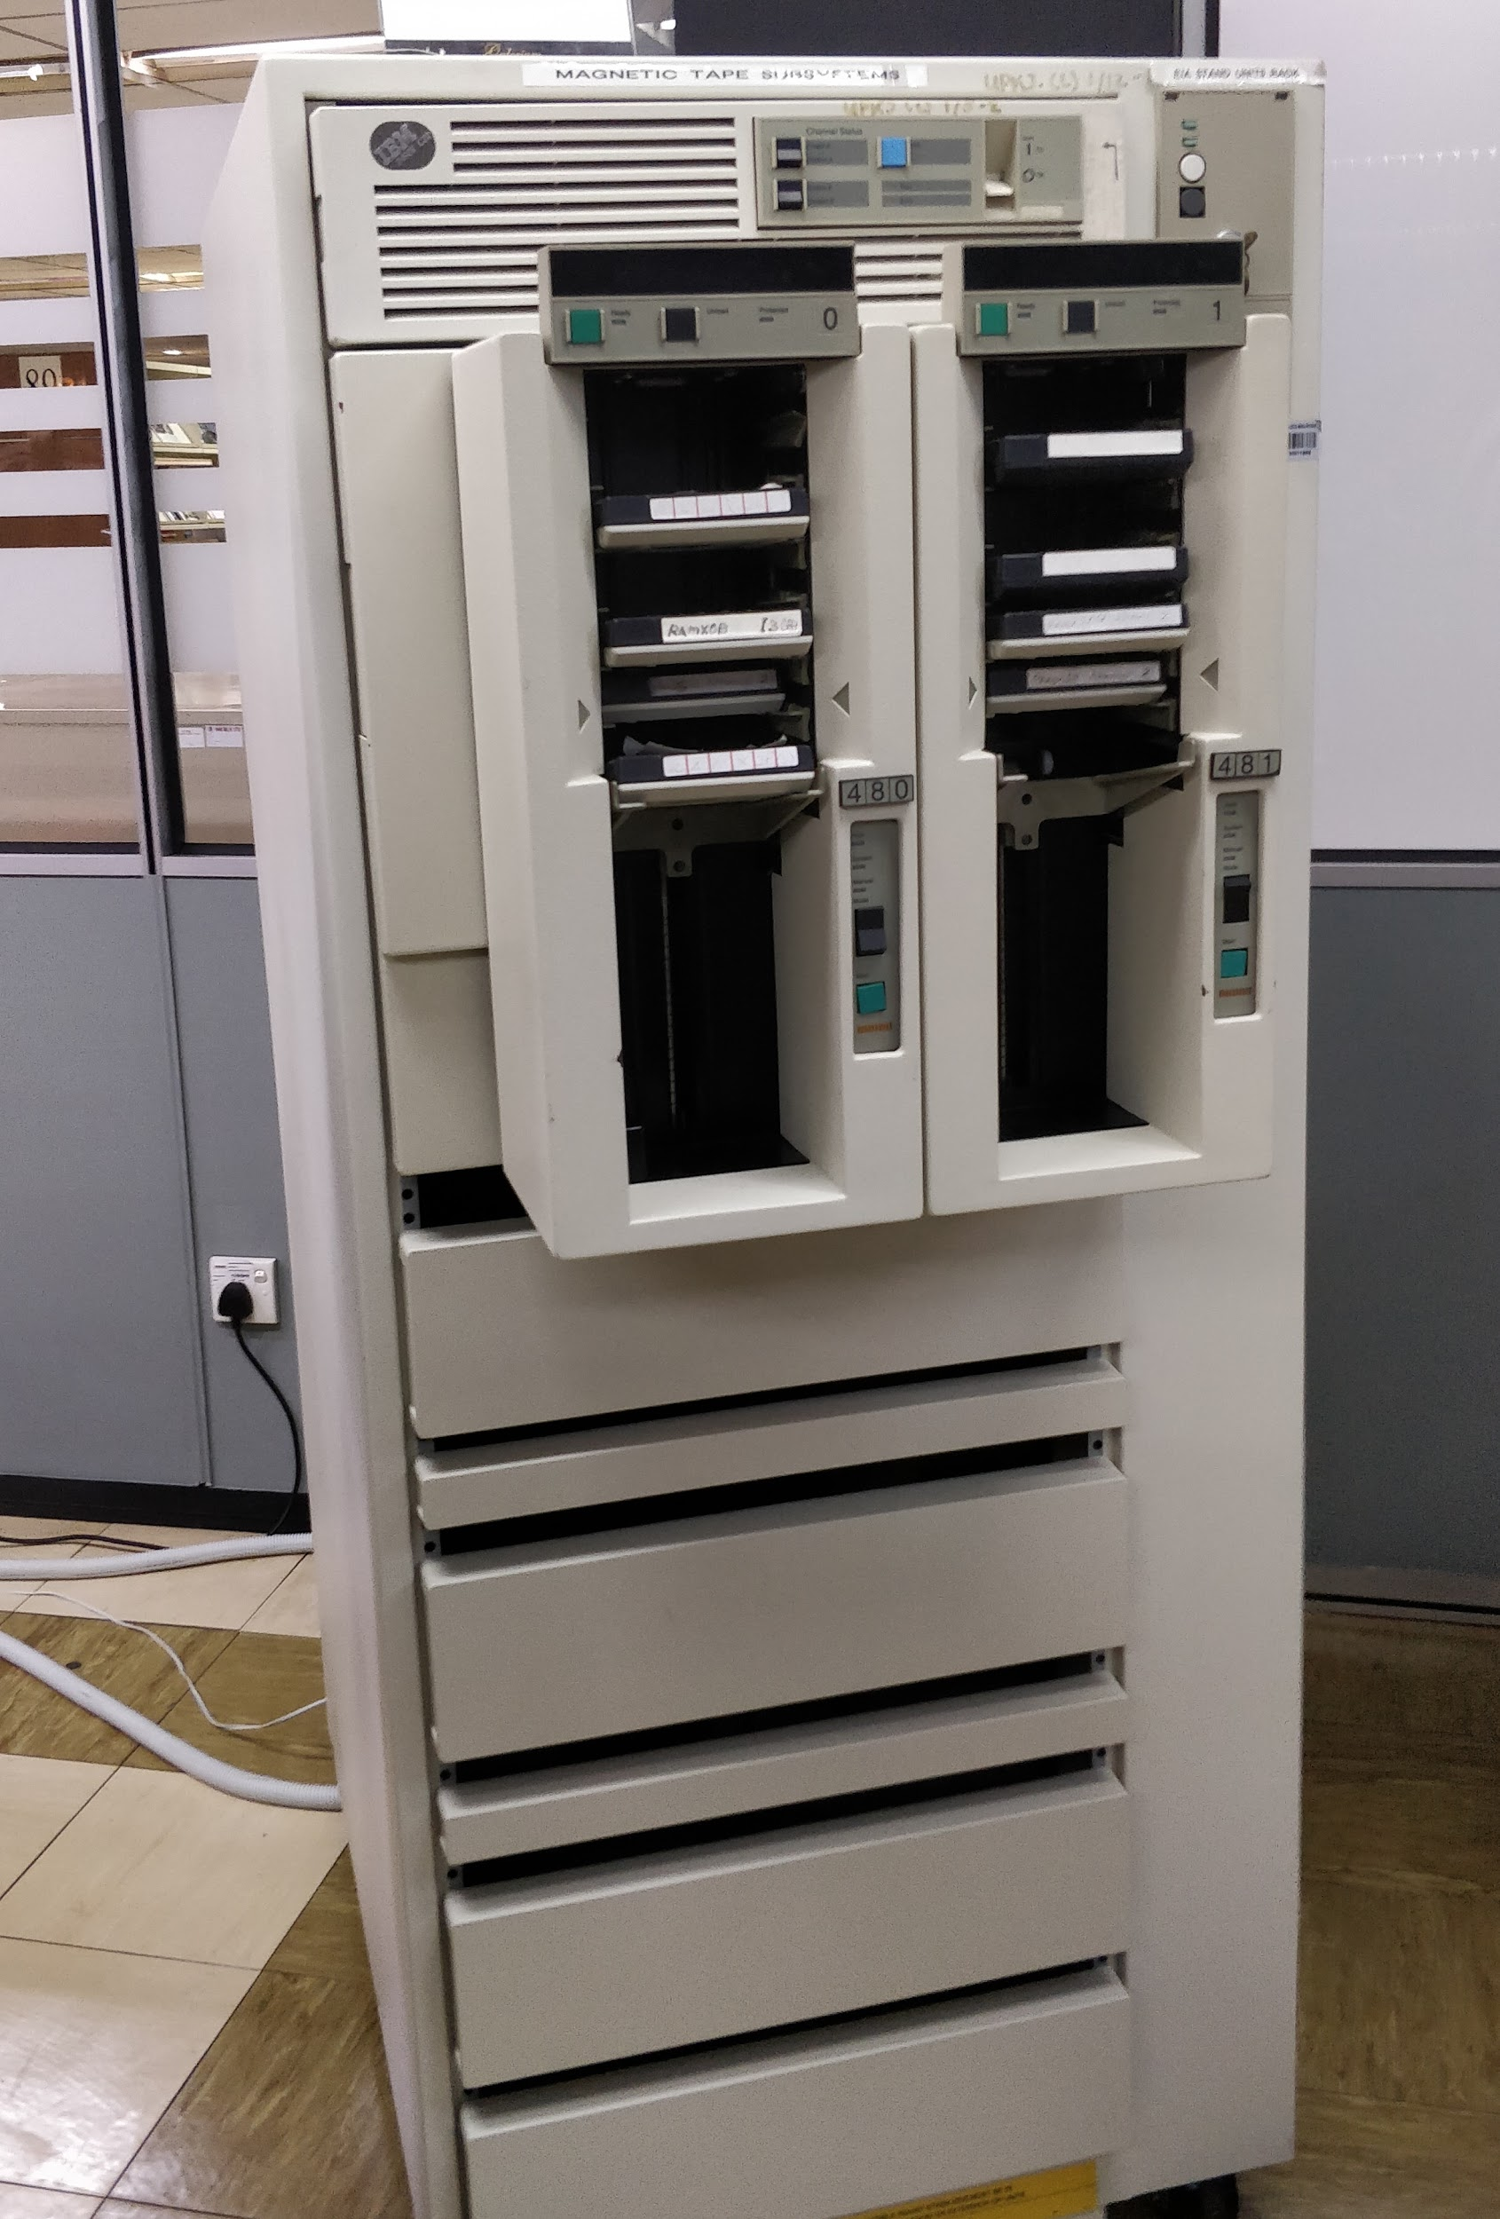
Mainframe computers or mainframes are computers used primarily by large organizations for critical applications which is bulk data processing, such as census, industry and consumer statistics, enterprise resource planning and transaction processing. They are larger and have more processing power than some other classes of computers: minicomputers, servers, workstations and personal computers. Mainframes process the large amounts of data that come into them from external sources. One of the well-known examples of mainframe is IBM.

Supercomputers are designed to work on types of problems whose primary constraint is calculation speed. Supercomputers also conduct large amounts of very fast and complex calculations on data stored in memory. These computers are built to purpose to run complex simulations or beating grandmasters in chess.

Mainframes and supercomputers can do tasks more efficiently than the other types of computers.

IBM Personal Computer

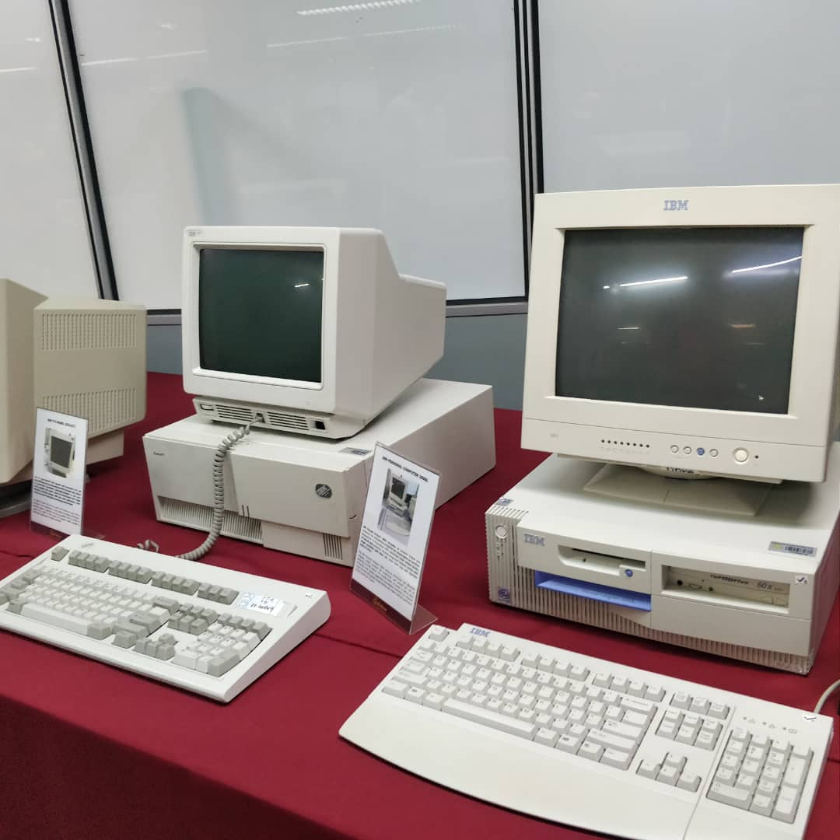
The IBM Personal Computer, commonly known as the IBM PC, is the original version of the IBM PC compatible hardware platform. It is IBM model number 5150 and was introduced on August 12, 1981. It was created by a team of engineers and designers under the direction of Philip Don Estridge of the IBM Entry Systems Division in Boca Raton, Florida.
The generic term "personal computer" ("PC") was in use years before 1981, applied as early as 1972 to the Xerox PARC's Alto, but the term "PC" came to mean more specifically a desktop microcomputer compatible with IBM's Personal Computer branded products. The machine was based on open architecture, and third-party suppliers sprang up to provide peripheral devices, expansion cards, and software. IBM had a substantial influence on the personal computer market in standardizing a platform for personal computers, and "IBM compatible" became an important criterion for sales growth. Only the Apple Macintosh family kept a significant share of the microcomputer market after the 1980s without compatibility to the IBM personal computer.

Microfilm
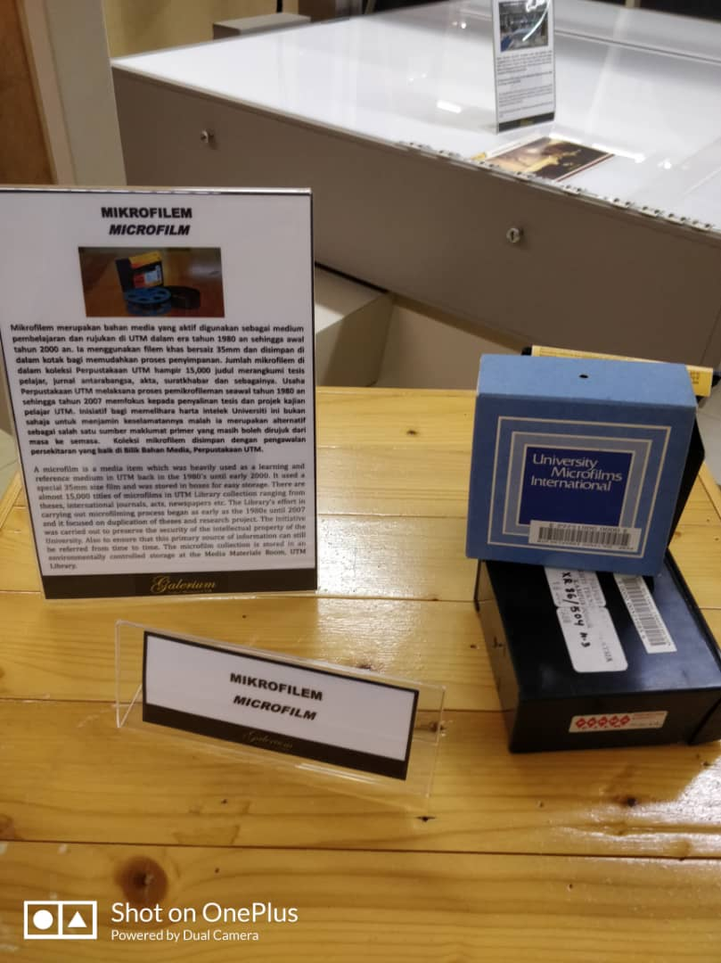
Microfilm is an analog storage medium using film reels which are exposed and developed into photographic records using a photographic process. It is typically used to store paper documents such as periodicals, legal documents, books and engineering drawings. It is compact in nature, is low cost to produce and store and requires far smaller storage space than paper documents. Therefore, it is considered to be a good archival form. Viewing microfilm requires microfilm readers, which are simple devices consisting of a light source and magnification. Microfilm can be converted into an electronic format so as to be computer accessible. There are different types of microfilm, such as silver gelatin film, vesicular film and diazo film. Silver gelatin film is used for records which need to be kept permanently or for high-quality images. Vesicular film and diazo film are highly sensitive to high humidity or temperature. Microfilm is considered best for records which are accessed less frequently, but are still necessary to retain.
There are many advantages associated with the use of microfilm. Compared to traditional film, it is much stronger and more reliable. Less breakage is associated with microfilm. It is considered a good standardized image storage medium and is used for long-term storage needs. Cost of maintenance is lower than digital images, and microfilm meets recognized archival standards.
Today, digital document storage is generally preferred over microfilm, as the stored contents are more accessible and distributable and are immune to any physical damage.

Darkroom Light - Wotan Model
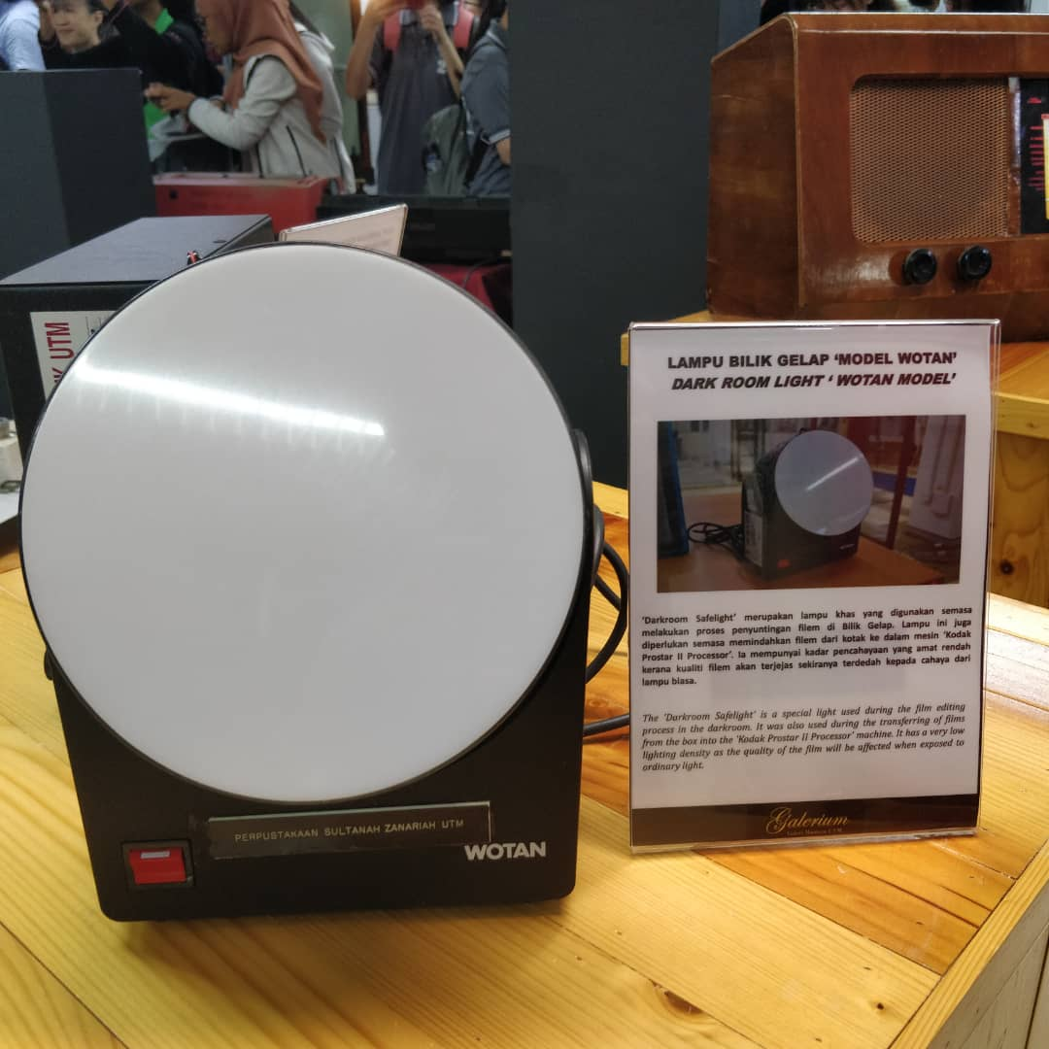
Here you see the Wotan Duka 10 Photographic Darkroom Safe Light, this Safe light uses the Osram NA10/FL Sodium Spectral Lamp and is used for lighting Photographic Darkrooms when the user is Printing Black and White Photographs using Photographic Paper The NA10/FL Sodium Lamp this Light uses, provides ample, narrow bandwidth, 589 nanometre light Spectrum, and has only a 3 minute warm–up time, making it best suited to general lighting applications where low levels of continuous light are needed, such as in busy printing rooms .

Reflection

The CICT have contributed a lot to the community especially to UTM. The CICT play a big role as support unit that offers and deliver ICT services for UTM staff and students.

The visit to CICT has exposed us more about the careers in ICT field. It was a great learning experience and we are motivated to build new career for example cloud engineer, IoT engineer and many which we maybe not discovered yet.

Our goal is we want to keep improving the technologies for the conveniences of mankind. We are from SCSJ program are not aiming to become a software engineer only but we may create my own career in the future which will meet the needs of mankind and bring a lot of good impact on both human and Mother Nature.

We will update and enhance our skills through joining competition that involves technical skills and critical thinking, joining workshop that related to ICT and analyze the needs of humans.

In conclusion, the visits surely motivated us to improve the potential of achieving our future goals, the visits made us realize that there is always a room for improvement in everything such as the evolution of computers and other hardware.

TASK OF EACH MEMBER

NO. | NAME OF MEMBER | TASK
1 | Muhammad Mukhlis | - Doing and edit report  - Ccomponent history - typewriter and mouse  - Taking pictures
2 | Rifadul Islam | ● Doing report and doing reflection  - Component history- ibm personal computer, darkroom light and mikrofilm.
3 | Shakil Chowdury | - Do report and introduction  - Component history- mainframes and supercomputer.

