Anika Rahman Antu
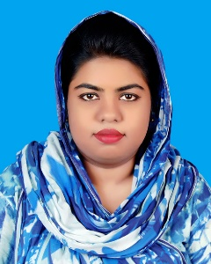
Address: 80, C K Ghosh Road, Mymensingh 2200.Bangladesh
Mobile: 01788499916
e-mail:antuanika@gmail.com

Career Objective:

To build up a long-term career development and looking for a challenging career in a dynamic situation where there is a scope for demonstration, thrive to imagination and passion to reach in esteem level.

Academic Qualification:

Exam Title | Concentration/Major | Institute/Board | Result | Pas.Year
Diploma in Engineering | Computer Technology | Mymensingh Polytechnic Institute | 3.29 out of 4 | 2018
S.S.C | Science | Dhaka | CGPA: 4.31  out of 5 | 2013

Training Summary:

Training Title | Topic | Institute | Country | Location | Year | Duration
Spoken English | English | S@ifurs | Bangladesh | Mymensingh | 2018 | 2 Months
ITES Foundation Skills Training | Web Design & Development | LICT, BASIS | Bangladesh | MPI | 2017 | 4 Months
Capacity Building For Mobile Game Development | Basic Game Development | ICT Division | Bangladesh | MPI | 2017 | 7 Days

Language Proficiency:

Language | Reading | Writing | Speaking
English | High | High | High
Bengali | High | High | High

Personal Details :

Father's Name : Alhajj Md. Anisur Rahman Bhuiyan
Mother's Name : Abeda Rahman Poly
Date of Birth : May 5th, 1997
Gender : Female
Marital Status : Single
Nationality : Bangladeshi
Religion : Islam
Permanent Address : 80, C K Ghosh Road, Mymensingh
Current Location : Same as above.

