Mid semester reflection

Graduate success attributes subject is one of the necessary core studies for a student in UTM. The subject is important as it is implemented for all first-year students in each of every available course. How important? Graduate success attribute subject act as an early guidance and training for all the student to shape themselves especially in facing the needs in future careers and also preparation in the challenges of the real-world working environment.
First of all, the subject was made compulsory by the Ministry of Higher Education as the main objective is to increase the rate of employability of Malaysian graduates. The source from local newspaper, Star on the 14th of July 2016 is that in 2015, a total of 227,421 graduates leaving from both public and local university and colleges and only 75.1% of the graduates are employed within six months after their study completion. The rest of approximately 50,000 graduates are either unemployed yearly or take more time than six months from their graduation to finally get employed. It was mentioned by an article by Roselina Shakir that the importance of human capital and upgrade of mentality and intellectual capacity of a nation in order to let Malaysia become a develop country was focused upon. Next is that universities and colleges needed to consider that the employment rate of their students upon graduation as it is very crucial because it affects the institutions image towards other people. Hence, the urge of introduction and integration of soft skill elements in undergraduate syllabus by public universities in Malaysia was announced by the Minister of Higher Education.
There is a different in what hard skills is and soft skills. Majority of people today will be sharpening their hard skills but forgot to do so with their soft skill. So, what are these two skills? For starters, during work, hard skill is basically referring as technical abilities or practical knowledge that one’s have that fit for the job. The skill is typically easy for us to observe, quantify, and measure. Normally, you can acquire and enhance your capabilities in this skill by learning it from classes, online courses, reading books or any other related materials or during on a job as the skill can be easily teachable and learn from one source to another. Fresh graduates are relatively easy to train for such skills as they have acquired the fundamental and necessary knowledge during their studies in universities and college.
Soft skill in another hand is what people usually refer to “people skills” or “working skill”, a set of skills that are not unique to any kind of job. Although the skill is very much needed and very sought after, soft skill is not something that can be easily taught and acquired. Soft skills can be categorized into three major categories which is, personal attributes, interpersonal skills, problem solving and also decision-making skills. By contrast, soft skills are the traits that make you a good employee, such as etiquette, communication and listening, getting along with other people. The course graduate attribute will be mostly focusing on knowledge and activities which will allow students to mainly focus on areas of soft skill that are needed to be develop and further enhance.

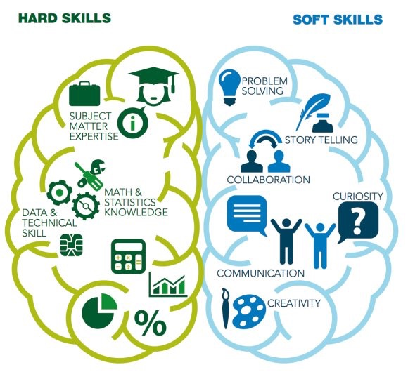
Figure 1. Quick difference of both skills (Source: Pathway to Aviation)

What do I get from these past eight weeks? First, the understanding of graduate employability and soft skills. The chapter explains to the student on how the soft skill makes up most of the reason why a certain number of fresh graduates are unemployed. Basically, in a working environment, it is called as employability skills. Employability skills are a set of skills and abilities that allow an individual to be sought after or employed. In my opinion, employability skill and soft skill are the same as most of the attributes are for example, communication skills, critical and creative thinking, problem solving, team work, time management, leadership and many more. Other than that, I am also exposed to what do employer or companies’ respondent citing skill deficits in fresh graduate and found out that the most critical deficits are the communication skill which is a whooping eighty-one percent of applied fresh graduates based on the statistic bar chart from TalentCorp.

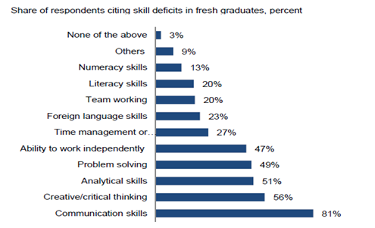
Figure 1.2. Share of respondent (Source: TalentCorp)

Personally, I have never experienced with any classes like this in my days during my studies in diploma at Kolej Poly-tech Mara Ipoh. It is not that we are not taught or not encourage to improve the skill, but it about a class which specifically focus on soft skill enhancement. First is that I thought that this class is just to fill in the credit hour requirement but realise that I was wrong. Graduate success attribute subject not only expose to me of what I am lacking in myself but also showed me that some of knowledge of the real world like future employment, skill building and exposure, writing and also communication skills.
Studying in degree level at a country’s top university is never an easy task. We will mostly provide ourselves with study materials and references which means that to survive here is to maximize our ability in adaptation and also self-motivation. Studying method also played and important role here and also the method to advance it for even better results. First, is to do a constant amount of studying every day. This does not mean I will be studying twenty-four seven but it means that to find the time to study even its just one hour or more. By keeping the knowledge constantly reminded and polished, this will greatly help me in remembering about it.
Subsequently, do some self-research and additional knowledge findings. Through this we will get some additional knowledge or some hidden facts about some of the subject we learn in class. Why? This because we student are encourage to this kind of self-exploration, the lecturers will not be feeding you all the necessary info of a certain subject as this no longer like primary or secondary school. Conclusion, all students should keep in mind that not all of us are gifted or a prodigy in studying, which is best to know that our effort makes up most of our success.
I also have a dream, a dream to be a successful person and live happy life. But before I reach that pinnacle of success, I have to complete my studies first. Are there any challenges than I am facing during my studies? Of course, there are challenges and obstacles that I faced as I myself am a normal student that sometimes have the urge laze around, overshadowed by state of denial, procrastinate work and assignments, conflicts and misunderstanding and many more. These problems are not rare but quite normal as most of other student also experienced it and overcoming it requires a whole lot of motivation and effort.
First of the challenges is the need of making new friends. This is a very common problem to some students especially in educational institutions. Some people already form their group of friends even before entering UTM and as I am not a direct entry diploma student, I started my life here as a first year. Not only that, I am a lone diploma student from Kolej Poly-tech Mara Ipoh which make me quite friendless from the stating week. This makes me quite sad of myself and I urge to change it. I first started to open myself to my roommate which I usually didn’t do in my previous experience and we manage to hang out all the time even though we are both from different courses. Next is that I tried to approached and make a group of friends from my class as fast as possible. Basically, I tried my best to become someone who I am not before, a person who can befriend other and not a person who waited to be befriended.
Consequently, I sometimes have the this very bad habit to procrastinate which is delaying my work, assignments and also studying for tests. This is not surprising as most all walk of life around globe have this bad habit. This will lead to other habit also, which is denial. Why? Sometimes when I laze around even though I know I have something to do and needed to finish it fast, I always give myself an excuse and always tried to come up with something like playing video games, watching online shows and more in order to keep myself occupied and avoid doing the much higher priority task. There is a way to solve this problem but it will be very hard and one hundred percent of self-motivation is needed. The only cure to laziness and procrastination is the need of self-change.
After that, I also have faced the challenge of conflict and misunderstanding. This usually happens with a group member during group work or just my relation ship with friends or other people. In a large and renown university like UTM means that will be surround with all kinds of people from different races, back grounds and even nationality. Keep in mind that everyone is a complete distinction to one another and a lot of thing should be kept in caution. In order to survive and dissolve a conflict, I should figure out who is the main cause of the problem and why did it happen. This kind of problem should be dealt with as soon as possible, think of it a plant as the hatred produced by the conflict will be planted within someone and the roots will only grow which make it harder to forget thus making it worst.
Lastly, student should make use of all the knowledge they learn during the graduate success attribute class as they teach us the method of preparation needed to face the real world and working life. Other than that, students should also prepare themselves thoroughly whether it be in gaining knowledge or problem solving as these are a common this that all student face and overcoming it will ensure your survival in your studies.

