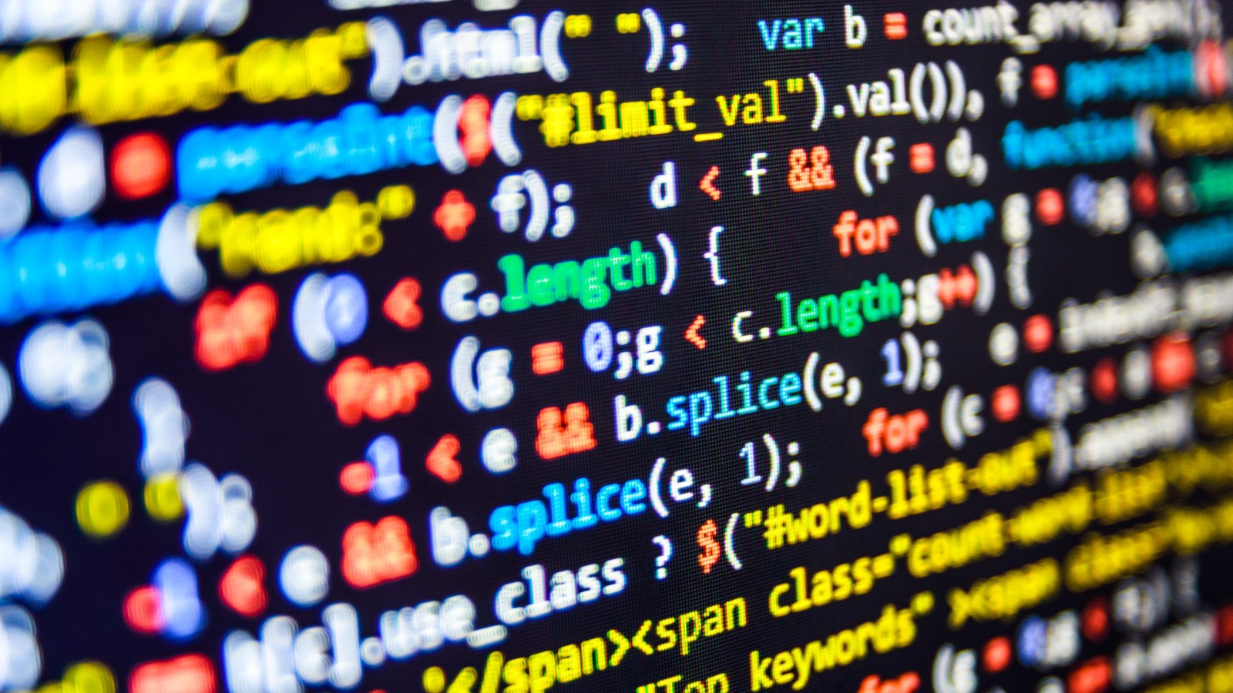
2019

Report:

Programming Language

TECNOLOGY & INFORMATION SYSTEMS (SECP1513-06)

PRASANT KARUNAMURTHI (A19EC0148)

SALEM ALI SALEM SULAIMAN

IQBAL MUZAKKI

MUHAMMAD RAFLY

History

Before the formal introduction of programming languages, very early computers ran without a stored program. This meant every arithmetic process required manual inputs from physical operators. These physical inputs were in the form of punched cards, magnetic tapes or toggle switches on the front panel of the computer. This kind of operation is called a machine language. The operator writes every code in a numeric form, which can directly be read by computers. Machine languages were later formally termed First Generation Programming Language (1GL).

ShortcomingsHistoryMMAD RAFLY

Contents

Contents 1

History 2

Shortcomings 2

Introduction 3

Detailed Description 4-7
1.0 Programming Language
2.0 Solution
3.0 Interview

Reflection 8

Programming language design report
October 9, 2019

History

Before the formal introduction of programming languages, very early computers ran without a stored program. This meant every arithmetic process required manual inputs from physical operators. These physical inputs were in the form of punched cards, magnetic tapes or toggle switches on the front panel of the computer. This kind of operation is called a machine language. The operator writes every code in a numeric form, which can directly be read by computers. Machine languages were later formally termed First Generation Programming Language (1GL).

Shortcomings

There were easily a lot of issues with the 1GL. For starters, it was very expensive to even run one computer. This was the direct cause of having multiple human operators to run one computer. There was also the issue of space. Due to the analog nature of the computers, they were large and heavy. Transportation was impossible without dismantling; which required skilled work which increases the cost further.

Introduction

The process of design thinking revolves around a problem which needs a solution. The end results are tailor-made to suit the needs of the end user. Design thinking process has 5 phases which are empathy, define, ideate, prototype and testing.

Empathy stage is when the programmer empathizes with the end user. This is the stage when the programmer identifies the problems faced by the end user and empathizes, creating a bond of sorts where they relate to the problems faced. This is a crucial stage because it plays a crucial role in producing the end results which favors all parties. We have interviewed a respondent who has been in the industry of programming languages for a considerable amount of time to gain an inside of the shortcomings faced by them.

Defining process is the making of a formal definition of the problem being resolved. It’s the process of acknowledging the problem and having a solid understanding of the situation. At this stage, we got a good understanding of the problem. The next stage; ideate, required us to brainstorm ideas. We got a good idea of the programming language we were going to build in order to overcome the shortcomings of not having one. Then we swiftly proceeded to the next stage which was building a working prototype. We made sure the prototype built covered all aspects of the problems and produced an outcome which pleased the end user; which was confirmed in the testing process.

This report will go through in detail all the processes which we took in the process of design thinking. In this project we have studied various generations of programming languages to get a comprehensive understanding of the topic.

Detailed Description

- Programming Languages
We have studied upon the advantages and shortcomings of certain programming languages which are being widely used.

- C - C is a programming language for general purposes, originally created for Unix systems. It is commonly used in cross-platform, Unix programming and software coding systems. It is often preferred because it is more portable than C++ and is more optimized. After Java, it is the second most common programming language. C is the ancestor of many other languages such as C #, Java, JavaScript, Perl, PHP, and Python. Even though C is very optimized, it’s not optimal for high volume coding.

- Objective-C – Is a programming language derived from C. Objective-C is the preferred
programming language for Mac OSX and IOS apps. It has message passing function and is known for being secure. Later it was later replaced by Apple for Swift.

- Java – Java is currently the most popular and widely used programming language in the world. This is mainly due to its simplicity and the open sourced nature of it. Java is ideal for multipurpose tasks because it’s cross platformed, meaning it works on mobile platform as well it works on desktop platforms.

- Python – Python is a sophisticated high-level language which is being favored by new and upcoming programmers/coders. Its designed in a way to be fun for beginners. Python is mostly used in the security field and academic data analysis.

- Solution
We have studied the various advantages and disadvantages related to programming languages. We have also concluded that not one programming language is good at everything. Certain programming language works better than others for certain conditions and for specific applications. Knowing these facts, we set out to brainstorm ideas to invent a certain type of programming language which is ideal in most conditions.

The factor which we were most critical about was how the program was written. Having a well-defined semantics helps a lot with the readability of the code. This helps non-coders and beginners to understand the flow of the program and understand what the program is doing. This has a big impact on how someone adapts the language and whether they continue using the language or not.

Library support is also crucial for a programming language. Having an extensive library supports the lifespan of the language; also providing endless free sourced and community made extensions and plugins. This way as time goes on, the usability, accessibility and the functions of our programming language will only keep on increasing.

- Interview
After identifying the most needed features and aspects of our programming language, we turned to a professional in this field, Dr. Lizawati who has been a professor in UTM for 19 years. We were interested in asking questions which would apply to the real-world scenario and were expecting to get answers which could further our understanding on programming languages. It’s safe to say that Dr. Lizawati did not disappoint. The following are the questions and answers;

3.1 What if there were no programming languages?
Programming language helps in decision making. Before the days of ATM machines
we had to go to the bank for something as basic as withdrawing money. ATM machines
works because of programming languages and they enable us to live a more stream-lined
life while at the same time saving us a ton of time and money.

“Before we don’t have any ATM machine, what we must do? We must go to the bank, we must que, we need to spend a lot of time only to withdraw our money.”

3.2 Important feature in a programming language?
According to Dr. Lizawati, the ease of writing a program is the most important feature.
If the developer can implement many block functions, it will save a lot of time for programmers
And could ease the process of learning for beginners. We don’t always need to start a program
From scratch, says Dr. Lizawati.

“If you learn from the basic, you need to use your own function, but if you just want to develop only system of application, assuming some software have been provided, you just need to put the logic in the program without knowing the concept and can still proceed.”

There were more questions asked which further our understandings of programming languages and bought us one step closer into developing our own programming language.

Reflection

Throughout the process of problem solving, we gained a lot of experience and knowledge regarding this topic. First and foremost, we learned the importance of teamworking. We learned to work together as a team to achieve a shared goal. Teamworking proved to be very important in this project because it increased the efficiency of the overall progress. We also learned to respect each other as a team.

Respect and understanding proved to be crucial particularly in our team because the team was comprised of mostly people of different backgrounds and language. The team was made up of mostly international students. Communication was difficult but we managed it using international language.

