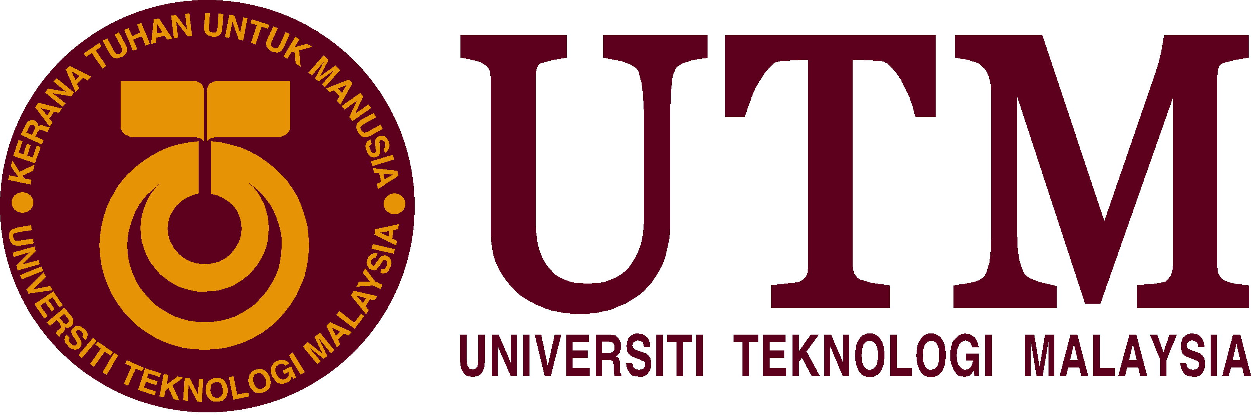

FACULTY OF ENGINEERING, SCHOOL OF COMPUTING
SCIENCE AND TECHNOLOGY THINKING
UHIT2302 SECTION 37
2019/2020

TITLE: REPORT ON SCIENCE AND TECHNOLOGY SEMINAR 2018

NAME : NURUL SYAMIRA BINTI AMAT JIFRI
MATRIC NO. : A19EC0145
LECTURER : DR. ABDUL BASIT BIN SAMAT@DARAWI
CONTENTS

- INTRODUCTION…………………………………………………………2
- ABOUT THE SPEAKER…………………………………………………2
- CONTENTS……………………………………………………………...2, 3, 4
- REFLECTION…………………………………………………………...4

INTRODUCTION
The seminar named was Intellectual Discourse on Thinking of Science and Technology 2018. It was the second time in year 2018, UTM organized an intellectual discourse and purposely organised the seminar for the students who registered in the course UICL2302. UTM were blessed to have a distinguished speaker, a scholar and an expert in science and technology especially in the field Artificial Intelligence or known as AI. As the world now embraced to the Industrial Revolution 4.0, a technological revolution and modernization that will fundamentally alter the way we live, work and relate to one another.

ABOUT THE SPEAKER

The MC of the seminar gave a short briefing to introduce the speaker of the seminar. The name given was Prof Datin Dr. Rubiyah Yusof. She works as the professor in the area of Artificial Intelligence (AI), machine vision, pattern recognition and image processing. In the year, she was a professor at the center of AI on robotics known as Cairo University International Campus Kuala Lumpur and has been with UTM since 1984. She received her degree in Bachelor of Electrical and Electronics Engineering from University of Loughborough, United KIngdom in 1983. Next, for Masters Degree in Control Systems from Cranfield Inst. Of Tech, United Kingdom in 1986. She also obtained her PhD in Control Systems from University of Tokushima, Japan in 1994. Prof. Datin Dr. Rubiyah was known to be active in doing research and contributing in Academia in her field and expertise. She also has delivered speech at various local and international seminar as well as conferences. UTM believed with her background, expertise and experiences, students could learn her thoughts on the seminar’s topic.

CONTENTS

What is Industrial Revolution 4.0? How Industrial Revolution 4.0 (IR 4.0) can impact our life and the human being? From the speaker’s point of view, it is an area that closes to her heart which is, Artifical Intelligence (AI).

The speaker explained about CAIRO in the shortform of Centre for Artificial Intelligence and Robotics. CAIRO have been dealing a lot with AI and robotic application. CAIRO has also graduated around 250 students for PhD and Masters. Not just that, they currently have more than 40 postgraduate students in their lab at that time. CAIRO also did a lot of publications to share their research and knowledges to the community.

How is it this IR 4.0 grew from the previous IR? It is said to be with the existence of technology of cloud. The ability of people to store data and information at one place connecting all the physical entitites. In this industry especially, a lot of machines were involved in the process. The system was known as Cyber Physical System (CPS). How IR 4.0 impacted the manufacturing industries as well as the society?

First, let’s get into Cyber Physical System or CPS. The speaker showed slides that explaining about CPS more. CPS is a system of collaborating computational elements controlling physical entities. CPS are physical and engineered systems whose operations are monitored, coordinated, controlled and integrated by a computing and communication core. CPS also allow us to add capabilities to physical systems by merging computing and communication with physical process. The next slide showed some comparison between IR 3.0 and IR 4.0.

Previously, more operators and operating machine were used but now, more knowledegeable workers were needed to work in industries and would contribute more. Speaker did mentioned that for the IR, the technology is moving very fast. There were two big countries that are nect to neck to each other in creating technology in IR which were United States and China. And there were the other countries were simply following to those two countries.

In the past, people have to buy around 10,000 dollars to store 1GB where now it only costs around 30 dollars. Currently, the data people had were sent to the cloud and there was physical physical server that stored people’s data. There were big companies mentioned such as Google and IBM and by using the cloud storage were how these famous companies made money in Industrial Revolution. The users were feeling more secured with the existence of cloud storage. Next, some famous application that were rising up in whole wide world such as Grab and AirBnB, also amoung the youngsters which were Instagram and Snapchat. The main feature on how these applications that user loves were on how easy they could use the functions and to communicate as well.

Moving to the highlight of the seminar, the speaker talked about Top 10 skills to be relevant in IR4.0. These skills were needed to be implemented to be able moving forward with IR4.0 in 2020. The ten skills mentioned were complex problem thinking, critical thinking, creativity, people management, coordinating with others, emotional intelligence, judgement and decision making, service orientation, negotiation and cognitive flexibility. From the list, there were two new skills compared from 2015’s list which were emotional intelligence and cognitive flexibility. To sum up the details about the skills in the list, the speaker reminded when she was studying in Japan that she really pleased with their culture that they always think of others. For example, their people did not throw rubbish on the roadside. Because when they did so, the other people will be stressed to unpleasantly look at rubbish on the roadside.

The speaker showed slides that explaining about IR that started way back then and how the technology grew by years until IR4.0. She talked about IR4.0 in area of manufacturing. She gave out information on Japan that were working on Society 5.0 that focusing technology on the society. One of the very impactful in IR4.0 technology was on precision medicine. This medicine were known to be prescribed for the user because of the user’s medical history not because everyone has the same diseases with one another. Other than that, to prove the IR4.0 technology, she talked about humans are good at recognizing patterns. And so, machines were needed to be trained to understand and recognize humans’ handwritings.

The impact of AI in Healthcare were compiled in a sentence “Today, 14 years to market the technology that can help 10,000 people. And tomorrow, it will only takes 7 years to market the technology that could help 10 million people.” This AI technology were moving very fast and already shown their abilities to ease people and the world.

Last but not least, the speaker asked for the last few minutes from her speak to share about one of system that she and her team developed in CAIRO. That was named Syariah-Compliant Automated Chicken Processing Machine. They focused on chicken processing in Halal way that related to the Muslims. She also mentioned about one of industry challenge that happened in Malaysia was misused of Halal certification. With that, SYCUT was developed to detect the chickens were processed either in syariah way or not. After showing a short video of how SYCUT worked, the speaker, Prof Datin Dr. Rubiyah Yusof ended her talk by thanked everyone who came to listen and to the organizer that invited her for this seminar.

REFLECTION

From my point of view, everyone is aware that technology do grow fast around the world. With all the new technologies that keep updating like artificial intelligence, robotics, mobile supercomputing and many more, it will produced seeping changes to the world. While we live in the era of technology, we must simply brace ourselves to not be lazy with the empowerment of technology that known to ease people’s work.

