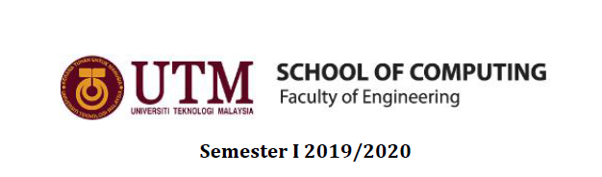

Subject: Technology and Information System

Section: 06

Task: Design Thinking

Due: 6th October 2019

Chapter 11:
DATABASES

Group 8:
Rezwanul Ashraf Ruddro
Bayes Ahmed Shoharto
Nurul Syamira binti Amat Jifri

Introduction

Databases are a part of everybody’s daily routine, even people who do not own a computer or mobile phone interact with them regularly. When we take out money from an ATM, check our bank balance, shop online, view social media or perform almost any digital interaction, we are accessing a database.

Database sounds familiar to most people but what is the definition about it? Roughly, database is like a library, secondary storage designed to store information. We all know how database is invented and be used by most people in different area including office workers, teachers, students and more. Examples of data included are facts or observations about people, places, things or events. And it can be in any format which are in audio, music, photographs and video.

Formally, database is a collection of integrated data, logically related files and records. The best phrase to describe about data is it provides an organizational strucure to store data. Some main purposes on why people need database are for sharing, security purposes, less data redundancy and data integrity. Back in the days, people used manual life system. In general, the manual file system was complicated and took a long time to be found manually. Precisely, when the information or data were needed urgently in case of emergency, then there was a rush between persons who were in charge of it.

Some of the advantages using the database are database itself helps saving our time and energy, has a better security and can backup the information. However, there are the disadvantages too. For instance, database needs higher cost to make sure their software is up to date. Next, the management of database is more complex than others.

There are four types of databases which are individual, company or shared, distributed and commercial. Firstly, individual is the integrated files used by just one person. Secondly, company which describes common operational or commonly used files shared in an organization. The third one, distributed means database spread geographically and accessed using database server. Last but not least, commercial is information utilities or data banks available to users on a wide range of topics.

Details of Design Thinking Process

- Empathy

Here are the list of questions that we prepared to ask our respondent.

- What do you think about the security of information processing in the database system?
- Are there any specific limitations and barriers in collecting and processing information in database system?

In short, stated below is the information about our respondent.

Name: Dr. Muhammad Iqbal Tariq bin Idris
Background: Senior Lecturer (DS51), School of Computing,
Faculty of Engineering, UTM
- mail: miqbaltariq@utm.my

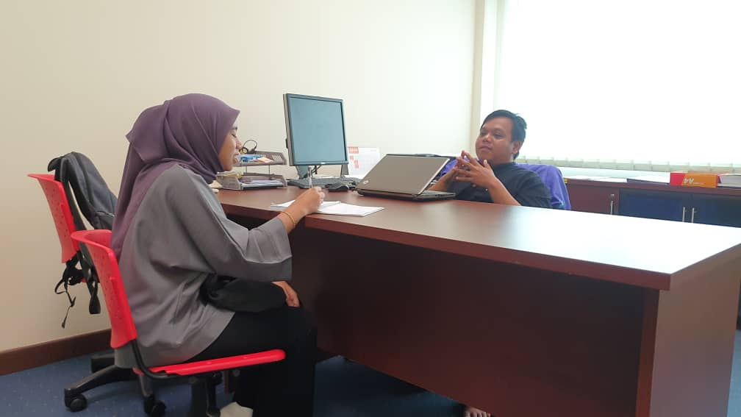

Through the interview, we have concluded some highlights that are referring to the importance of database based on our respondent’s experiences.

For the first question we asked, the respondent answered that absolutely the database system has better security than the physical database or the other name is manual file system. This is because when it comes to database means all the datas are in virtual form which concerns the privacy of it.

Moving on to the next question, our respondent explained he could not sure on whether there are limitations or not. But one thing he realised was everyone needs to have be aware with the revolution of database. Why is it important? Collecting and processing information using database system really gives positive feedbacks to the user. By operating and applying the use of database when be needed would reduce the cost of database. This is because everyone is already aware and knows the basic of using IT that includes database thus, there’s no need to attend any beginner class.

- Define

The database created to replace the manual file system.

- Ideate

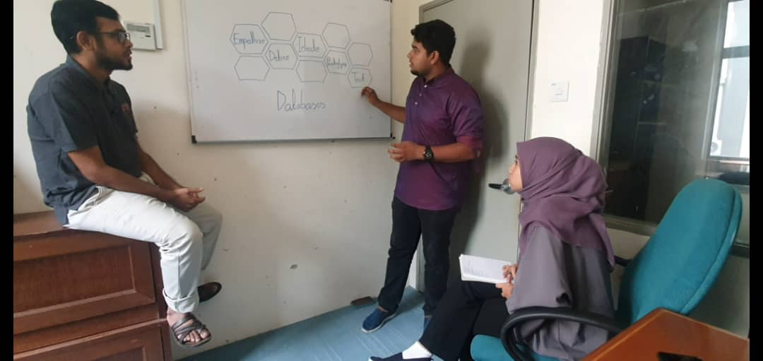

- Prototype

- Testing

Detailed description

Problem

Before database system existed, manual file system are being used which they need to collect information and recorded on paper. When any of the records are needed, finding the certain file manually will take a long time.

Other than that, the placements of files are not fully secured since it can be misplaced anywhere.

In addition, there were also unexpected situations that could happened such as fire or flood that could destroyed the files.

Solution

In result, our group sat down to try and find a way to overcome these limitations of traditional way of using paper.

Using database, it will save our time and energy. This is said because the files are organized effectively. Next, database also provide better security with the existence of backup. We can backup data from real time or previous time for future references.

Team working

