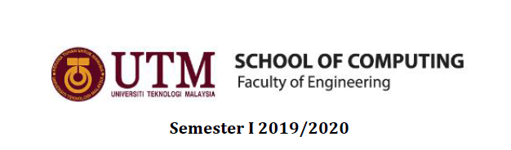

SUBJECT: TECHNOLOGY AND INFORMATION SYSTEM (SECP1513)
SECTION: 06
TASK: INDUSTRIAL VISIT 1 - CICT (GALLERIUM, PSZ)

PREPARED FOR:
DR. ARYATI BINTI BAKRI

PREPARED BY: GROUP 8
NURUL SYAMIRA BT AMAT JIFRI ( A19EC0145 )
BAYES AHMAD SHOHARTO ( A18CS4051 )
REZWANUL ASHRAF RUDDRO ( A19EC4020 )

INDEX

- INTRODUCTION……………………………………………………… 3
- DETAILS OF THE VISIT…………………………………………….. 4
- HISTORY OF COMPONENTS RELATED TO COMPUTING
- MAINFRAME & SUPERCOMPUTERS……………………………….. 5
- COMPUTERS…………………………………………………………… 6
- MOUSE………………………………………………………………….. 7
- REFLECTIONS……………………………………………………… 8
INTRODUCTION

CICT is a support unit that offers and delivers ICT services for the university (staffs and students) especially in ICT infrastructure, system development and academic or administrative activities. As we all know, CICT is introduced here in UTM. CICT was also known as the computer as the Computer Centre back in 1975, and then it became the Institute of Computer Science in 1984. They changed the name to Computer Centre UTM (PKUTM) in 1991. At last, the name CICT was chosen in the year of 2004 until today.

There are some facilities that CICT provides which are internet & WIFI, CRM, web management, infrastructure & security, ID account & access, application development, multimedia, softwares and ICT facilities. And importantly, all these facilities listed benefitting the students and also the staff of UTM.
DETAILS OF THE VISIT

The students from SECP1513 section 06 were scheduled to attend our first industrial visit as followed:

Industrial Visit 1: CICT Gallerium
Date: 20th October 2019
Place: Level 2, Perpustakaan Sultanah Zanariah (PSZ), UTM
Time: 3:00 - 4:00 pm

On the date, we entered the exhibition of CICT Gallerium roughly at 3.30 pm. When we first entered, we were welcomed by Encik Zahari bin Zainal Abidin who is known as the Assistant Chief of Information Technology. He prepared a short briefing about the history of CICT and also the facilites that provided by CICT.

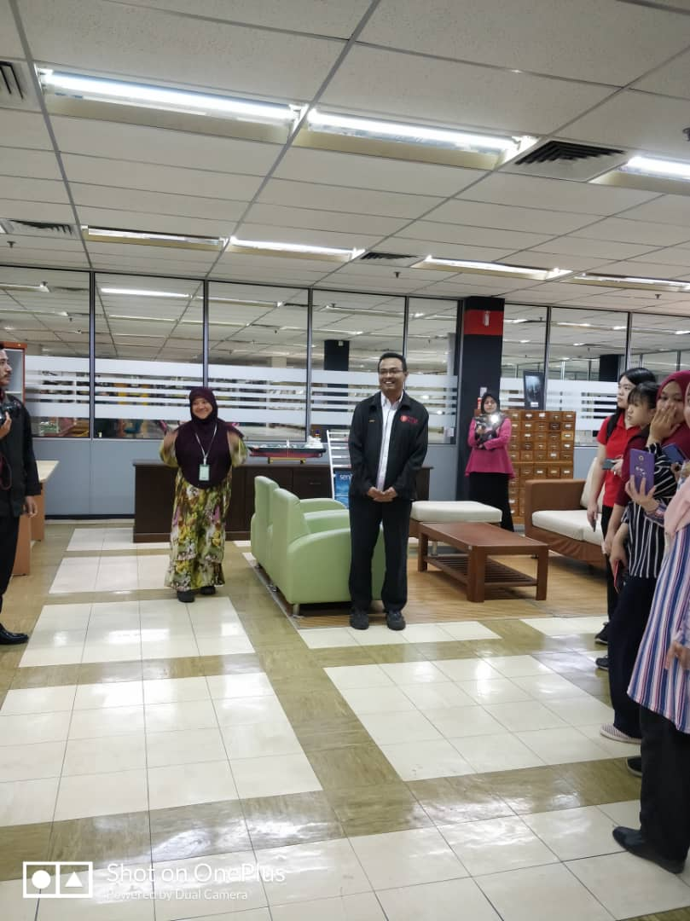
Listening to the short briefing.

HISTORY OF COMPONENTS RELATED TO COMPUTING

MAINFRAME & SUPERCOMPUTERS
The Mainframe Tape Subsystem was used as a ‘back up’ for mainframe system and information database of staff and students as as other University’s information system during the year 1987 model used a square shape tape after the round shape tape was no longer in use.

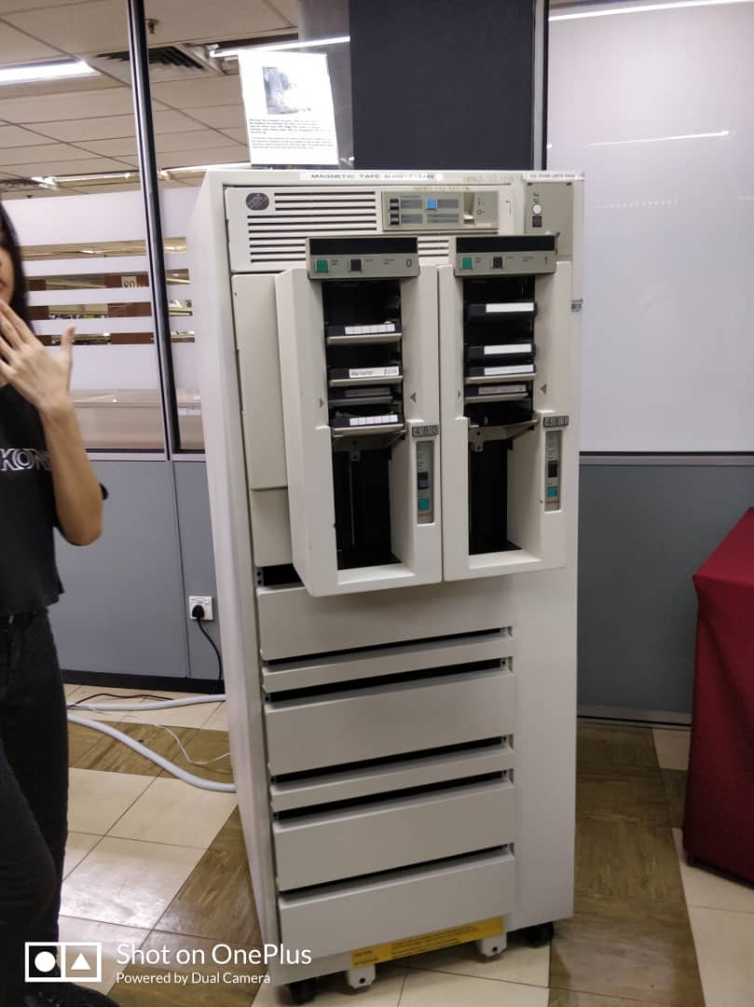
Mainframes computer or mainframes are computers used primarily by large organizations for critical applications which is bulk data processing, such as census, industry and consumer statistics, enterprise resource planning and transation processing. They are larger and have more processing power than some other classes of computers: minicomputers, servers, workstations and personal computers. Mainframes process the large amounts of data that come into them from external sources. One of the well-known example of mainframe is IBM.

Supercomputers are designed to work on types of problems whose primary constraint is calculation speed. Supercomputers also conduct large amounts of very fast and complex calculations on data stored in memory. These computers are built to purpose to run complex simulations or beating grand masters in chess.

Mainframes and supercomputers can do tasks more efficiently than the other types of computers.

COMPUTERS
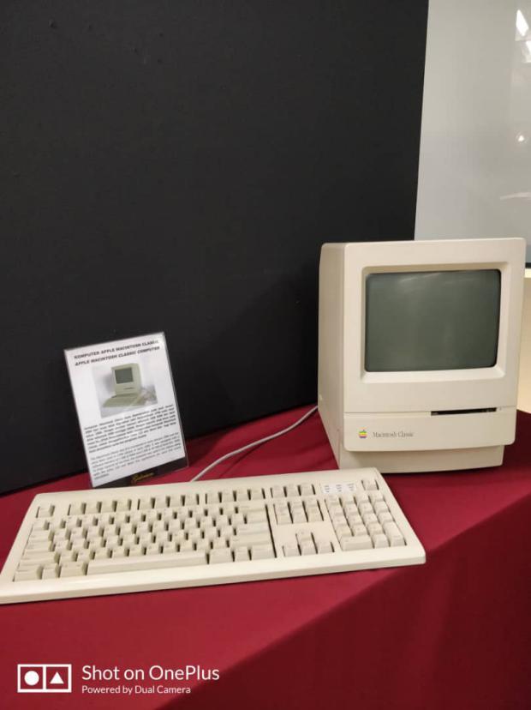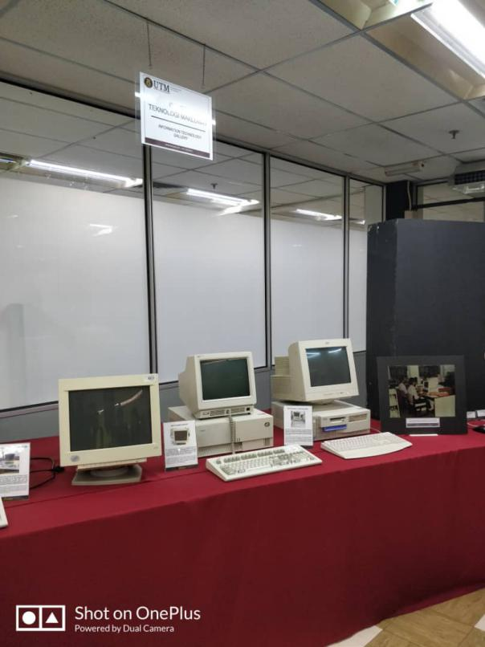
Some of the computers displayed.

A computer is a machine that can be instructed to carry out sequences of aritmetic or logical operations automatically via computer programming. Computers are used as control systems for a wide variety of industrial and consumer devices. The Internet runs on computers and it connects hundreds of millions other computers and their users.

Early computers were only conceived as calculating devices. Since ancient times, simple manual devices like the abacus people use in doing calculations.

Modern computers consists of at least one processing element, typically a central processing unit (CPU) in the form of micrprocessor along with some type of computer memory. The processing element carries out arithmetic and logical operations, and sequencing and control unit can change the order of operations in response to store information.

MOUSE

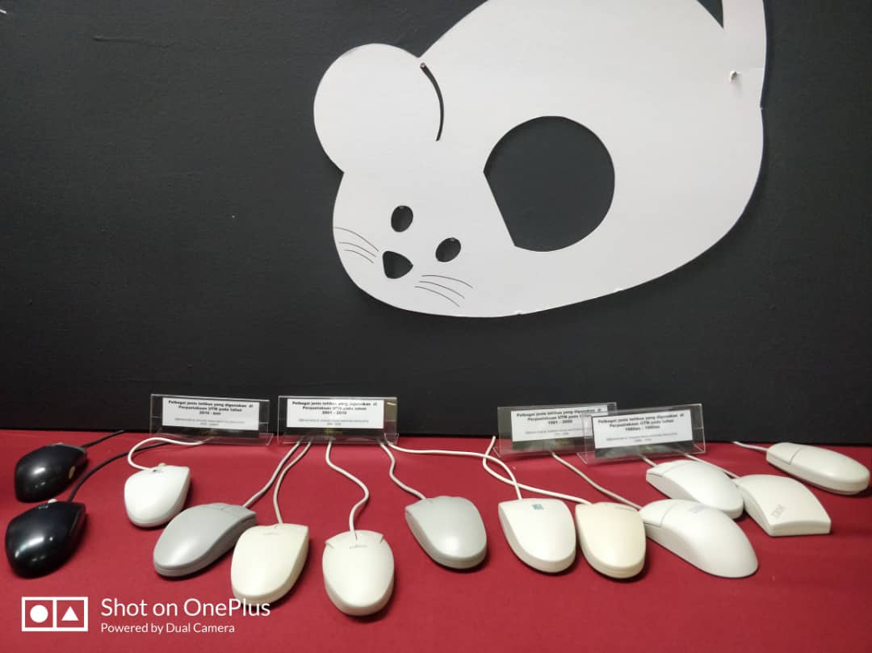
Evolution of mouse.

Technically, the mouse is an essential input device for all modern computers but it was not long ago that computers had no mouse and no graphical user interface. Data was entered by typing commands on a keyboard.

The first mouse was invented by Douglas Engelbart in 1964 and consisted of a wooden shell, circuit board and two metal wheels that came into contact with the surface it was being used on.

As years passed by, the mouse developed any further. And now today, the optical mouse has completely replaced the ball mouse, being supplied as standard with all new computers.

REFLECTIONS
Nurul Syamira’s Reflection.
What can I reflect from this industrial visit?

First of all, my group were very glad as CICT conducted an exhibition like this Gallerium for the students to visit. As everyone knows how technology is growing days by days then years by years, to get know how technology works on some of the components related to computing really helps us to learn more about it.

We feel that we learned and developed a lot of knowledge from just the first industrial visit. Furthermore, the industrial visit was in ties with our course. So, by heart we got to know more about the course we are learning. It will also help us in focusing more on what we are learning after knowing the history behind it.

We were impressed on how Encik Zahari patiently explaining to us, the students in many groups in details about some of the components and gave a short briefing about the evolution of technology. This teached us that good plans gave out a great result.

This industrial visit also taught us that without the grows of technology, the students or generally people nowadays could not face yet. This actually gave us a responsibility to hold and to advancing the technology that already growing to better place and even higher terms. There’s a saying on the Internet, “Technology is a tool applied to achieve the result”. We evolve together, we shape our tools and in return they shape us and how we live. ‘they’ in the previous sentence referring to the technology. Last but not least, to keep improving our potential in the industry is to create ideas and prototypes which are likely to grow, to evolve and to be adapated to the next phase and for the next generation.

