

NIGHT MARKET REPORT

Course name: MALAYSIAN STUDIES 3

Course lecturer :DR Ana Haziqah A Rashid

Group members ::

Hamzeh Wahed Bajbouj (A19EC4009)
Rafah Ragheb Omar AL-Qirshi (A19EC4019)
Abdelrahman Rashad Ali (A19EC4001)
Muhamad Akram Tello Alnshwati (A19EC4031)
Mohammd Arsalan Mujaddadi (A18CS4035)
Salem Omar Salem Bakarker (A19EC4008)

Section: UHMS1022-07.
Group: 2

Content…

Introduction
Where and when did we go?
general information about night markets.

experience and impressions:

Abdelrahman Rashad Ali.
Muhamad Akram Tello Alnshwati
Mohammd Arsalan Mujaddadi
Hamzeh Wahed Bajbouj
Rafah Ragheb Omar AL-Qirshi
Salem Omar Salem Bakarker

Conclusion…

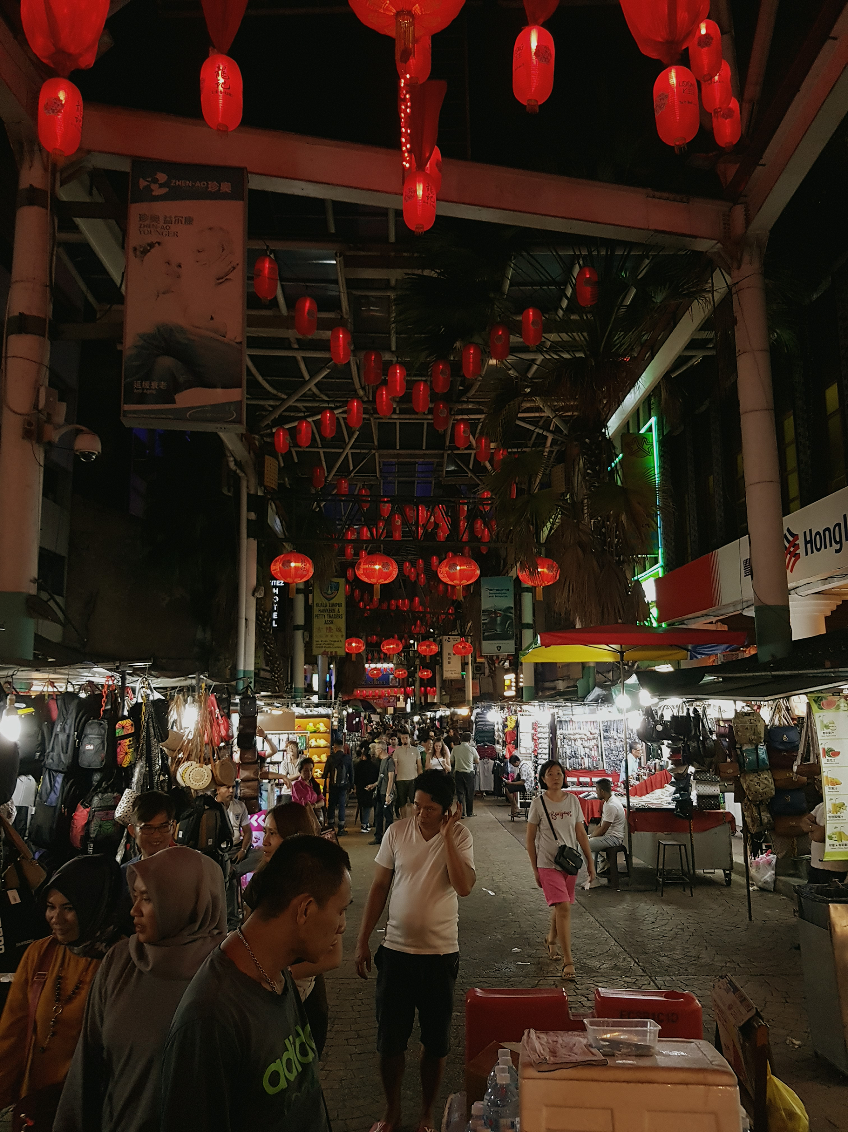

Introduction..

Night market or bazaar is an out-of-door type of market, which means that it occurs in the street. The main difference between a night market and a normal market is that the night market takes place at night. In this type of market, you can find various local street food, traditional clothes and souvenirs in addition to handicrafts and arts.

Where and when did we go?
We went to Chinatown which is located in Kuala Lumpur, and it’s considered to be one of the famous tourist places in Kuala Lumpur ,because its streets are full of life , and it’s known by its loud and crowded streets.
The Chinatown opens its door from 12 afternoon till 12 midnight.
general information about night markets.
You can find in Chinatown almost all the normal tourists are looking for, where you can find various collection of street food , as well as the traditional clothes and this is not all , also you can find souvenirs, herbs ,toys and other goods that reflect the Malaysian multicultural society.
Usually the sellers announce their goods with loud voices to attract the shopper, where there are some sellers they just show their goods in their booths, by organizing them in attractive way to have the shoppers eyes, on the other hand there are some sellers they use the normal way that just put the goods on shelves in their stores .

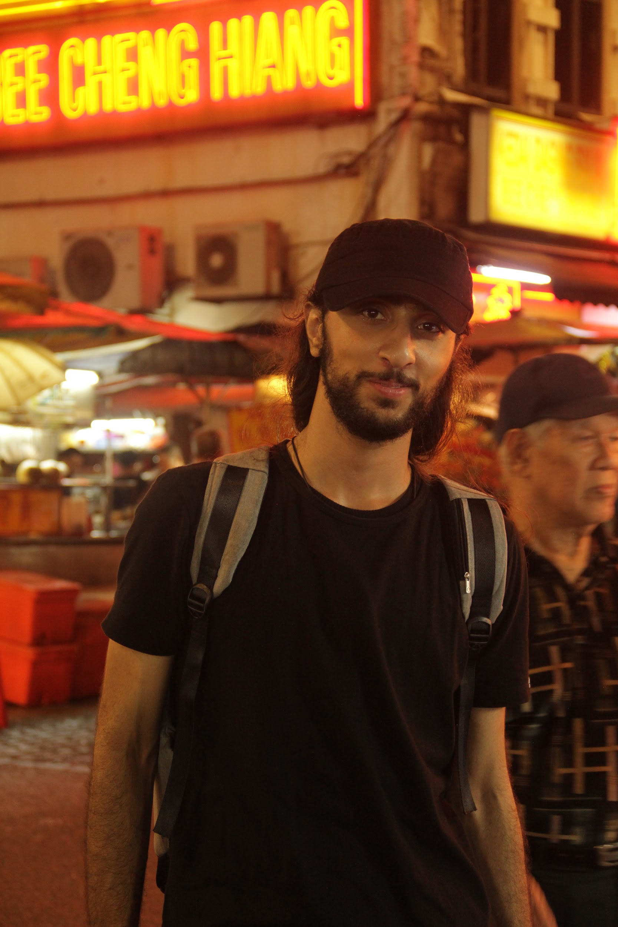
experience and impressions:

Hamzeh Wahed Bajbouj.
When I came to Malaysia, I had to adapt to a new life and a new culture, since I’m from southwest Asia a lot of things were weird and not logical.
One of the major problems that I faced that almost all the stores close at 10 pm, it’s a weird thing for a guy used to start his day after 8 pm literally.
First time I heard about the night markets was when I start my study , there were a journey organized by the college to visit the touristic monuments in Johor Bahru , the night market was one of these places, I didn’t go I wasn’t so excited for the idea. Especially when they mentioned about the night markets, I told myself nothing unique in night markets eventually is going to be just some booths and a lot of people in this place, crowded place, unsafe easy to get robbed. These thoughts that I had was because of the movies that I used to watch it.
These thoughts were wrong when I had to go to the night market due to this subject , I went with my group to a night market called the Chinese Town located in Kuala Lumpur, the place seemed to be different than what I expected , the place was full of life , many tourists , the Chinese lanterns were everywhere lighting the streets as well as the booths were stacked on both sides of the streets.
There were many food booths that make traditional Malay food but the majority was Chinese food , the booths weren’t only for food they were also tens of booths that sell traditional goods , antiques and clothes . but !!! that’s not everything behind scenes almost all the goods were counterfeit.
For instance I entered a sport shop that sells beautiful sport shoes, the seller man kept swearing that the shoes are not fake , but by judging on the prices there were definitely counterfeit goods , since I already went to official branch for the same brand before I go to the night market and for sure the price was much different .
Also the counterfeit goods were everywhere it’s easy to get half price of anything you want whenever the seller tells you the price just say I will buy with the half of the price and he will accept directly since the real price is even less than half .The only thing that I bought was Medal that carved in the form of a sword.
Finally I think the night market wasn’t that bad but you have to be careful and watch out from the scammers and you have to be aware from their tricks.
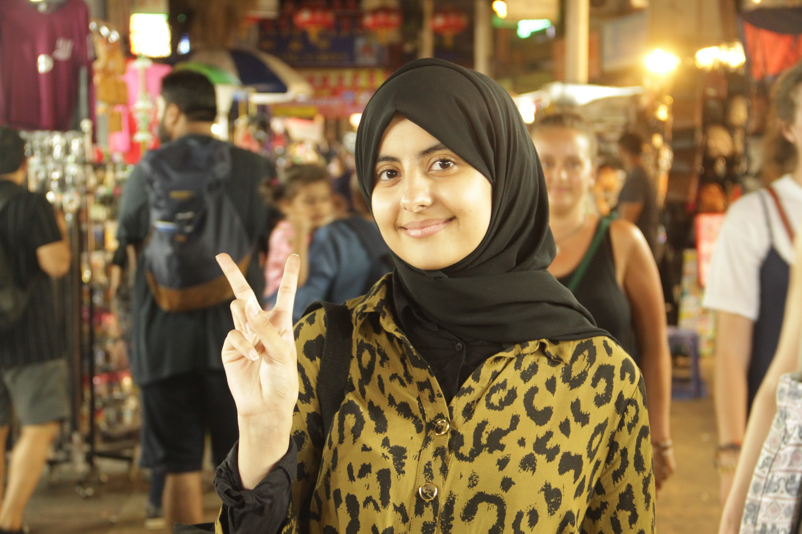
Rafah Ragheb Omar AL-Qirshi.

My personal experience in the night market is not enough to explain its characteristics, since I had no opportunity to visit it except twice. First time I went to the night market located in Johor Bahru with the university staff, in order to get to know the places in the city. The second time I visited the night market was for this subject but this time It was in Kuala Lumpur.

Actually, my expectations for the night market were different from what I found, and I can say that the real was much better. Because the place is full of lights and tourists, in addition to the fact that the price of goods is not expensive. The night market contains various merchandise and dishes that you can imagine. You can find stores that sell souvenirs, accessories and clothes. You can also find different types of food and drinks.

As for me, as I mentioned, I went to the night market twice. In the first visit, I can remember two things there. First is a nice store that contains some souvenirs and gifts, but unfortunately, I did not buy anything from it, I just went in and took a look at their cute items and gifts, which I liked very much especially that I love this kind of stores. The second thing is that there were some people who were dancing in the night market. I did not have a chance to see them until the end since I had to go back to the university, but I think it was a good performance.

The second visit was in Kuala Lumpur, in fact, the night market of Kuala Lumpur was bigger and more crowded than the one I visited in Johor, perhaps this because Kuala Lumpur is the capital and has more tourists. The number of stores was much more, but I tried to go to as many stores as I can. There were so many booths selling food and traditional clothes in addition to counterfeit brands. This time I bought some accessories from a big accessories store.

Finally, I can admit that I really liked the night market as it contains stores of various kinds in order to satisfy the interests of different people, and the fact that it opens at night.

Muhamad Akram Tello Alnswati
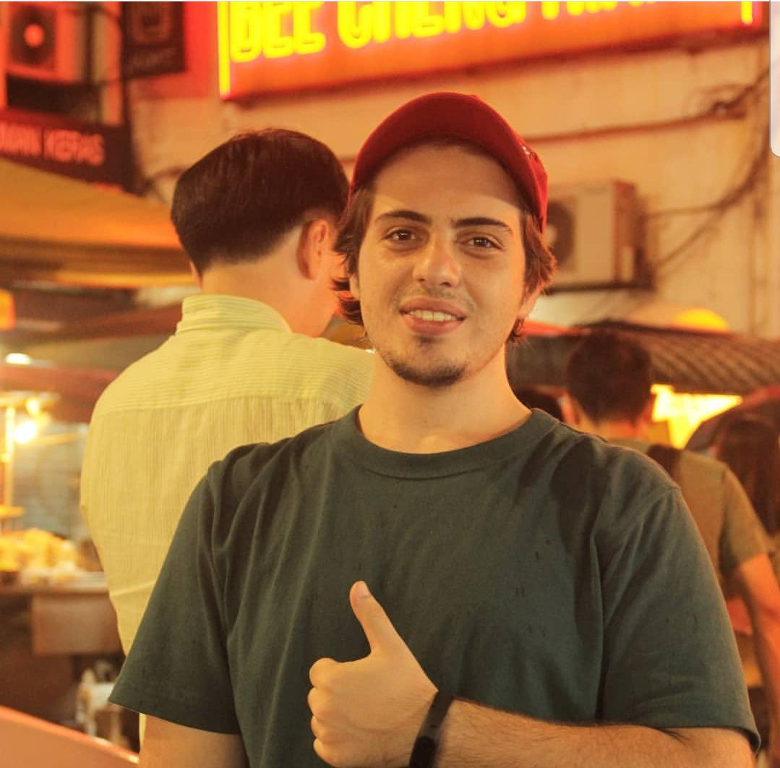

My own experience about the night market which is called “ pasar seni ” that was really surprised me when I saw People who worked at the bazar were mostly made of families, I saw one store that we bought fresh fruits from the seller was a senior woman with her kid, I very much liked how they teach their kids to work from an early age, likely as where I came from in Syria, some kids already have an experience about work and life even in some families they didn’t ask for money from their parents, which leads to fully of responsibility.

Almost all of the people who came to the bazaar are from different countries since this place is a landmark in Kuala Lumpur. In fact, that was located in the middle of the old town city which is very attractive for many tourists. Actually, There are different goods and dishes that you can imagine on this night market. Shops selling souvenirs, accessories, and clothes are easily accessible. Also, there were various types of food and beverages were available.
Also, one store we visited the workers was a guy with his wife where they divided the work between them and they also were working while taking care of their child. Still, they faced us with a bright smile and a very good attitude that made us smile back and buy from them they were selling some nice souvenirs and accessories that handmade gifts.
Personally do believe that crowded areas do need protection just in case something bad happens. Usually crowded places like this you will see a lot of robbed, and unsafe so, in general, I will be more appreciate if I see security guards or police in there to make the place safer.

The place sadly was mostly full of Chinese only, although they sell fake goods at a good price, I wished if there was more Indian Malaysian and Malay.
One of the things I liked is how the bazar was set ready for the rain, I thought when I was going with my friends that we should cancel it since its heavy raining, but it turns out that rain made the experience even better.

After we grabbed some dessert from a cake store, which was so unbelievably delicious and was kind of similar to our dessertS, we went a couple of meters behind the bazar and there was Central Market, we had spent some fun time there before went home.
One surprising thing was even though each ethnic has its language all people were speaking and using the English language, but the hard part was that only very few of the workers do not speak English, was one of my friends doesn’t find the size of the jeans, so it wasn’t easy to tell the seller.
This made me want to learn Malay language, even more, thinking about how good and easy it will make living in Malaysia.

lastly, I enjoyed the visit so much and made me experience a lot of things, the place was very beautiful and the people were so kind and food and goods overall were okay.

Salem Omar Salem Bakarker

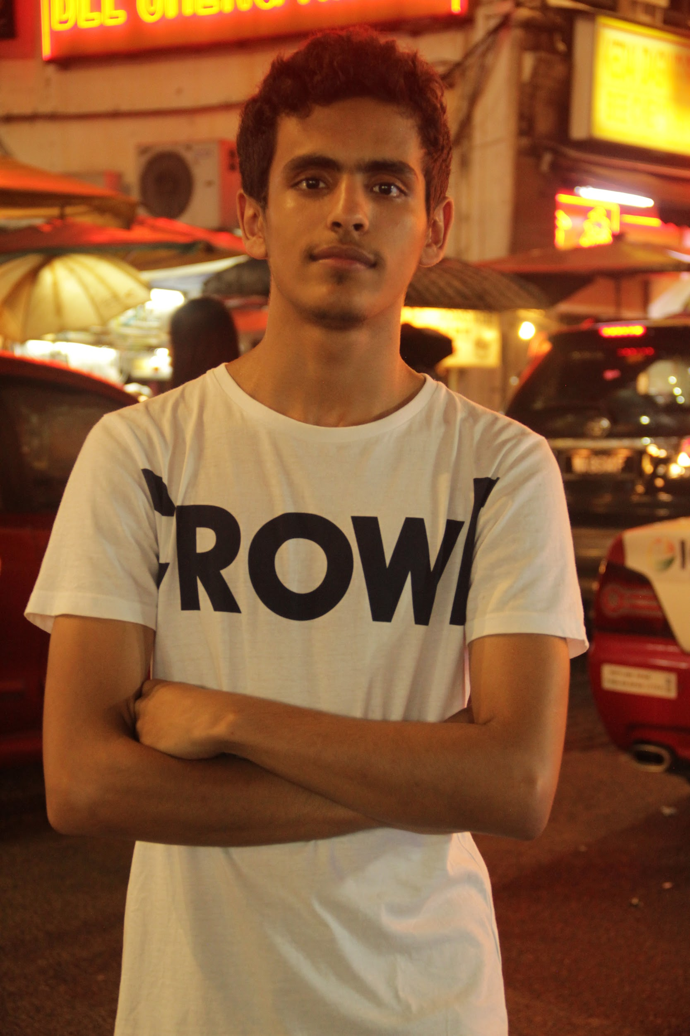
The night market, which is one of the new experiences that I had on my arrival in Malaysia. In the beginning, I would like to make it clear that I am not a fan of shopping, as I do not usually go shopping with my friends or family, but the difference in the night market that I visited is that it is not just a market in which some products are sold, but you can learn about many cultures there as it is a good fortune for my trip. The first was the night market in Kuala Lumpur, which is called Chinatown.

Since I entered the market, I felt energetic because of the beautiful lights that are spread all over the place. The place is also full of life. When I started looking for something to buy, I noticed that there are many international brands offered for sale at low prices, so I was surprised, but one of my colleagues explained to me that they are selling a replica that is similar to the original in appearance but differs in quality.

One of the things that I liked also was the spread of traditional restaurants in the market, where I was able to experience many Malaysian dishes such as Satay , Tandoori and nasi dagang, I also noticed the spread of traditional clothing stores, so I decided to enter one of them. I liked the seller’s dealings with us, as he was friendly and costed his time to explain to us the types of traditional clothes in Malaysia, such as Paju Melayu, which is the traditional costume for Malaysians and the kurta, which is the traditional costume for Indian Malaysians. It was an important information for us, especially since our final project talks about traditional attire in Malaysia. All this enabled me to learn more about the different cultures in Malaysia as the market is a good place to spread the country’s culture due to the presence of many foreigners in it.

In conclusion, I can say that my trip to the Kuala Lumpur Night Market is one of the experiences that I will be happy to do again . As I got acquainted with new types of foods, and I feel remorse for not buying anything. I suspect that my colleague warns, as I mentioned earlier, was the reason that I didn't buy anything, but in my next trip I will try to buy some things that I may only find in places like this.

Mohammd Arsalan Mujaddadi

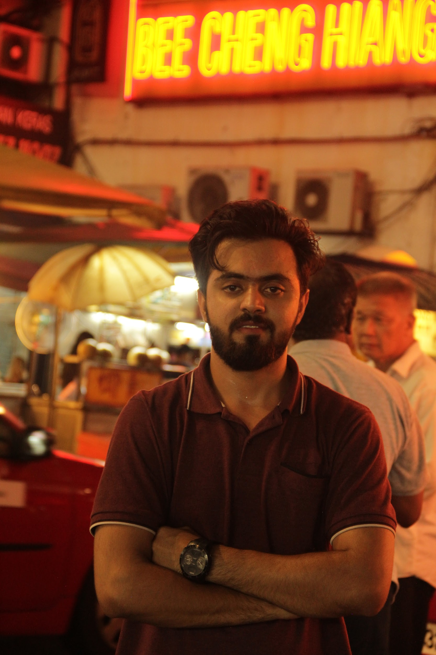
The night market was one of the rewarding and worth remembering night for me due to exploring Malaysian culture with Arab friends.
We gathered in KL to explore the night market of Kuala Lumpur. We went to Petaling street, Chinatown and finally had dinner in an Arab restaurant.
We started with petaling street, it actually opens from noon but mainly at night so people call it a night market. Afterwards I tested some of the Malay food, talked to some of the Malay people and finally snapped some pictures .
I personally liked and enjoyed the night market alot after having so much stuff to do, well forgot to mention that this was not my first time going to a night market. I have been to the night markets of JB and Penang, but I liked it better than others due to the location and crowd.

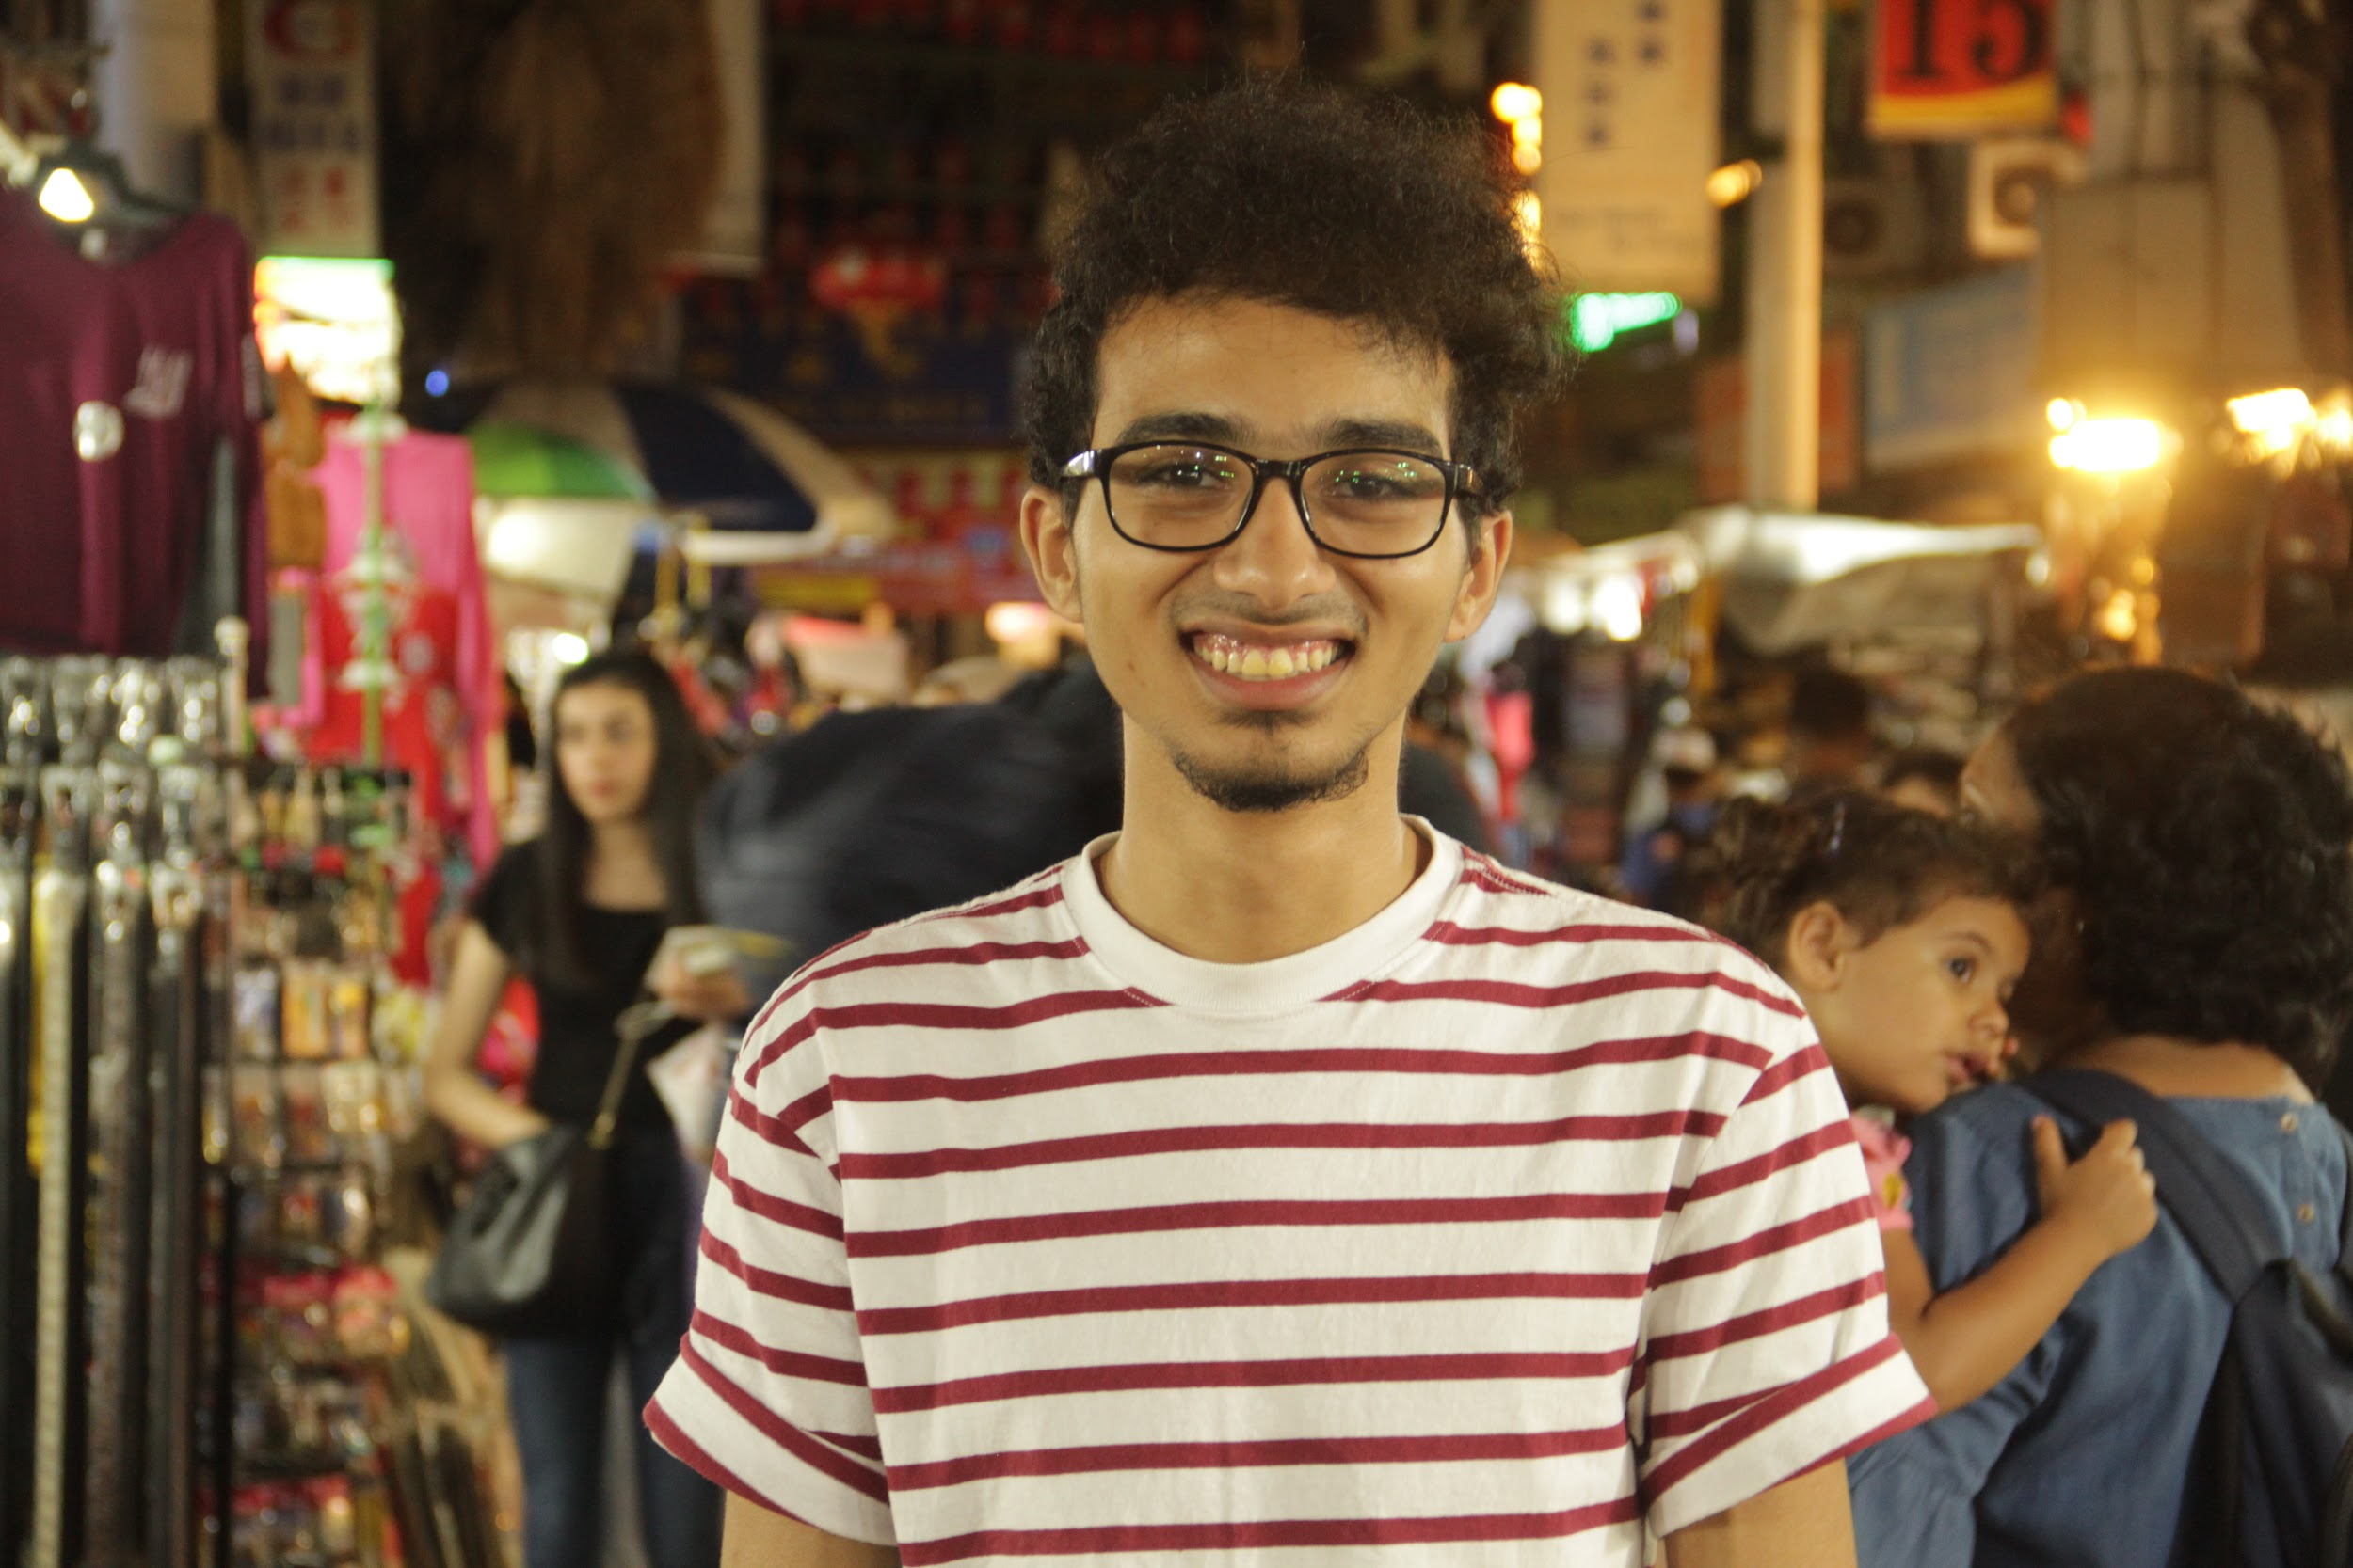
Abdelrahman Rashad Ali

For me night market was so cool cause I’m person who prefer the night life and unfortunately as I have notice most of Malaysia close at 10PM not like my home town which was close at 1PM, so we decided me and my group to try something new and hanging out at night . in addition to I’m student in UTM I have been living in Malaysia for four years , specifically in Kuala Lumpur , So I have invited my friends to visit me to show them some parts of KL also to go to night market together. We have been to China town’s night market , The atmosphere the was so amazing we manage to find a good products with a cheap prices farther more we have tried a new kind of Chinese food and Indian food it called tandury and it was delicious , also we bought some souvenir and gifts and I bout a T-shirt for myself and we had some beautiful pictures together , overall I could say we had a great night together with a beautiful experience which I recommended to everyone and definitely I would go for it one more time .

conclusion

After completing our tour in the market, we concluded our night with dinner in one of the most famous restaurants in Kuala called Halab, and each of us reviewed what we bought from the night market. In conclusion, we would like to say that our experience in visiting the night market was one of the most beautiful experiences that we had, where first we gained experience in dealing with Sellers, as most of them offer you a product with a double price so that it will be profitable if you have discussed it to reduce the price for this when anything is offered to you. Offer half of the price to him. We also were wrong to go there afternoon as most of the stores were closed, which is supposed to be clear due to the name of the market (Night ). Also, this trip allowed us to get to know the customs and cultures of this country more as we got to know the concept New to the word market, as it is just a centimeter Think of the word market, imagine huge malls and expensive stores, and forget those traditional and small shops that sell protection items at an affordable price. Of course, we will repeat this trip again whenever we have an opportunity.

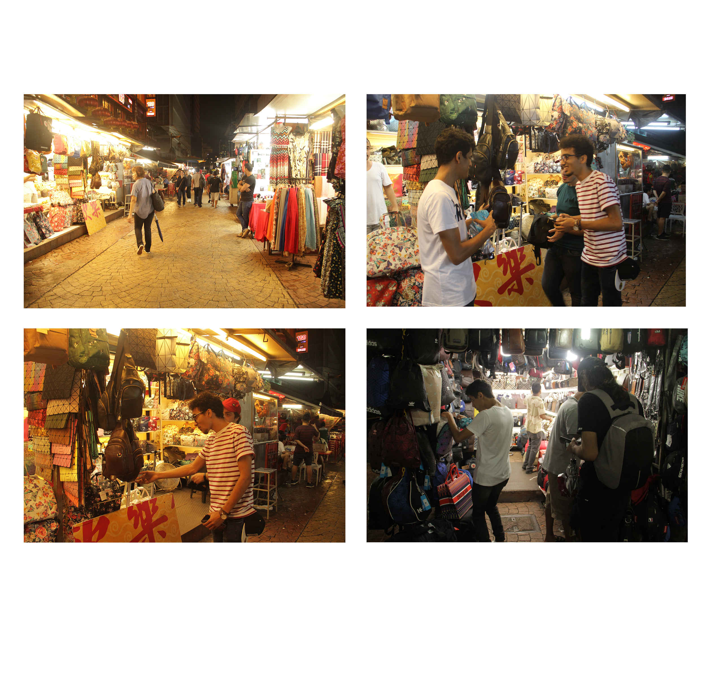
photos from our journey

