

MUSIC AND NATIONAL ATTIRE IN MALAYSIA

Course name: MALAYSIAN STUDIES 3

Course lecturer:DR Ana Haziqah A Rashid

Group members::

Hamzeh Wahed Bajbouj (A19EC4009)
Rafah Ragheb Omar AL-Qirshi (A19EC4019)
Abdelrahman Rashad Ali (A19EC4001)
Muhamad Akram Tello Alnshwati (A19EC4031)
Mohammd Arsalan Mujaddadi (A18CS4035)
Salem Omar Salem Bakarker (A19EC4008)

Section: UHMS1022-07.
Group: 2

content...
Malaysian Traditional Music:
1.History of Malaysian music
- Malaysian society.
- Malaysian music and colonizatio

2.Types of Malaysian music.
- Classical music.
- Syncretic music.
- Folk music.
3.Facts about music in Malaysia.
4.Malaysian musical instruments.
- introduction
- most common instruments
Malaysian Traditional Attire:
1.Malay attire
- The term of national custom
- Malaysian female attire(Baju kurung)
- Malaysian male attire(Baju melayu)
- When do Malaysian wear it
2. Chinese attire
- The term of national custom
- Cheongsam 2.3 Hanfu
- Kun Qua
- wedding Chinese attire
3.Malay Indian Clothes
appendix
references….

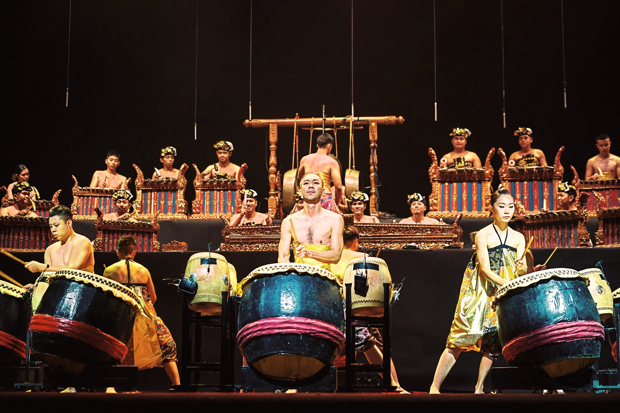
Malaysian Traditional Music…

1. History of Malaysian music :[3]
The history of music in Malaysia has been through a lot of changes through time, there are many factors that have apparent influence on the Malaysian music.Two main factors that have a big influence which they are the multi-racial society and colonization.
1.1 Malaysian society:[1][2]
Since Malaysia is one of the societies that is a multi-cultural and multi-racial, this ethnic diversity in Malaysia has an obvious effect on Malaysian music history.
They are three main races in Malaysia
1. Chinese race.
2. Malay race.
3. Indian race.
Due to multi-racial community, each different ethnic group have their own type of music that reflect their culture, as a result of that various kinds of music has been appeared, we can see this music diversity in Folk music.
1.2 Malaysian music and colonization:[2]
The second obvious factor is the colonization, Malaysia has went through two phases of colonization.
The British colonization and the Portuguese colonization.
The Britch’s influence wasn’t significant as the Portuguese influence, since they are credited with the introduction of the violin and the guitar.
Europeans have also directly influenced the development of semi-modern syncretic.
2. Types of Malaysian music:[1][2][4]
In general there are three categories of music, each type is played in specific times or special events.
2.1 Classical music
The classical music is considered to be one of the origin music types that has not been affected by the different factors as well as the folk music.
It’s first appeared before the pre-colonial period, it only uses the musical instrument without any human voices or singing.
The classical music is used to be for the upper class of people like the royal families.
This type of music required a lot of hard training that needs a lot of time and patience , since it's performed in the special and important events such as the coronation event. examples classical music: Nobat , jogat gamelan.
2.2 Syncretic music
The syncretic music is a combination of folk music, classic elements with foreign music elements From other countries.
it started after the Portuguese colonization period influenced by many factors.
Examples of Syncretic music: Ghazal, dondang sayang, joget.

2.3 Folk music:
folk music is considered to be for common people, and it’s usually performed in rites of passage, festivals and healing rituals.
the diversity of music can clearly appear here since,each race has their own kind of music .
Malay music : malay music uses the percussion instruments,it’s usually made from natural materials.The most common type of percussion instrument is the drums,There exists more than 10 kinds of this traditional drums. most famous drum type is called gendang.
Dondang Sayang this is one of the malay music, It contains a combination of traditional malay elements along with other foreign elements.
Chinese music :Same as the malay music it is a mixture of their traditional Chinese music with the westerns. some examples : banhu ,gaohu ,yueqin.
Indian music: Unlike the two other races the Indian Malay race has influenced their music from India only. In India they have two types of music the Hindustani and Carnatic classical music, and since the Tamil population in Malaysia predominates,Carnatic music is the more popular.
Year after year, the Punjabi music assert itself in Malaysia. Nowadays the “Dhol” sound is included in music among the three races in Malaysia. They even have a Bhangra group called Goldkarts.
3. Facts about music in Malaysia:[1][4]
Here are some interesting facts about Malaysian music.
1. First recording of music was in 1903 made by Fred Gaisberg.
2. The Malaysian music used to be recorded in Singapore in EMI studios, before the independence of Malaysian in 1957.
3. Even after the industrial music moved to Malaysia , the music used to be produced in India before it re-sent to Malaysia for sale, due to the lack of locally music production.
4. Foreign bands must submit a copy of a recent concert before playing in Malaysia.

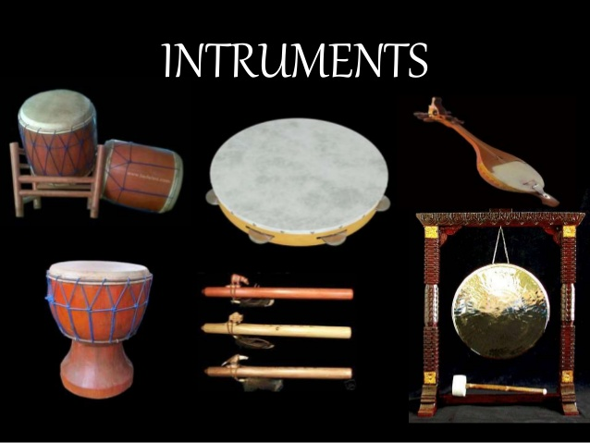
4.Malaysian musical instruments:[5]

4.1 introduction:
According to Malaysian history there is a variety of cultures which caused a variety in instruments , for instance drams, stringed instruments and wind instruments. Even though there is a lot of instruments but the most famous five will be showed at this part .

4.2 most common instruments
4.2.1 Kompang<1>
First of all Kompang. Kompang is a kind of traditional musical instruments and the most popular for Malaysian community. It is a group of drums can played with hummer and have different siizes , it is manufactured from cow skin, buffalo and synthetic rubber. Kompang is usually played during marches, wedding ,feasts and other traditional ceremonies. The tradition is to hit the drums while singing or poetry in classical Malay language ,Whereas the modern playing is where the drums blows associated with movement or dance. This instrument came originally from Arab nations and were brought into Malaysia whether early Melaka by Indian Muslim sailors, and get into Java in the 13th century by Arab traders.
4.2.2GAMELAN<2>
Second kind of instruments is the GAMELAN , it is a percussive instrument and this set of brass percussion is performed like an orchestra. It is made from copper and it comes originally from Indonesia specifically from Java basically it is the origin music of Balinese and Javanese in Indonesia which they play it in celebrities and ceremonies . The word gamelan taken from the Javanese word gamel, which means a type of mallet used to hit the instruments. However the popularity of gamelan has fall back since the new kind of pop music has started ,However gamelan is still usually played on formal generates and in many traditional ceremonies .

4.2.3 GENDANG<3>
There also GENDANG which is the third instrument . These are Malay drums of different sizes made out of cows’ heads or taut buffalo. There are different drums for the Royals of Malaysia and common people. In Royal family, the biggest drum is called the gendang nobat and for common folk, the biggest drum is the rebang ubi. Head on over to Kelantan and Serawak to find these drums. These drums are exist in a variety of sizes and uses also These drums have 2 sizes, one called the mother drum and the other one called the baby drum. There is a drum used for martial for the Malaysian. There are drums used for dance and some are used to celebrate Royal celebrations or ceremonies.
4.2.4 SERULING<4>
Fourth instrument is SERULING , it’s a wind instrument. Seruling is a small Malay flute made out of bamboo , In addition to it was the first instrument used by the ancient Malay people in the past.
4.2.5 SERUNAI <5>
Last but not least , SERUNAI. is also a wind instrument . It’s made out of wood and consists of seven holes on the upper part and one hole at the bottom. It comes originally from India beside It is often used in traditional performances such as the ‘Wayang Kulit’ performance in Kelantan.

Malaysian Traditional Attire:
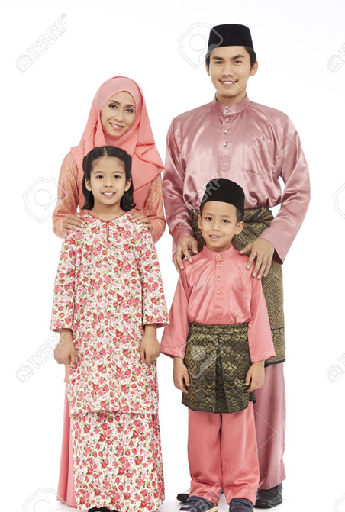
1.Malay attire
1.1 The term of national custom :
For along time the term ”baju kurung” was used as a name for the traditional attire for men and women in Malaysia till they renamed it to ”baju Melayu” as it has been the national costume of the Malays.
1.2 Malaysian female attire(Baju kurung) :[6]
Baju kurung is a loose dress with a full length, flat skirt and blouse. Long skirt with a collarless blouse, has a long stretch, and extends between the hips and knees. Usually it is made of silk from the states of Terengganu or Kelantan in Malaysia.
Types:
1-Baju Kurung Kedah
2-Baju Kurung Cekak Musang
3-Baju Kurung Teluk Belanga

1.3 Malaysian male traditional attire(baju melayu):
Long sleeved shirt made of nylon or silk worn with pants, it usually comes with samban which is considered as a robe worn around the hips. It is often worn with the Songkook or kopiah which is very popular among Muslims. It is in the form of a cut cone, for songkok it usually made of black fur, cotton or velvet. For kopiah it’s made from the same materials, but it is white in color, representing purity.
Types:
1-baju melayu teluk belanga
2-baju melayu cekak musang
1.4 When do Malaysians wear it:
Most of Malaysians wear “baju melayu” and “baju kurung” in Occasions, weddings and in Friday but it is not necessary that you wear it only at these times as most Malaysians consider it as a daily wear dress as it does not cause them any discomfort when wearing it for long periods.
2. Chinese attire
2.1The term of national custom:
In Malaysian Chinese culture, there are no specific rules on dressing, but traditional dresses are seldom worn particularly among people, except for festivals and religious events. Men usually wear a small sleeved t-shirt, lightweight jeans, and casual, comfort sandals. Chengosam, Hanfu and Kun Qua, which has been crafted in several silk fabric layers and some are completely brodered with colorful threads, are commonly worn by Malaysian Chinese people and are available with different designs and shapes. We will talk about them in more detail.
2.2 Cheongsam <1>
Cheongsam represents simply "long shirt." Cheongsam is a traditional Chinese dress made of Silk, fabrics designed with a high collar and a small clothes/toggles diagonally designed, which hooks up the cloth together. It is especially popular around the time of the Chinese new year and other formal gatherings such as tea ceremony.
2.3 Hanfu <2>
HANFU is mainly made of silk cloth and is typically painted in colors of red and green, and has been worn mostly by the han dialect, the most prevalent ethical group of Chinese and the first wave of Chinese migrants arriving in Malacca in the 15th century. In Malaysia, the hanfu is mostly worn during some festivals, ritualistic ceremonies (such are coming of age or rite of passage).

2.4 Kun Qua <3>
Kun Qua Kun literally means "skirt and jacket," typically Kun Qua is deeply pantied into a red Qun kua is usually actually stuck with silver or gold threads, which is often used to symbolize the wealth of the family. During the wedding ceremonies in Malaysia the Kun Qua is usually worn by the bride. i.e. Tea Ceremony, a formal ceremony of marriage that the couples served their new parents ' cup of Tea, signifying love and affection. During this modern age, the kuas used are chosen mostly by brides and generally are based on latest design during a ceremonial ceremony.

2.5 wedding Chinese attire
it is a very colorful dressing affair in which the bride and groom are expected to wear Cheongsam or Hanfu or Kun Qua.

3.Malay Indian Clothes
Malay Indian clothes are same as Indian clothes with some difference in style and embroidery. There are 8 percent people in Malaysia who are Indians so basically these Malay Indians who are living in Malaysia now are originally from south India. Most of the Malay Indians are from Tamilnado state which is located in south India, and their main language is Tamil. Moreover, there are not only Tamil living in Malaysia besides, Tamil there are Sikhs too but in small percentage. The clothes for Sikhs are somehow different from other Malay Indians, they wear Shalwar Kameez most of the time. Shalwar basically means the trouser which could be in any colour same goes for Kameez which means knee length shirt. In the past Shalwar Kameez for the Sikhs were so simple but nowadays it is modern and much more stylish in terms of design and embroidery.

All Indian women around the globe wear Saree, it is basically a cloth which is made of 5 - 7 meters which is usually worn with a similar shade of coat.

It is usually wrapped around the whole body so that the embroidered end hangs over the shoulder, while the coat is worn for upper side of the body to support the saree and also for the look.
Another popular kind of traditional dress for malay indian women is Shalwar Kameez women and this dress is worn by the modern families and also sikh families here, and it is worn over with the matching trousers or can be with different trousers and matching shawl is used with Shalwar Kameez.it made of the rewarding quality of silk which is also used in factories to make sarees. Some of the families with high standings and high standards buy the expensive clothes in which some of the gold and silver is used. In formal occasions and wedding ceremonies Malay Indian women wear Sarees but in normal days they like to wear shalwar Kameez.
Malay Indian men wear Kurta in formal events and high occasions, it is a knee length shirt with many different colours. But in wedding most of them wear Sherwani which is another famous kind of dress for the Malay indian men.
Other famous types of indian Malay dress for men is Lungi, Dhoti and Kurta-Pajama.

The Lungi is a traditional dress which is originally from south and today it is worn by both men and women. It is simply a short length of substantial worn around the thighs rather like a sarong.
The Dhoti is most primordial recorded Indian dress is a dhoti. They require a piece of cloth which seems longer and larger than what was worn in the past, but their folding is often simpler, and they are not decorated with straps and builts anymore. All dhotis begin with the same basic closing. The middle of the textile is knotted around the hips. Each part of the cloth is then swathed around the leg on its side.
In Kurta Pejama top is a knee size colourless shirt which is beautified in frequently white or light colours. But today you will find Kurtas made out of the most delightful and colourful of draperies. Pyjama-are like loose jeans with a cord tie at the belly. By tradition its white in colour but now you can find in any colour specially the modern Indian Malay.

appendix
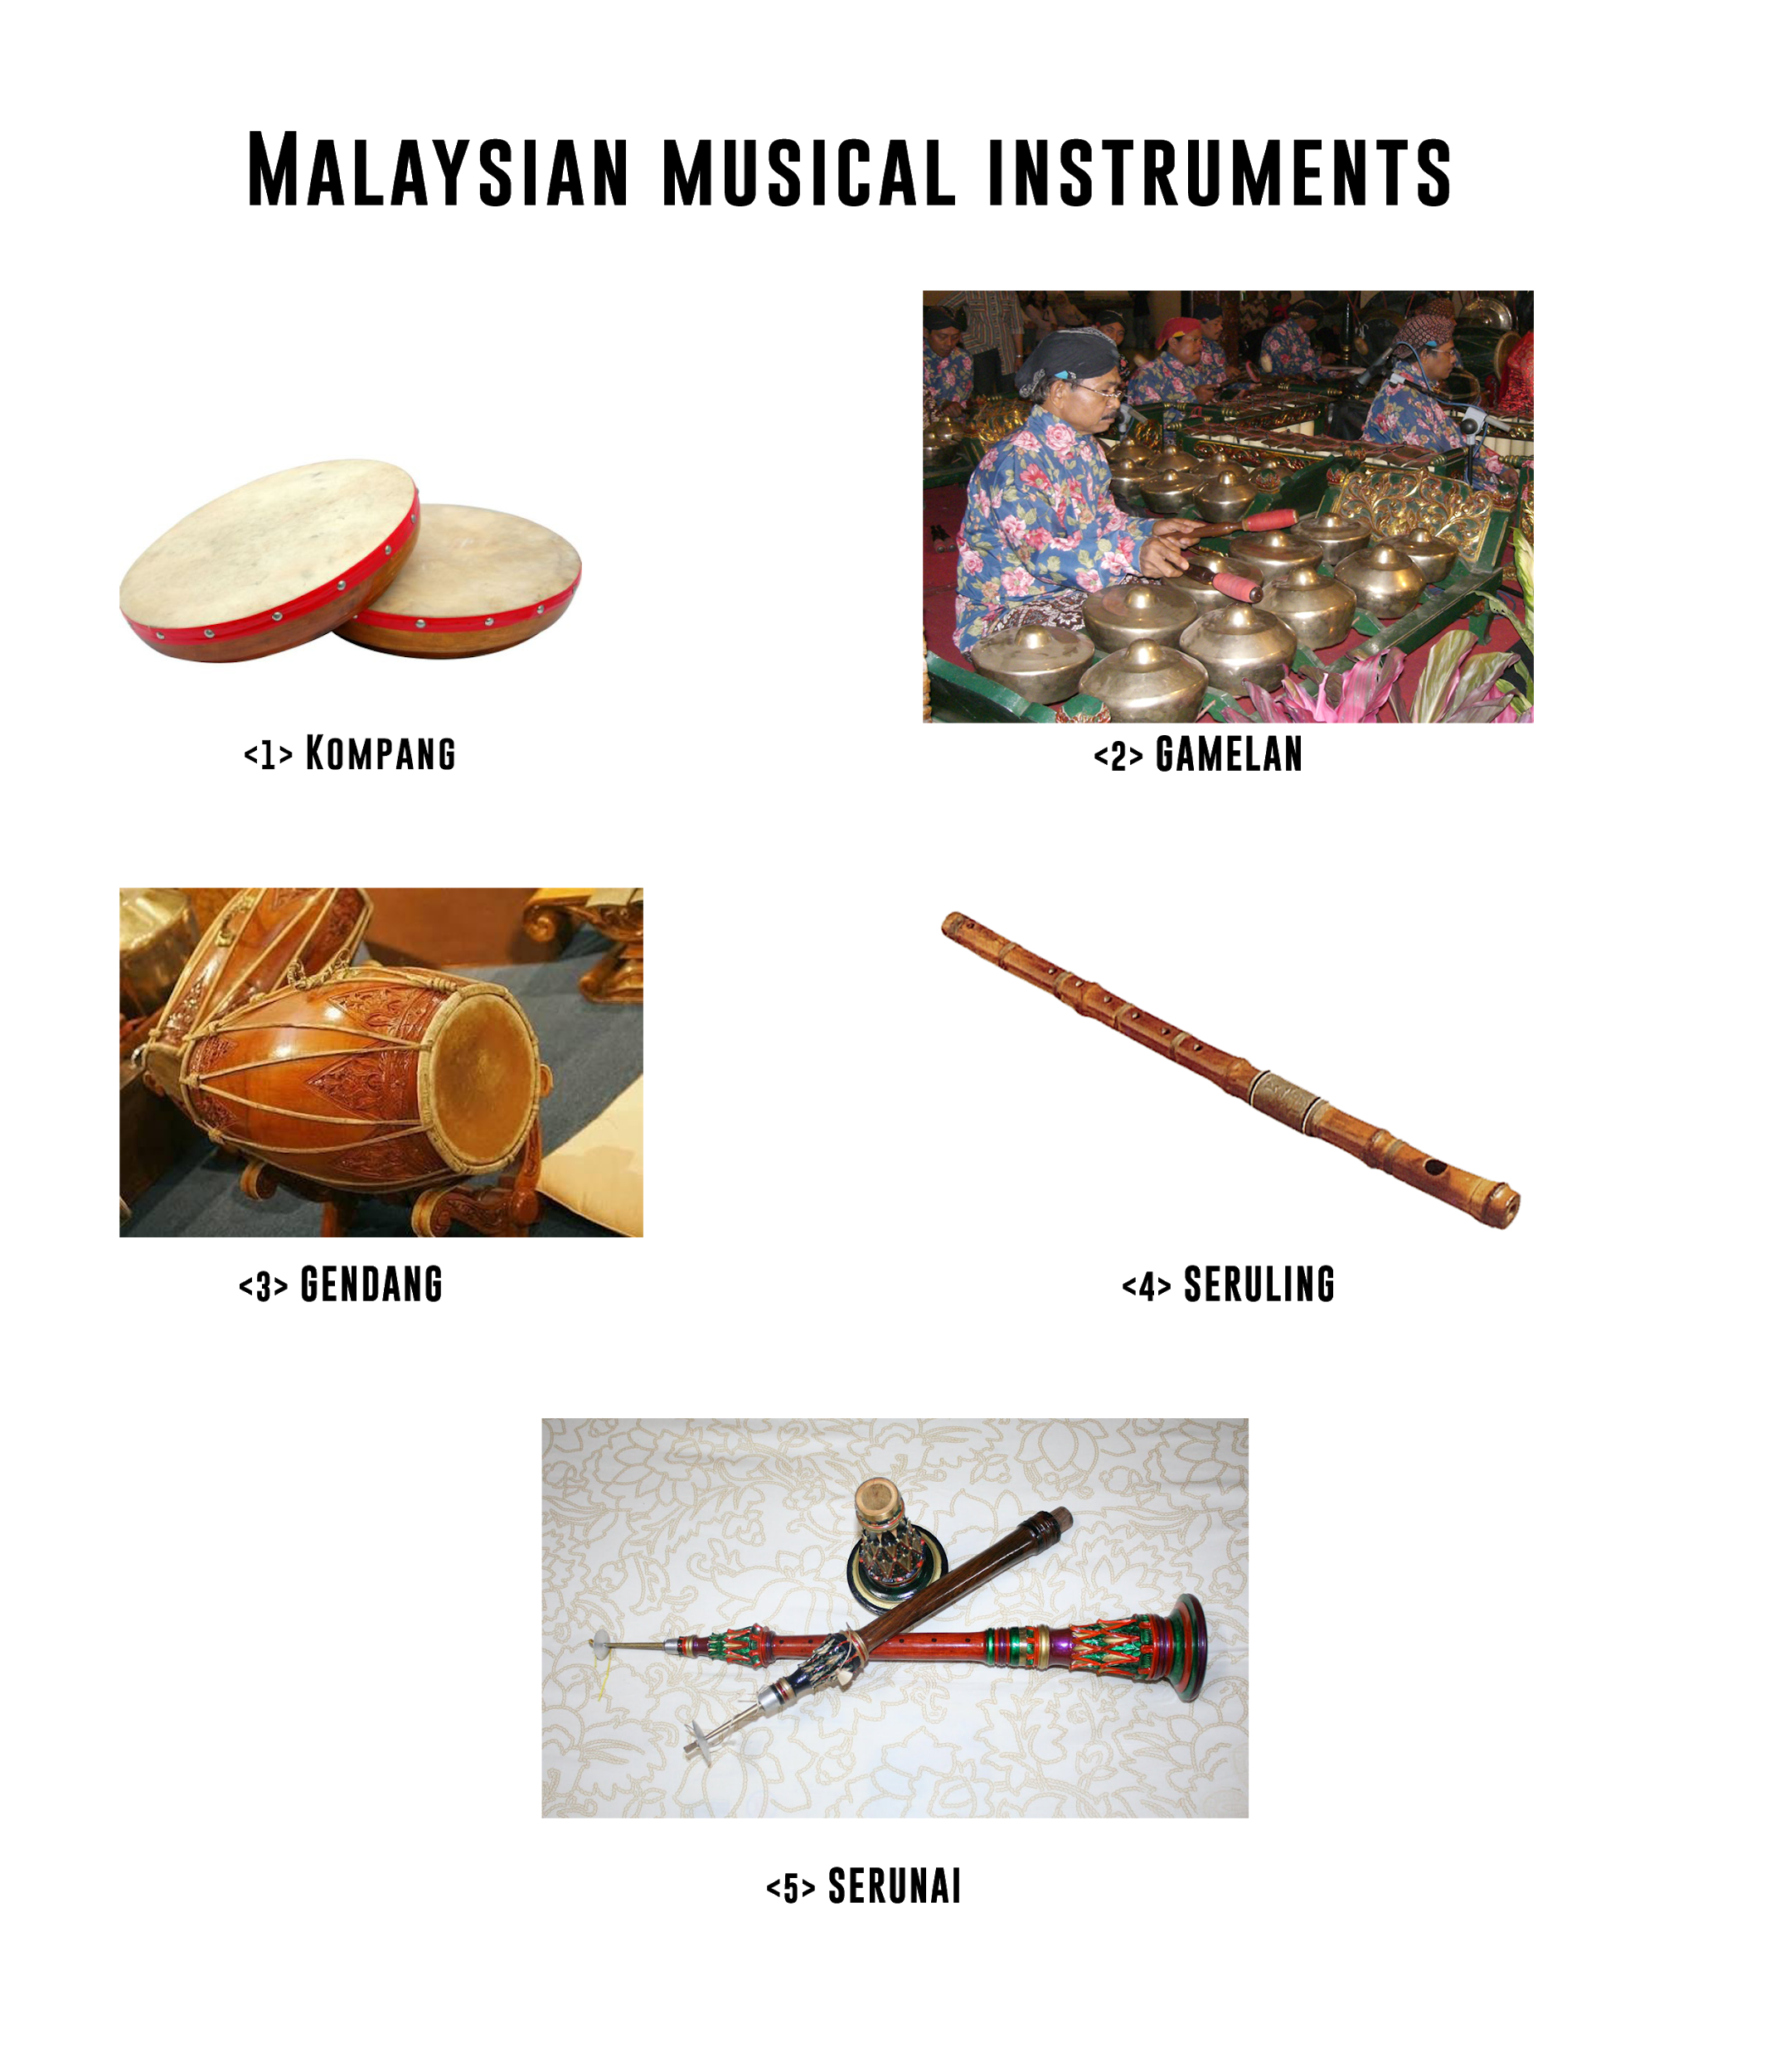

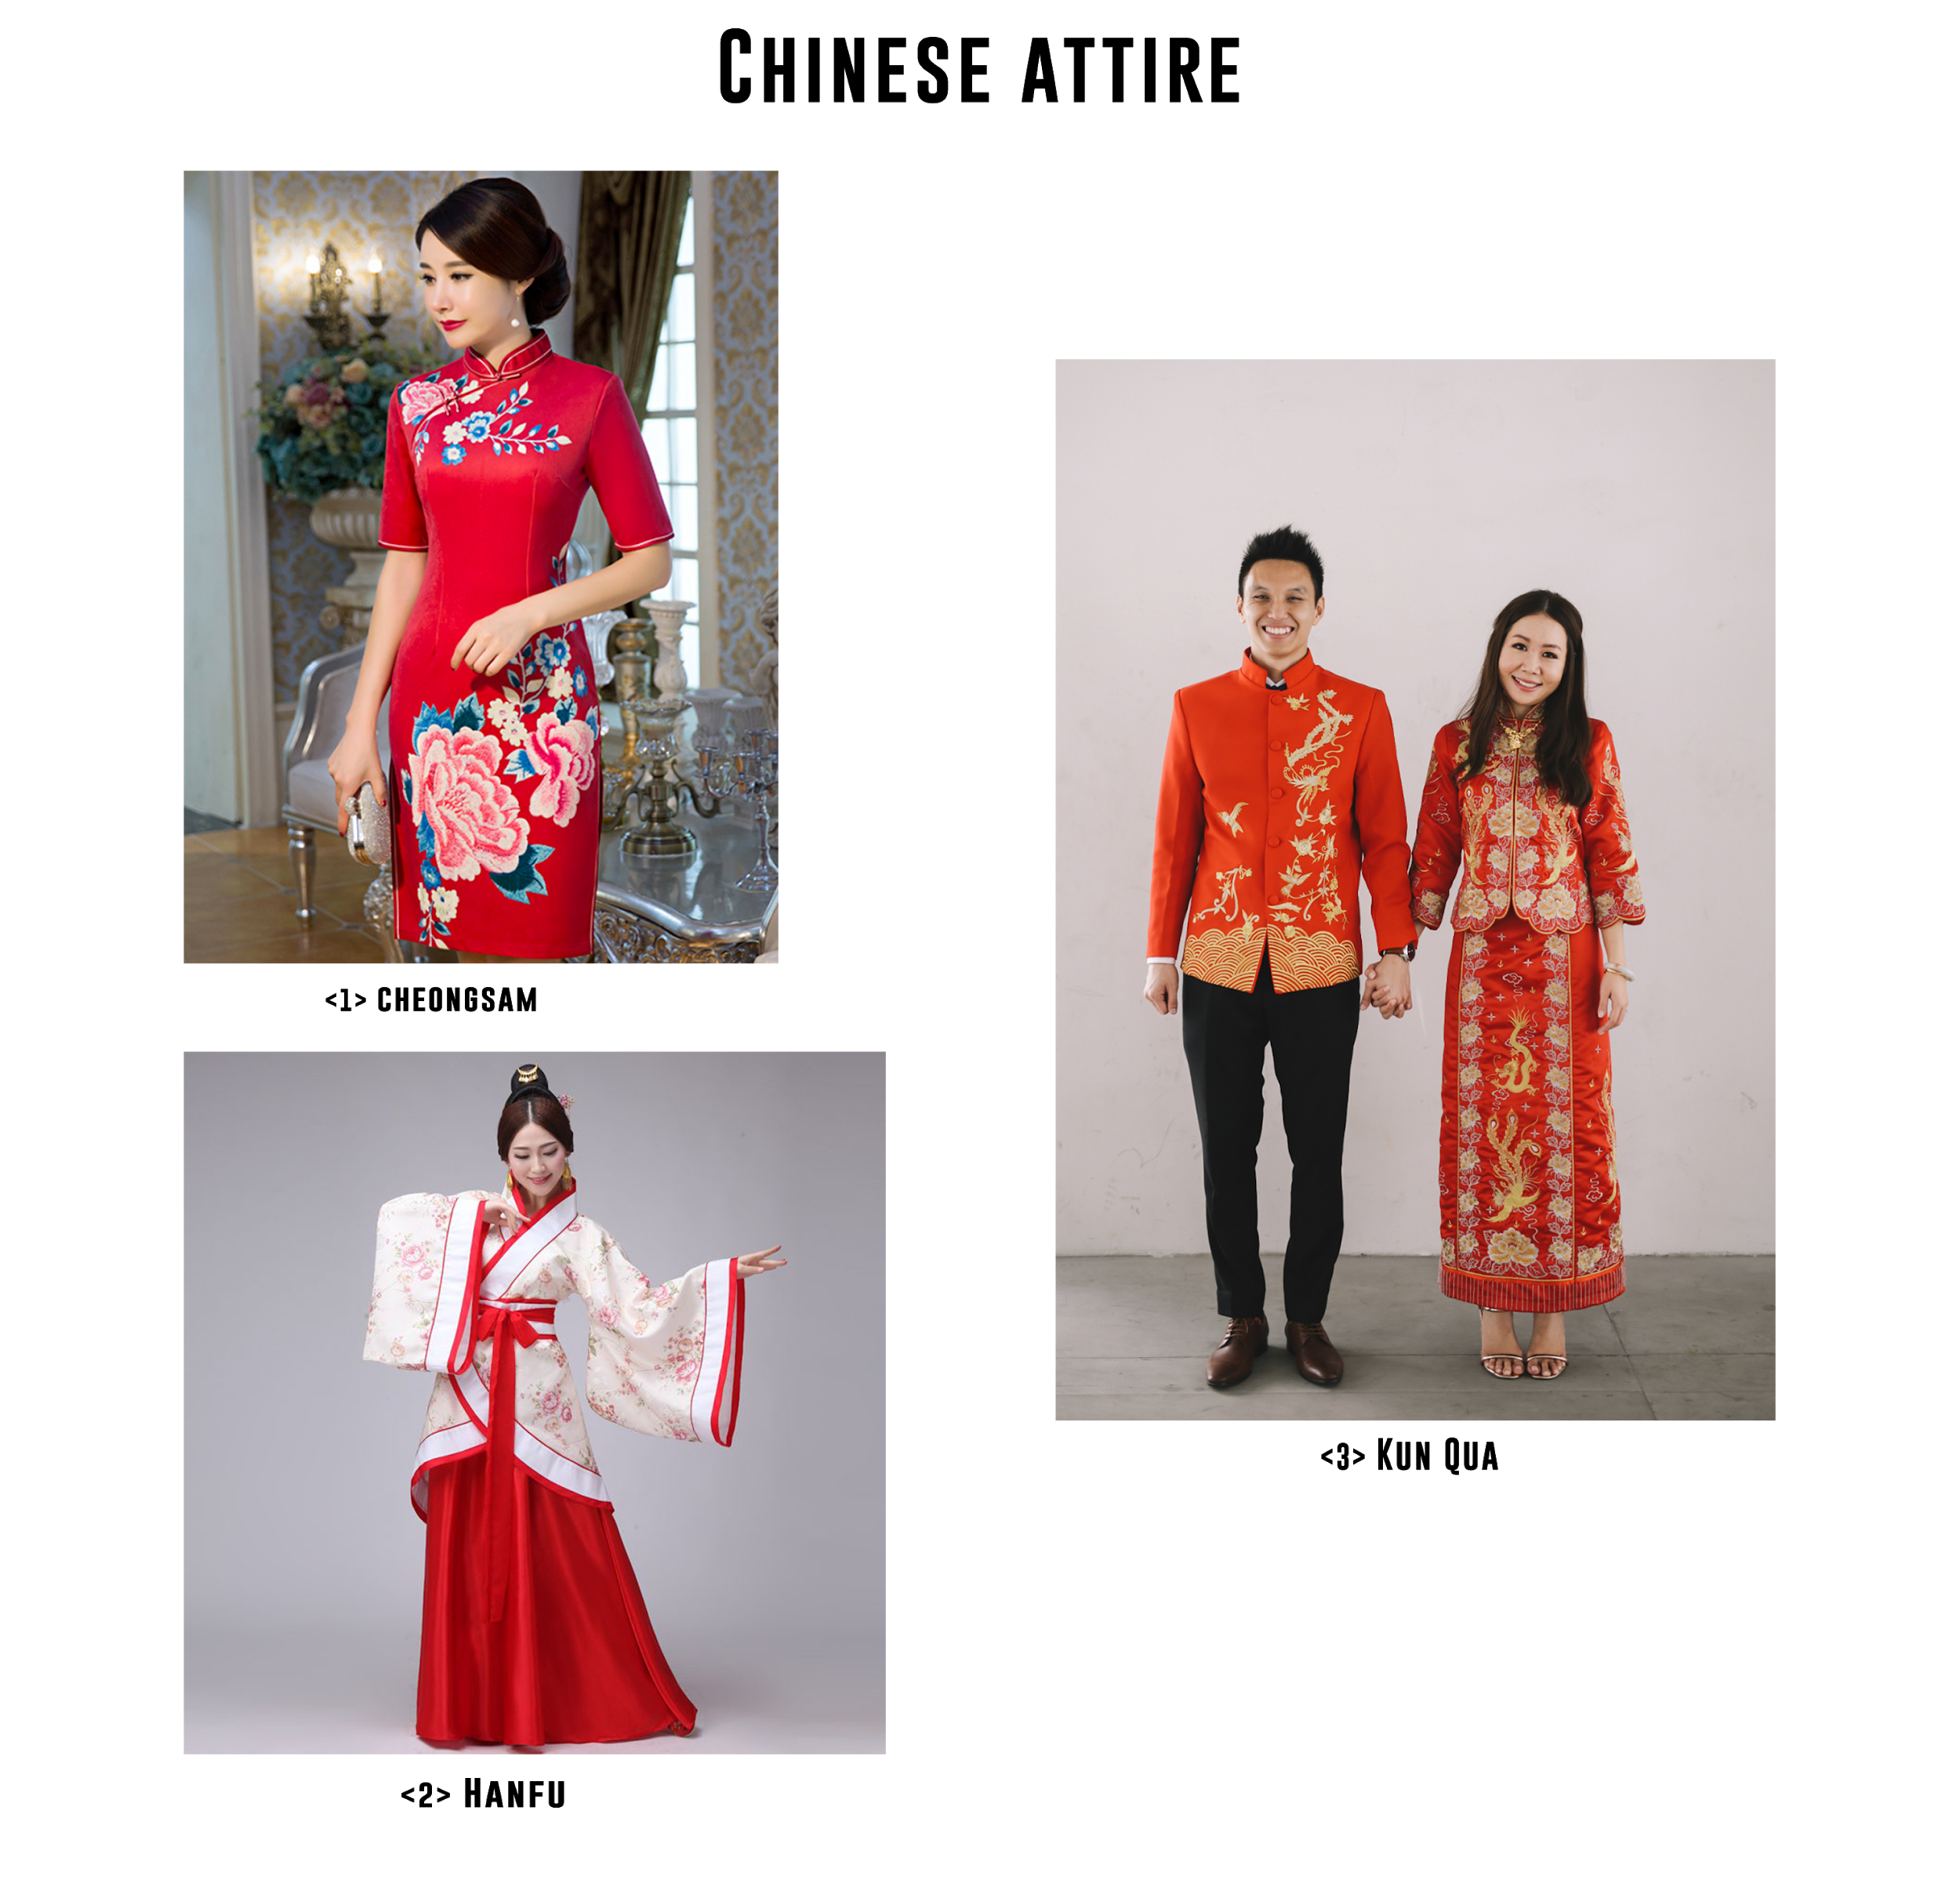

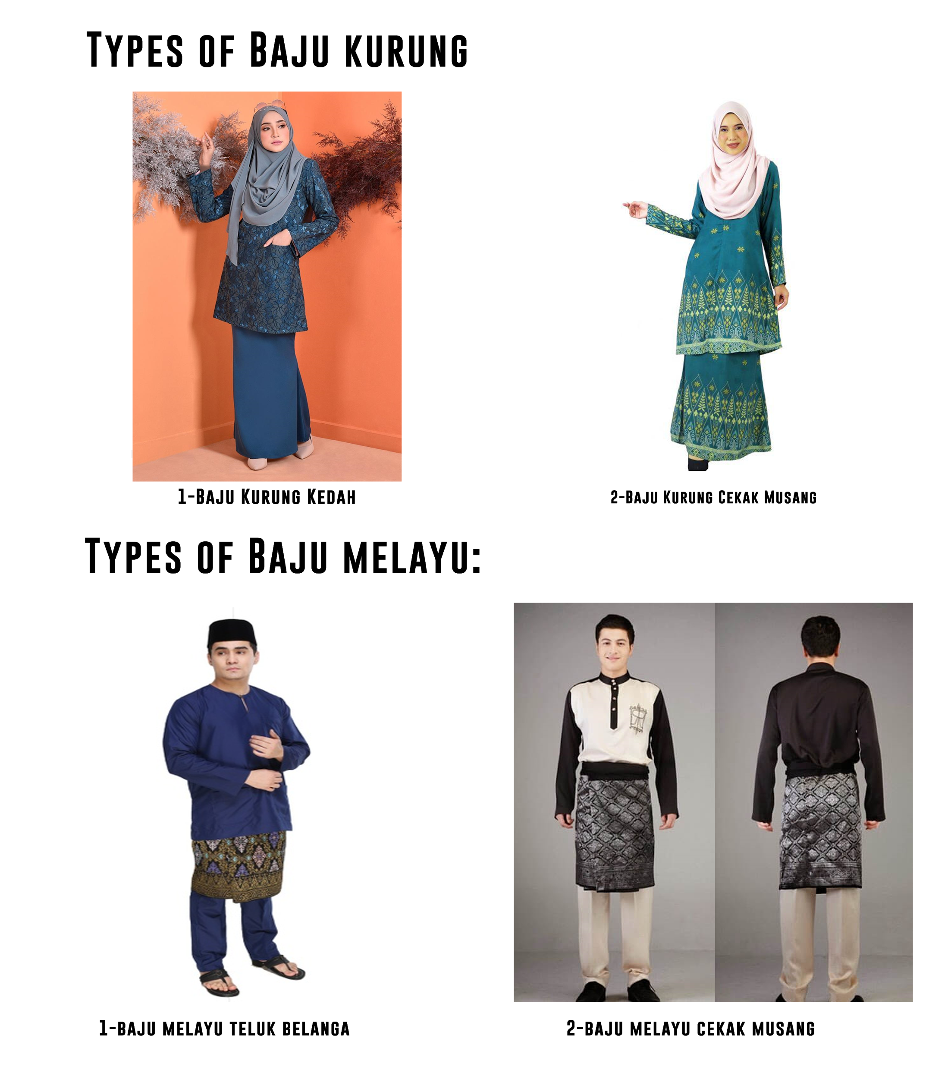
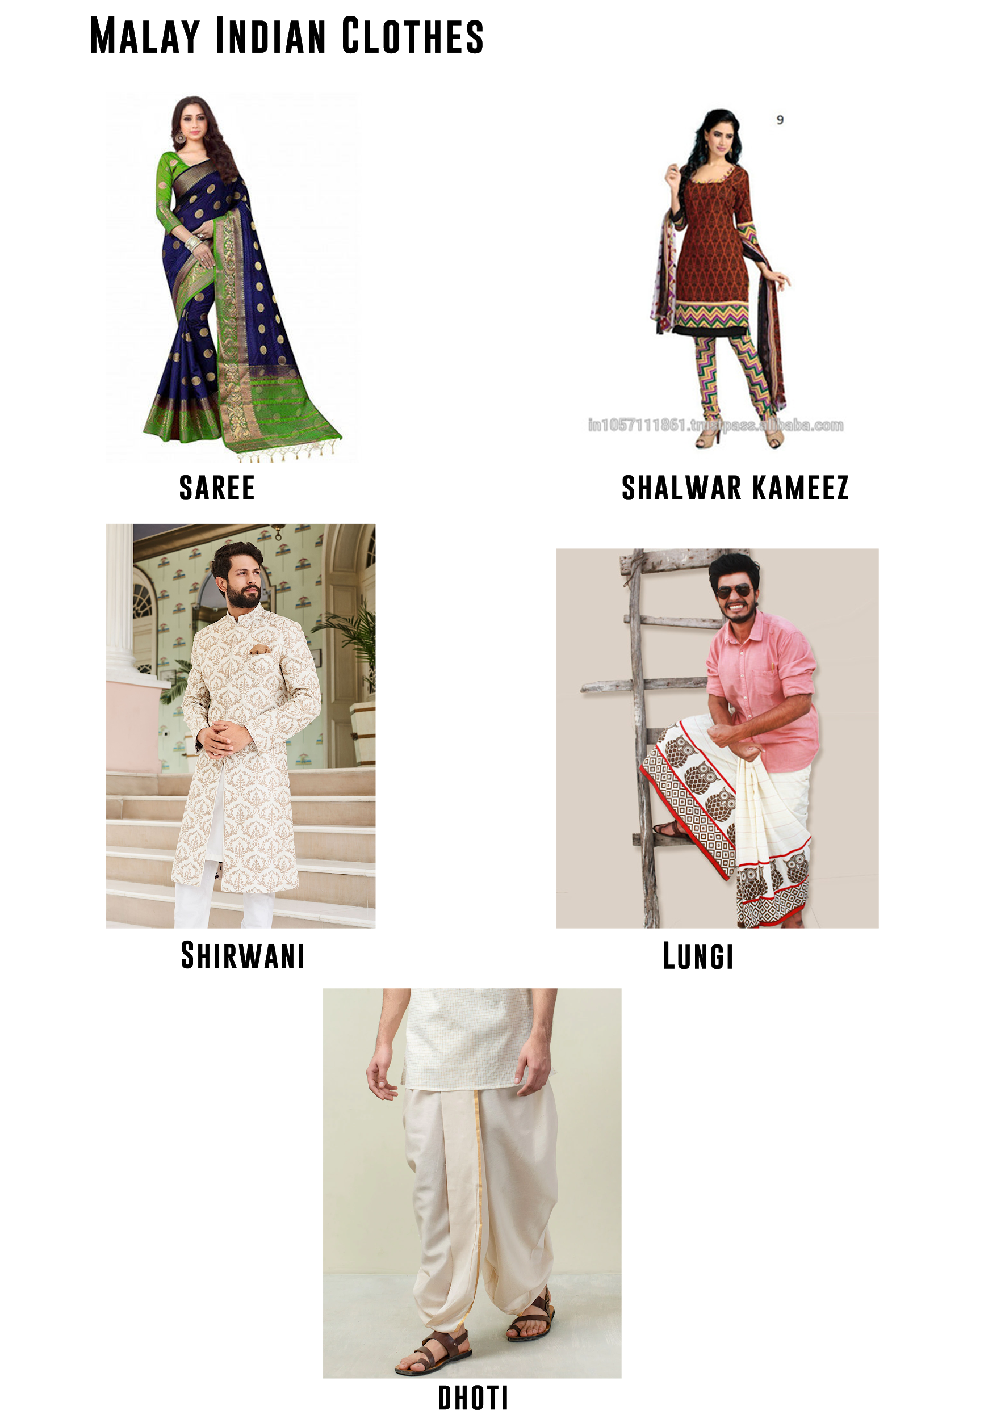

references:
[1] The Music of Malaysia: The Classical, Folk and Syncretic Traditions,Patricia Matusky, Second edition 2017.
[2] Essays, UK. (November 2018). Traditional malaysian music.
[3] Music History And Asian Music.
[4]TRADITIONAL MUSIC, POP MUSIC AND DANCE IN MALAYSIA,’’2008 Jeffrey Hays’’
[5]THE RICH HISTORY OF MALAYSIAN MUSIC AND ITS INSTRUMENTS.
[6]Baju kurung still a popular choice for many,'by Allmsia, Friday 17 Aug 2012'.

