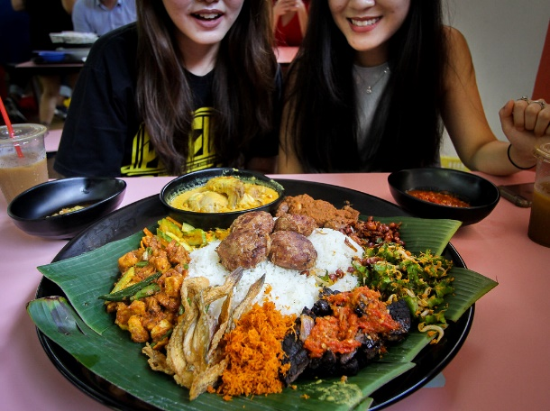
Name::
Hamzeh Wahed Bajbouj
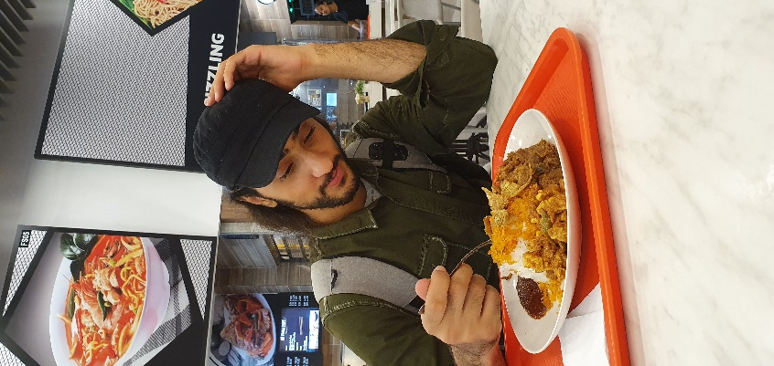
Matric No.:
A19EC4009

In middle east almost all the foods there has one or two main components ,
When I tried a dish that has at least 4 different components and sometimes 12 components!!!
it was a weird experiment, it’s difficult to describe how the taste was, it mixes between sweetness and saltness. In the First bit, you will feel that you’re eating salty dish but when you take the second bit from a different component you feel sweetness. what makes the Nasi ambang unique dish is the variation of the components.

We faced a problem when It came to find a restaurant that makes Nasi Ambang, since to make the dish you have to cook each component separately. We found a restaurant in Mydin Mall called KACANG POOL. The owner was too nice with us. Surprisingly when we asked him If he served Nasi ambang, he asked us if it’s for a Malaysian assignment food!!
Malaysian people usually eat this food in special occasions and ceremonies, for instance in Ramadan and in weddings.
I mentioned that the dish has so many components, but they are five main components that’s every Nasi ambang should have which they are:
- Streamed white rice.
- chicken or beef.
- salted fish.
- vegetables.
- spiced grated coconut.
Nasi Ambang is just one of the Malaysian Cuisine dishes , I can’t wait till I tried another dish from the Malaysian cuisine .

