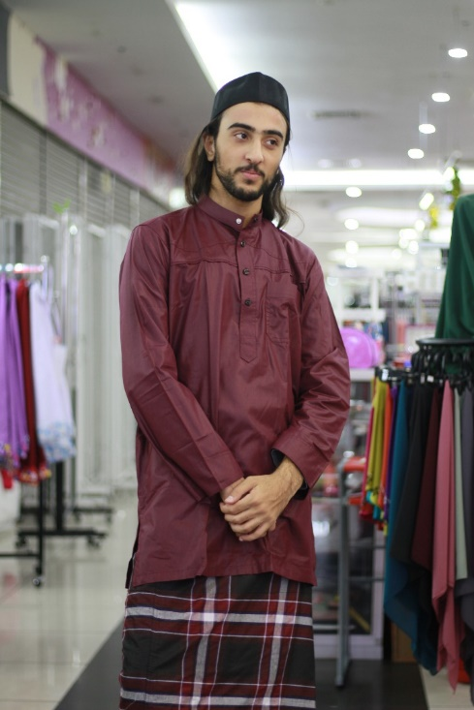
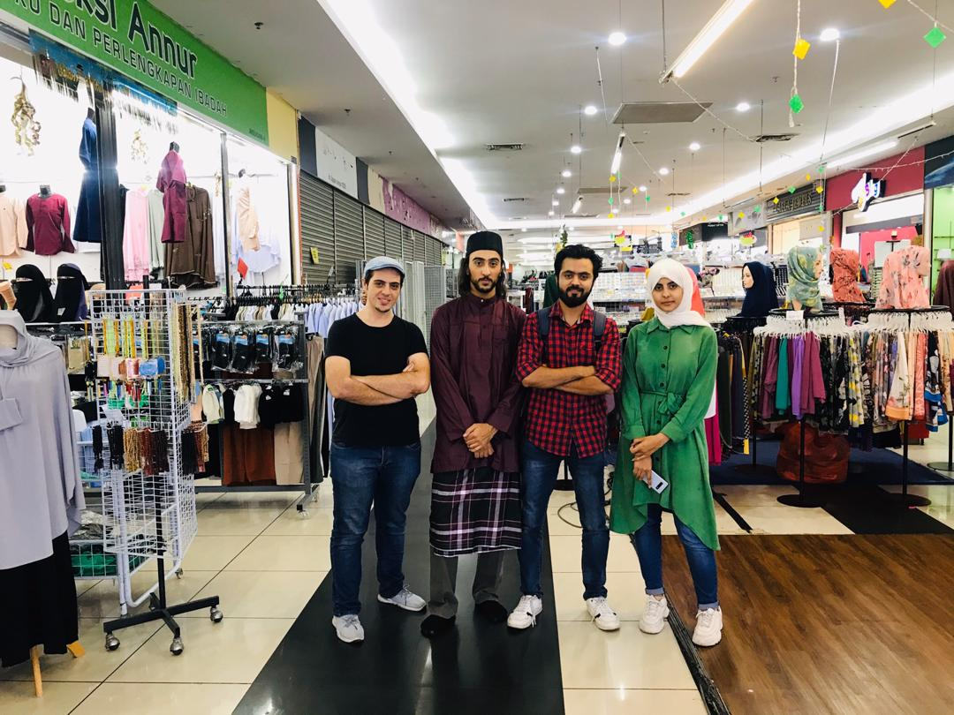

Name:: Hamzeh Wahed Bajbouj.
Matric No.: A19EC4009

Our attire is called KURTA and it’s a traditional attire in Malaysia ,Bangladesh , Pakistan and India.
And they are two types: one for men which known as Kurta and another type for women which is called as Kurti.
The roots of the attire comes from central Asia, and it’s made from cotton or silk.
It’s common between Malay and Indian people in Malaysia .
Usually the people wear it in the formal occasions. You can see the Malay people wear it in aljumah pray ,and also in weddings .
I went with my group to U Mall, Skudai ,Johor Bahru to buy this attire, it’s not difficult to find shops that sell this kind of attires. The owner of the shop was to nice with us and she showed us many different types of traditional attires. I bought the Kurta attire the same one that I’m wearing it in my photo.

A Kurta is a loose shirt that normally features long sleeves and a buttoned placket. The length is normally upto the knees of the wearer.

