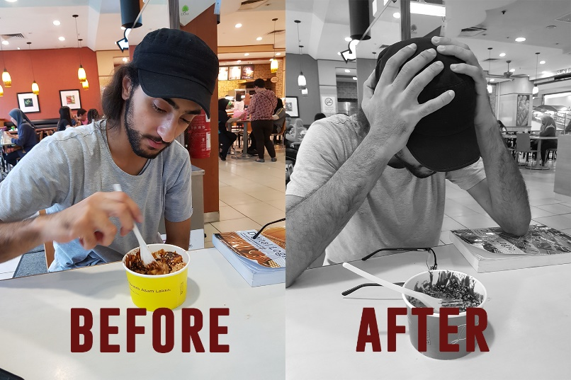

Name::
Hamzeh Wahed Bajbouj
Matric No.:
A19EC4009

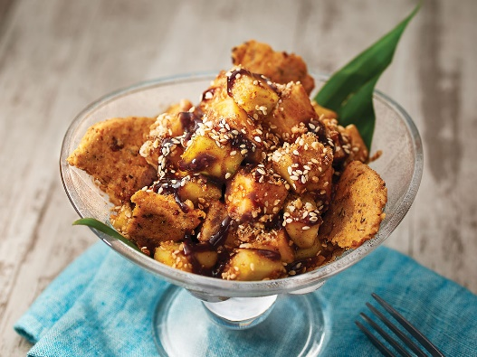

When I knew that Rojak Petis is a salad that mix vegetable and fruit together, I was expecting a unique dish since they are few salad dishes that mix vegetable an fruits together, because almost all the fruit has sweetness taste where vegetables on the opposite side has a variation of flavors so it’s hard to make a dish mix them together, but unfortunately it wasn’t as I expected, as you see in my picture after I took the first bit.
I think Petis sauce gave it a weird flavor that I can’t find a word in the dictionary to explain how was it even in Arabic I can’t explain how was the taste .
I think if the salad was without Petis sauce It would be great and I would even eat it in my breakfast since it combines all what our bodies need.

To eat this salad we went to a restaurant called D laksa which is located in AEON Tamam university .
Malaysians consider this salad as a snack so there is no specific time to eat, like in the breakfast or in lunch.
Since it’s salad and it has many food elements that our bodies need, I think it’s a good option to add it in our diet food list.

The dish consist many component but the main are :
- Pineapple
- Green Apple
- Cucumber
- Yam Bean
- Petis sauce

