No. | Group Members | Time Arrival with Signature | Time Finish with Signature | Group Meeting Agenda |  |  |  | Other Remarks  e.g potential problems/ difficulties/limitations
 |  |  |  | Date: 29/11/2019 (Friday)  Time: 10.00 a.m. |  | Who took the notes?  Name: Sharmarke | Who is leading the discussion?  Name: Ifaz
 |  |  |  | No. | Agenda Items  What are the things discussed at the meeting? | Who is talking/giving ideas? | What action needs to be taken? What do we need to bring?
1 | SEE WEN XIANG  A19EC0206 | 10.00a.m. | 11.30a.m. | 1
2 | MUHAMMAD MUKHLIS BIN MOHD FERIS HALMY  A19EC5225 | 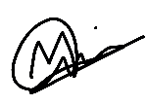10.00a.m. | 11.30a.m. | 2
3 | VIMALRAJ A/L SIVARAJOO  A19EC0213 | 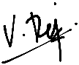10.00a.m. | 11.30a.m. | 3
4 | MANFRED JOHN JASON DASS  A19EC5238 | 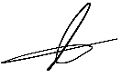10.00a.m. | 11.30a.m. | 4
5 | SATISHWARAN A/L RAJA LINGAM  A19EC0158 | 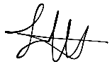10.00a.m. | 11.30a.m. | 5
6 | SHARMARKE HUSSEIN IBRAHIM  A19EC4022 | 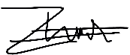10.10a.m. | 11.30a.m.
7 | MOHAMMED FAHMID FAIYAZ IFAZ  A19EC9029 | 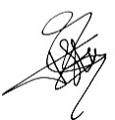10.00a.m. | 11.30a.m.

