TECHNOLOGY INFORMATION SYSTEMS
REPORT ON ROBOKAR WORKSHOP
ROBOKAR: INTRODUCTION
On Monday the 9th of December 2019, the UTM students of section 3, Technology information systems, were grouped into teams of about six individuals and we commenced our ROBOT PROGRAMMING WORKSHOP in the active learning lab in the faculty of computing N28 during the lecture hours. This workshop was led by IMG representatives of ROBOKAR team, Miss Anurul Nazihaha and Miss Meryl Nadia. They gave a detailed explanation of what the Robokar is and the foundation of the IMG community/organization.
WHAT IS THE ROBOKAR?
The Robokar is a small mobile robot. The ROBOKARS brain is made of Arduino. The program is written to control the movement of the Robokar using Arduino IDE in programming C
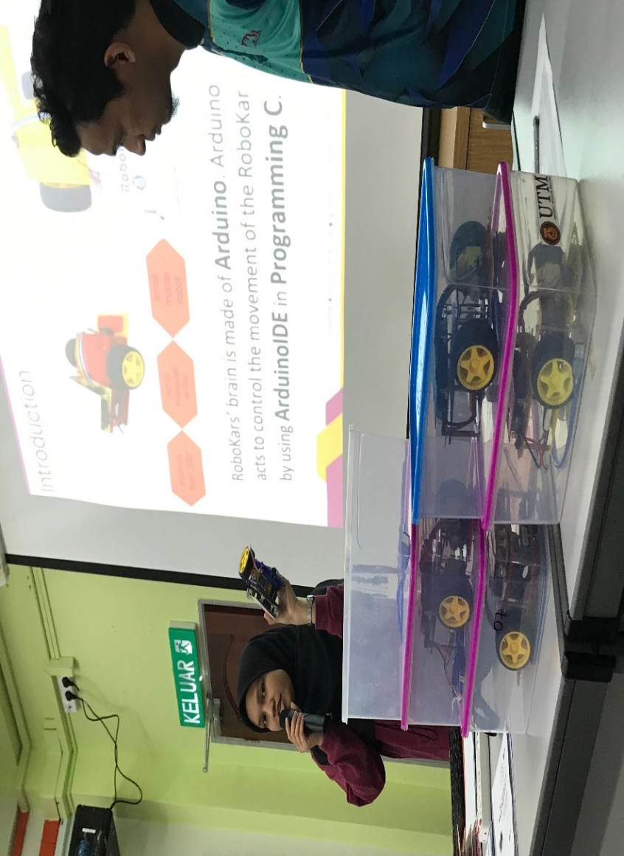
Miss Anurul Nazihaha explaining the robokar.

.
OBJECTIVE AND FOUNDATION OF THE COMMUNITY
The team Started in 2012 and has engaged more than 1000 participants which include matriculation students, school students and school teachers.
The organization was proposed in 2007 and was to be used in teaching and learning for undergraduates. In 2017, IOT development started and currently the industry is involved in the program.
It is used to promote generic skills to community and undergraduates, which includes team work, communication, problem solving and creative thinking.
ACTIVITIES:
- Discussing code on Arduino programming
- REAL TIME SOFTWARE ENGINEERNG 4TH YEAR
- Teacher assisting the students to setup ROBOKAR programming platform.
- Implementing ideas to computer program
- Preparing for competitions.
- Applying generic skills during competitions

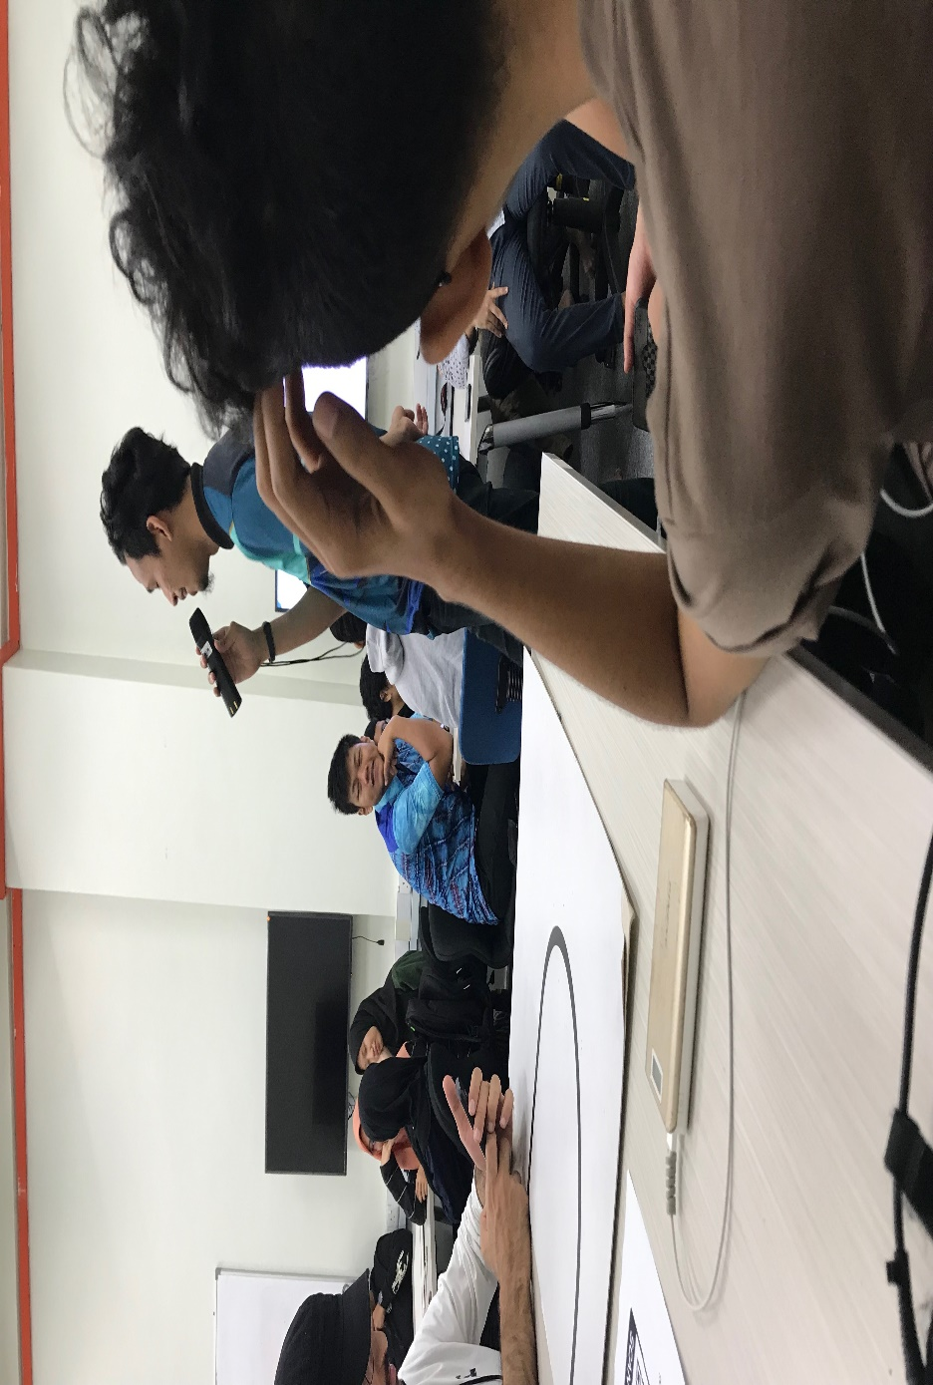

ROBOKAR PROGRAMMING
The robot has sensors and proper instructions have to be given to avoid obstacles.
THINGS REQUIRED FOR PROGRAMMING
- ROBOKAR + USB CABLE
- ARDUINO IDE
- ROBOKAR CONFIGURATION AND LIBRARY
- ROBOKARLIBS.INO
- ROBOKARLIBS.H
- BASIC C PROGRAMMING
- A SET OF BRAINS

FUNCTIONS:
FUNCTION | DESCRIPTION
roboSetup() | It is a compulsory function in making sure that the robots are ready
roboHonk() | Robokar Hon
RoboLED_on() & roboLED_off() | To switch on the LED and can also be used for debugging purpose
waitSeconds(time) | To delay the process flow
Wait4keyPress() | The robocar would run after the key is pressed
readlineSensor() | Robokar read line value
roboStop() | To stop the robot
roboForward(speed) | Robokar move forward
roboReverse(speed) | Robokar moves backward
roboTurnleft(speed) | Robokar turn left

Following the detailed explanation of the Robokar and brief history of the organization the groups were guided towards writing a program to ensure the robocar moves on the black lines along a track. Students completed the task and after which moved to the 2nd floor for a competition to determine the team whose roboKar would move the fastest along the tracks. The best team emerged with 1.15 seconds of the Robokar getting to the final point and my team came in second place with 1.16 seconds. The first and second teams were awarded and all the students were encouraged.
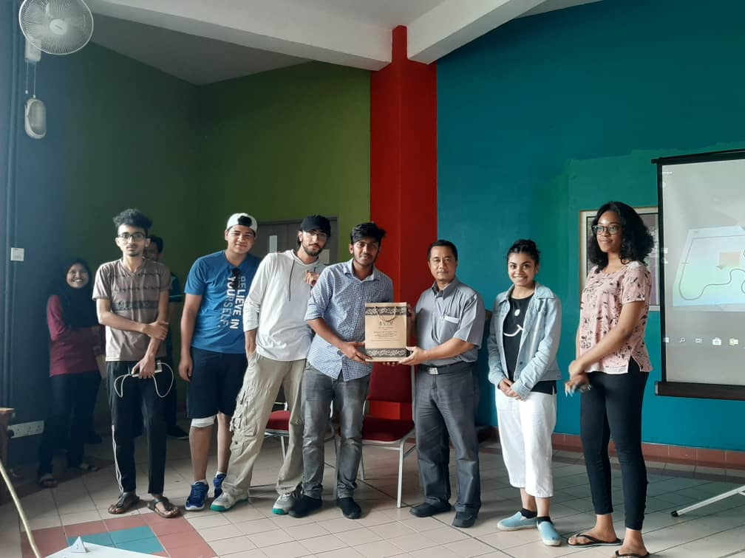

REFLECTION

ALUGE ELINOR OSEI-AMAKA
Software engineering is a course that deals with problem solving. It encompasses our ability to analyze the needs of the users and design, test and develop software to meet those needs.
As aspiring software engineers, we are developing the required skills such as critical thinking, logical reasoning, team work, verbal and written communication, and software development. These skills would be very important for us to achieve our goals as software engineers.
GOALS
Our major goal is to be problem solvers. In a world where the needs of computer users are rising rapidly, we aim to provide solutions to these problems.
- We aim to improve and develop our technical skills which are the software engineering skills and our collaboration skills with regards to team work.
- I aim to solve problems by designing programs that can make handling tasks easier.
IMPACT OF THE VISIT
In the course of this visit we were grouped in teams and this helped to improve our team working abilities. Furthermore, we were taught how to program the robocar and even encouraged with awards.
This workshop helped us to see programming from a more practical aspect as this concept applies to other simple machines such as lawn mowers, vacuum cleaners etc.
PLAN
The software engineering industry is and industry that is growing at a very fast speed. The number of people picking interest in the course is also on the fast rise. In order for me to be successful and compete with other good programmers I have to really improve my programming skills. Improving my programming skills entails increasing the number of hours I spend practicing and solving problems. It is mandatory that I get out of my comfort zone and put In more effort.

REFLECTION
MAIDUL HASAN MASUM
Assalamu Alaikum. This is group no 5. Alhamdulillah our group secured 2nd position in "Robot Programming Workshop".
Firstly, I would like to begin by thanking Dr. Haswadi, for giving us such a great opportunity to learn about Robotics. To be honest first time I have learned about how robot run from this program. All our instructors were so good and helpful, this made us more attentive in our robocar session. We were very excited from the beginning and the time my robocar was working we were more than elated.
A student like me who is taking a course in Software Engineering dreams to be able to make a better world for the future with the help of programming. We are in the age of science and technology. Our world is getting digitalized and most of it needs a program to run its specific task. For example, we have applications for ordering food, transportation, finding a life partner and online shopping and so on like this. All these applications are done by programmers, and our dream is to make the future better with our programming skills for making our life easier and more comfortable.
We were given a robocar with a sensor that was previously functioned. The function of the sensor was to detect the black lines and move towards it. We were supposed to do programming and run it. After our group worked hard in writing the program, we were able to run the program, and the robocar worked effectively, our joy had no bounds. The pleasure attained will further ignite our interest in our course. When we fail or make mistakes, we won't give up, we will keep trying until we achieve our goals.
Therefore, this Robocar program will put a great impact on our goal.
Now I need to practice more and more and need to attend these kinds of program, it will help me to practice and It would also increase my curiosity and excitement and that will bring success Inshallah. Due to the fact that programing is the base of this program, it will help in my course also as I am doing software engineering where also programming is the base. So from now I will practice more and find out more workshops like this to attend.

HAMZEH WAHED BAJBOUJ
My reflection :
As an engineer my goal is to design drones.
To be very honest I wasn’t expecting a lot from this visit, as I’m not really interested in Robo cars.
However, my goals are similar to Robo cars, as it applies the same concept. While I dream to create devices that fly in the sky, the visit introduced us to programming a device that would run on land.
This visit gave me a simple overview about the programming part and it really was useful.
At the moment my goal seems too far to reach, but I will work on improving myself more in programming generally as well as how I can program electronic devices to carry out specific tasks.
Since programming Robo Cars can enhance my knowledge and skills in this field , I would love to be a part of the Utm Robokar club in the nearest future, which is going to be my first step in this field.

GROUP MEMBERS:
1. ALUGE ELINOR OSEI-AMAKA A19EC4005
2.ABDELRAHMAN RASHAD ALI A19EC4001
3.ZEYAD MOSTAFA TALAAT A19EC0297
4.HAMZEH WAHED BAJBOUJ A19EC4009
5.MAIDUL HASAN MASUM A19EC4011
6.ANIKA SHAHZAD A19EC4007
7.

