


SECP1513 – 08 TEKNOLOGI DAN SAINS MAKLUMAT

REPORT
ROBOKAR: ROBOT PROGRAMMING WORKSHOP

SECTION : 08 – 1/SECR
COURSE NAME : BACHELOR OF COMPUTER SCIENCE – COMPUTER NETWORK & SECURITY
LECTURER’S NAME : Dr. Haswadi Bin Hasan
DATE OF SUBMISSION : 19/12/2019
NO | NAME | STUDENT ID
1 | AZ MUKHLIS ISKANDAR BIN AZLI | A19EC0183
2 | AHMAD RAMADHAN SYUKRI BIN JAMALUDIN | A19EC0009
3 | AMEENUDDIN BIN ISMAIL | A19EC0016
4 | MUHAMMAD ISYRAFF IRFAN BIN MOHD RIZAL | A19EC0099
5 | MUHAMMAD RAFIQ REDHA BIN RUSHIDI | A19EC0106
6 | AHMAD SAMMAN | A17CS4013

Contents
Introduction 3
Details 4
Activity Details 5
Reflection 10
Task for Each Member 11

Introduction

Last Sunday, on 8 December 2019, our Technology and Information System class under Dr. Haswadi had a robot programming workshop at the Active-Learning Lab in level 3 (351-01) of Faculty Computing N28. The members of ROBOKAR club consist of our seniors from School of Computing. The workshop started at 2:00 p.m. and ended at 5:00 p.m. and we were divided into 6 groups.
What is ROBOKAR
ROBOKAR is a line follower robot that uses three sensors to differentiate black and white lines that will then be used to determine the speed and direction of the robot. The robot itself has 2 big wheels on its sides, 1 roller at the back of the body and an Arduino board on its body. It uses 2 DC motors in order for the ROBOKAR to move at 3 different speed; FAST, MEDIUM, and SLOW. The robot had already been assembled and students only needed to code using the Arduino software as instruction for the robot.

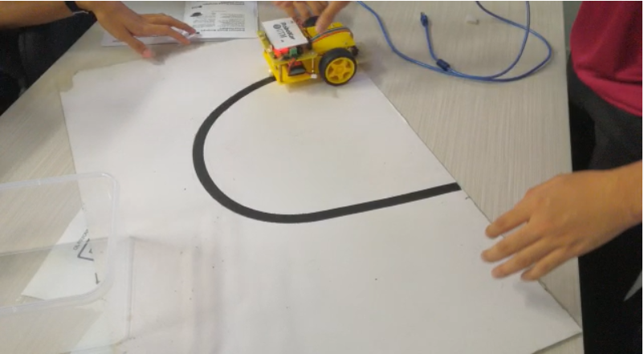
Figure 1: Robocar and track

Details

TENTATIVE PROGRAM
TIME EVENT
2.00 pm Arrival of Participants
Registration
2.20 pm RoboKar : Introduction
Venue: Active Lab Learning, Level 3, N28, School of Computing
Presentor: Nurul Nazihah binti Jamal & Muhammad Irsyad bin Kamil Riadz
2.40 pm RoboKar : Programming
Venue: Active Lab Learning, Level 3, N28, School of Computing
Presentor: Nurul Nazihah binti Jamal & Muhammad Irsyad bin Kamil Riadz
3.00 pm Practical Session
4.00 pm Robokar : Game
Venue: Lobby, Level 2, N28, School of Computing
Moderator: Ahmad Syahir bin Abdul Hanim & Ahmad Nazri bin Abdullah
4.30 pm Award Giving and Closing Ceremony

Activity Details

First, when we entered the room, they gave us a warm greeting and asked us to sit according to group. There were 6 tables enough for each group and on the table, there were a box containing a robocar and a cable. After we were seated, they immediately began their workshop by briefing us about their club background and achievements. The briefing session was with few seniors and some technical professional staffs about half an hour by introducing themselves and they talked about the origin of ROBOKAR in UTM. They also told us that our university have some competition and sharing session on this robotic programming activity around different schools and faculties and taught the students some of the basic robotic programming and give them a chance to do hands on with this technology.
Then, after the briefing session, they explain to us about the ROBOKAR, how to use it and how to program it.
The three sensors use binary number to determine the line that will decide whether it will move forward, to the left, to the right, backwards or stop. The speed of the movement is decided by us using the Arduino software.
We did some programming in the Arduino software using the if else statements to change the orientation and speed of the robokar. The robokar was then tested on a piece of cardboard that has a black line with different orientations so that we could try and error with the program. We sped up and slowed down the movements according to our necessities so the robokar can make correct movements with precise speed after detecting lines using its sensors. For instance, we will slow down the movement when we want the robokar to turn left or right so that the robokar will not turn so hard that the sensors cannot detect the black line anymore.

Here is an example of the coding from the Arduino software:
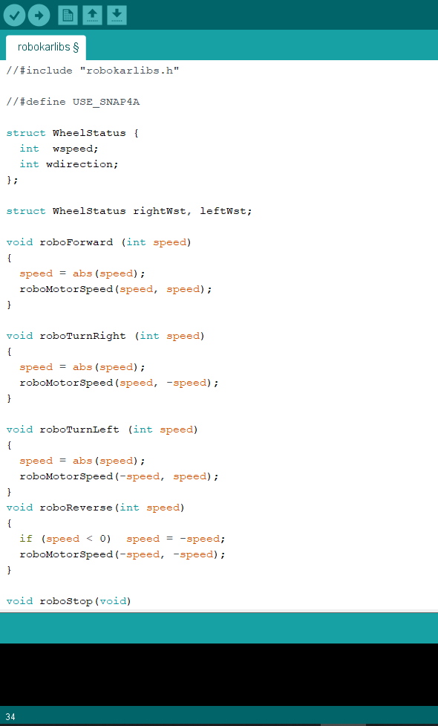
Figure 2: Part of coding
After the program was completed, we integrate the instruction on the software with the Arduino board on the robokar using a USB connector.
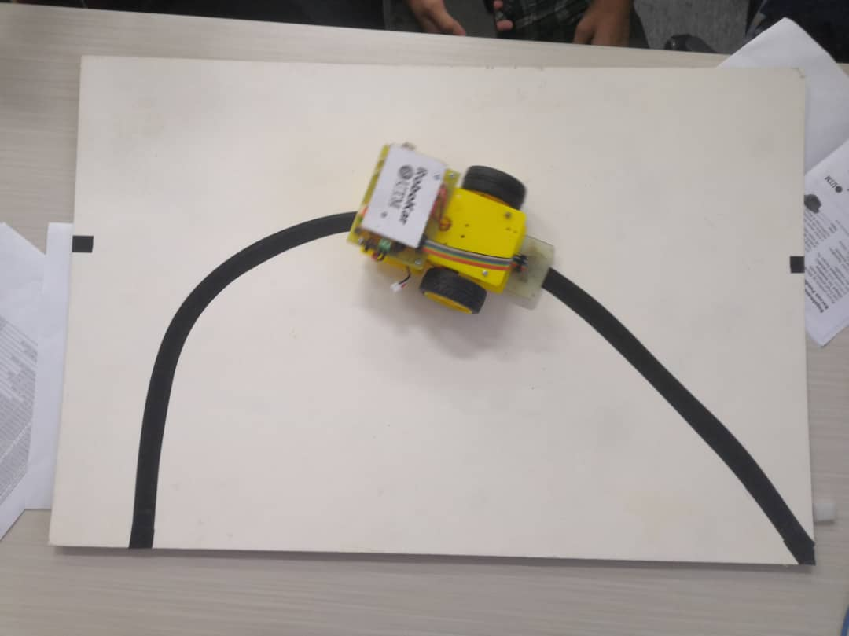
Figure 3: Testing our robokar on a black line track

After the programming session had come to an end, we went to the lobby located at level 2 of block N28 to compete among ourselves. The way the winner was determined was based on the time taken to complete the black line track and the amount of checkpoint that the robokar passed through. The time given to complete the track was 3 minutes and if your robokar took more than 3 minutes to complete the track it will take into consideration the amount of checkpoint passed through by the robokar.

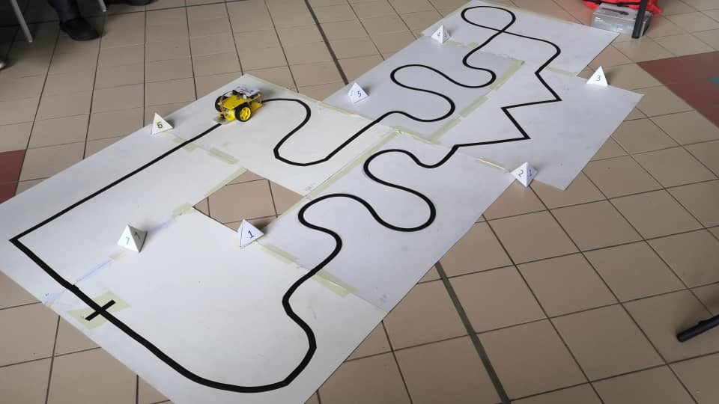
Figure 4: Our robokar on the completed track for the competition

At the end of the day, we won 3rd place for the competition with time 1 minute and 35 seconds. Unfortunately, the only gave award to the first two winners (Group 4 and Group 6).

Finally, after the prize giving ceremony, we had photography session with our lecturer Dr. Haswadi, the members of Robokar club and with other groups which are our fellow classmates.

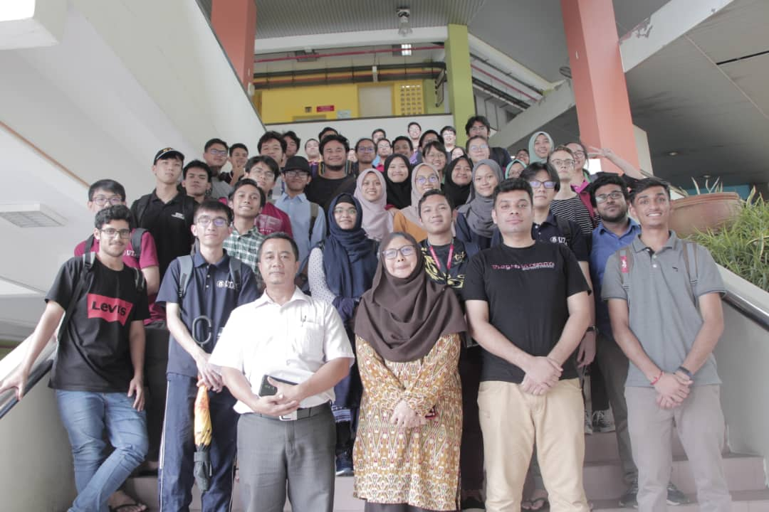
Figure 5: Photography session after the end ceremony
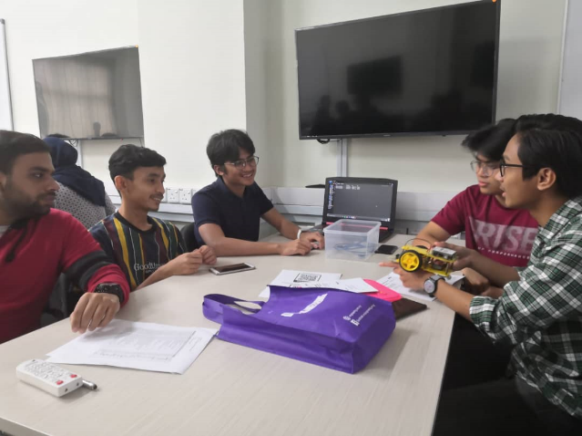
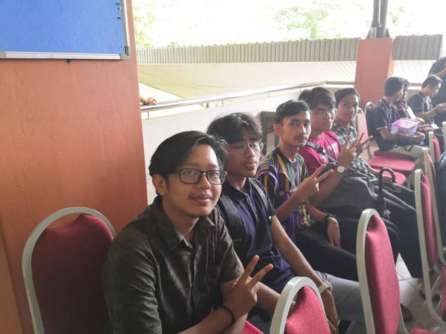
Figure 7: We were discussing on how to program our robokar
Figure 6: We were full of flutter while waiting for the result

Reflection

What is your goal/dream with regard to your course/program?

The difference between information systems and information technology is that information systems incorporates the technology, people and processes involved with information. Information technology is the design and implementation of information, or data, within the information system. From this perspective i can easily came up a mind that my contribution for this subject will be the implementation of the data, information’s design into the technology which can be embedded into software-based prototype. My goal for this program is to make something legally which will be in the help of humanity. Without having a positive ethics i am afraid my invention can be misused for the distraction of human. Alhamdulillah my goal is to look in future with such a positive motive which makes our life at ease. Also, our respective lecturer taught us this.

How does this design thinking impact on your goal/dream with regard to your program?
I am very optimistic guy with ethics mixed in my project work. Previously I mentioned that I would like to work in the purpose of helping humanity. Robots are the future. In future human work will be replaced by the robots. This design thinking inspires me to work with the robots in future. This also puts a significant impressions in us to make robotic racing cars. We are learning in the beginning level but our dream is too high. One of the innovative things we wanna implement is “robot-psychologist”. We will need to teach robots what behavior is seen as correct and what isn’t. The group of people that will experience the biggest social impact of robots are children. Robots will enter schools and assist children in learning. But robots can also take over tasks. Children will quickly find out that robots are very good at making homework. Would that be a good or a bad development? Let’s see! But we are wishing froward to use the good side of the creation.

What is the action/improvement/plan necessary for you to improve your potential in the industry?

To be able to determine if something is good or bad we need some sort of specification of what is good. But “good” depends on many things. For example on your social values. Also “good” will differ over time. Currently we may not like it when robots take over jobs of taxi-drivers. But if robots do the work so much more efficient that we only have to work one day a week to earn our salary we may actually like robots very much and spend a lot of time on doing things we really enjoy.
Robots will have social impact. Both positive and negative. It’s us how we will use it. As I said as a human being we need to use technology for our human world. So why don’t we improve this robots to ease our life,That sounds fair enough.

Task for Each Member
Name | Task
AZ MUKHLIS ISKANDAR BIN AZLI | Introduction
AHMAD RAMADHAN SYUKRI BIN JAMALUDIN | Activity Details
AMEENUDDIN BIN ISMAIL | Activity Details
MUHAMMAD ISYRAFF IRFAN BIN MOHD RIZAL | Activity Details
MUHAMMAD RAFIQ REDHA BIN RUSHIDI | Details
AHMAD SAMMAN | Reflection

