
SEMESTER 1
SESSION 2019/2020
SECP1513

DESIGN THINKING:
COMMUNICATION AND NETWORK

Prepared By :
- Muhammad Mukhlis Bin Mohd Feris Halmy (A19EC5225)
- Rifadul Islam ( A18CS4050)
- Md Shakil Chowdhury (A18CS4047)
Lecturer Name : Dr. Aryati Binti Bakri
Table of Contents
Introduction 3
Empathy 4
Define 5
Ideate 6
Prototype 7
Reflection 13
TASK FOR EACH MEMBER 14
VIDEO LINK 15

Introduction
Design thinking is now part of education where we use this skill to analyze problem and we apply this design thinking to create new and can help people better.

As the world keeps evolving, communication and network also keeps changing and changing without we knowing it. As to what to communication is the imparting or exchanging of information by speaking, writing, or using some other medium such software, phone and etc.
On the other hand network is a communication system that connects two or more computers so they can exchange information and share resources. So, as we know before people, communicate using paper where there write on it and pass it to the postmen to deliver it. People wait for a few days waiting for their message to arrive and after that the same thing repeats. Before this network, is still not that good. But nowadays with network has increasingly develop, many things change same goes for the communication. Network now can be connected wirelessly without wired connection and the speed also increase. For communication, people can now communicate with people from around the world. It is because we manage to create a communication software where people can instantly message their friend, family or relative.

It is clear that communication and network has undergoes many transformations that have improved our lives and make life easier for us. We can see how design thinking skills make us.

Empathy
The main phase of the procedure of configuration thinking causes you to build up a empathetic comprehension of the issue you are attempting to fathom, as a rule through client inquire about. Empathy is vital to an arrangement of human-focused improvement, for example, plan thinking, as it encourages you to put aside your own reality discernment's and increase genuine understanding into clients and their needs.

Communication networks are regular patterns of person-to-person relationships through which information flows in an organization. This means that the flow of information is managed, regulated. and structured. Communication networks may be formal or informal.

We found these various problems to be somewhat significant but it seemed to be critical after we conducted an interview of Dr. Mohammad Raihan on this matter. After talking to him we found that the current communication networks still have advantages and too many disadvantages. So, we moved forward with keeping these in mind.
Here is the list of questions that we prepared to ask our respondent.
      - Tell us about communication system?
      - Which kind of network system do you prefer?
      - Share your idea about physical communication system?
      - Can you share your facing problems in communication to others?
In short, stated below is the information about our respondent.
Through the interview, we have concluded some highlights that are referring to the importance of database based on our respondent’s experiences.

For the first question we asked, we get to know about many types of communication system. After our first question, we are able to know which type of network system he prefers. We get to know more about wireless communication system.
Moving to the next question, he shares more about physical communication system and we are able to know the problems of commutation system.

Define

In defining, we put collectively the information what we’ve created and gathered at some stage in out empathize stage. Based on this part simply the ideate section is created. We have to are trying to find to outline the problem as a trouble statement in a human-centered manner.

In this outline stage will help us collect super innovative ideas to set up features, features and any different factors that will allow to clear up our problems in very handy and high-quality way.

Communications networks are changing rapidly, opening the door to a entire new swath of competitors. Network verbal exchange Today it owns the country's largest mobile communications network, and its agencies span oil and fuel exploration and production, textiles, monetary services, power and insurance

Ideate
Ideate is that the area in design thinking wherever people and groups elevate and celebrate the facility of risk. it's the transition from characteristic a specific question or drawback to generating a large style of potential answers and solutions.

Actually, create by mental act is that the mode throughout planning method wherever we will specialize in plan generation. It is the artistic method of generating, developing and innovating new ideas, wherever a plan is knowing as a basic component of thought which will be either visual, concrete, or abstract.

One of the foremost necessary aspects of a home network is that the ability to share network resources. There square measure a spread of the way to accomplish this. A server is that the best resolution, however not several home users can have one. Network connected Storage or NAS devices square measure a lot of price effective and easier to use during these surroundings. to find out a lot of concerning NAS, browse the ten Best NAS Devices. As another, several routers have integral USB ports which may be accustomed share arduous drives or printers among all network users.

Mobile broadband may be a very straightforward plan and it comes in 2 totally different varieties: it's either delivered over a radiotelephone network or via Wi-Fi from what's, basically, simply a subscriber line or cable broadband link to the web. As we've already coated the latter up higher than, the remainder of this text focuses on however radiotelephone networks deliver mobile broadband. The technical marrow of however that works gets quite complex; we'll offer you a fast and easy summary for starters, followed by a lot of elaborate technical clarification at the top.

Prototype

Prototype is the preliminary version of a system which is used to explain the idea and also to design the other forms. To design the prototype, at first, we held a meeting. We researched about some existing systems including the softwares and hardwares which relates to our project. Then we designed our prototype with the help of the knowledge we got from our research. We used different stationery products to make the prototype. That is how we developed the prototype.

Prototype testing for user:

- The user is connecting the router:
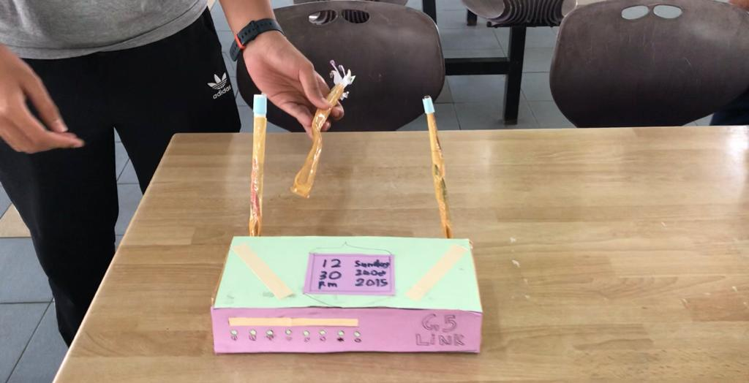

- The user is connecting his device to the network :

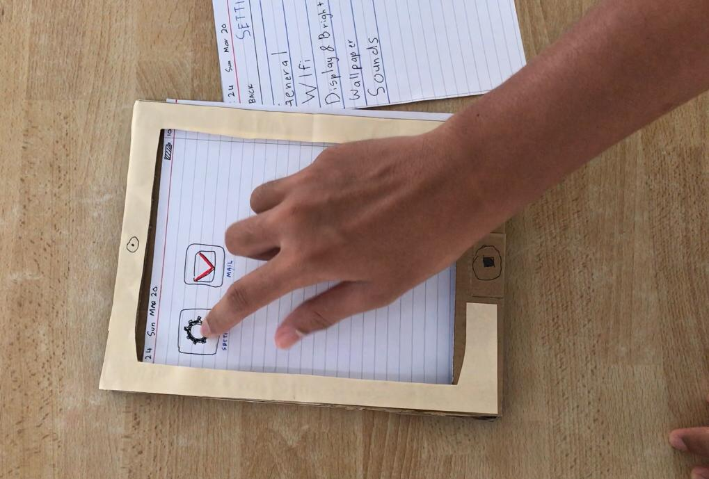
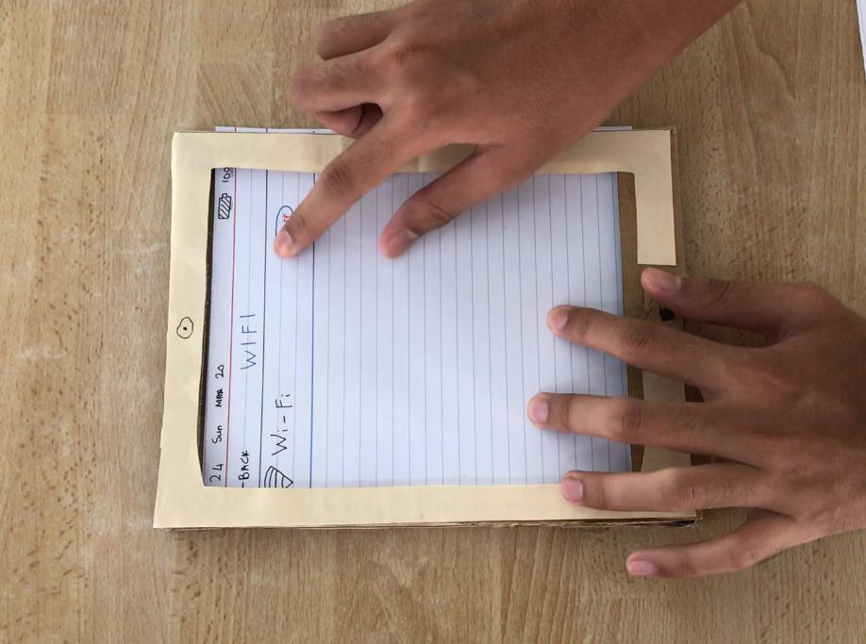

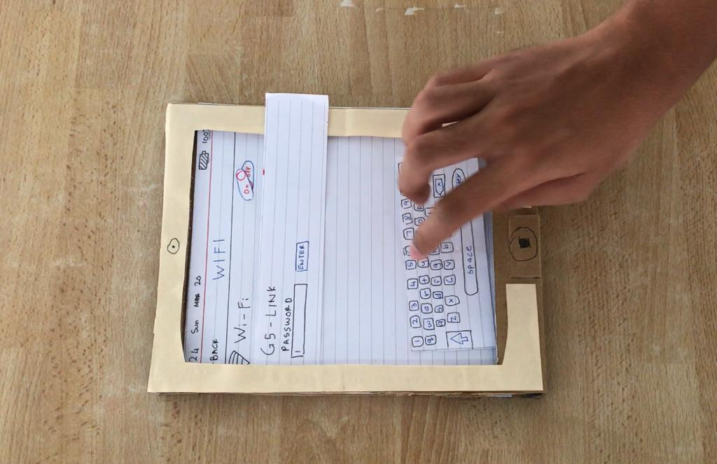

- The user is sending an email using the router’s wifi connection:
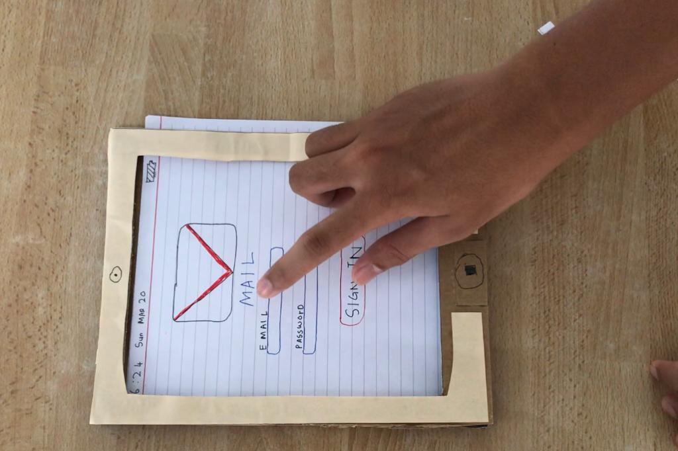

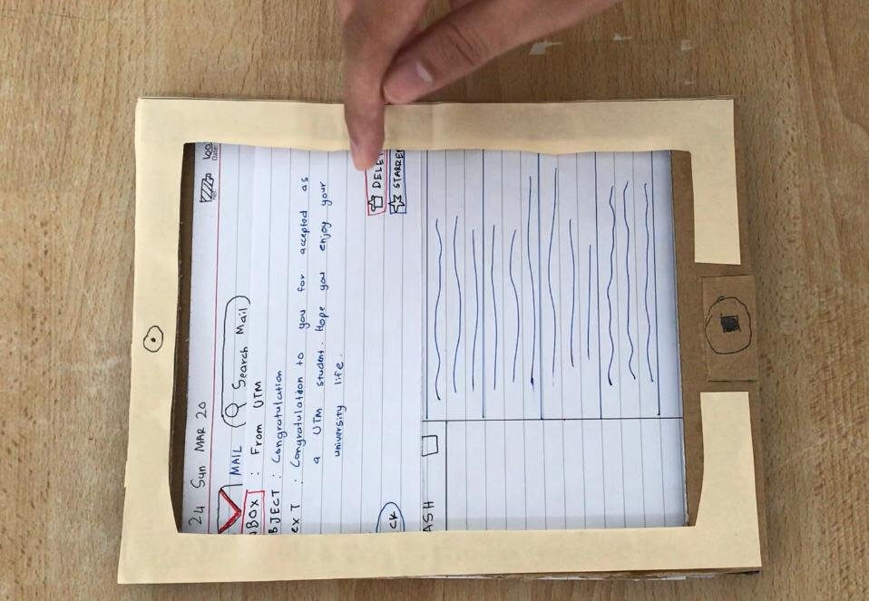

Reflection

As we can see, design thinking has a big impact on how we approach something. For example, on how we approach the problem, how we want to get it and how we solve it. Design thinking taught us that we need to approach something step by step as in design thinking that are start from empathy until prototype phase. This design thinking skill have made people become critical thinking and adaptable person. This can be related to the course that we are taking that is Technology and Information System where the goal is to make sure student become a capable and useful graduate that can improve our society. Other than, design thinking teaches us that we should study and learn only for exam but it also can apply to our everyday lives.

With this Industrial Revolution 4.0(IR 4.0), employers today are looking for graduates who are capable of critical thinking, responsible and have the other skills. Why did they want this graduate? Employers want a graduate that can apply this skill in their field and bring something new to their company. They will not take the graduate who is only excel in studies and have a good pointer, instead they want graduates who have the design thinking skills. The pointer or CGPA may be their 2nd choice. That’s why design thinking crucial if we want to have our dream come true and help us manage our goal.

Regardless of that, we also need to improve ourselves before we entering the industry work. What we can do is to have more experience. For example, we can volunteer ourselves to join their company to get experience on our jobs or join any available projects so we can sharpen our leadership skills and team working skills. Moreover, we can learn how to interact with people and improve our communication skills. Lastly, it helps us face any kind of situations and problems in the future.

TASK FOR EACH MEMBER

NO. | NAME OF MEMBER | TASK
1 | Muhammad Mukhlis | ● Writes report – introduction, reflection  ● build prototypes  - Wireless Modem router  - Mobile Broadband  - Communication Device  ● helping with edit video  ● idea generation
2 | Rifadul Islam | - Video Editing  - Recording video  - Taking Interview  - Idea generation  - Report writing- emphathy, prototype  - Helping with prototype
3 | Md Shakil Chowdhury | - Report Writing- define, ideate  - Video Editing  - Taking Interview

VIDEO LINK

https://youtu.be/s6npKWXA3zg

