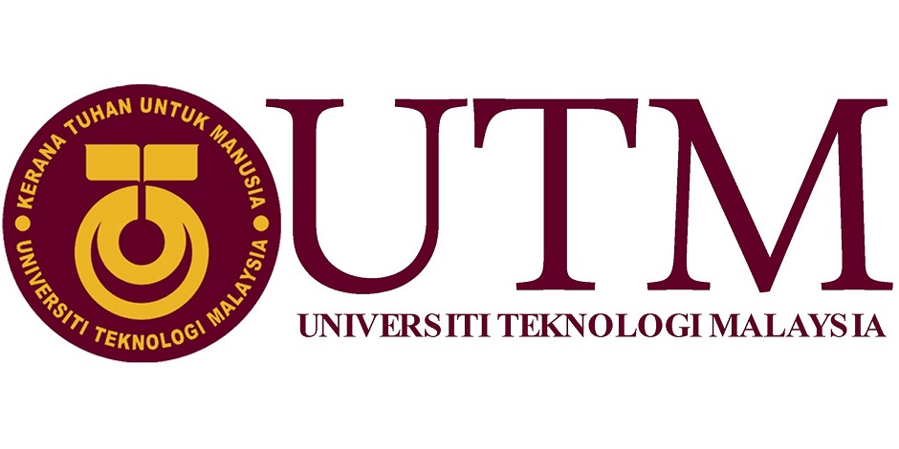

TECHNOLOGY AND INFORMATION SYSTEMS
SCSP1513-06
FACULTY OF ENGINEERING
SCHOOL OF COMPUTING

INDUSTRIAL VISIT
REPORT

PREPARED BY:
ASWIND SARVANESH VARMAN A/L SARAVANAN | A19EC0025
OMAR ALAAELDIN HASSAN KHATER | A19EC9030
IRMA ZAFIRAH BINTI MOHD IKRAM | A19EC0054

Table of Contents

1.0 INTRODUCTION 3
1.1 CICT 3
1.2 PSZ 5
1.3 GALLERIUM 5
2.0 DETAILS ABOUT EVENT 6
2.1 HISTORY OF THE COMPONENT 6
3.0 REFLECTION 11
4.0 TASK FOR EACH MEMBER 12
6.0 REFERENCES 13

1.0 INTRODUCTION

1.1 CICT

CICT, also known as Centre for Information & Communication Technology a support unit that offers and delivers ICT service for the university’s member. The building of CICT is located at Lingkaran Ilmu, Universiti Teknologi Malaysia, Skudai, Johor Bahru, Johor.

VISION
Digital University Driver

MISSION
Strengthening academia-centric service delivery through data driven digital ecosystem
Organisation Structure of CICT

1.2 PSZ

Perpustakaan Sultanah Zanariah (PSZ) is the UTM library located in the middle of the university. It was officiated by Her Majesty Sultanah Zanariah, the Chancellor of Universiti Teknologi Malaysia on the 3rd of February 1991.

VISION
To be the centre of knowledge in science, technology and engineering

MISSION
To enhancement the knowledge for users through easy access and sharing the resources of science, technology and engineering

1.3 GALLERIUM

Gallerium is a part of Perpustakaan Sultanah Zanariah (PSZ). It is an important entity for the university to conserve and record university’s historical heritage including University Heritage Gallery, Microfilm Gallery, Information Technology Gallery and Audience Gallery. The gallerium was officiated Ybhg. Prof. Datuk Ir. Dr. Wahid bin Omar who is the 6th Vice Chancellor of UTM on the 28th of September 2017.

2.0 DETAILS ABOUT EVENT

2.1 HISTORY OF THE COMPONENT

The industrial visit was held on the 20th of October 2019 at Perpustakaan Sultanah Zanariah (PSZ). Students from Section 6 and Section 7 gathered at the gallerium at 3pm and subsequently, the visit started around 3.30pm. Encik Mohd Zahari Bin Zainal Abidin, who is a staff of CICT, did a briefing about the history of components in UTM throughout the visit.

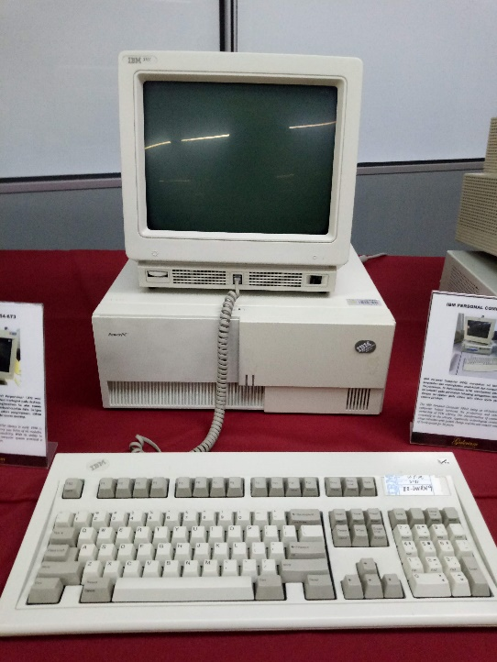
Figure 1
Firstly, Encik Zahari was explaining about IBM Personal Computer 300GL (Figure 1). It was said that it was an all-inclusive and affordable computer. It helped with increasing the productivity and reducing the cost of ownership of UTM Library. It was evident with application of Dynix system for 10 years.
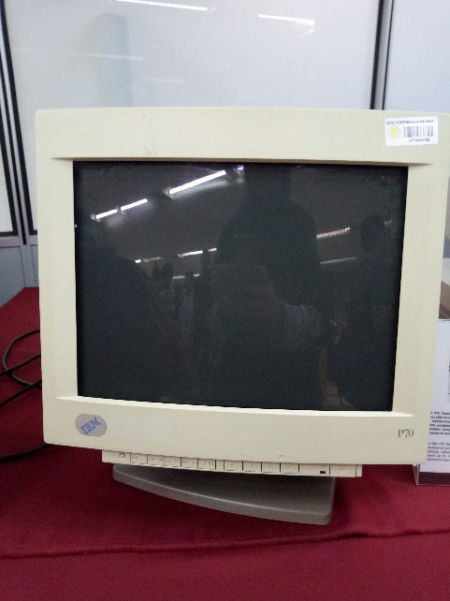
Figure 2
IBM P70 Model 6554-673 (Figure 2) was used in UTM library in early 1998. It contributed to great work performance. The library was liable of all module databases, software operations and data accessibility. It could occupy up to 16MB on disk storage. The computer system also provided performance improvement on desktop operation.

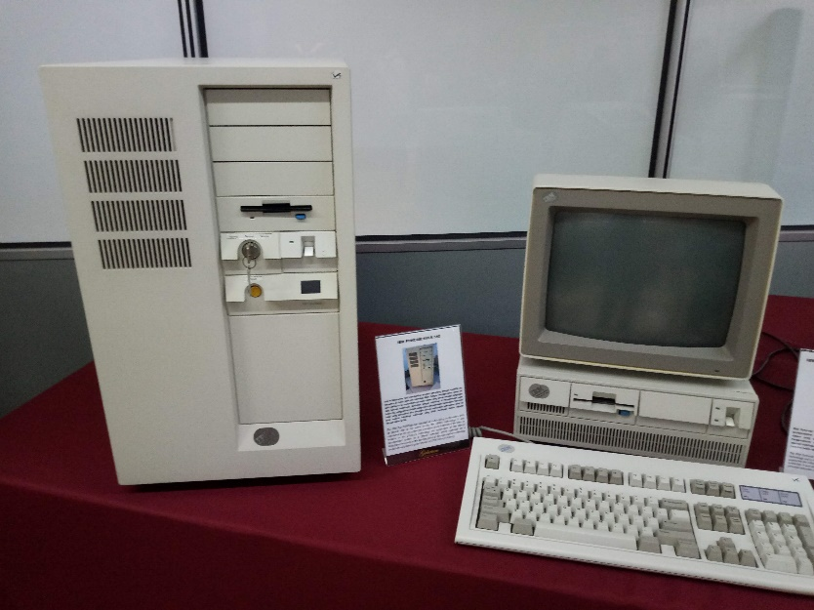
Figure 3
As for IBM Personal System/2 Model 70 386 (Figure 3), it featured high density memory technology and a range of integrated features. The computer with its system could support the library significantly in performance improvement for desktop operation. It was also compatible with most software products available for a personal computer system in UTM Library. Most importantly, the IBM 550 Powerserver (Figure 3) gave a great impact on UTM Library’s history. This powerserver boasted an outstanding performance with its fastest chip in the world during the 1990’s technology. It was considered as an apt system for a medium-sized database at the time. In relation to the Library’s technology, the application of the library management system on freeze terminal which on a mainframe was seen as the starting point oh the information technology evolution.

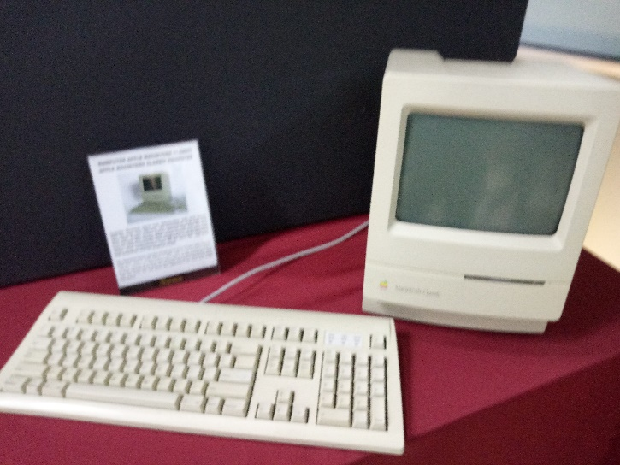
Figure 4
Apple Macintosh Classic computer (Figure 4) was introduced in early January 1984 and has been used in UTM in early 1990. It was equipped with a software memory of 1MB of RAM and 2MB to 40MB of hard disk. This computer was used in the library along with the Lotus 123 and Word Star applications for work and simple calculation as it had a large capacity.

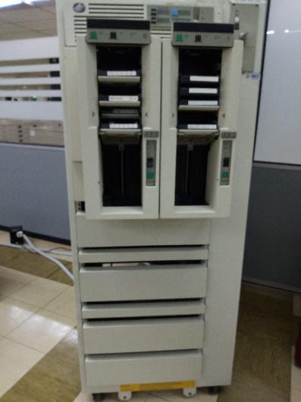
Figure 5
The usage of mainframe system at UTM began in the 1970’s at Computer Centre, UTM campus in Kuala Lumpur. It served as a data control of students’ and staff’s information. The mainframe has been used for almost 20 years for various components and functions such as processing, storing, securing and printing the university’s information data.
Mainframe Tape Subsystem (Figure 5) was used as a backup for mainframe system and information database of staff and students as well as university’s information system during the year 1987 until 1995. This model used a square shaped tape after the round shaped one was no longer in use.

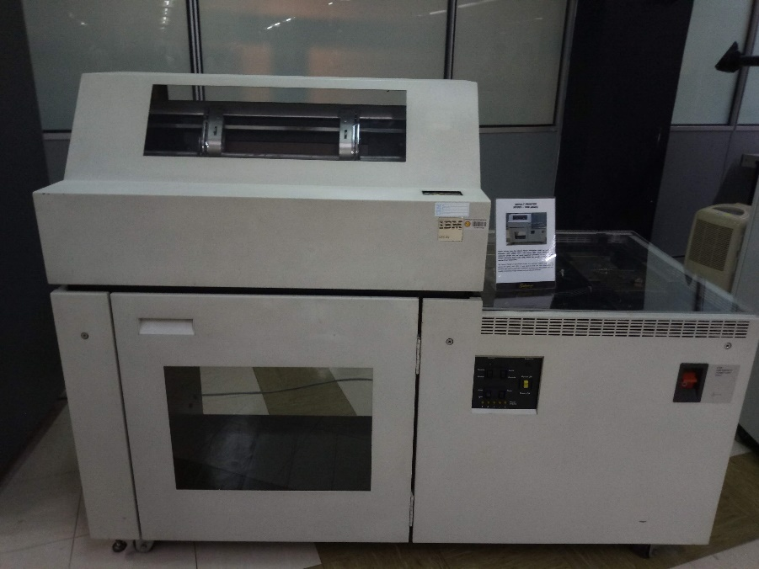
Figure 6
The impact printer or known as Dot Matrix Printer (Figure 6) is a printing machine used in UTM during the 1990’s until 2011. It was used to print the data information of students and staff to meet university’s requirements. This printer was also capable of printing in high volumes and non-stop for 48 hours.

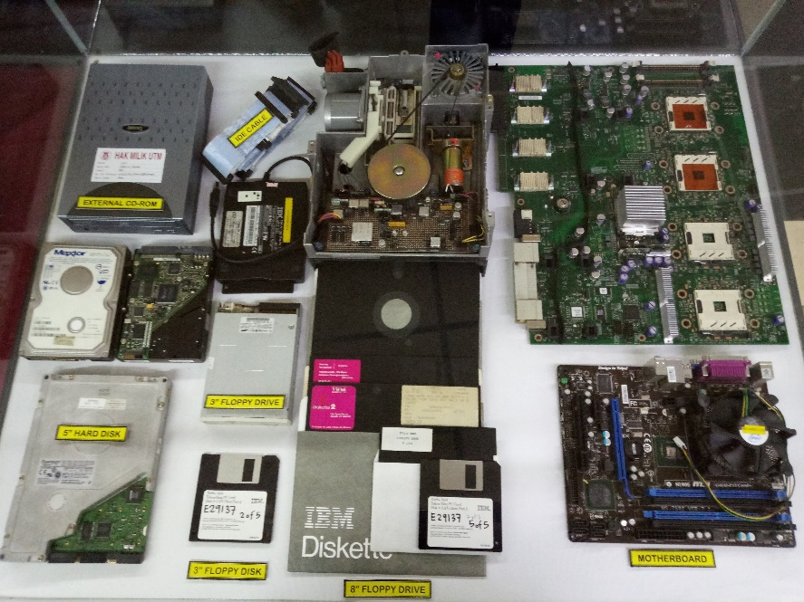
Figure 7
Lastly, there were CPU components displayed in the gallerium. Basically, CPU consists of motherboard which is the most essential part in computer system. It holds, and allows, communication between many of the crucial electronic components of a system, such as the central processing unit and memory, and provides connectors for other peripherals. Next, CPU consists of hard disk which is used to store and retrieve digital information. Floppy drive is a hardware device that reads data storage information from floppy disk. Furthermore, external CD-ROM is a device to read data storage information from CD-ROM which is an optical disc that contains audio or software data whose memory is read-only.

3.0 REFLECTION

3(a). There is a saying, “One way to keep momentum going is to have constantly greater goals.” The members of group 2 are students of computer science (software engineering and graphics & multimedia software). We, as computer science students undeniably have several goals regarding to our program. The goals include long-term goal and short-term goal. First and foremost, for the short-term goal, we are striving to graduate with our own program degree. With this degree, we could find a job at a stable company. Second short-term goal is to expertise at programming languages in order to be a better programmer. As for the long-term goal, we would want to be able to create solutions and applications innovatively and creatively that are useful for society. Therefore, we could create an operating system for an application or software for business and general purpose uses.
3(b). This CICT visit was very beneficial to us by many ways. As a science computer studying Graphics and Multimedia software and software engineering, we have a lot to learn about technology and the science behind it. The CICT visit enriched me with vast knowledges about various system units, hardware designs, networking systems and so on. The coordinator during the visit also helped me more to understand about all the inventions and technological stuffs by explaining the process clearly and how it evolved to be what it is today. He explained the history behind the development of those hardware in detail. This CICT visit impacted on our dream, which is to become a successful and professional computer scientist in the upcoming future, with also the regards of our program. For an example, during the visit, we got to learn that computing powers of hardware and system units have increased exponentially throughout the year but their sizes have been decreasing relatively to their power. It showed us that as science computer students, we will always face problems that are big and makes me slow at the start. But once we work the problem and sort things out, we can minimize the issues and increase our productivity level. The easiest example for this was the generation of computers that they displayed in this visit. Having a big, slow computer at the beginning did not stop the computer scientists back then to improve the innovations and they proved that there is always room for improvement for technology. We hope that we will, too, be able to create better and faster inventions that improve our way of life and broaden the field of computer science.
3(c). We believe that anyone in any course or program should never stop studying and learning as it is always the key to success. We believe that we should continue developing our skills required for being a successful people. We plan on learning more programming languages and take more courses to widen our chances in the industry even more. In conclusion, before we can accomplish anything in life, we must know what we want, in other words, we need to set our goals. Thus, we get to decide which one is more important to prioritize it then focus on achieving the goal.

4.0 TASK FOR EACH MEMBER

NAME | TASK
ASWIND SARVANESH VARMAN A/L SARAVANAN | - The leader of the group  - Took pictures at the event  - Made some reflections
OMAR ALAAELDIN HASSAN KHATER | - Took pictures at the event  - Made some reflections
IRMA ZAFIRAH BINTI MOHD IKRAM | - Wrote the report  - Made some reflections

6.0 REFERENCES

- UTM Library. (2019). Retrieved from http://library.utm.my/about-the-library/vision-mission-goals/

- UTM Library. (2019). Retrieved from http://library.utm.my/utmgallerium

- CICT UTM. (2019). Retrieved from https://cict.utm.my

- Zaidi Hj. Mohmod (2019, September 12). Perpustakaan Sultanah Zanariah. Retrieved from https://www.utm.my/edutourism/psz

